# 2019103555 PRANAVA RAMAN B M S 13/09/2021

**LAB – 02**

Illustrate a classification algorithm, a clustering algorithm and a regression algorithm using Weka Tool. Evaluate suitable performance metrics.

**Dataset:-**

[Index of /ml/machine-learning-databases/tic-tac-toe (uci.edu)](https://archive.ics.uci.edu/ml/machine-learning-databases/tic-tac-toe/)

**Preprocess:-**

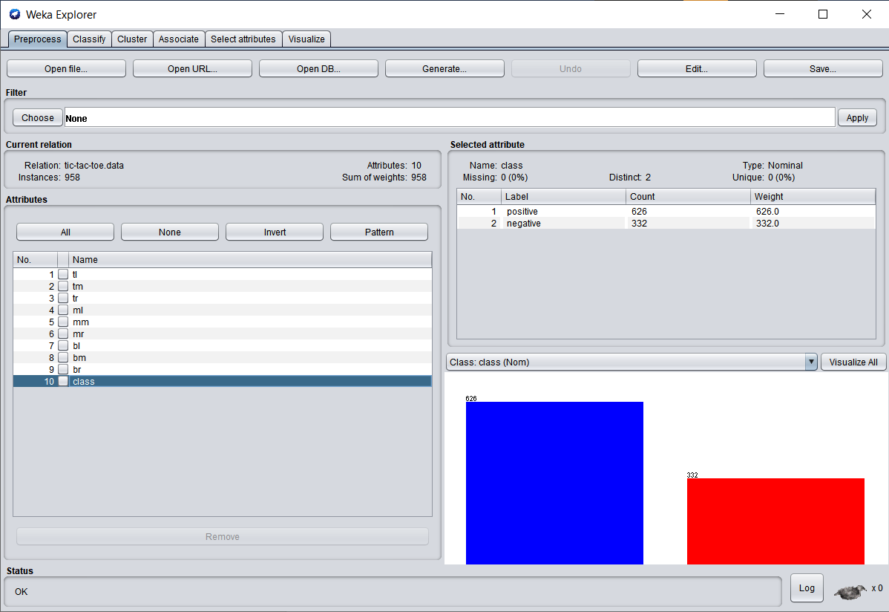

**Algorithms:-**

1. **AdaBoostM1 (Classifier)**

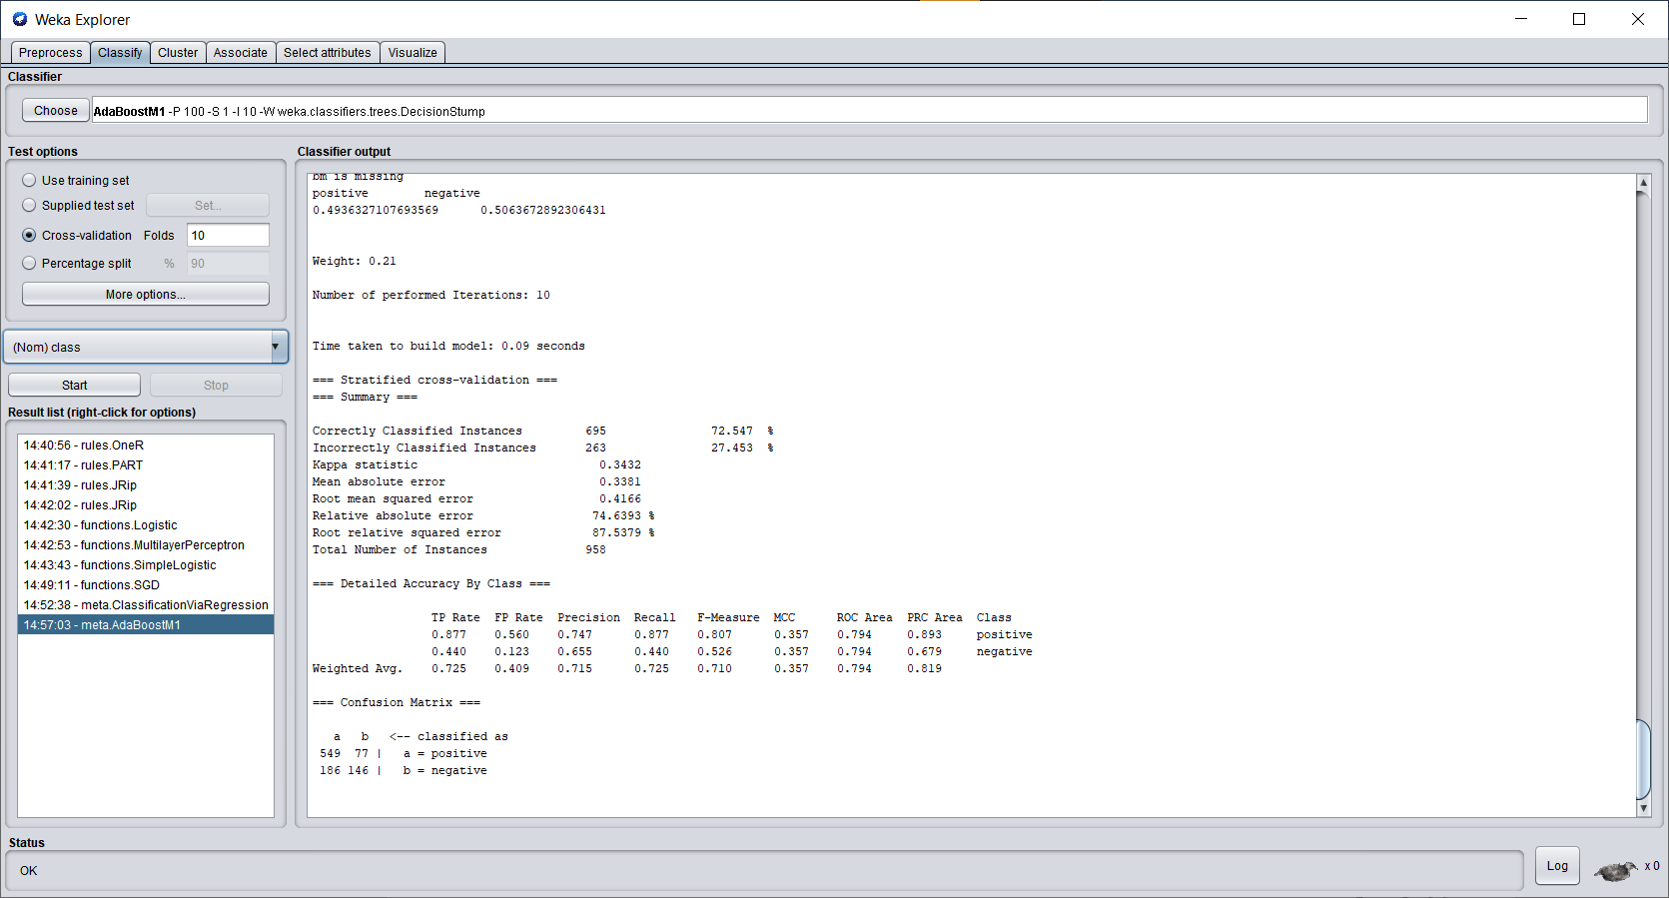

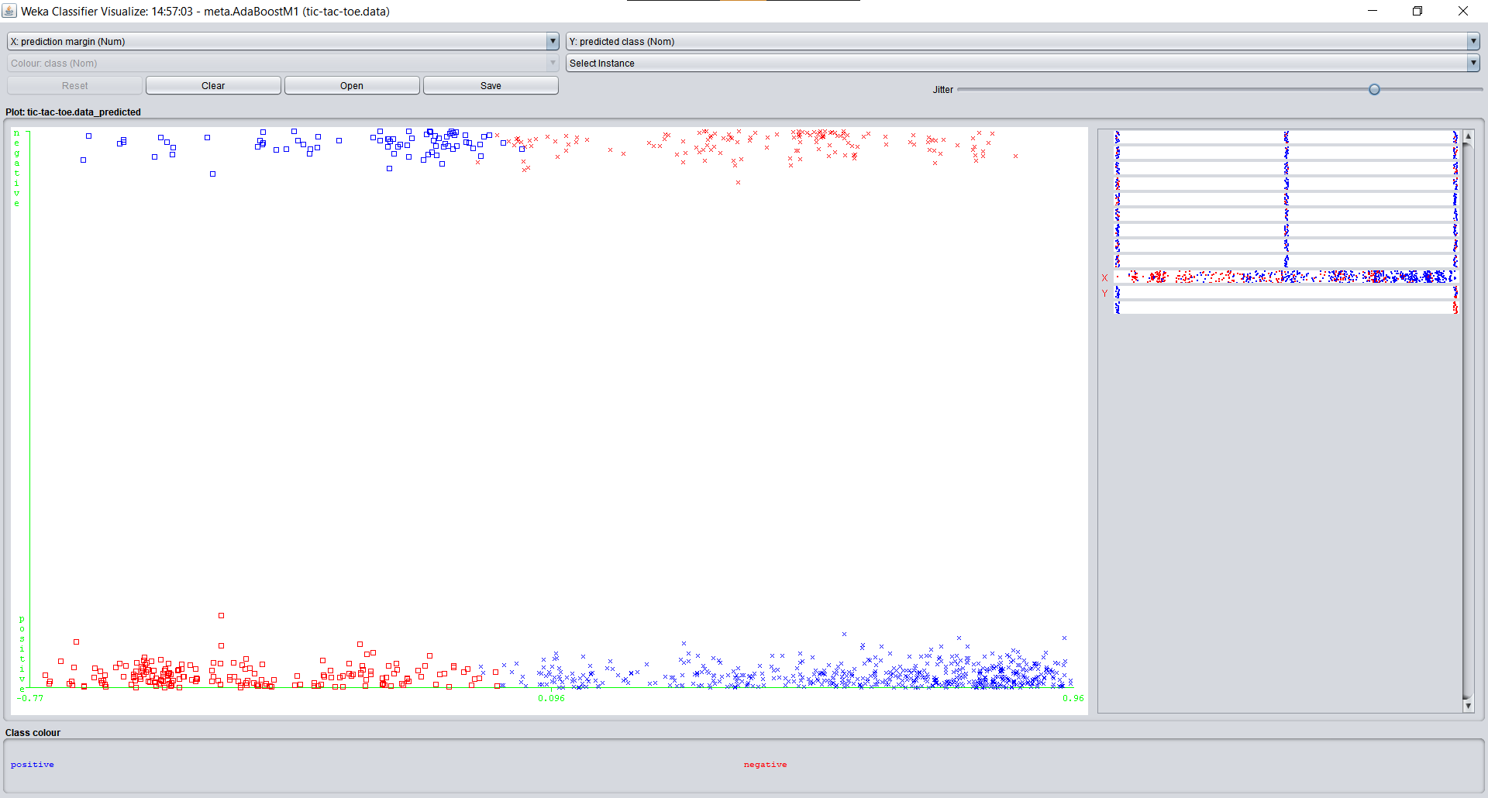

The model was quick to compile but very bad at the actual classification, as can be viewed from the confusion matrix.

1. **Logistic (Regression)**

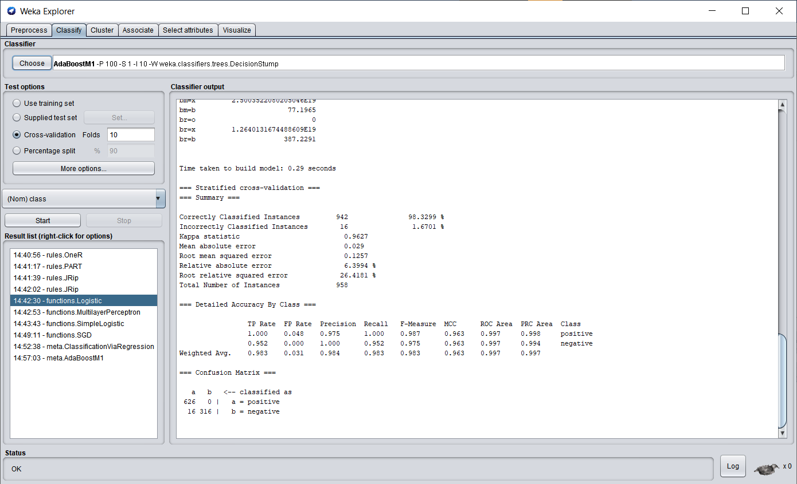

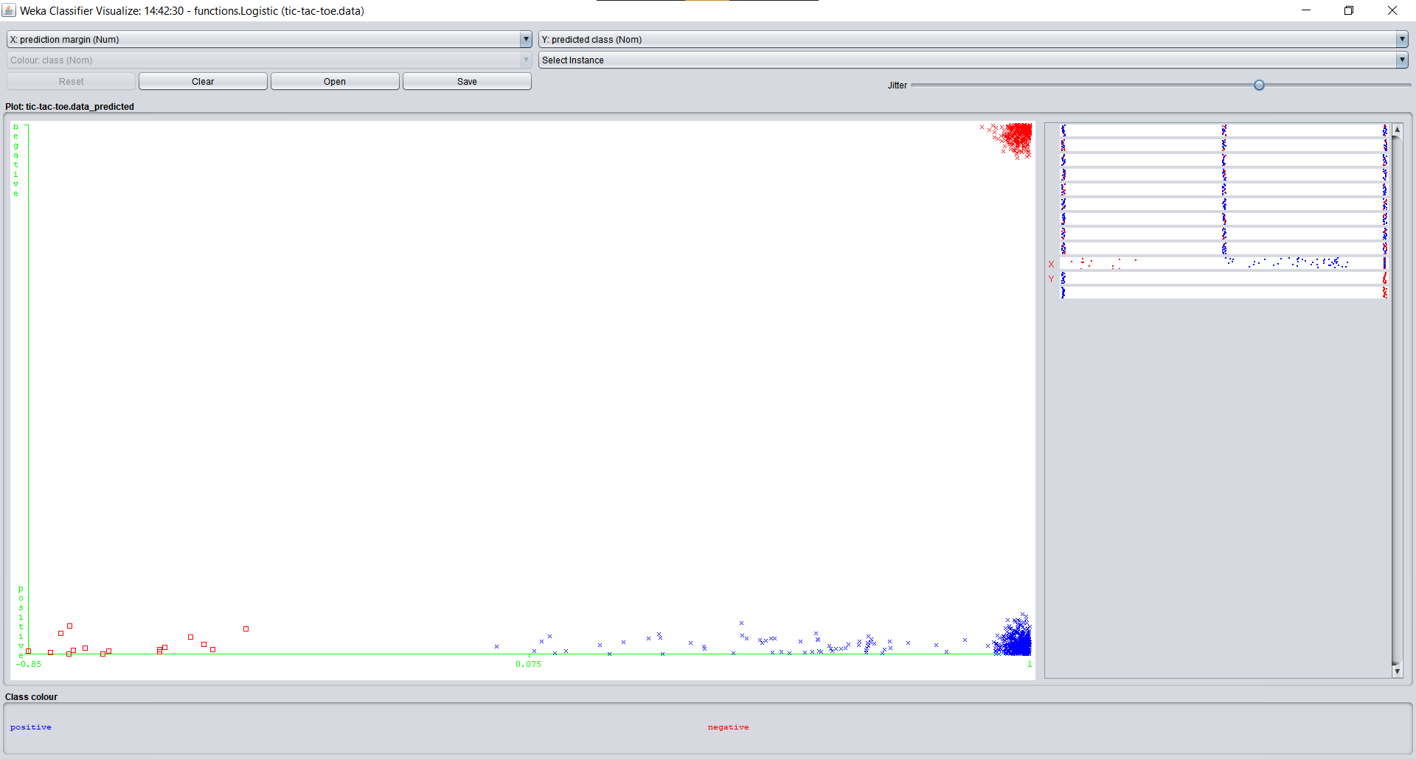

1. **Stochastic Gradient Descent**

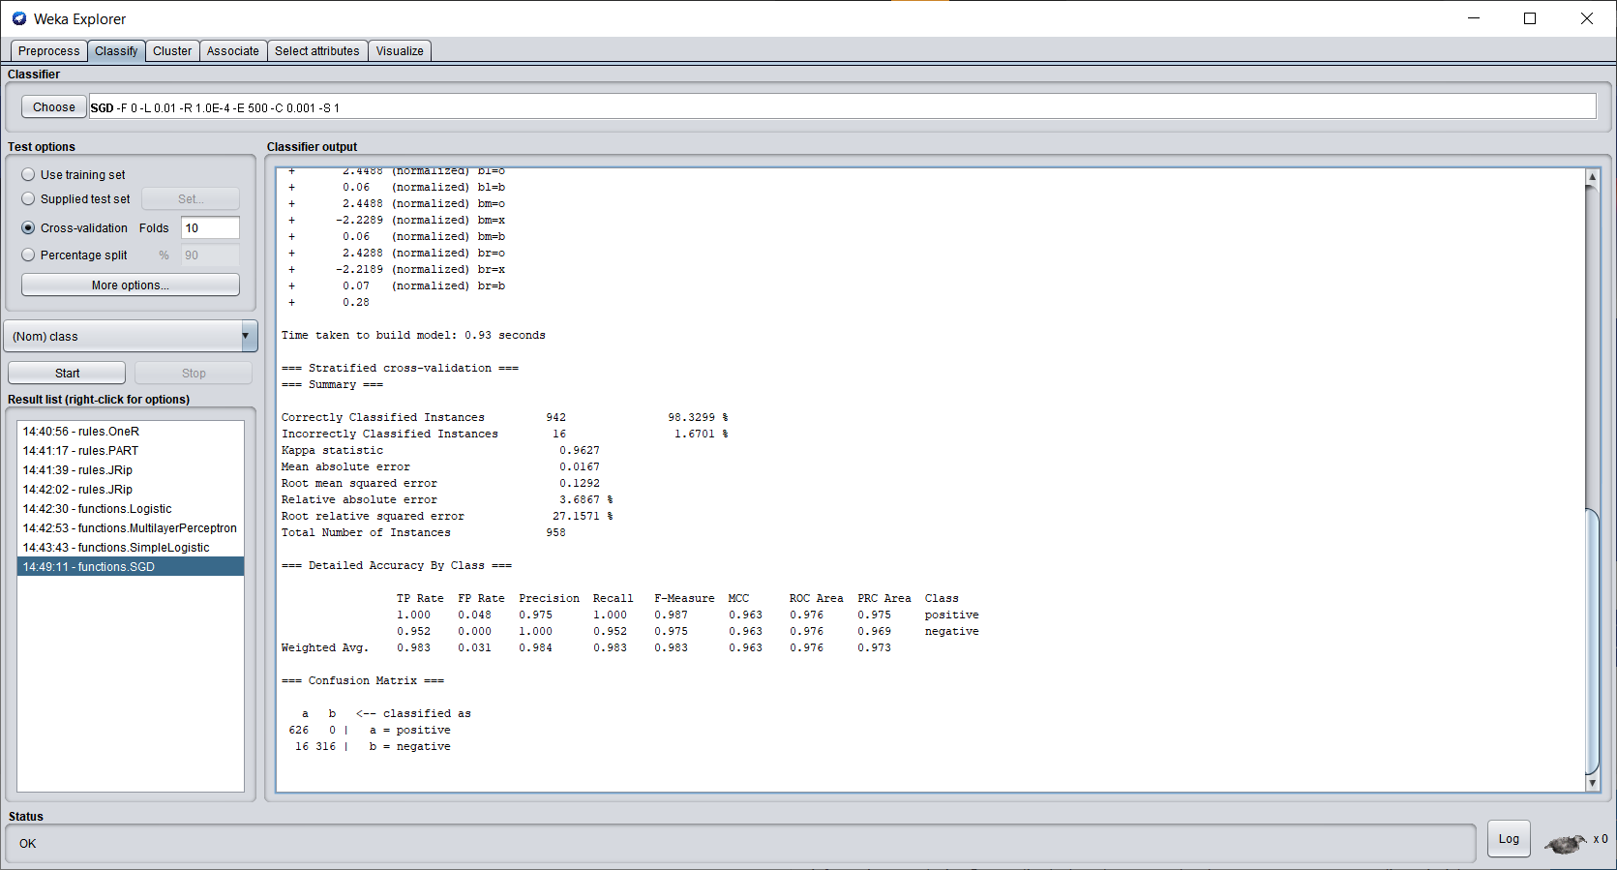

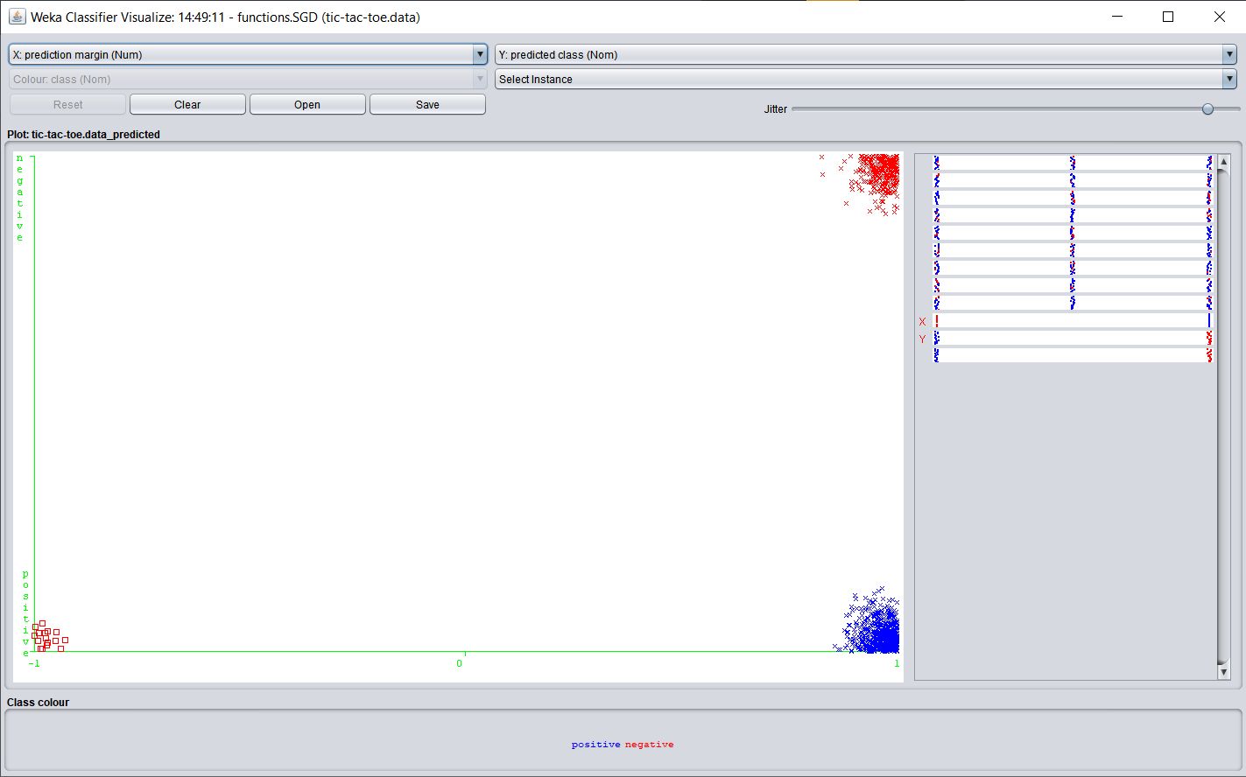

1. **Classification via Regression**

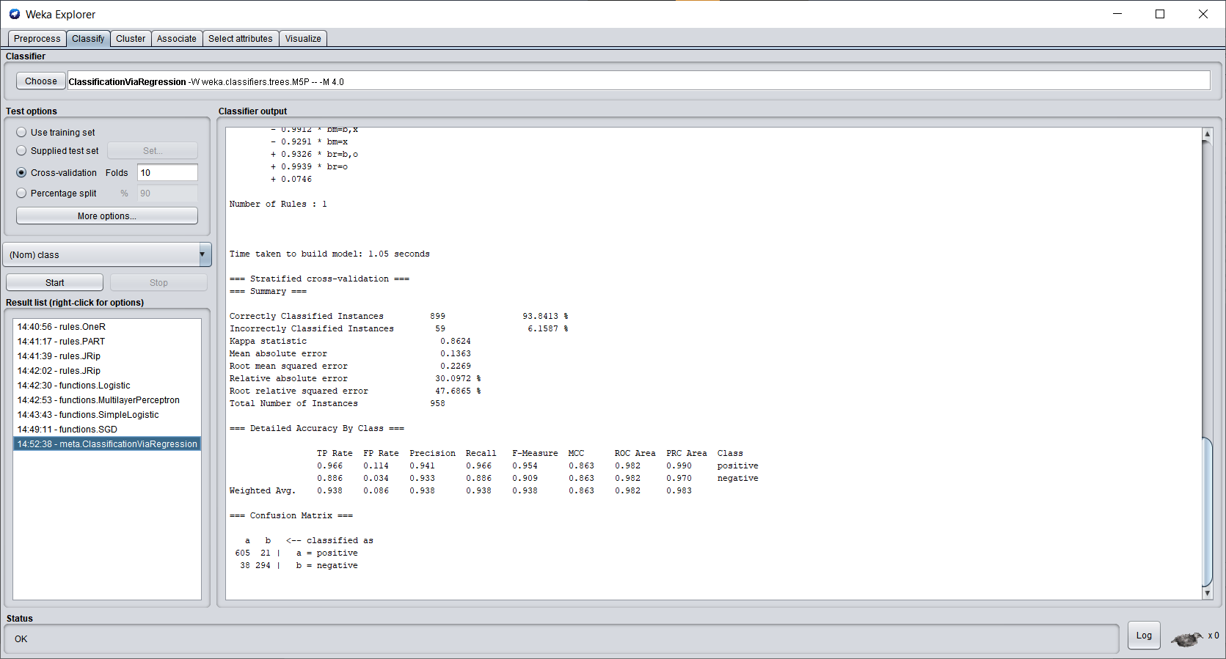

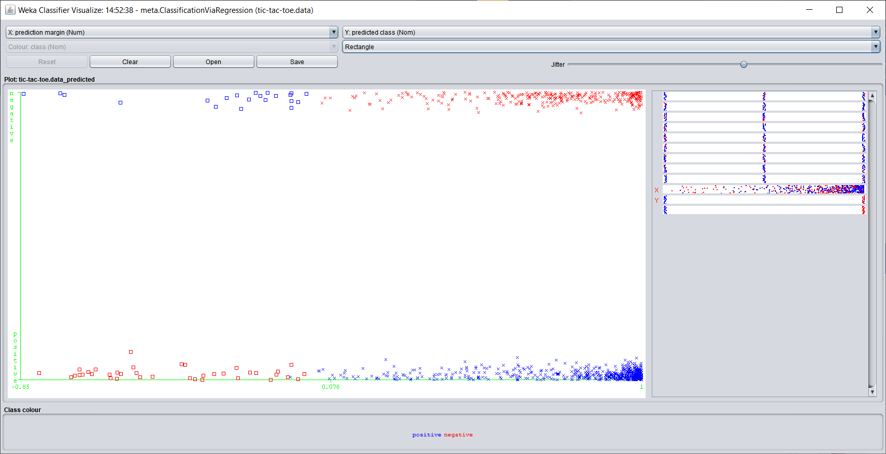

**Clustering:-**

1. **Simple K-Means**

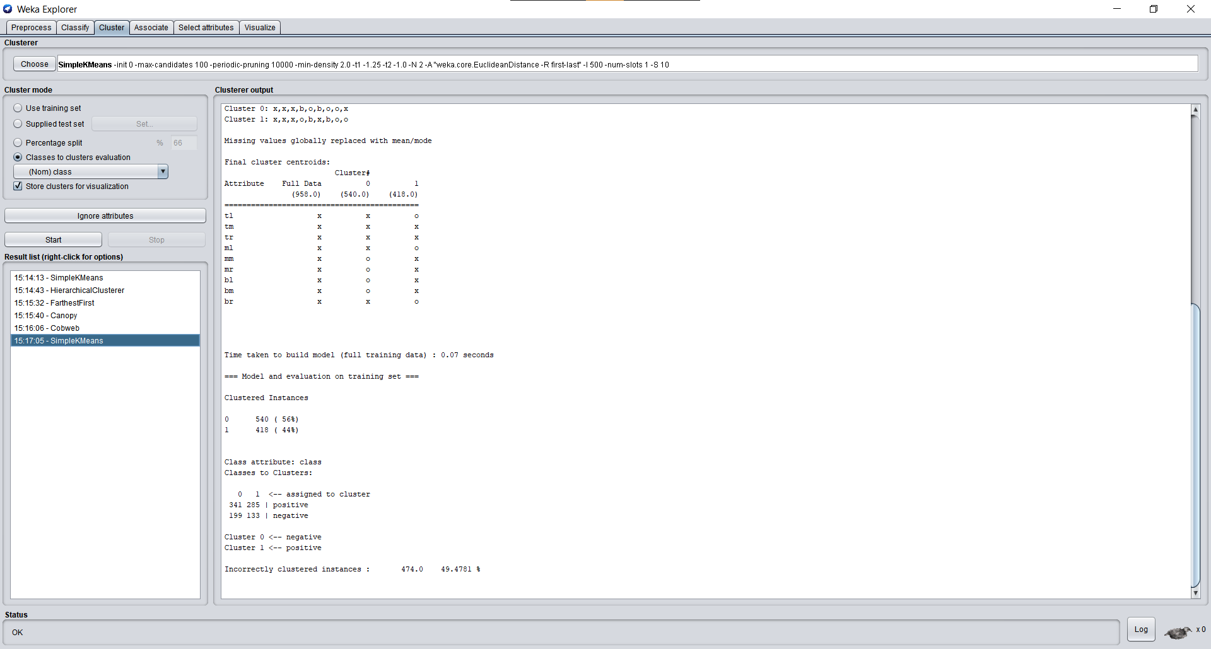

1. **Farthest First**

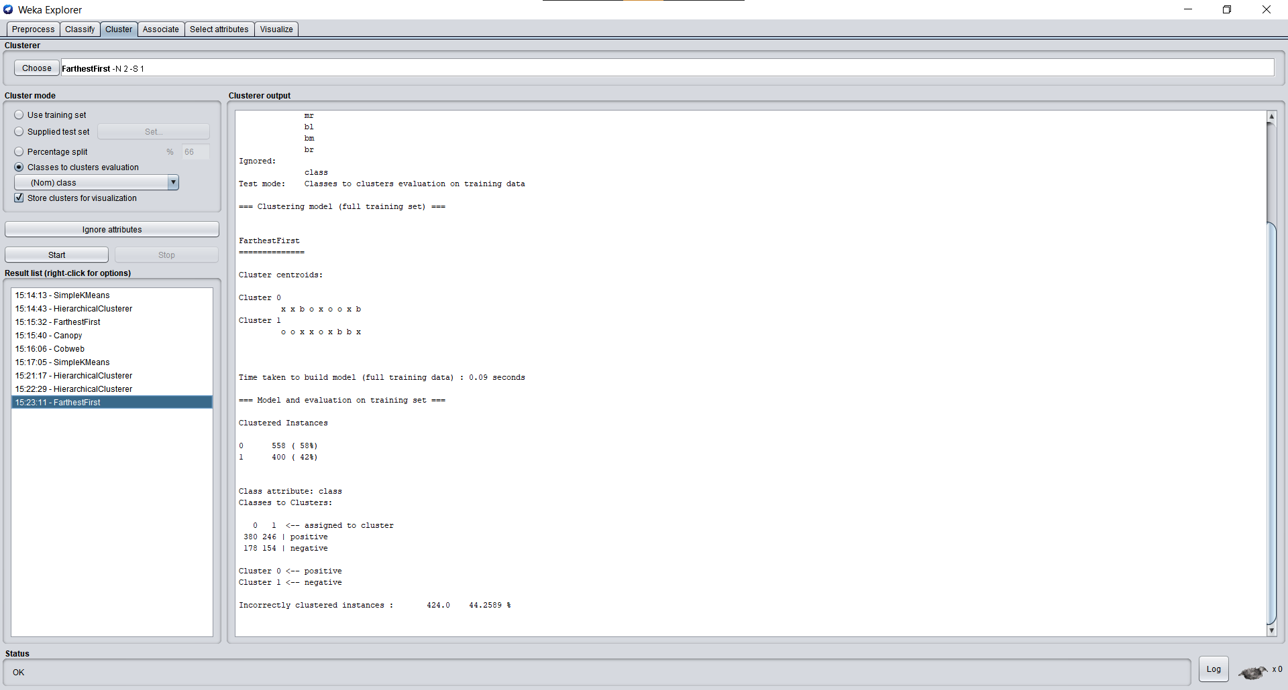

1. **Hierarchical Cluster**

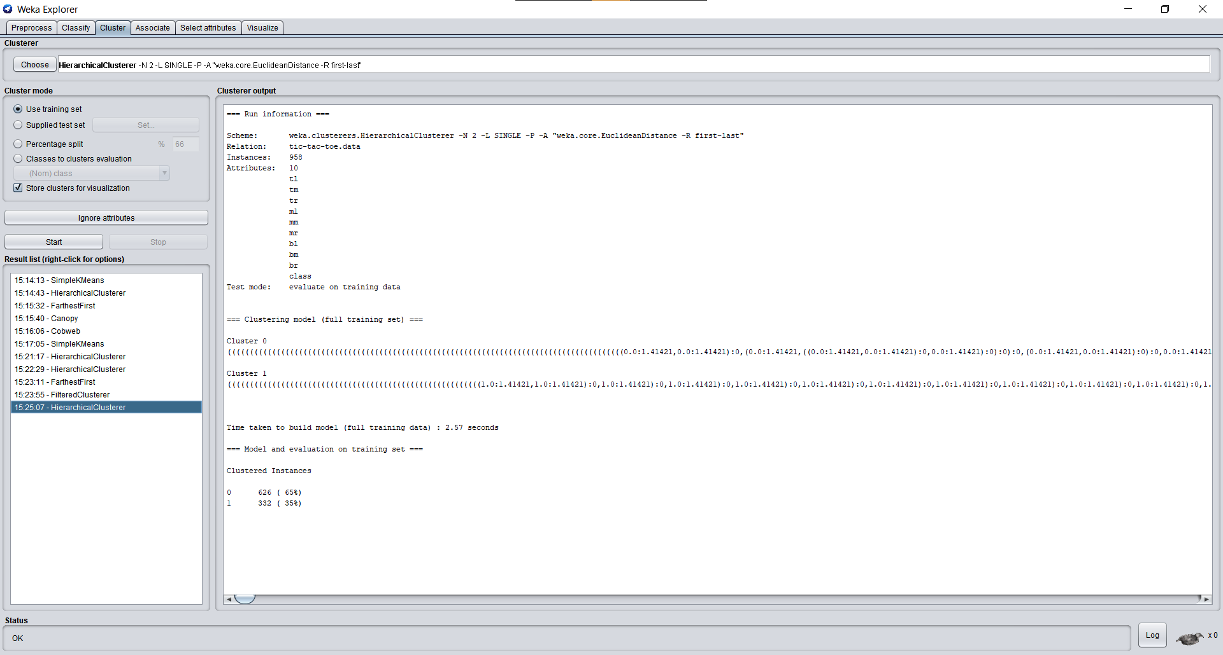

1. **EM**

