# 2019103555 PRANAVA RAMAN B M S 13/09/2021

**LAB – 02 - SPOT**

Change atleast one parameter in each of the algorithms illustrated as part of lab exercise. Show the change in performance.

**Dataset:-**

[Index of /ml/machine-learning-databases/tic-tac-toe (uci.edu)](https://archive.ics.uci.edu/ml/machine-learning-databases/tic-tac-toe/)

**Algorithms:-**

1. **AdaBoostM1**

With default attributes:-

Batch size-100, num of iterations: 10, classifier: Decision stump

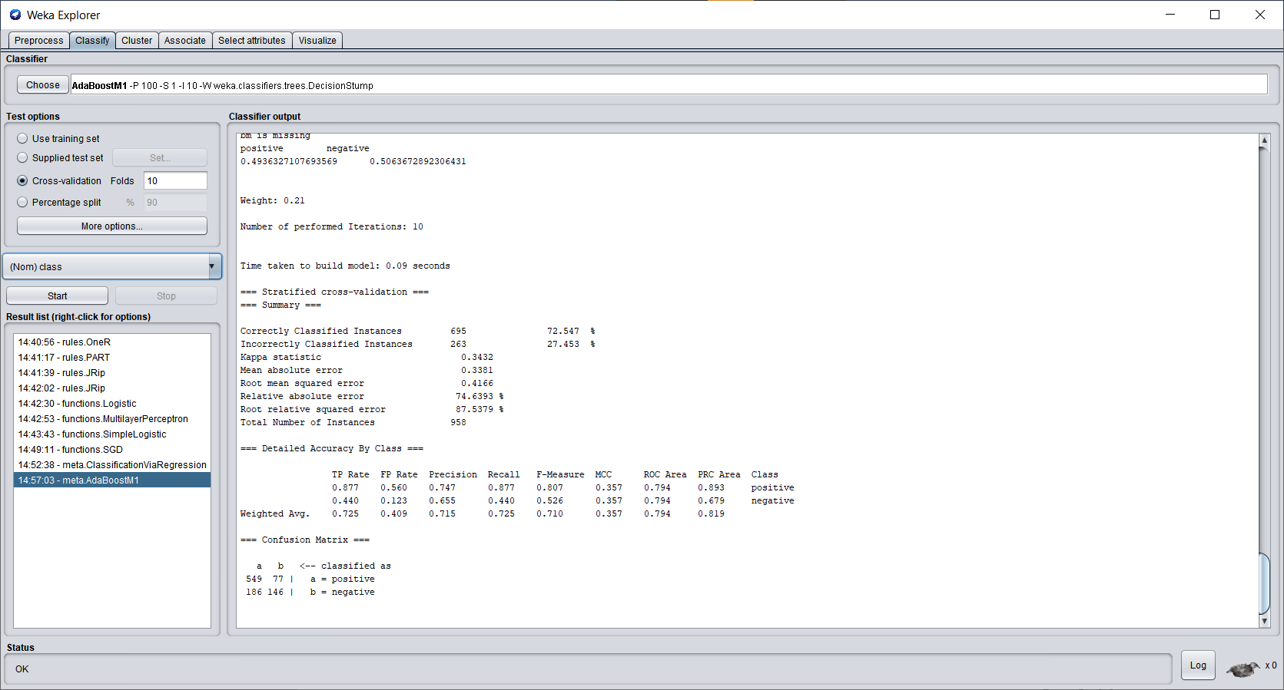

After changing parameters:

Batch size-10, number of iterations: 25, classifier: Random Forest

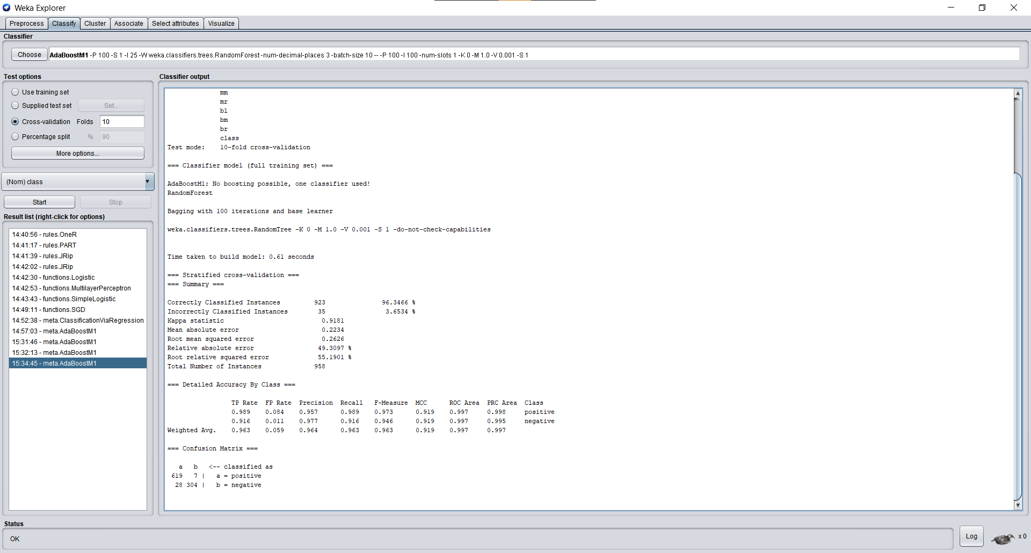

We can see that the confusion matrix has far less deviation and the error has reduced significantly.

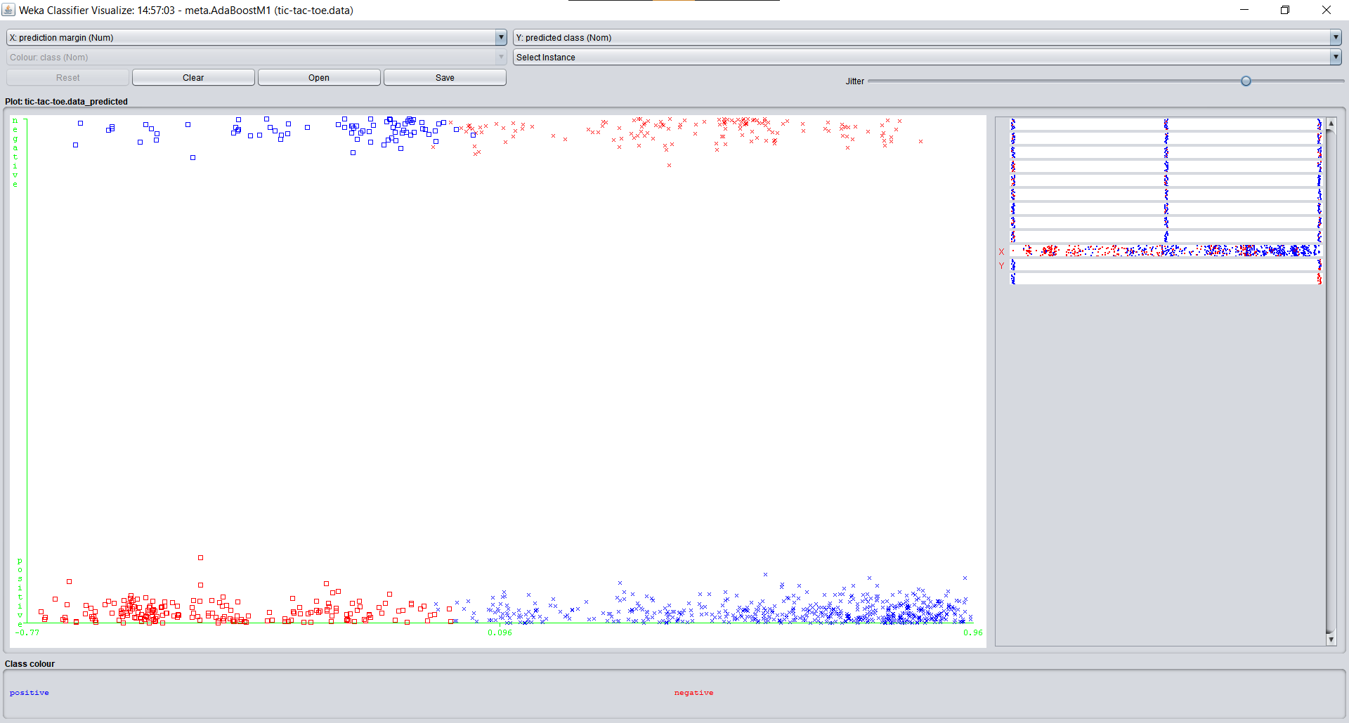

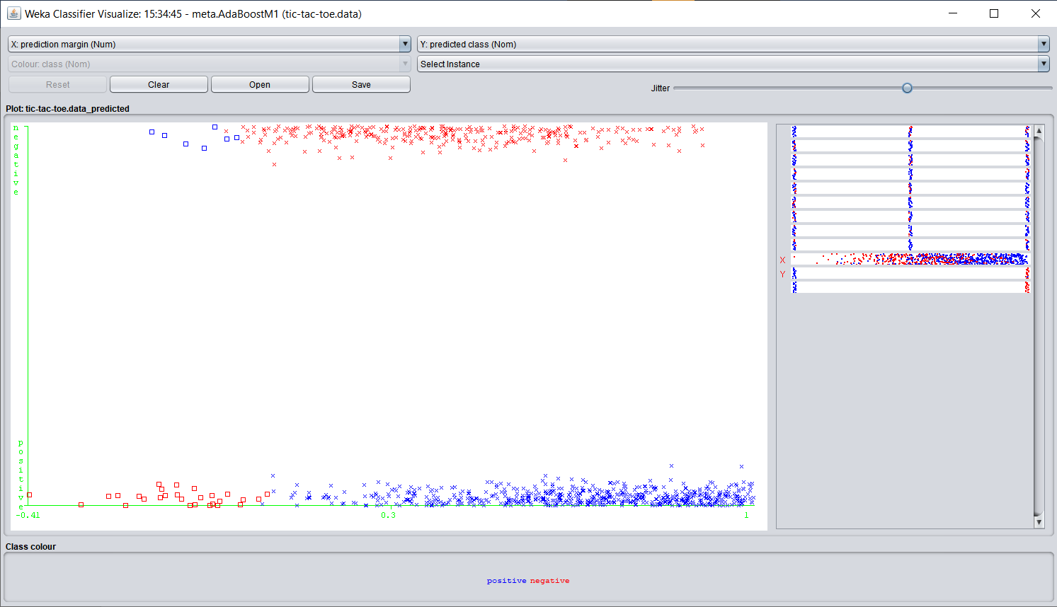

1. **Classification via Regression**

**Using default attributes:-**

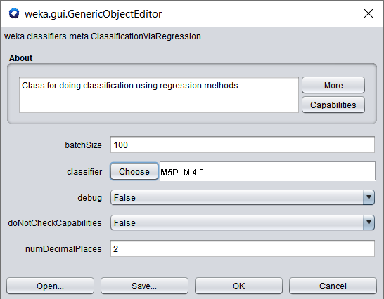

Performance metrics:-

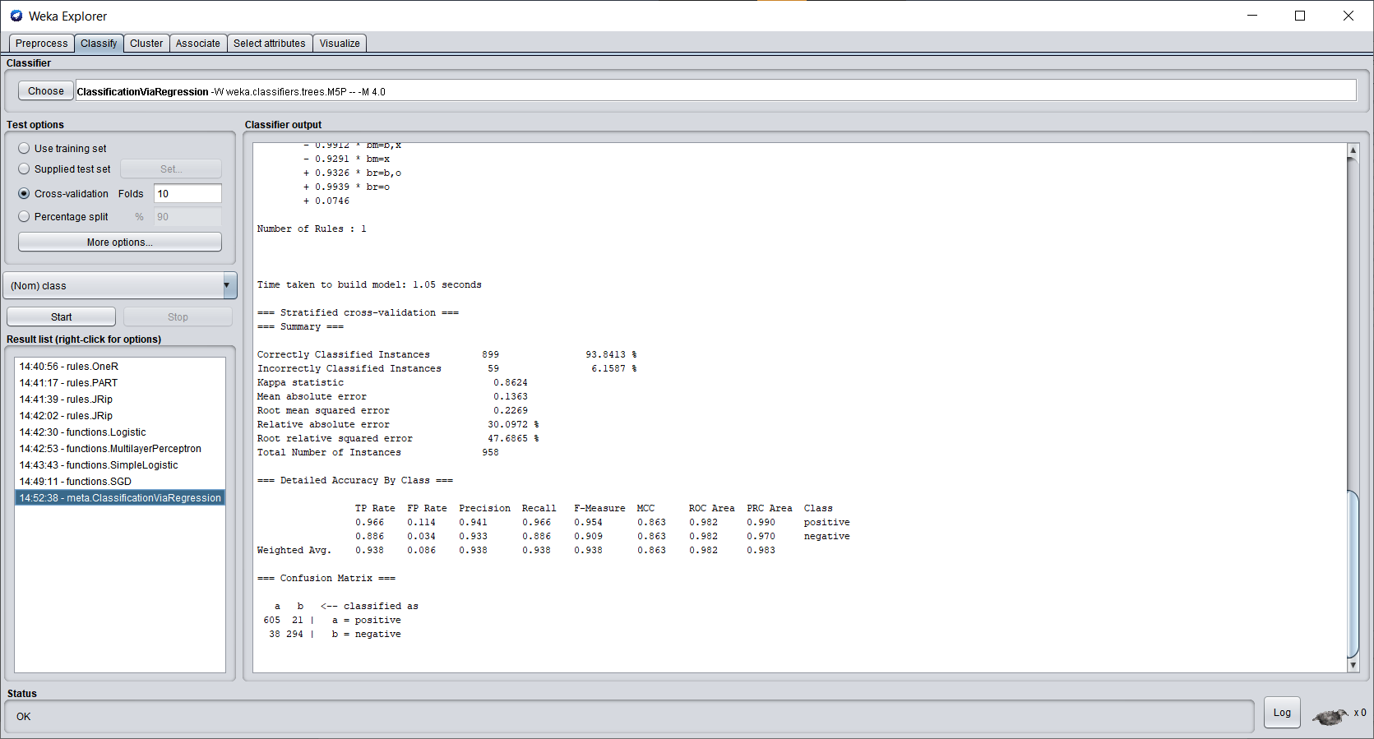

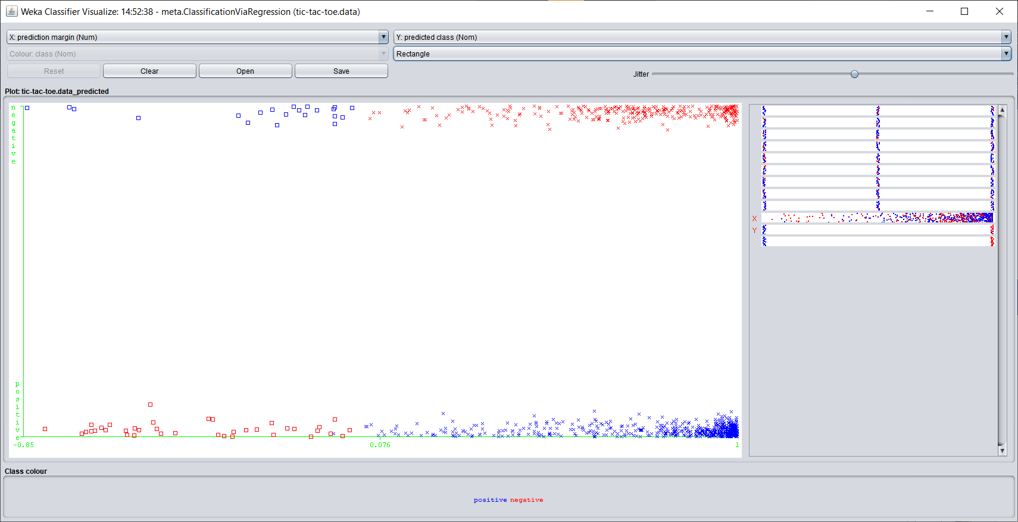

**Changing parameters to:-**

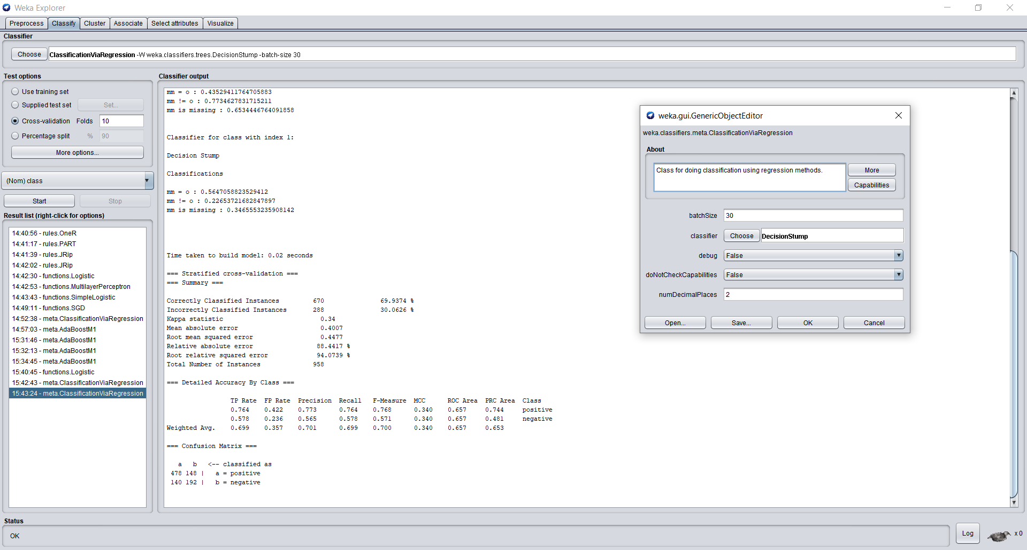

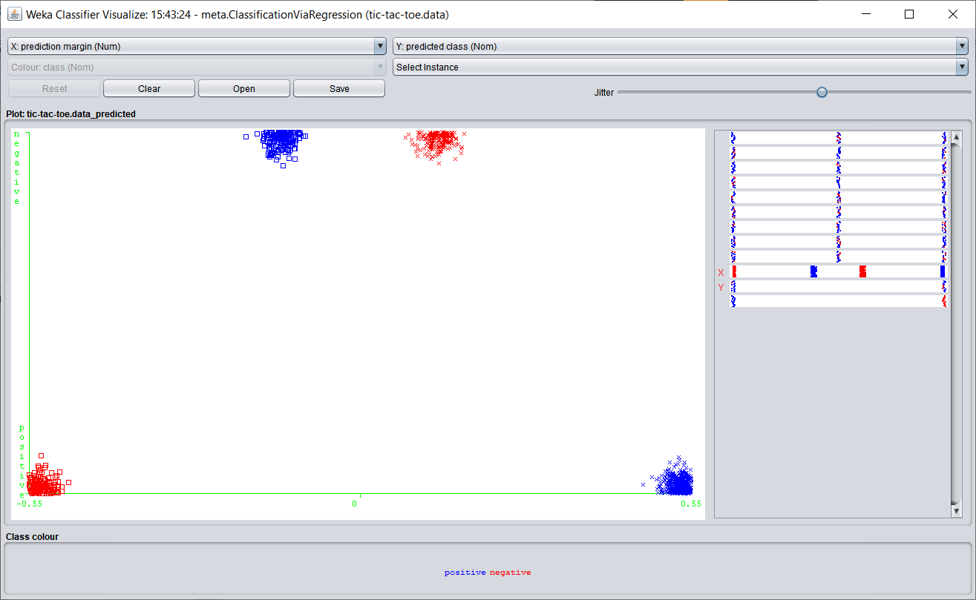

Changed classifier from M5P to Decision stump has decreased the accuracy of the model significantly. But the values are not spread out in the prediction margin vs class graph.

**Clustering:-**

1. **Simple K-Means**

**Default Attributes:-**

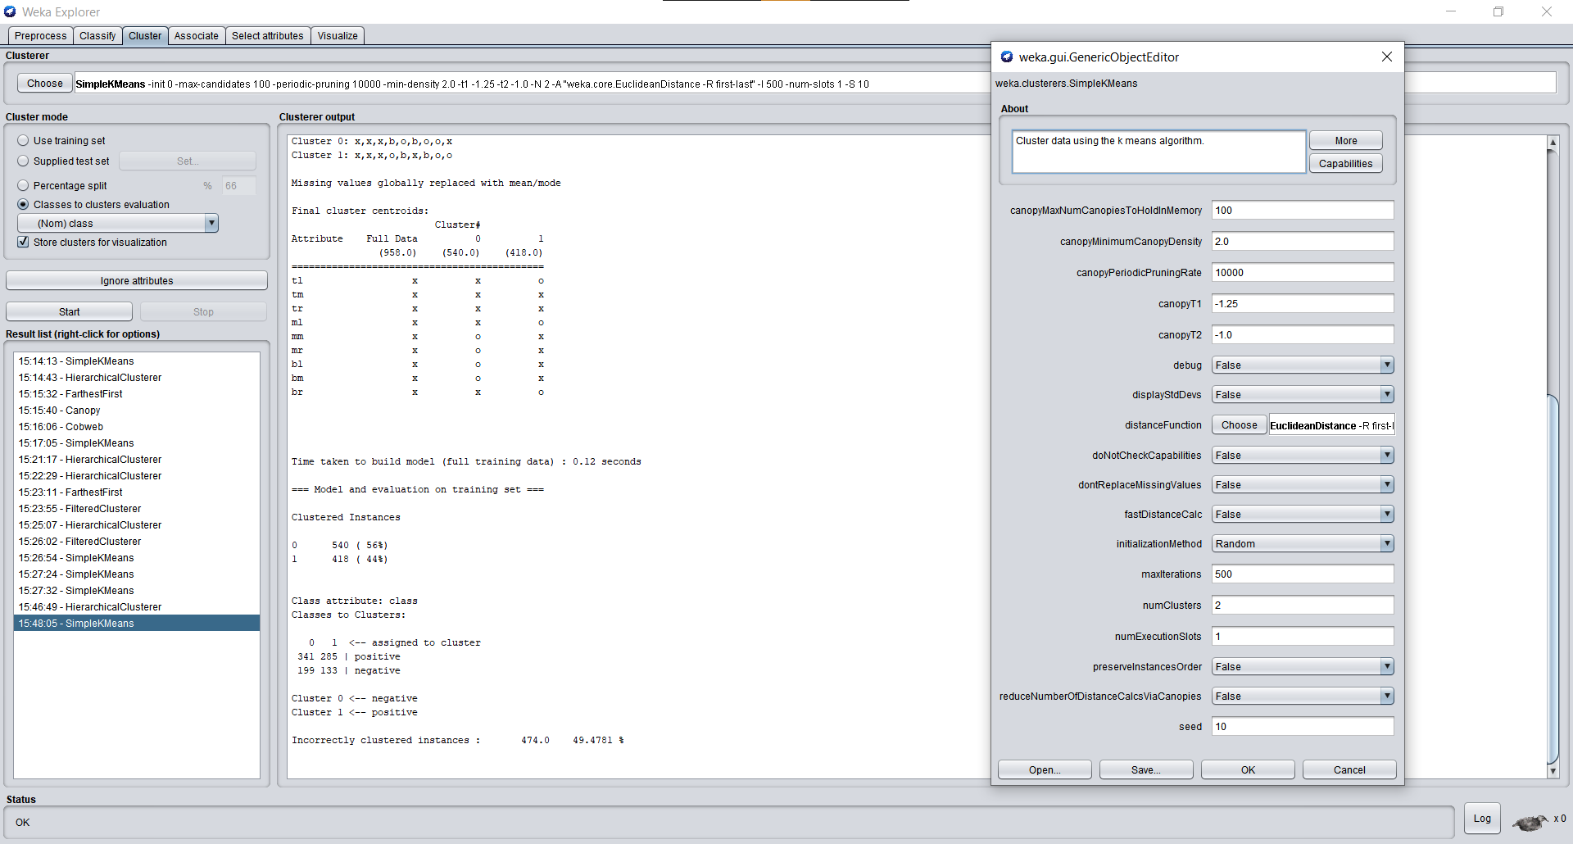

**After changing attributes:-**

Here I am forcing it to cluster into 3 clusters and distance function has been changed.

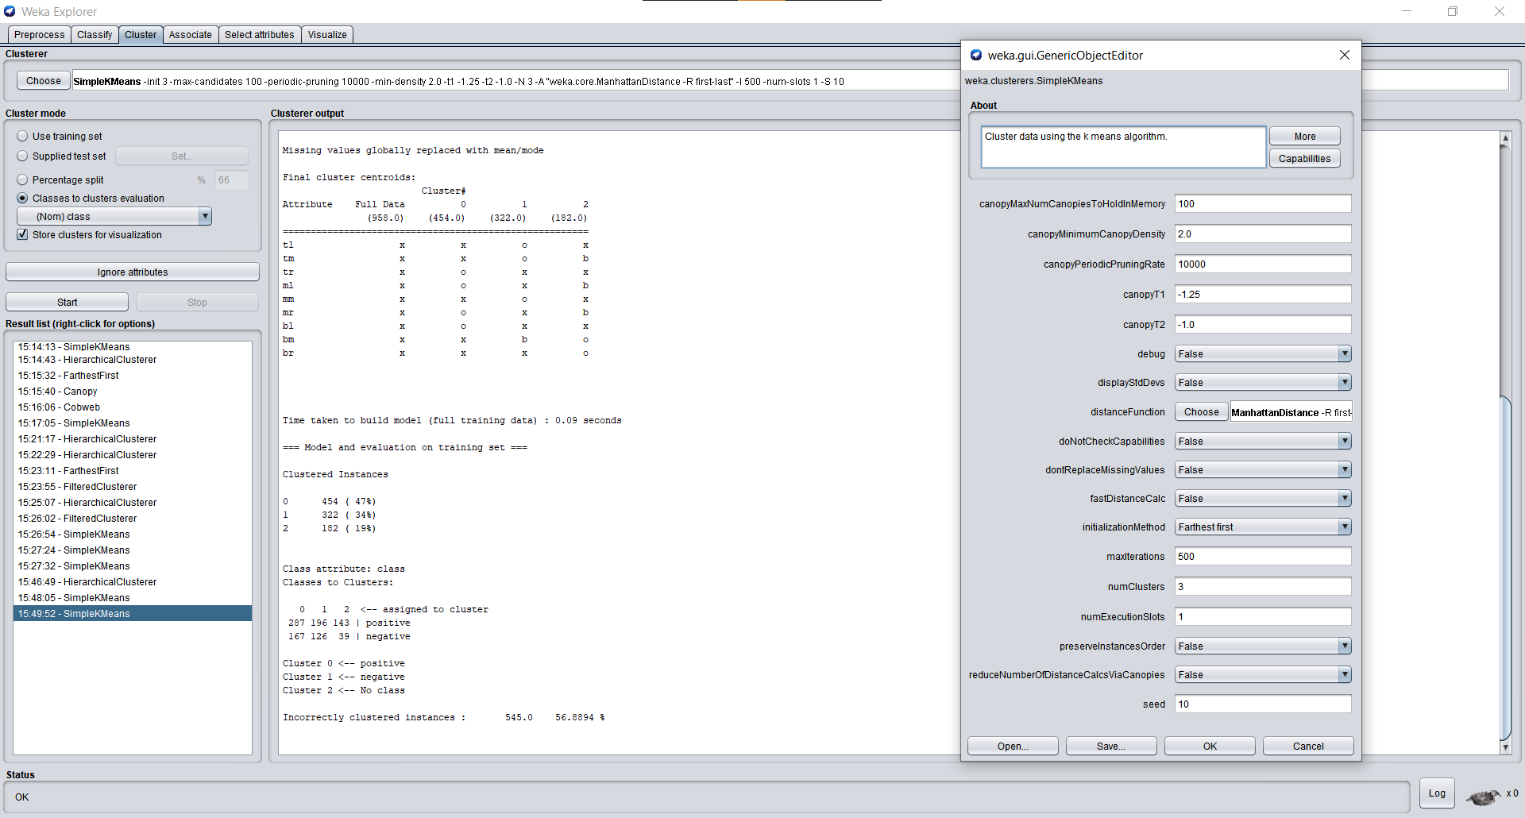

1. **Farthest First**

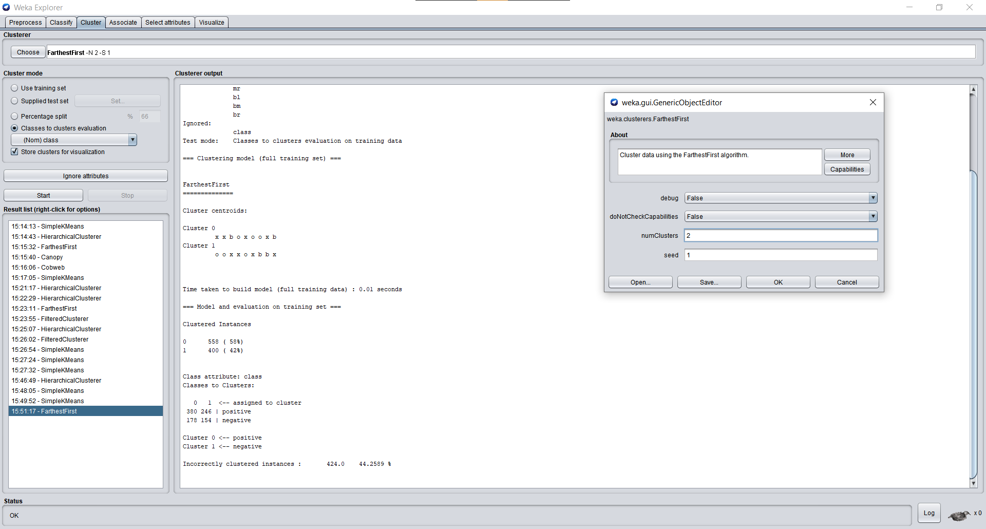

**After changing attributes:-**

On increasing number of clusters, the values are become increasingly random.

