# 2019103555 PRANAVA RAMAN B M S 20/09/2021

**MACHINE LEARNING LABORATORY**

**LAB – 03 – KNIME TOOL**

**Various algorithm using Knime tool:-**

Dataset – [Index of /ml/machine-learning-databases/glass (uci.edu)](https://archive.ics.uci.edu/ml/machine-learning-databases/glass/)

Statistics:-

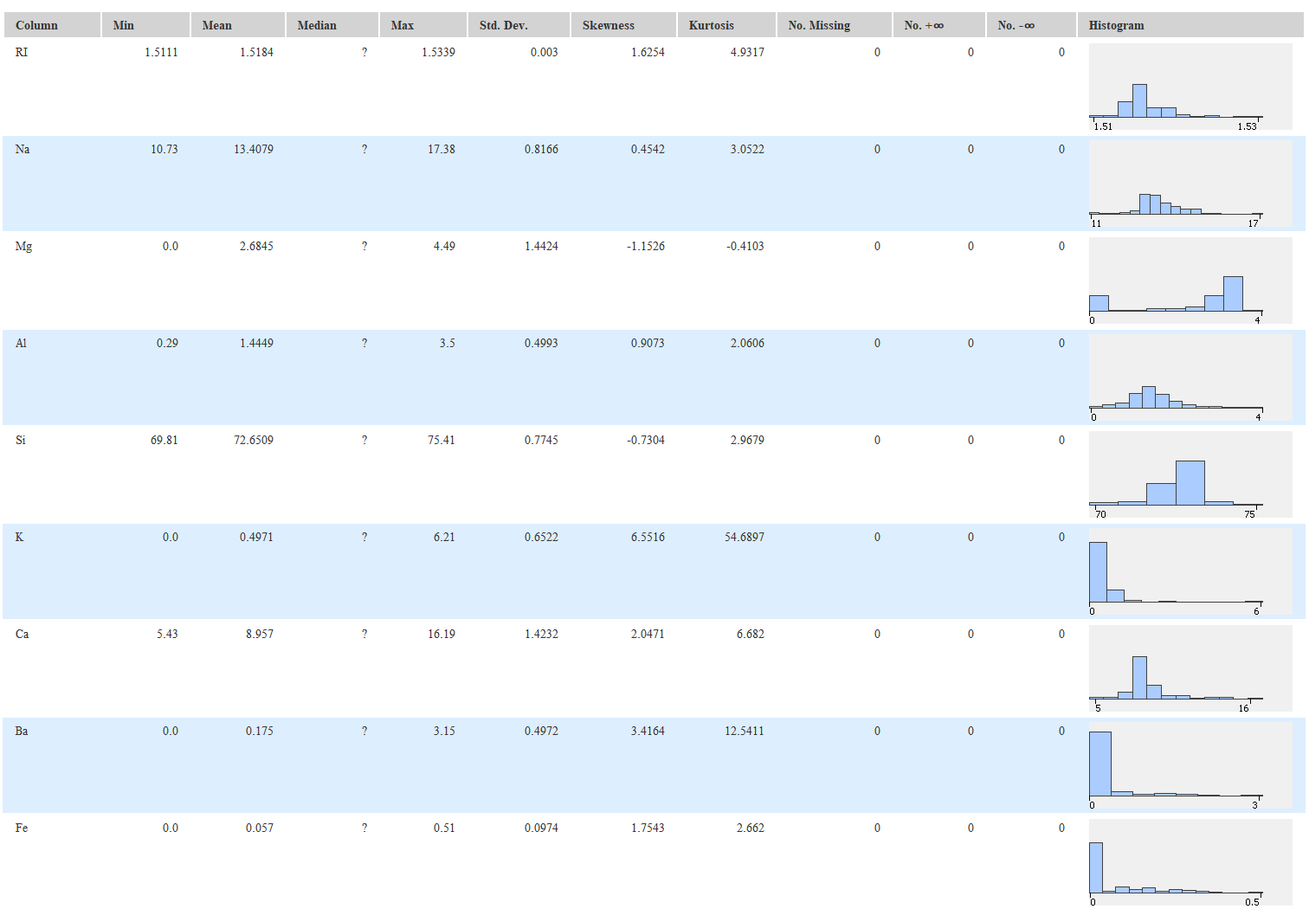

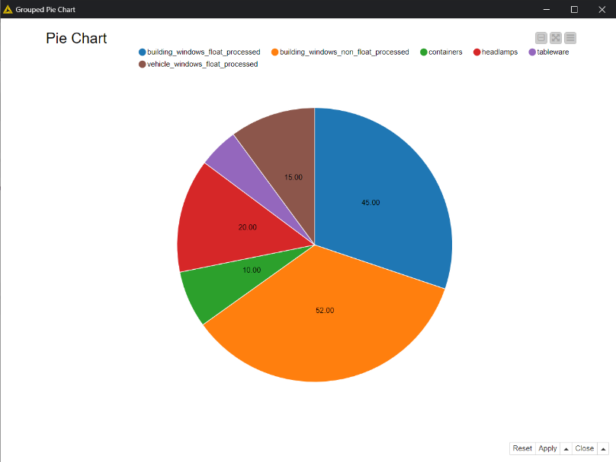

1. **Clustering algorithm (K-means)** **:-**

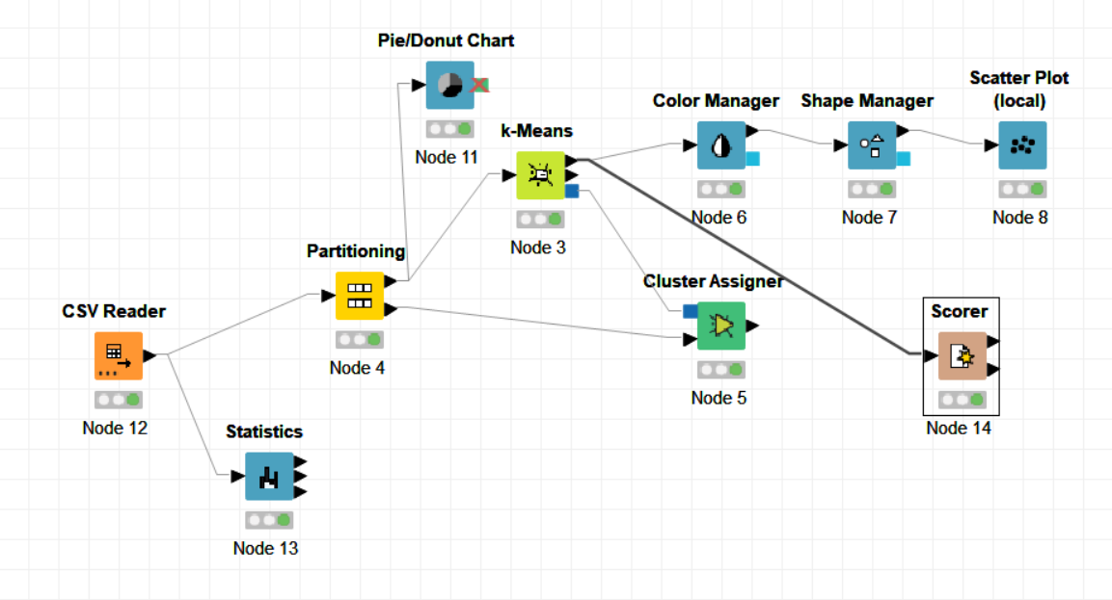

**Cluster assigner (some rows are shown):-**

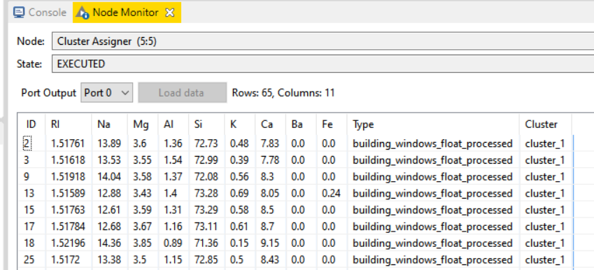

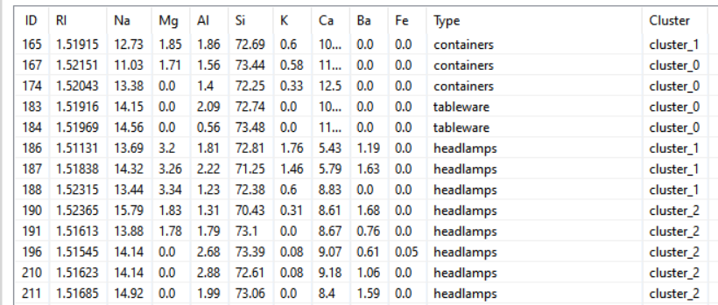

**Clustering output**

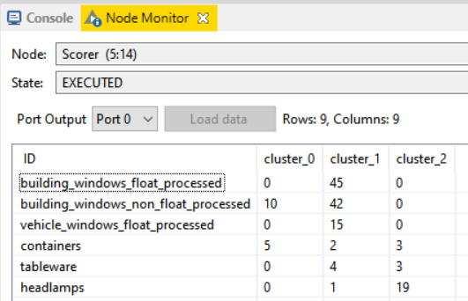

**Scatter Plot:-**

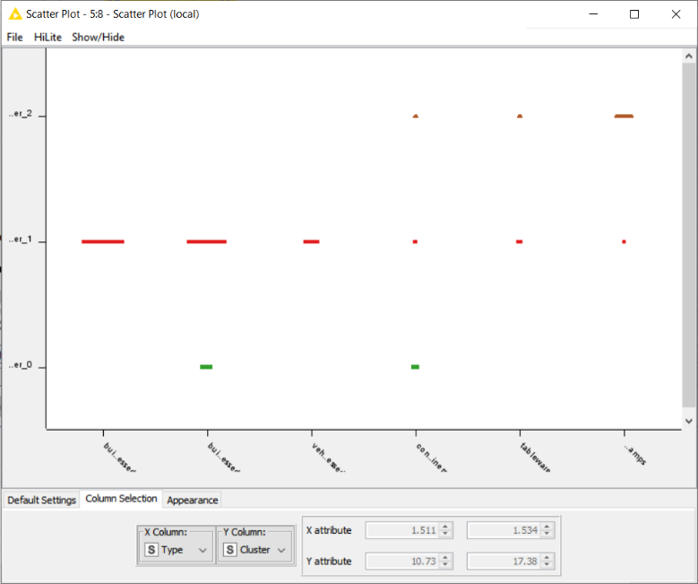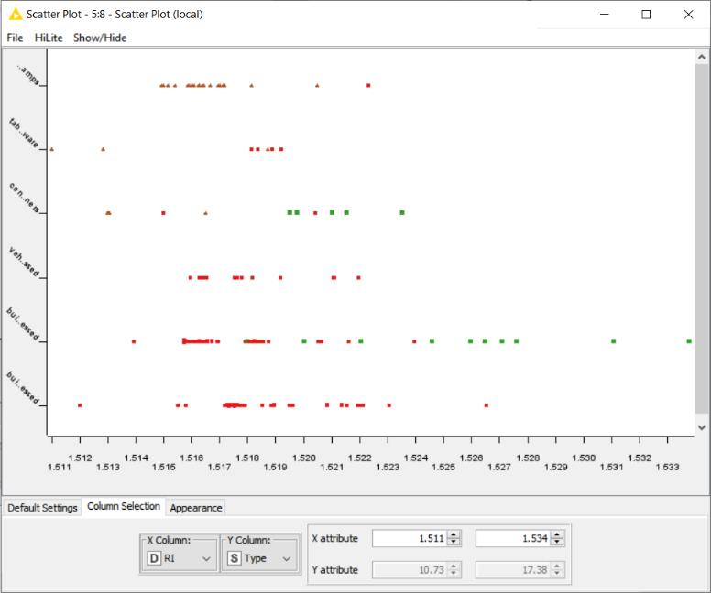

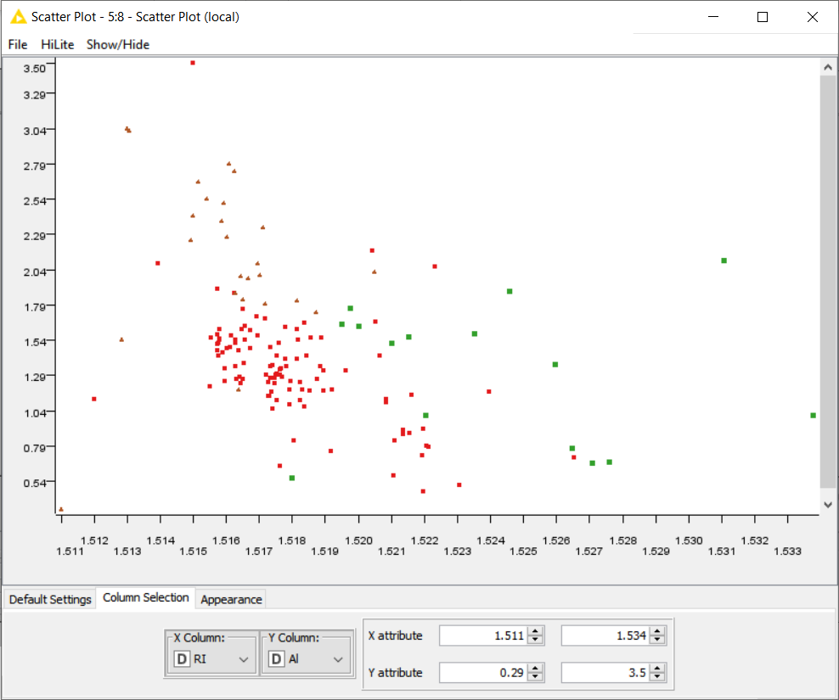

1. **Classification Algorithms (Decision tree)**

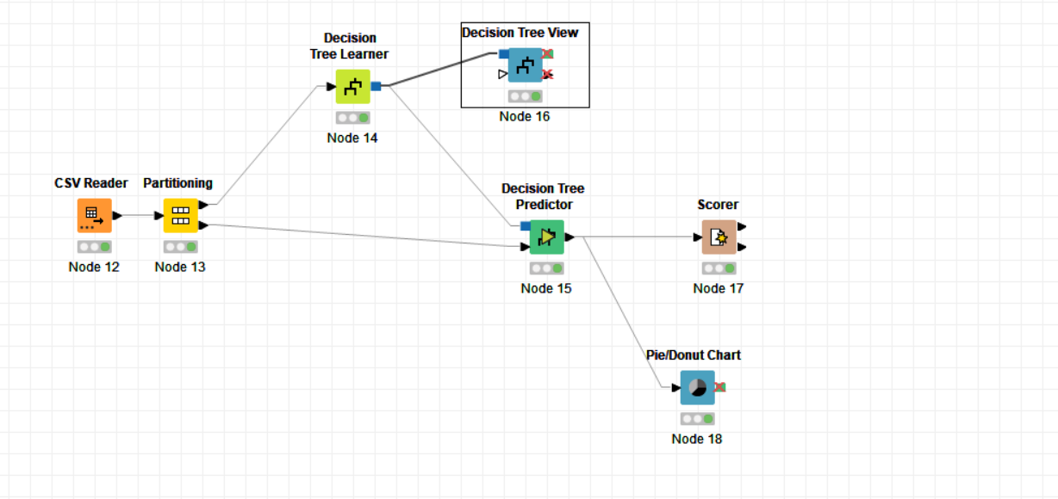

**Desision tree view:-**

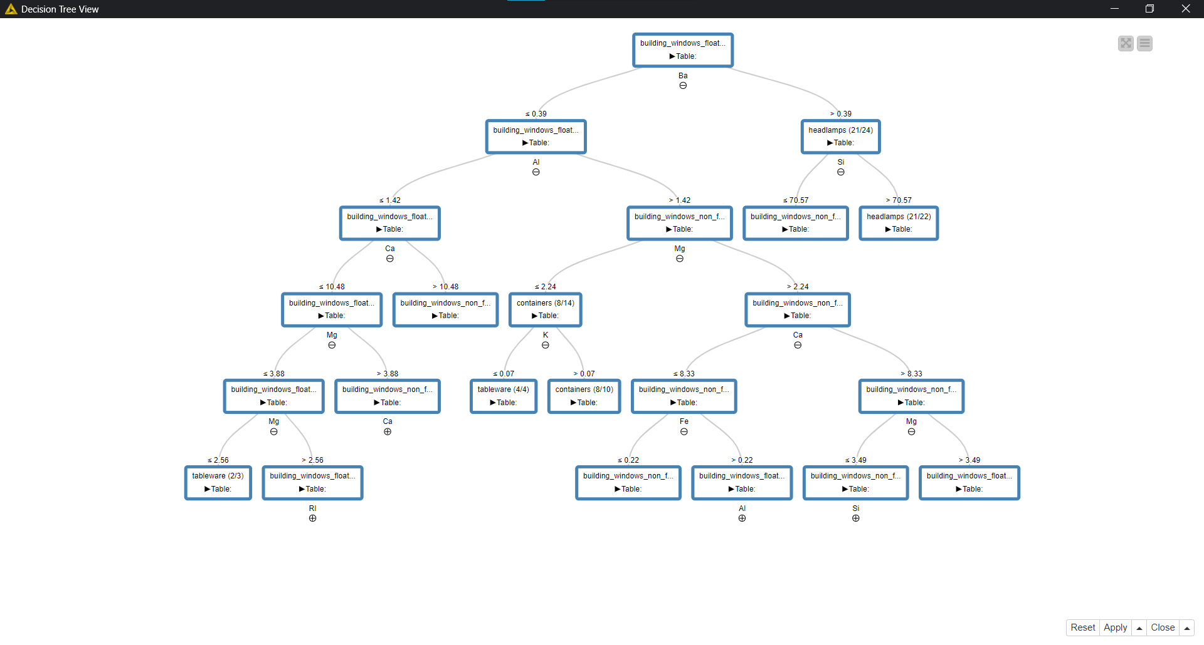

**Prediction value:-**

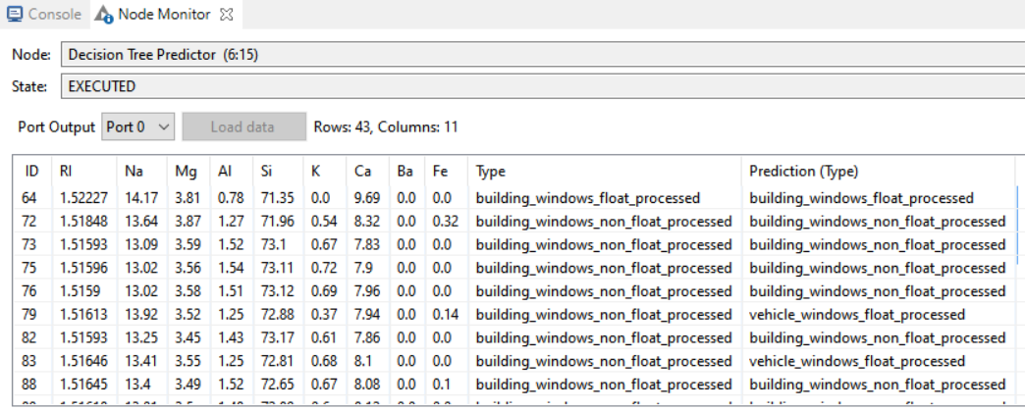

**Confusion matrix:-**

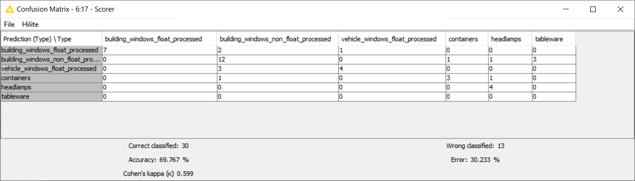

**Prediction pie chart vs normal pie chart:-**

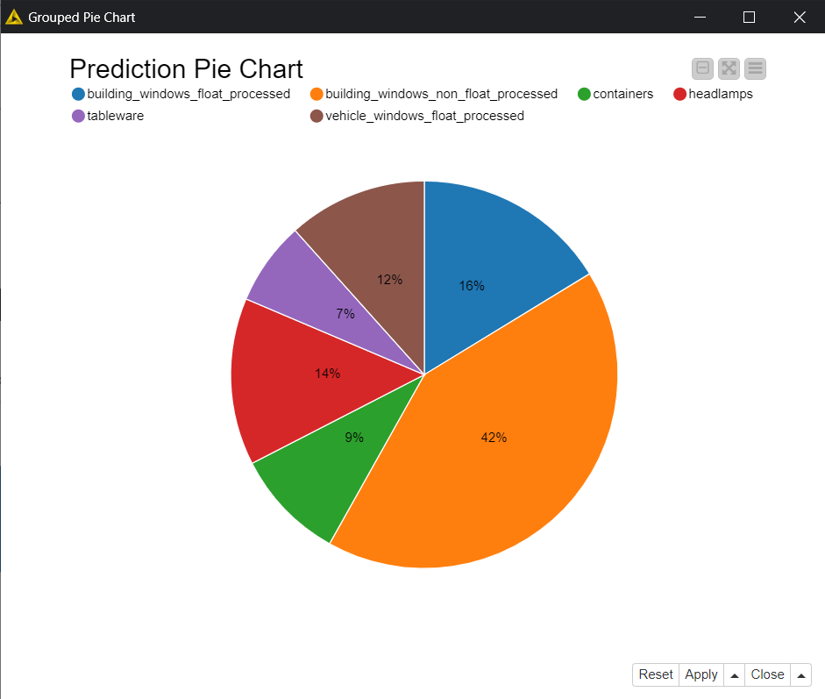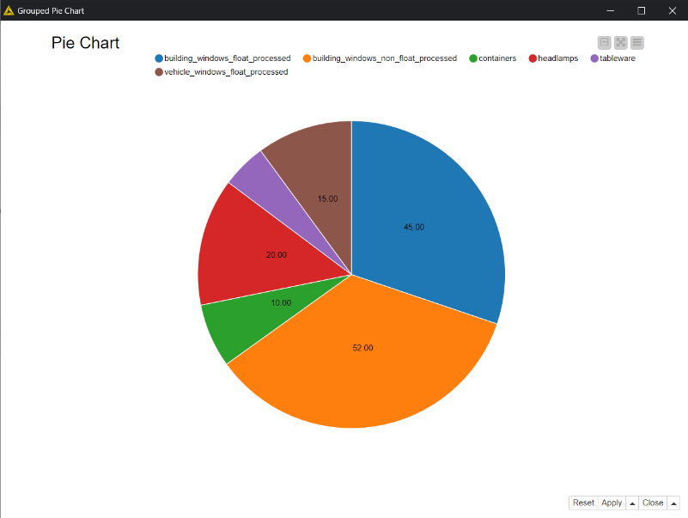

1. **Logistic Regression**

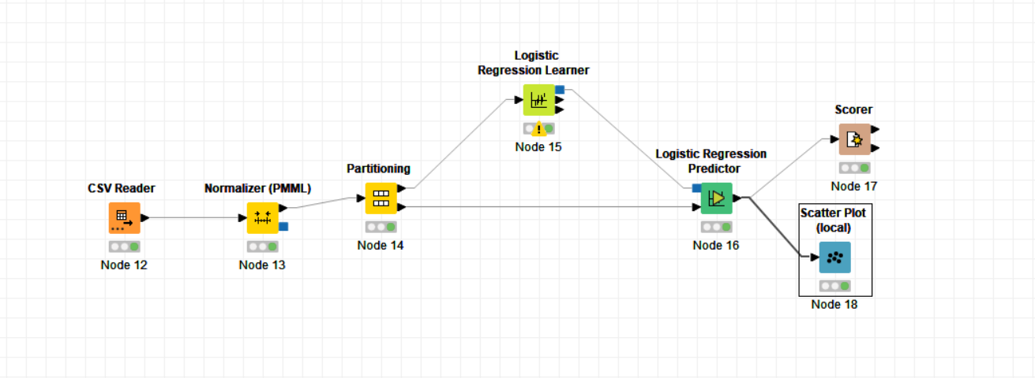

**Confusion matrix:-**

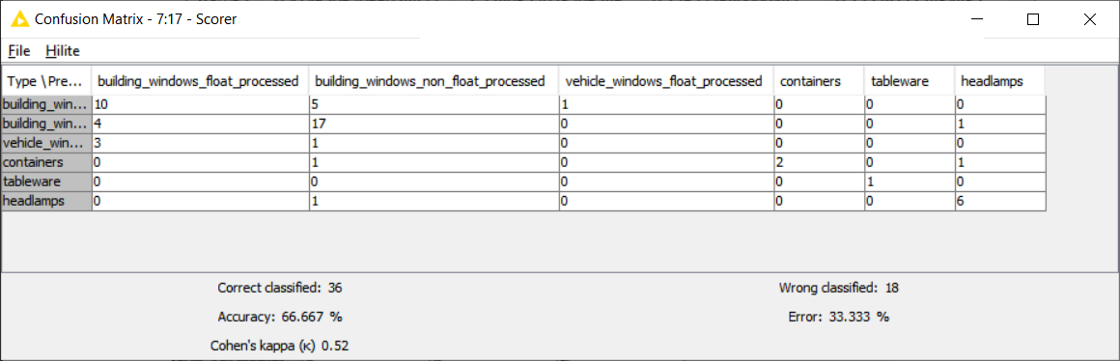

**Normalized output:-**

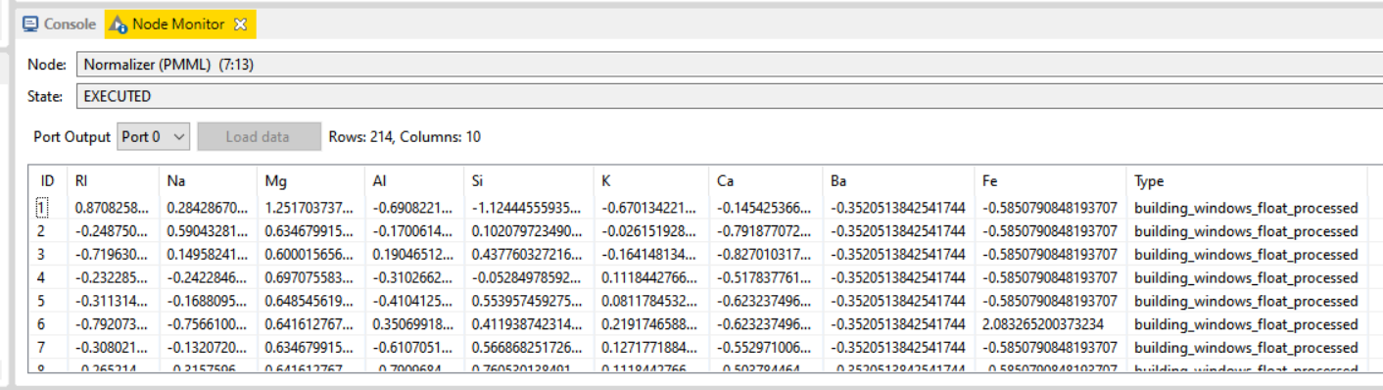

**Pie chart:-**

