# 2019103555 PRANAVA RAMAN B M S 27/09/2021

LAB – 04 - EXECUTION

3 DATASETS:-

Weather.csv

|  |  |  |  |  |  |  |
| --- | --- | --- | --- | --- | --- | --- |
| **sky** | **air temp** | **humidity** | **wind** | **water** | **forecast** | **enjoy sport** |
| sunny | warm | normal | strong | warm | same | yes |
| sunny | warm | high | strong | warm | same | yes |
| rainy | cold | high | strong | warm | change | no |
| sunny | warm | high | strong | cool | change | yes |

Book-citation.csv

|  |  |  |  |  |  |
| --- | --- | --- | --- | --- | --- |
| **citations** | **size** | **inLibrary** | **price** | **editions** | **buy** |
| some | small | no | affordable | many | no |
| many | big | no | expensive | one | yes |
| some | big | always | expensive | few | no |
| many | medium | no | expensive | many | yes |
| many | small | no | affordable | many | yes |

Health.csv

|  |  |  |  |
| --- | --- | --- | --- |
| **nose** | **cough** | **skin** | **class** |
| running nose | coughing | red skin | yes |
| running nose | coughing | normal | yes |
| running nose | normal | red skin | no |
| normal | coughing | red skin | no |
| normal | normal | red skin | no |
| normal | normal | normal | no |

1. **FIND-S ALGORITHM**

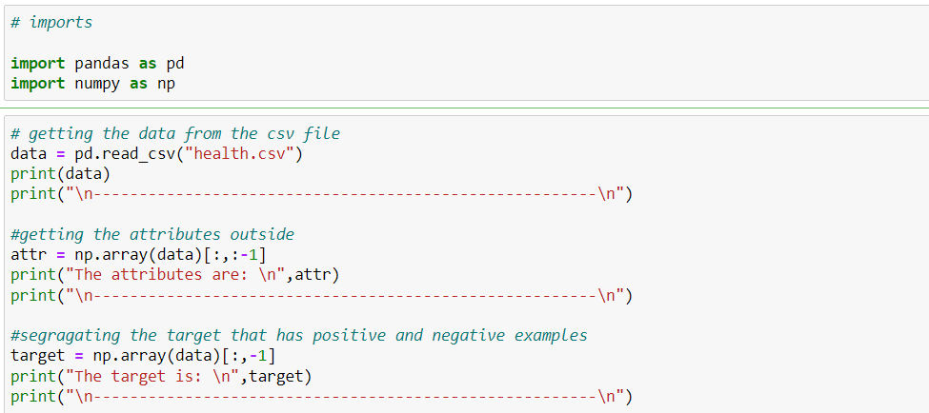

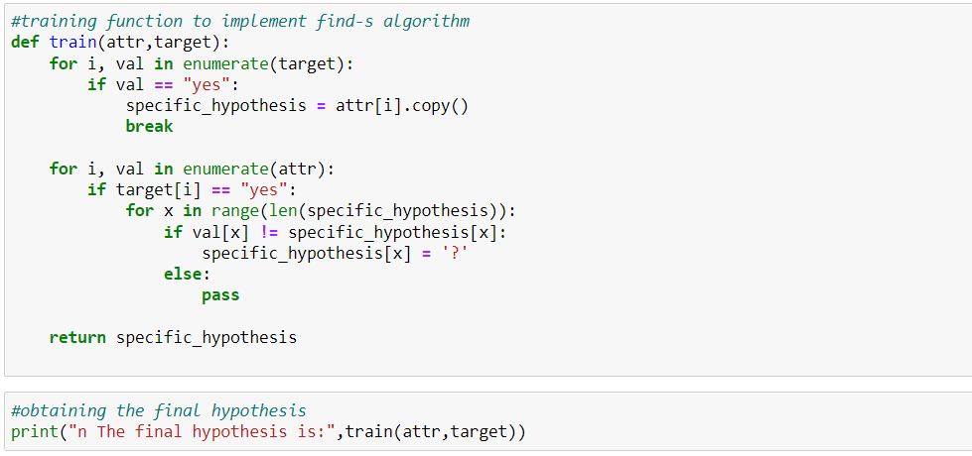

**Output:-**

**Weather.csv:-**

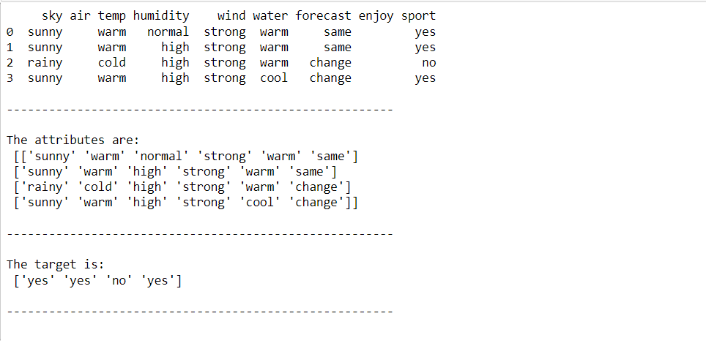



**Book-citation.csv**

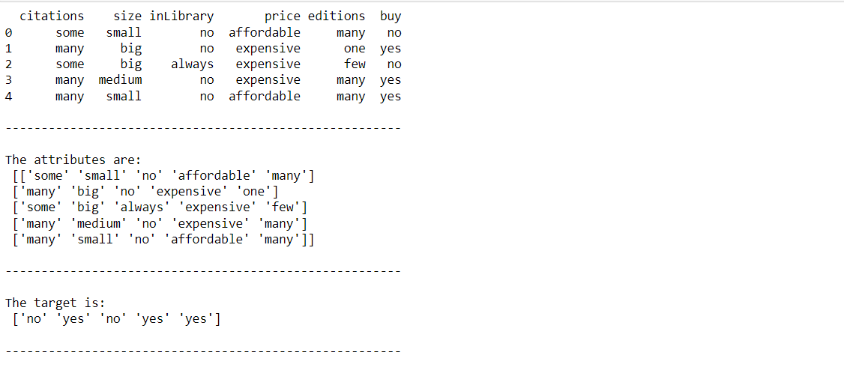



**Health.csv**

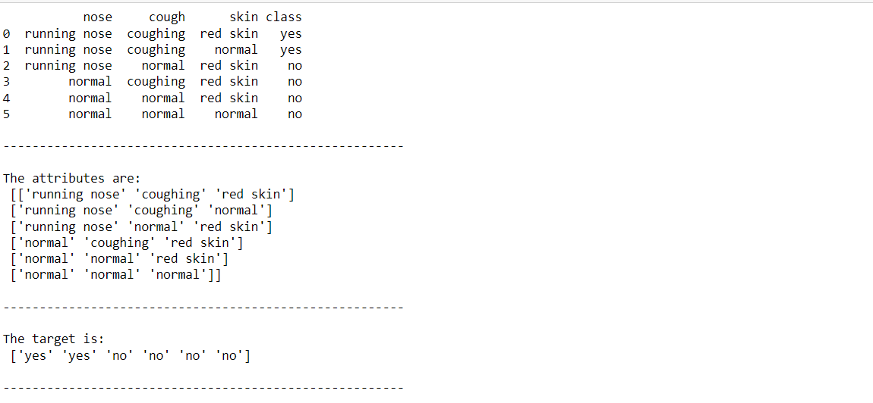



1. **CANDIDATE ELIMINATION ALGORITHM**

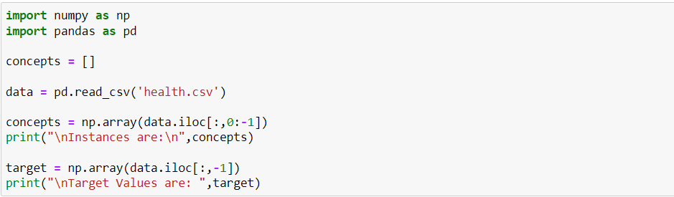

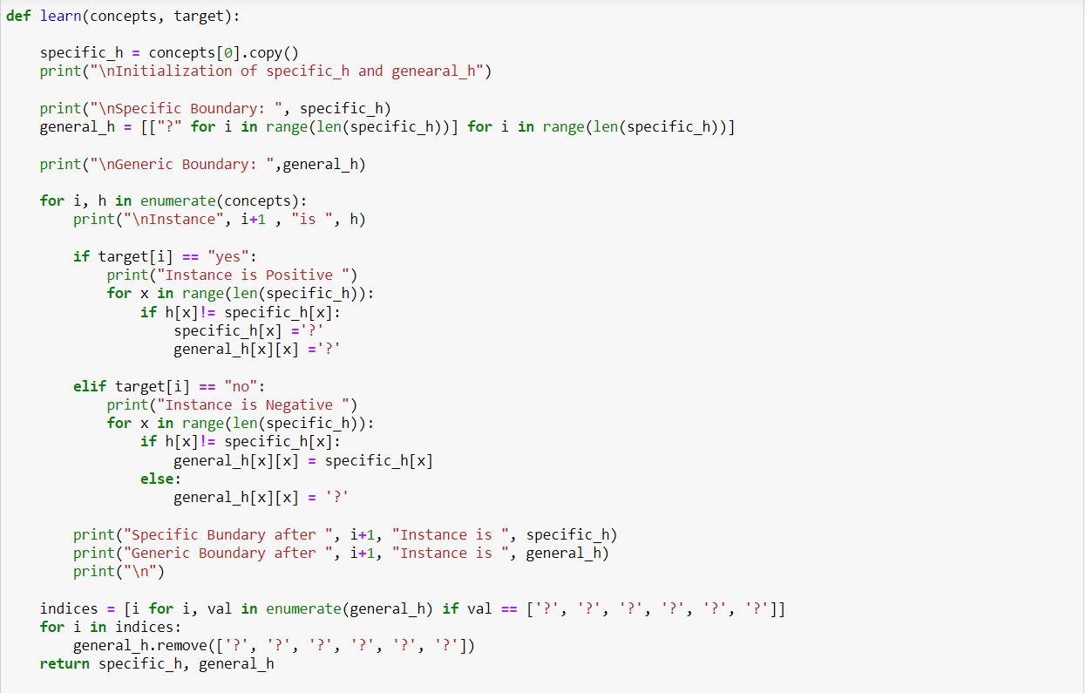



**Output:-**

**Weather.csv**

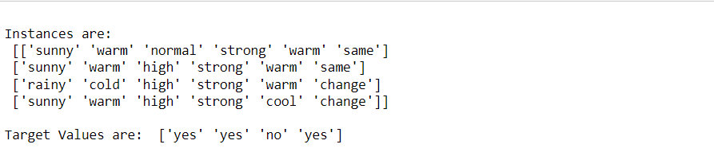

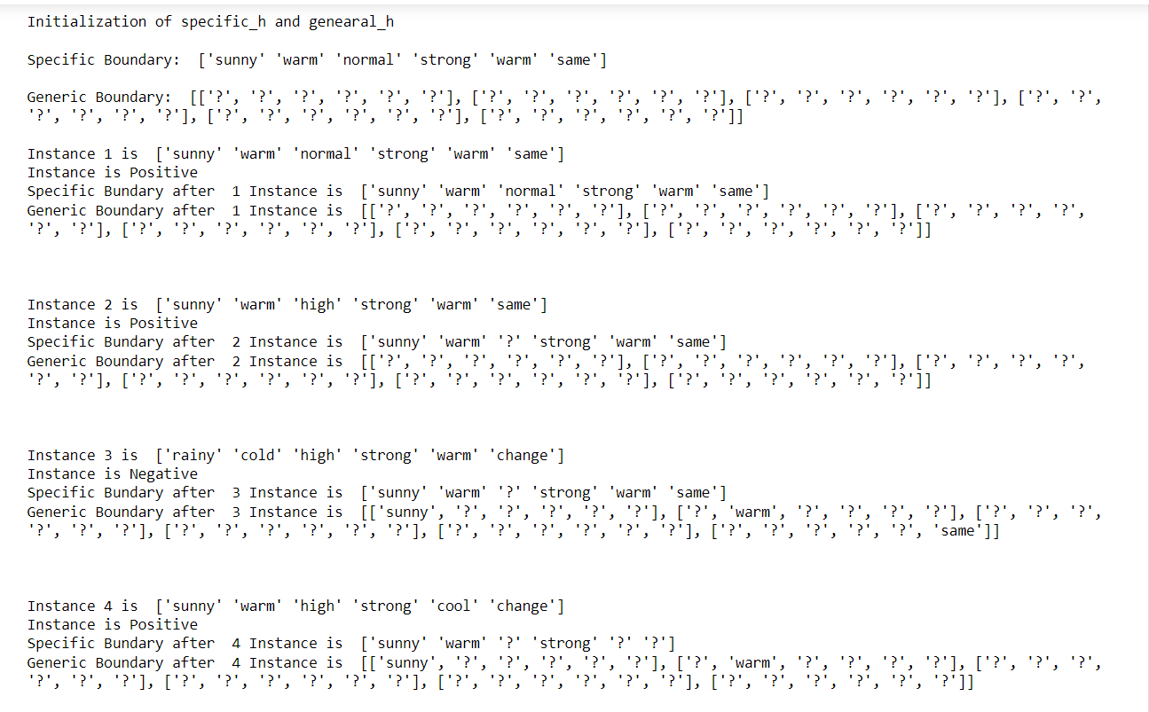



**Book-citation.csv**

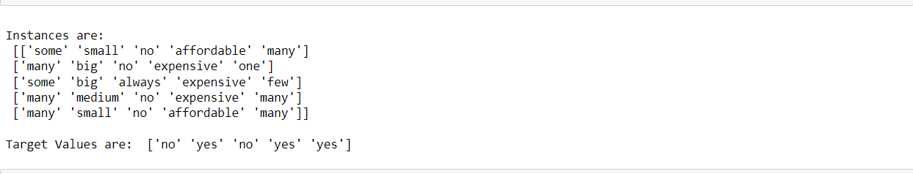

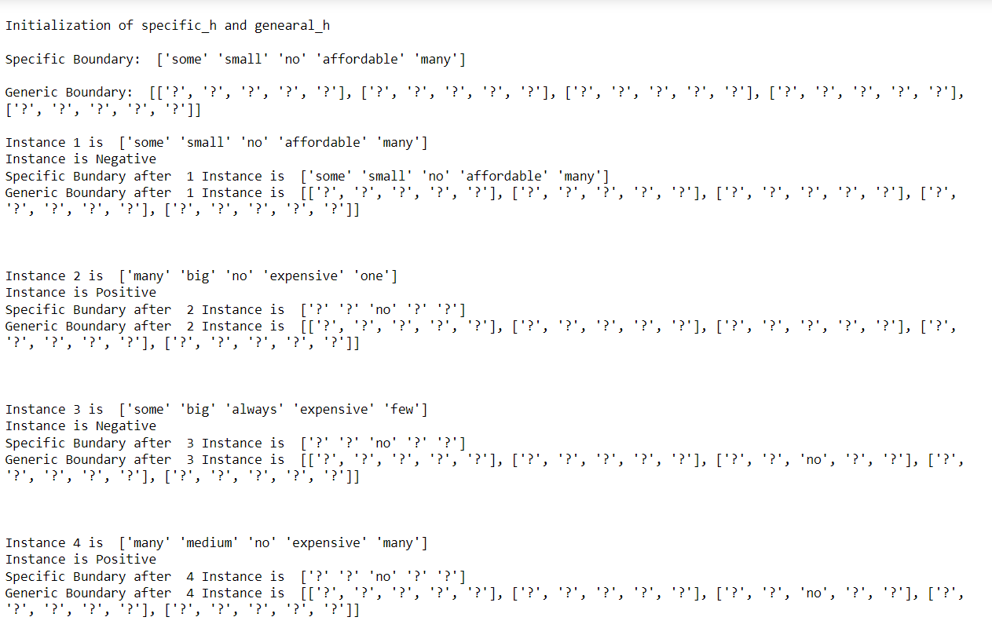

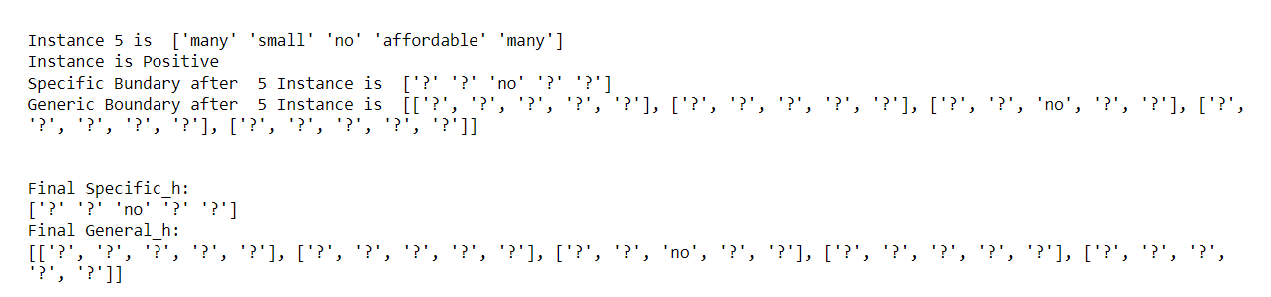

**Health.csv**

