# 2019103555 PRANAVA RAMAN B M S 04/10/2021

**LAB – 5 – SINGLE LAYER PERCEPTRON - LAB**

**CODE:-**

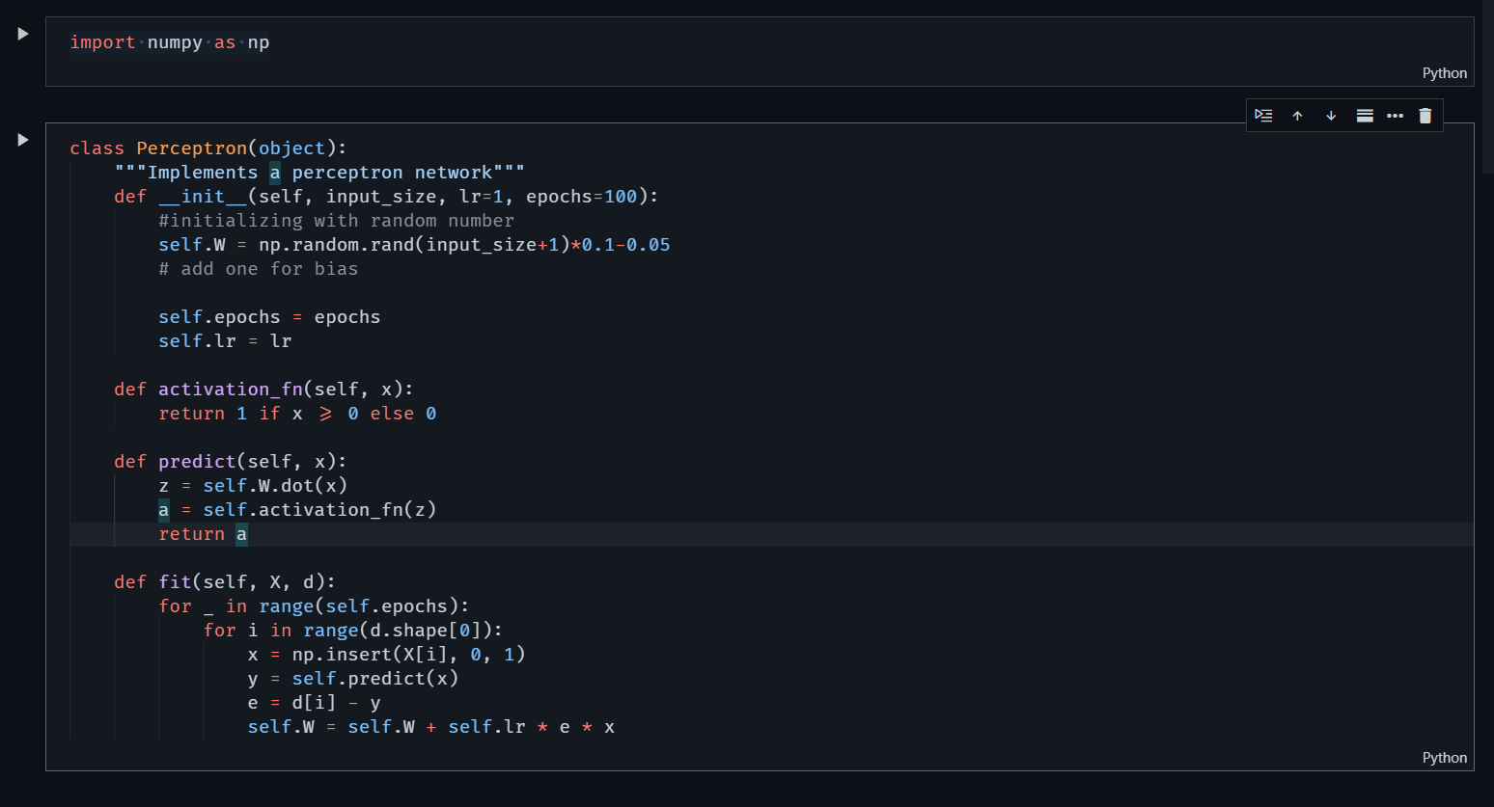

AND GATE:-

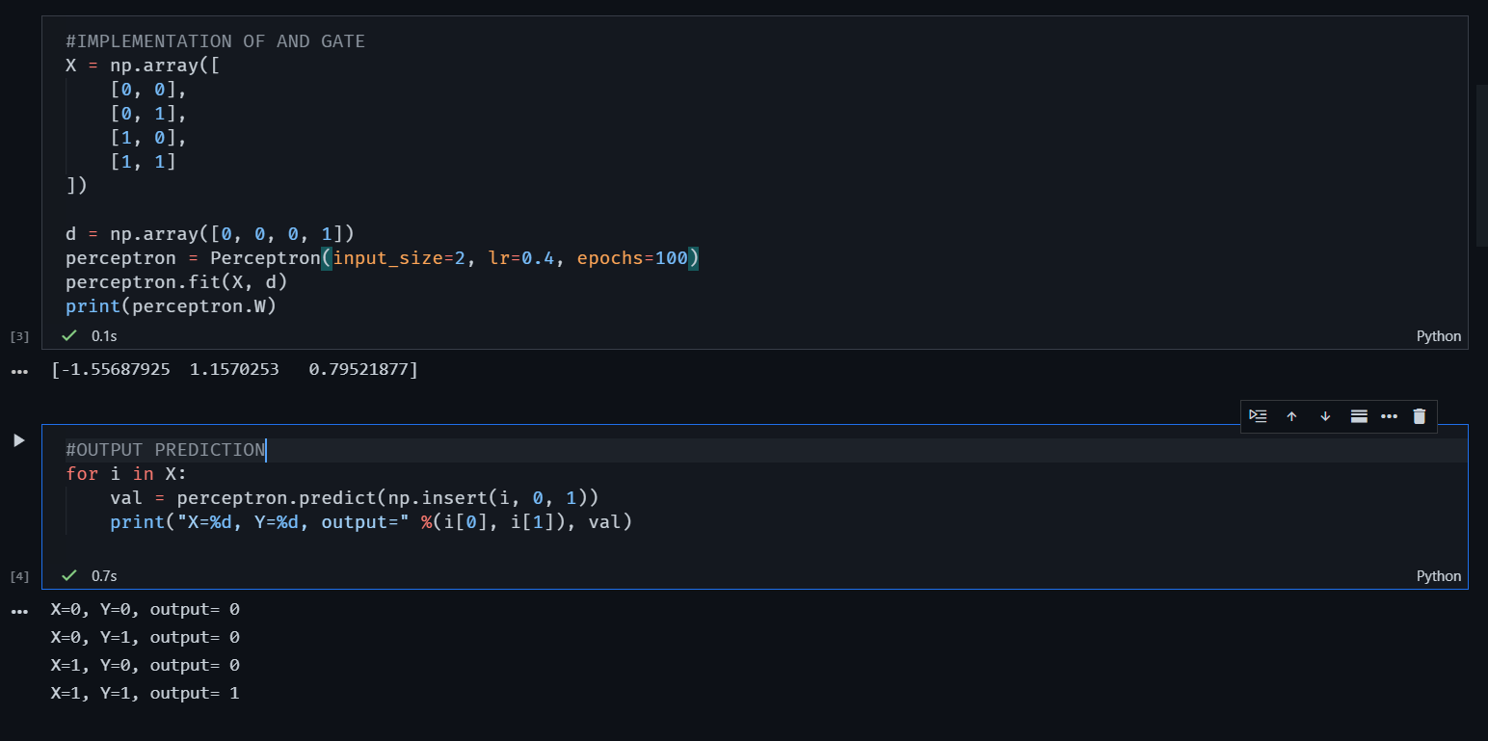

OR GATE

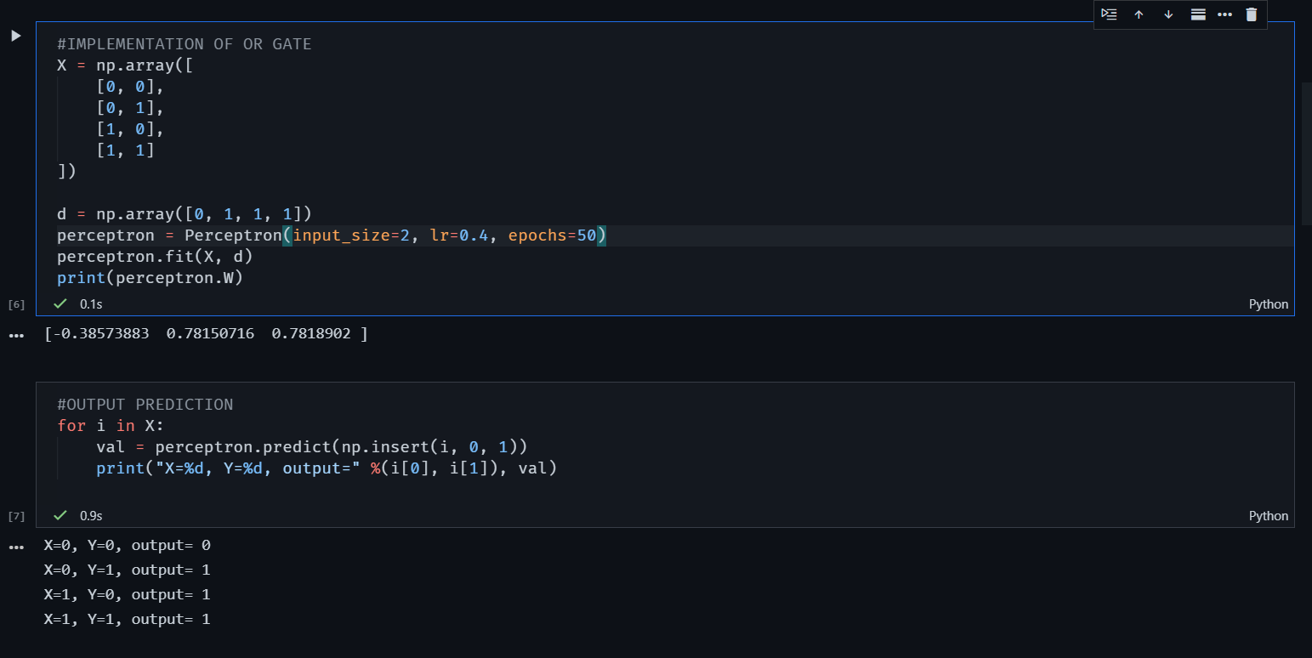

BOTH AND , OR ARE LINEARLY SEPARABLE HENCE CAN USE A SINGLE LAYER PERCEPTRON TO MAKE IT LEARN.

XOR GATE:-

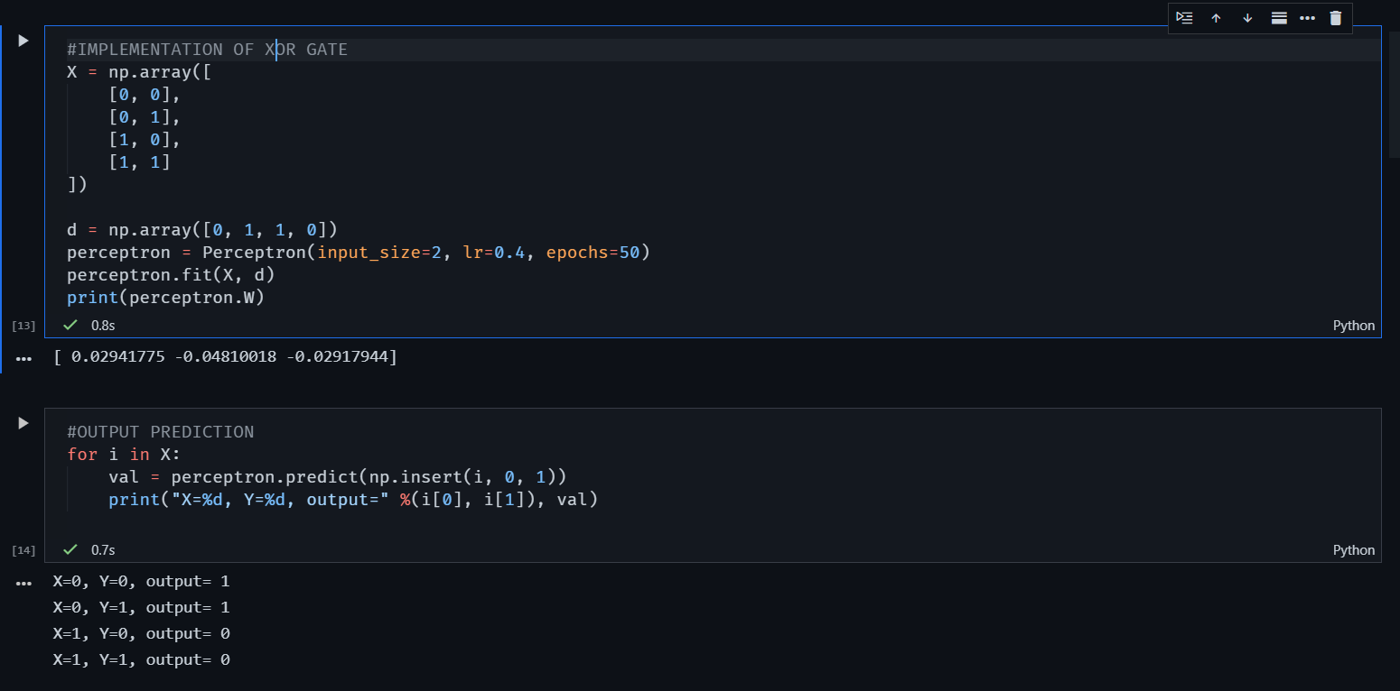

Here we can see that we can’t use our single-layer perceptron to model an XOR gate.