# 2019103555 PRANAVA RAMAN B M S 11/10/2021

**WEEK-6-SPOT**

**MULTIPLE LAYERS, NEURONS EFFECT ON PERFORMANCE METRICS:-**

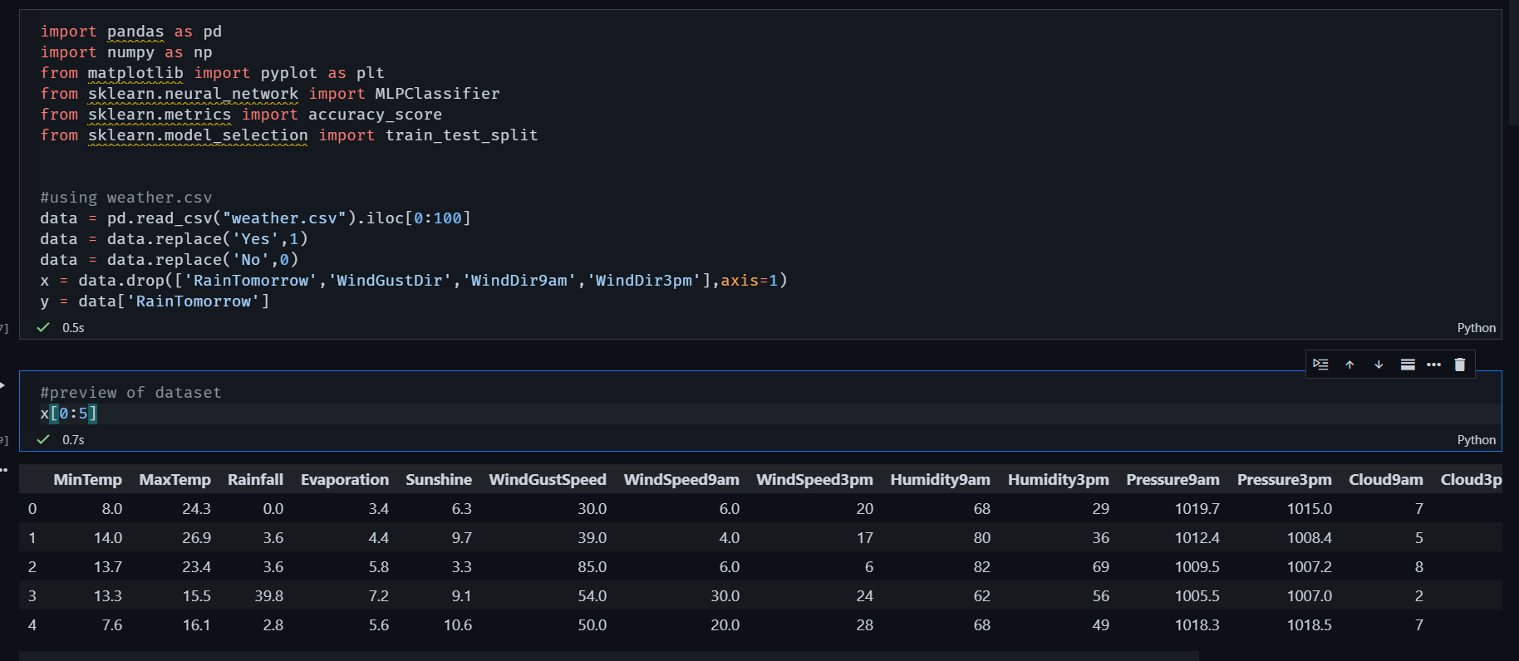

**Changing number of neurons in hidden layers from 1 to 50**

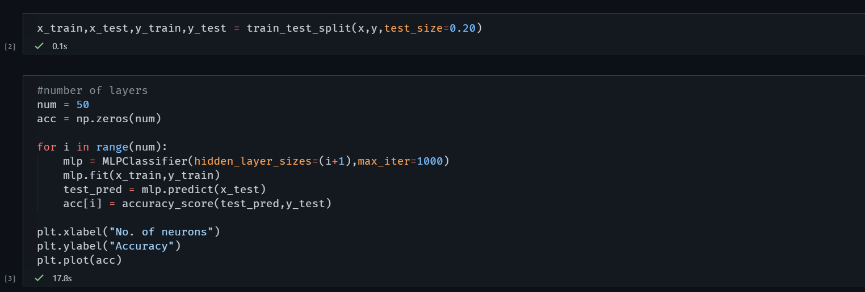

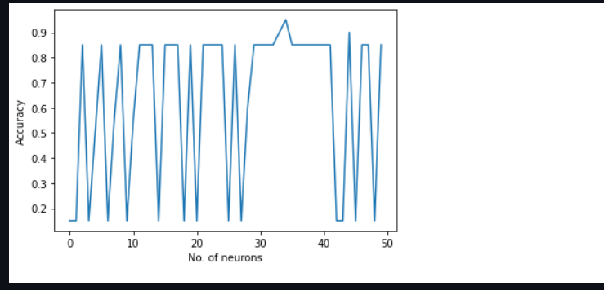

Here we can see that for each number of neurons the accuracy varies drastically.

**Changing the number of layers:-**

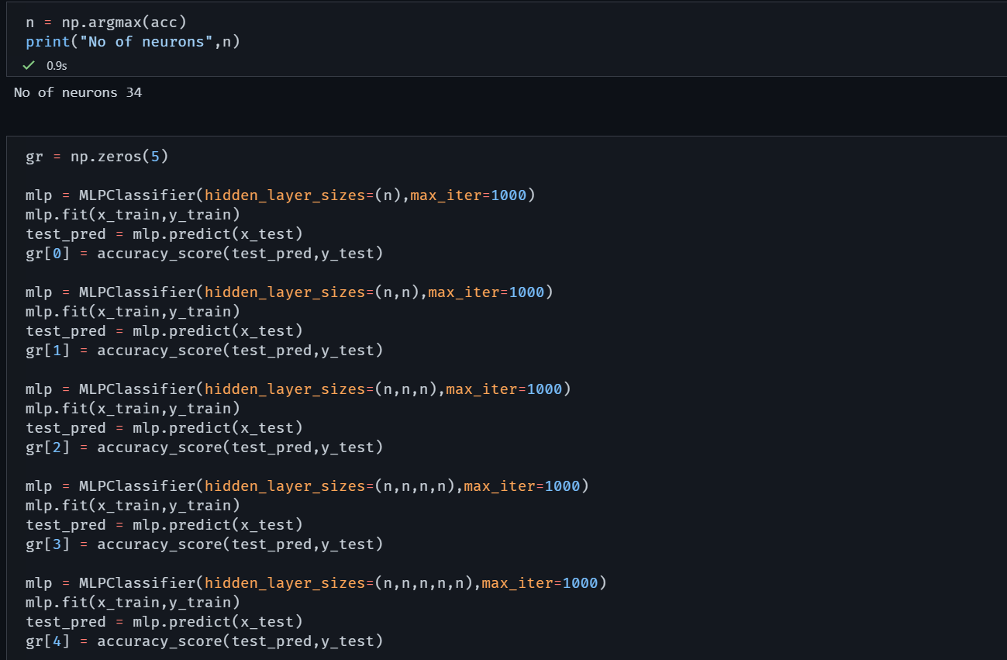

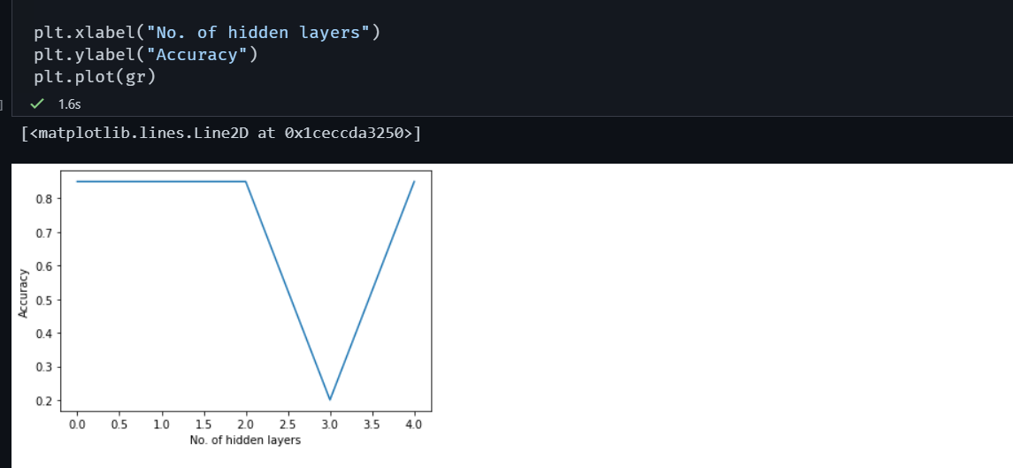

**The maximum neuron performs differently on changing the number of hidden layers also.**