# 2019103555 PRANAVA RAMAN B M S 18/10/2021

**LAB – 07 – RADIAL BASIS FUNCTION NETWORK**

1. Implement RBF network for classification. Use your own dataset
2. Compare the performance of RBF with Multi Layer Perceptron

**RBF network code:-**

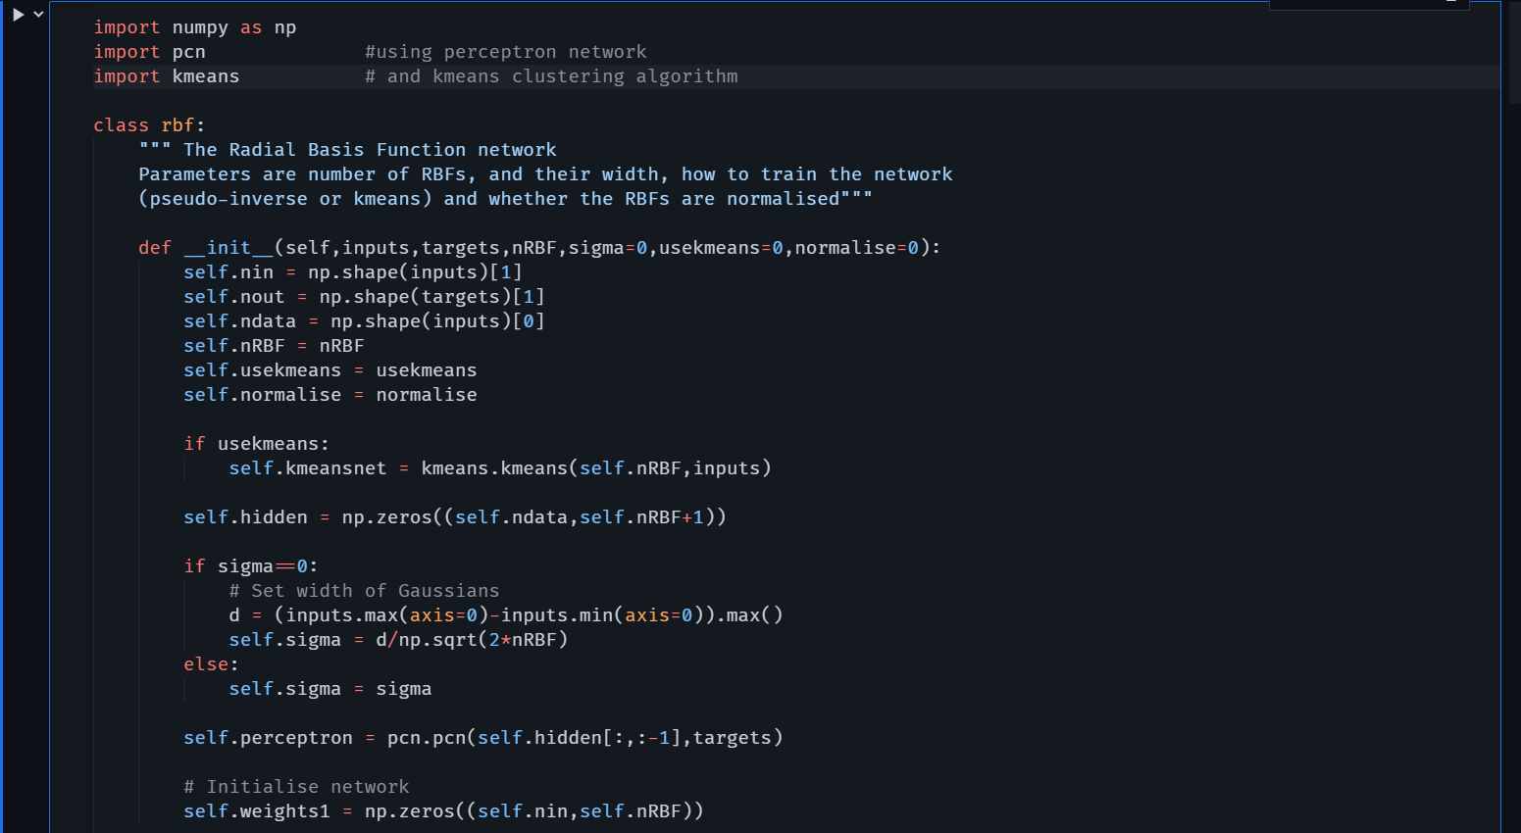

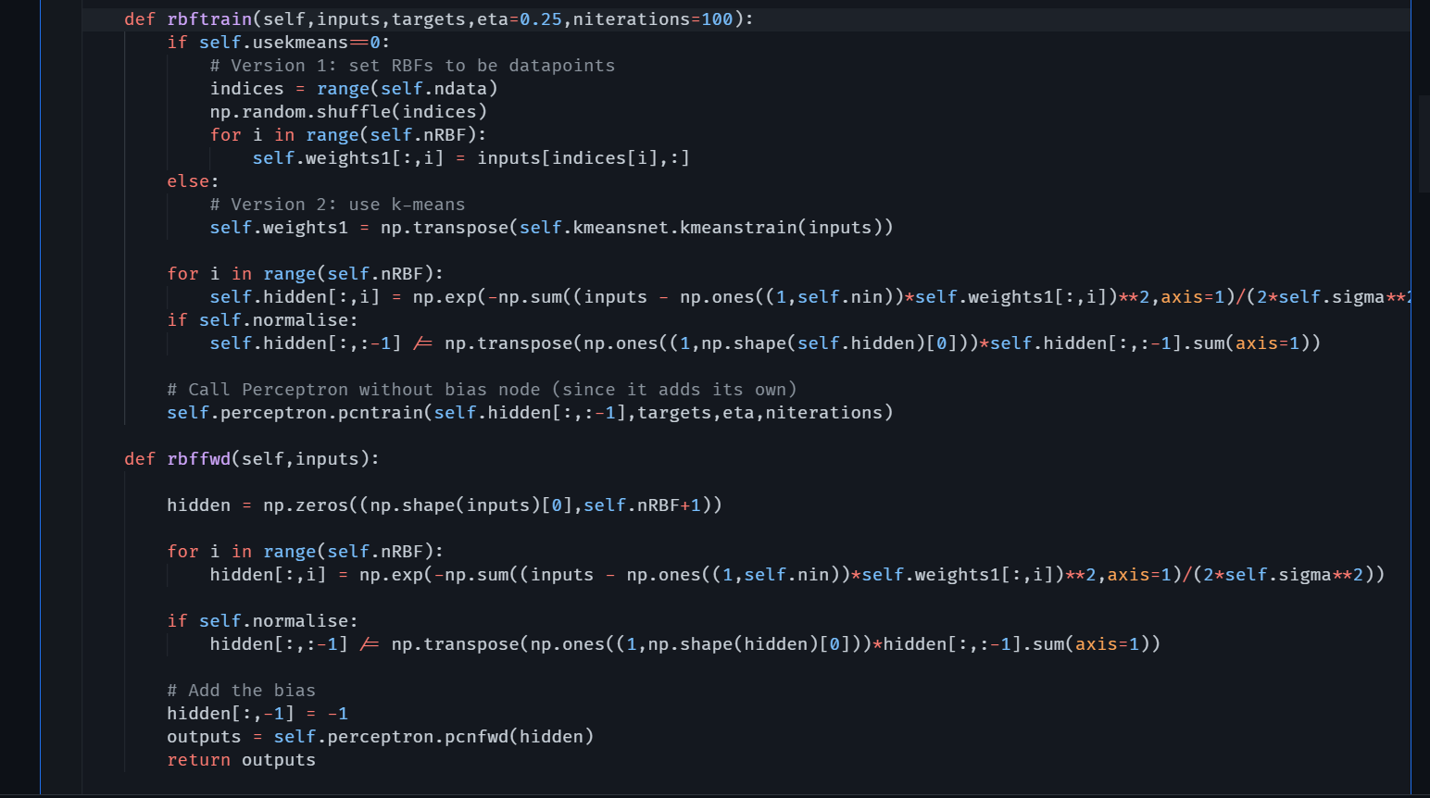

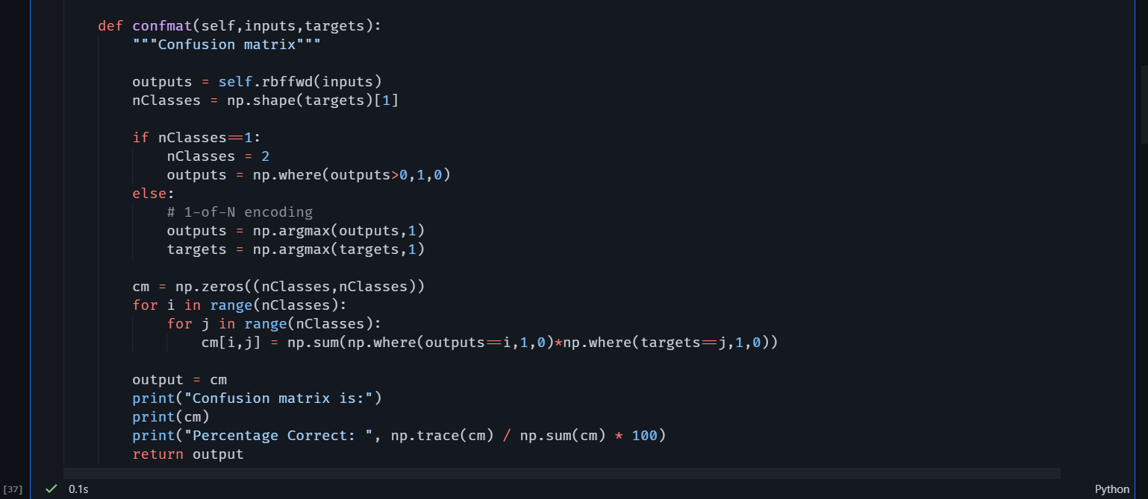

**Using the banknote dataset:-**

The Banknote Dataset involves predicting whether a given banknote is authentic given a number of measures taken from a photograph.

It is a binary (2-class) classification problem. The number of observations for each class is not balanced. There are 1,372 observations with 4 input variables and 1 output variable. The variable names are as follows:

1. Variance of Wavelet Transformed image (continuous).
2. Skewness of Wavelet Transformed image (continuous).
3. Kurtosis of Wavelet Transformed image (continuous).
4. Entropy of image (continuous).
5. Class (0 for authentic, 1 for inauthentic).

The baseline performance of predicting the most prevalent class is a classification accuracy of approximately 50%.

[UCI Machine Learning Repository: banknote authentication Data Set](https://archive.ics.uci.edu/ml/datasets/banknote+authentication)

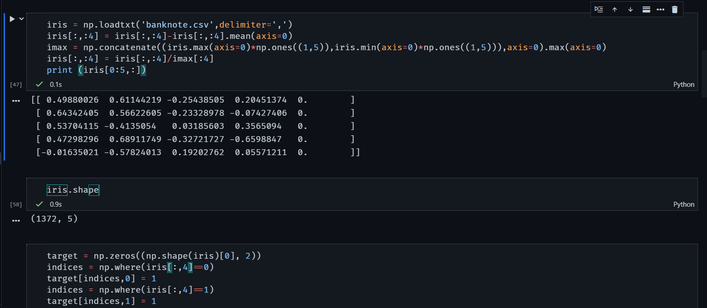

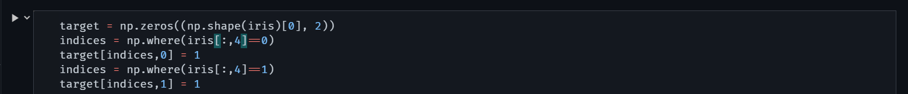

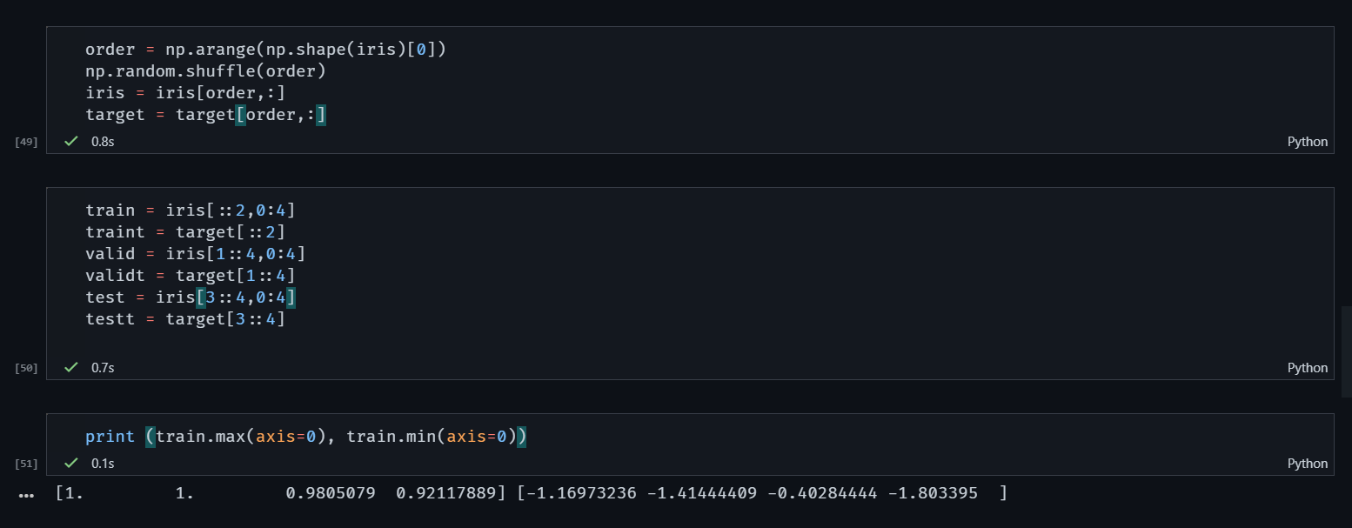

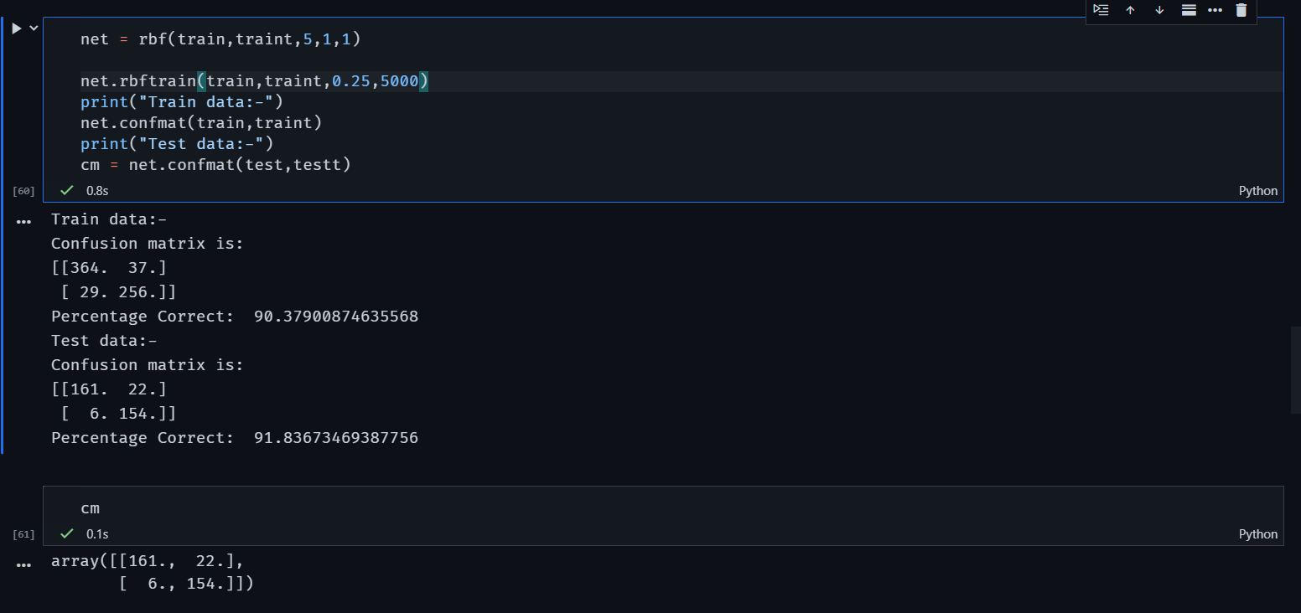

**Performance metrics of the network:-**

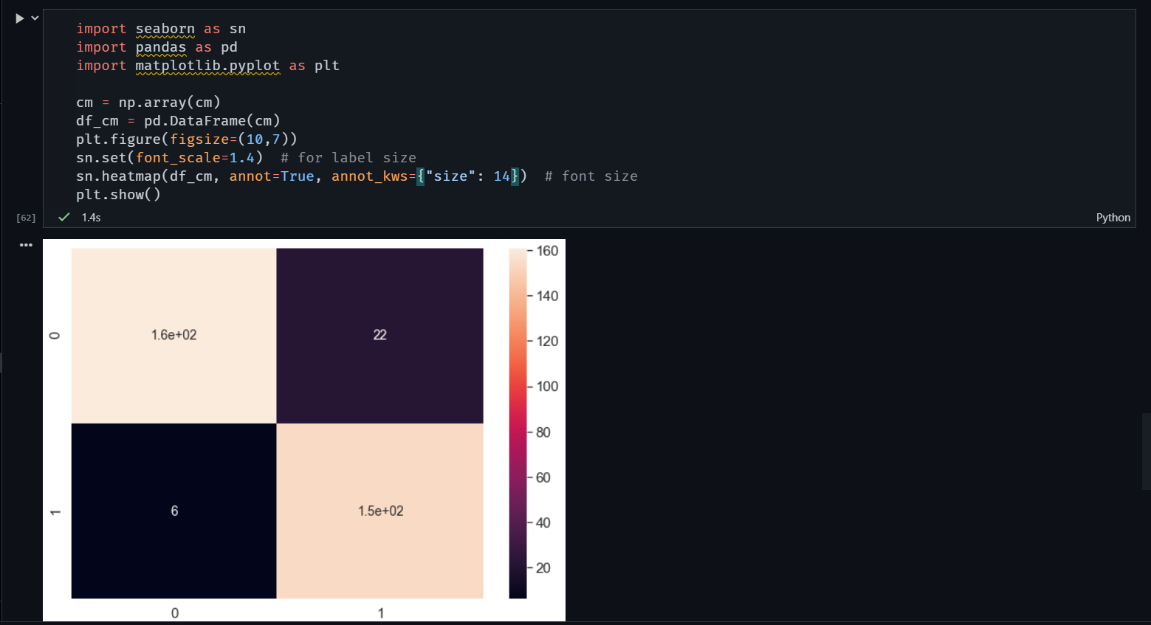

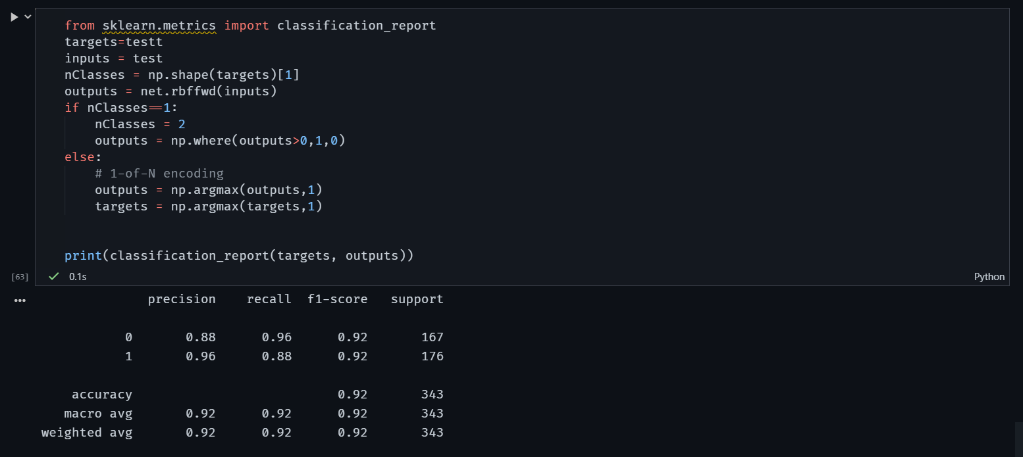

**Now comparing the network with MLP for the same data:-**

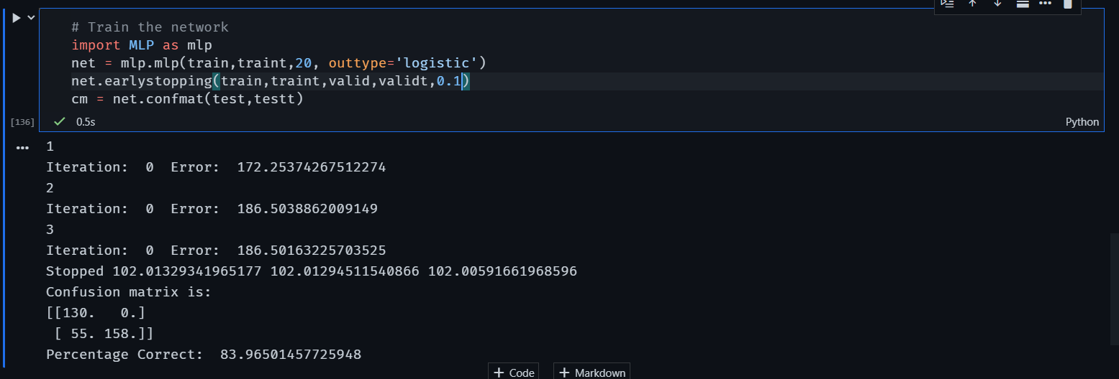

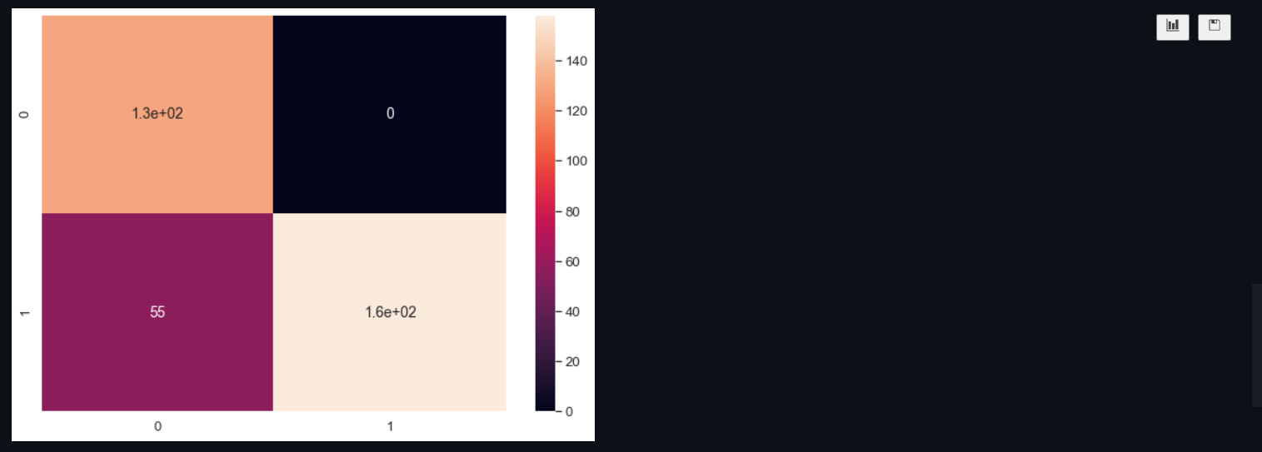

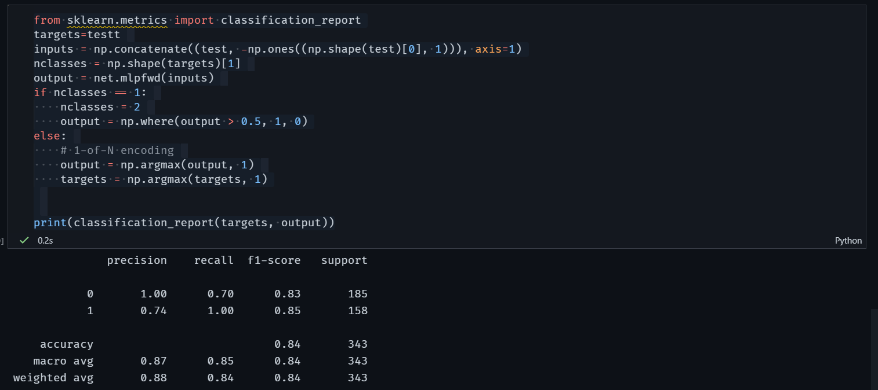

Here we can clearly see that using RBF network has given a significantly better accurate output for the same training data. Also notable is that MLP was fully precise when classifying the negative outputs.