### 2019103555 PRANAVA RAMAN B M S 15/11/2021

LAB - 10 - PCA AND LDA

DATASET:- <https://archive-beta.ics.uci.edu/ml/datasets/iris>

1. Principal Component Analysis

PCA is a dimensionality-reduction method that is often used to reduce the dimensionality of large data sets, by transforming a large set of variables into a smaller one that still contains most of the information in the large set.It reduces the number of variables of a data set, while preserving as much information as possible.

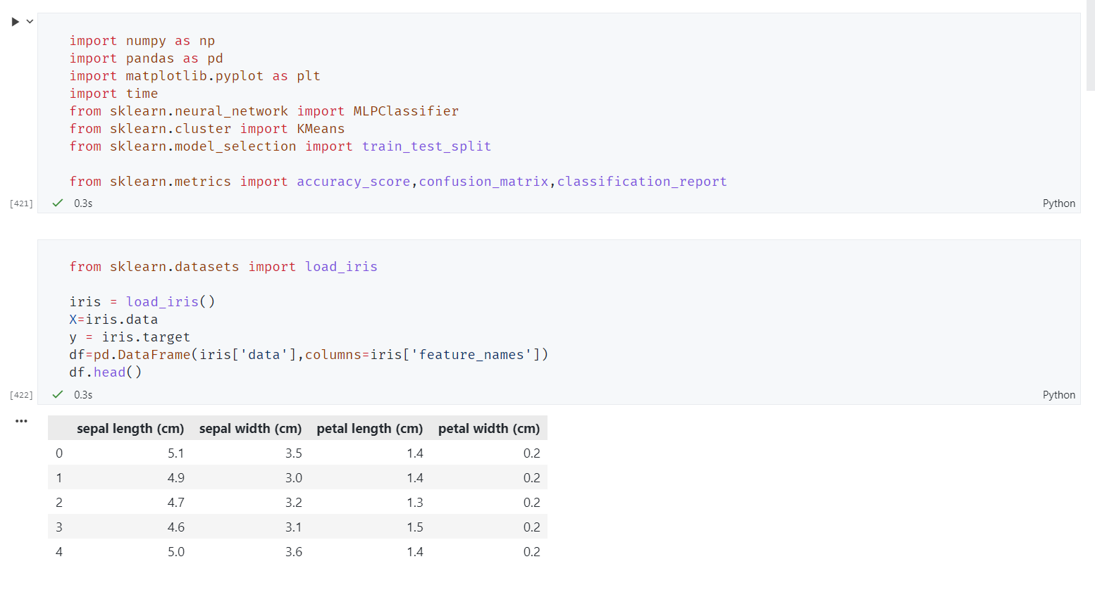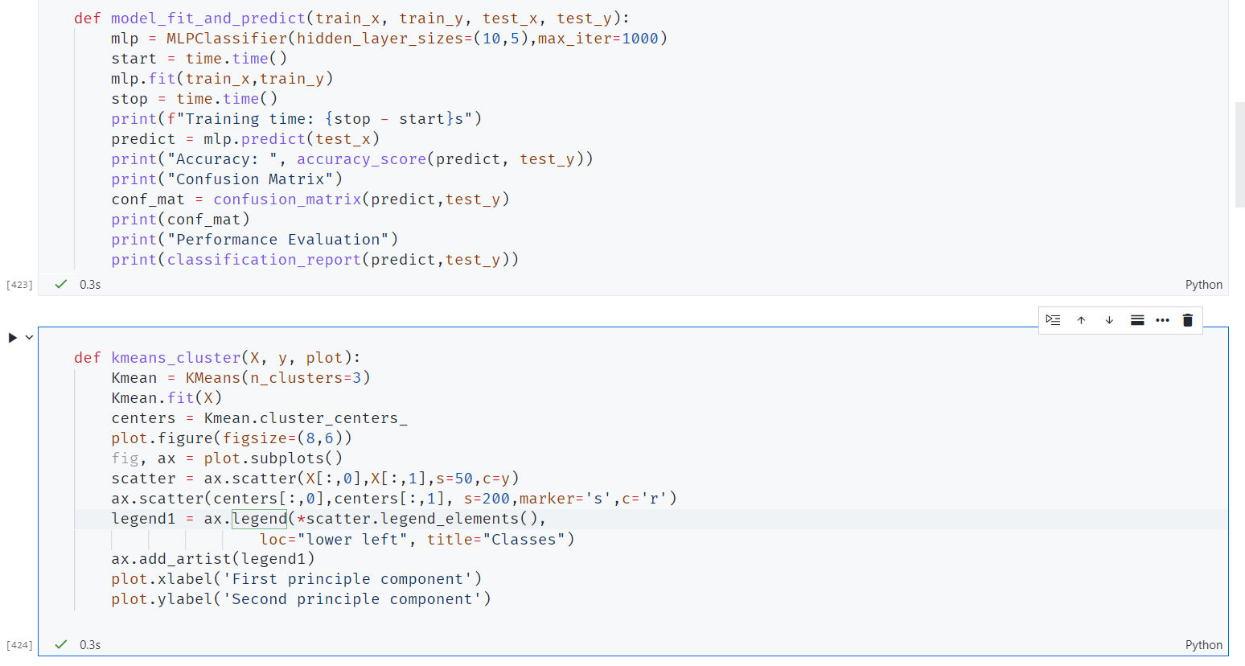

Before using PCA:-

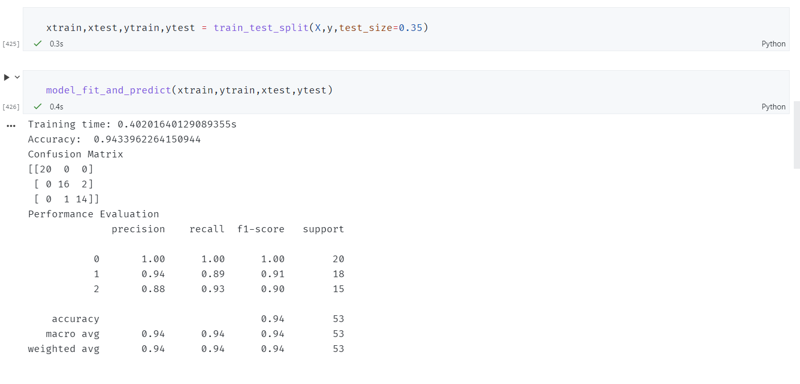

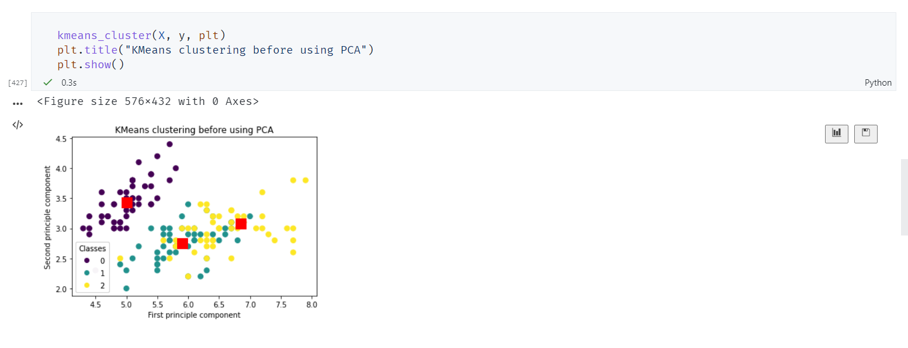

PCA definition:-

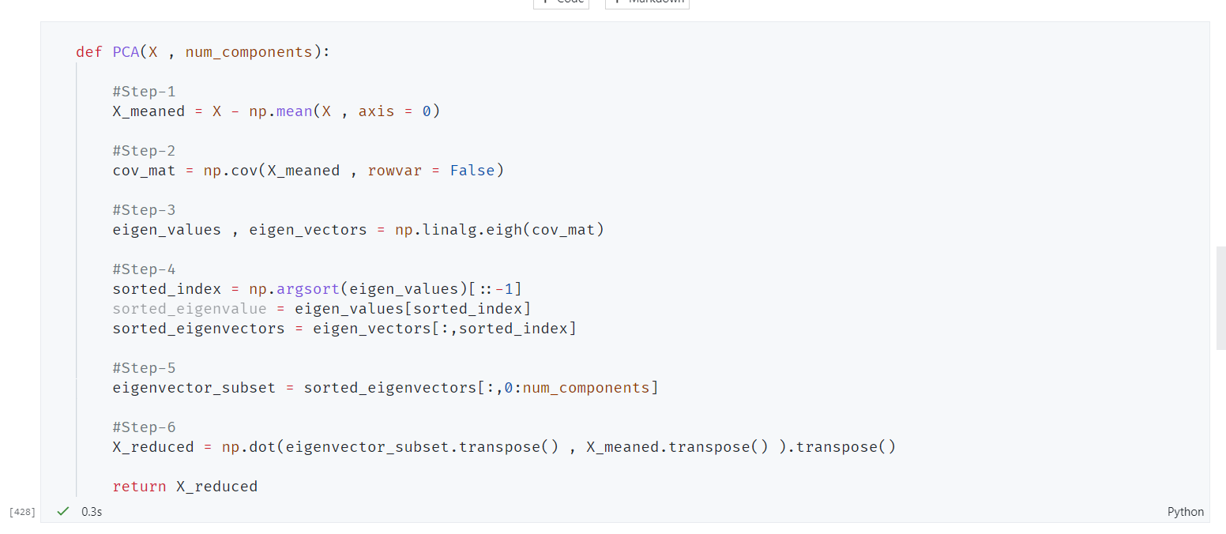

After applying PCA:-

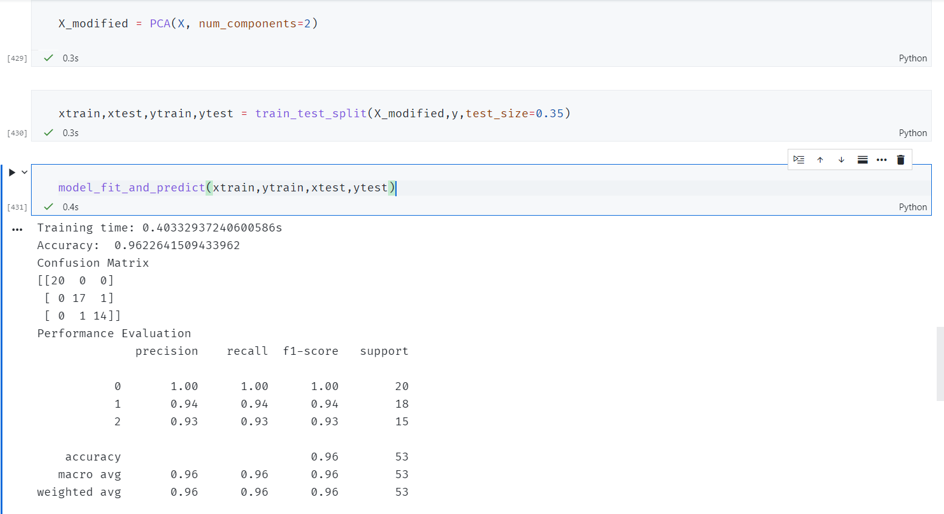

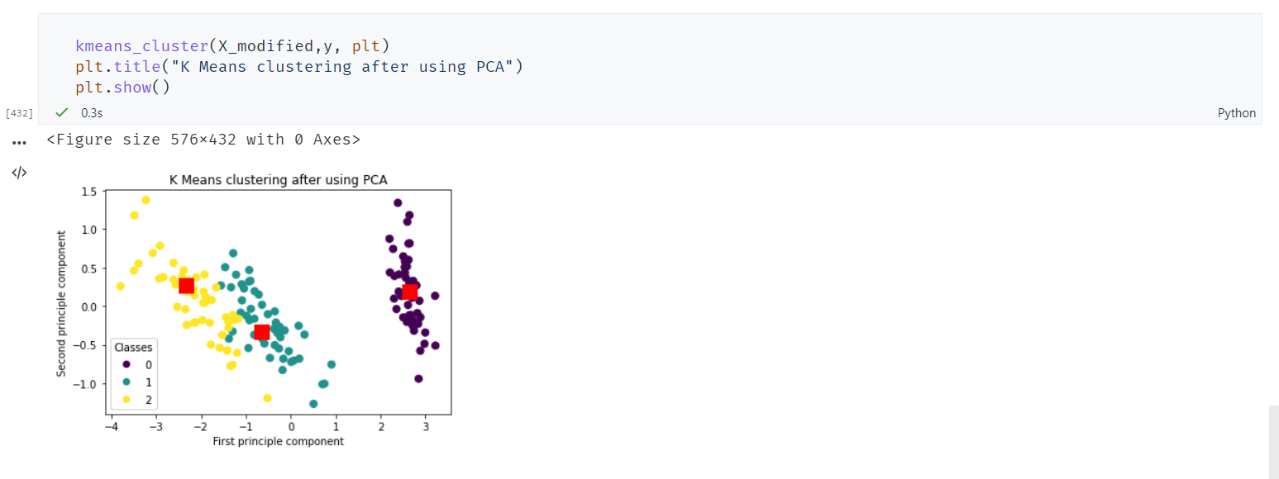

After applying PCA, the accuracy has increased marginally while maintaining the same training time, but the Clustering is cleanly done. Before PCA, the clusters were intermingled, but after PCA the segregation is more pronounced.

1. Linear Discriminant Analysis

It is a dimensionality reduction technique. It is used as a pre-processing step in Machine Learning and applications of pattern classification. The goal of LDA is to project the features in higher dimensional space onto a lowerdimensional space in order to avoid the curse of dimensionality and also reduce resources and dimensional costs. LDA is a supervised classification technique that is considered a part of crafting competitive machine learning models. This category of dimensionality reduction is used in areas like image recognition and predictive analysis in marketing

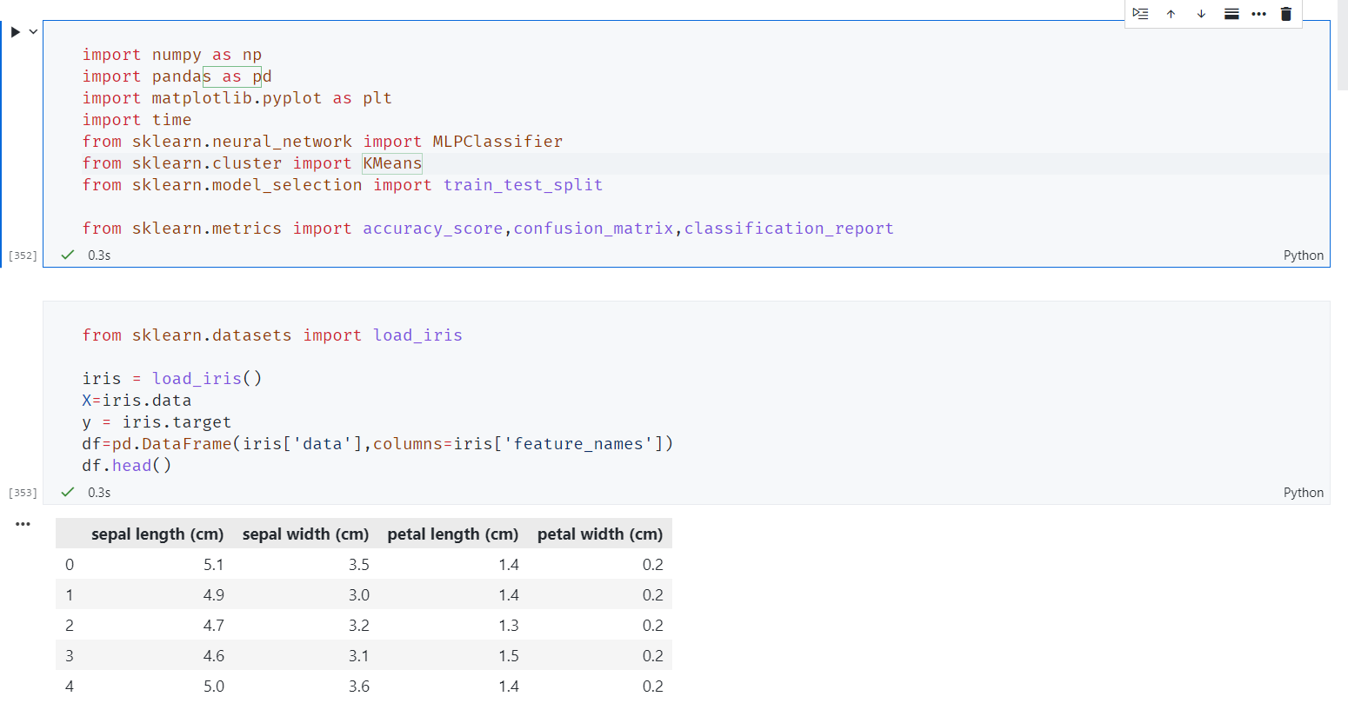

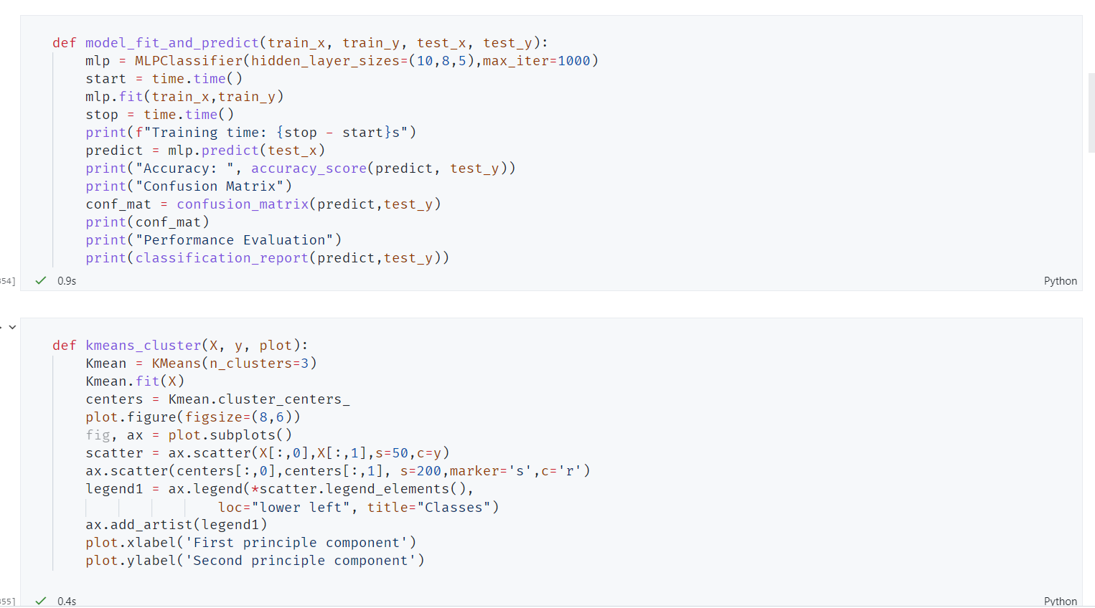

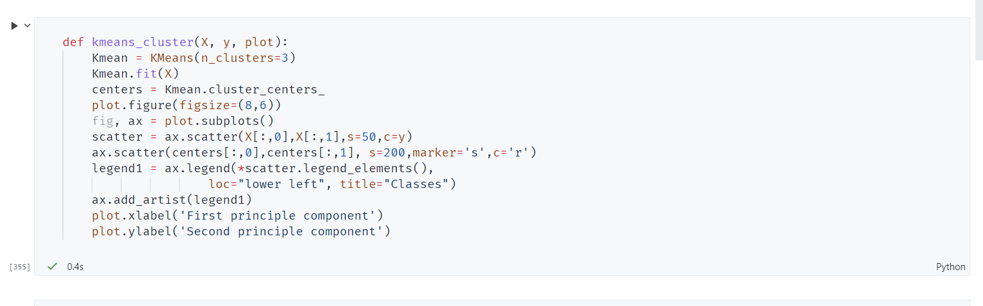

Performance of MLP and K means clustering before LDA

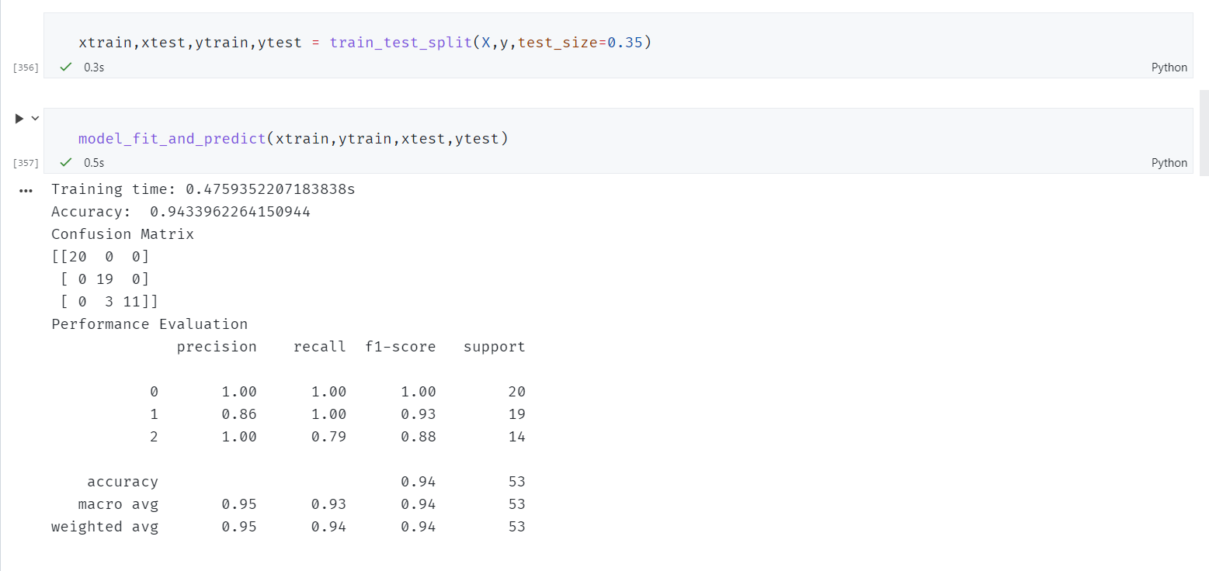

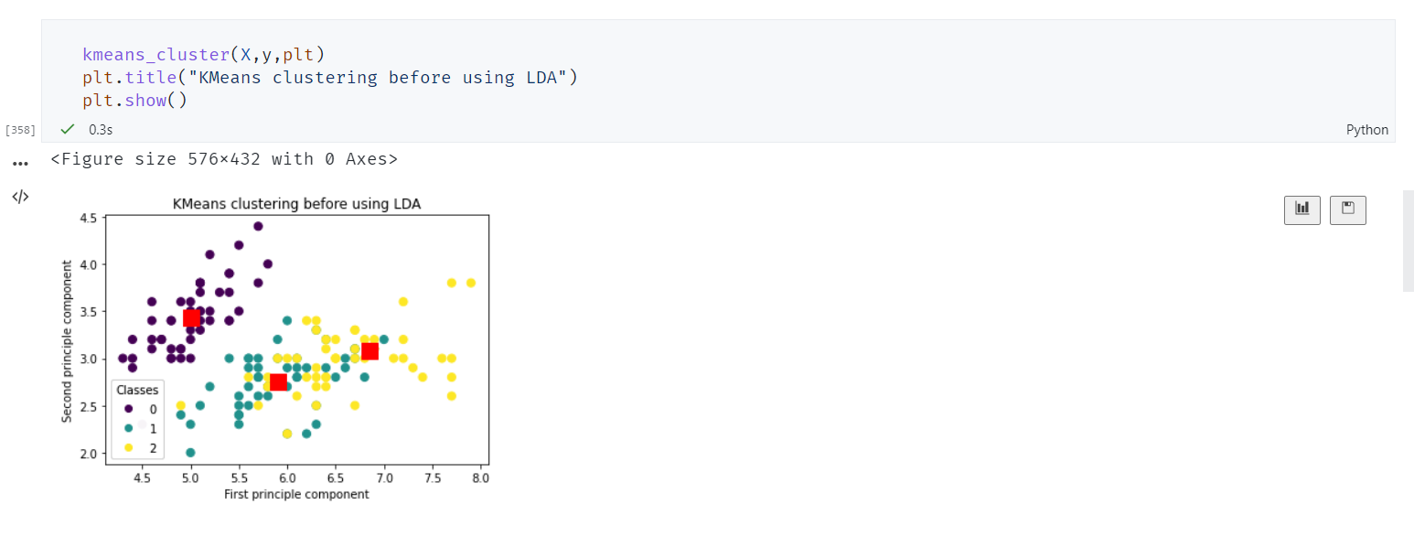

Here we can see that the classes of type 2 and 3 are intermingled before using LDA.

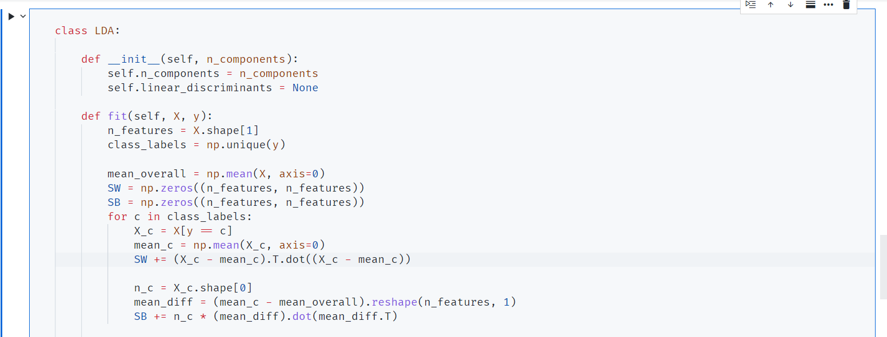

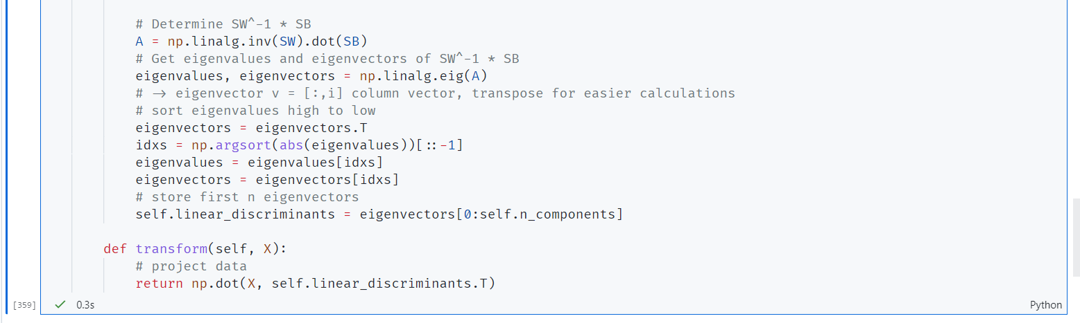

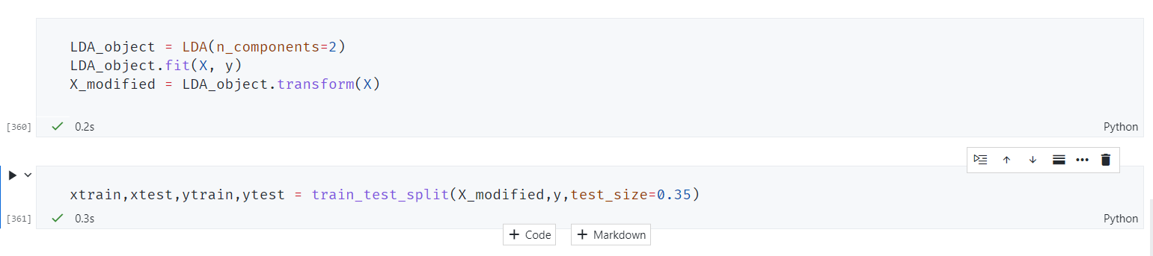

Now after using LDA:-

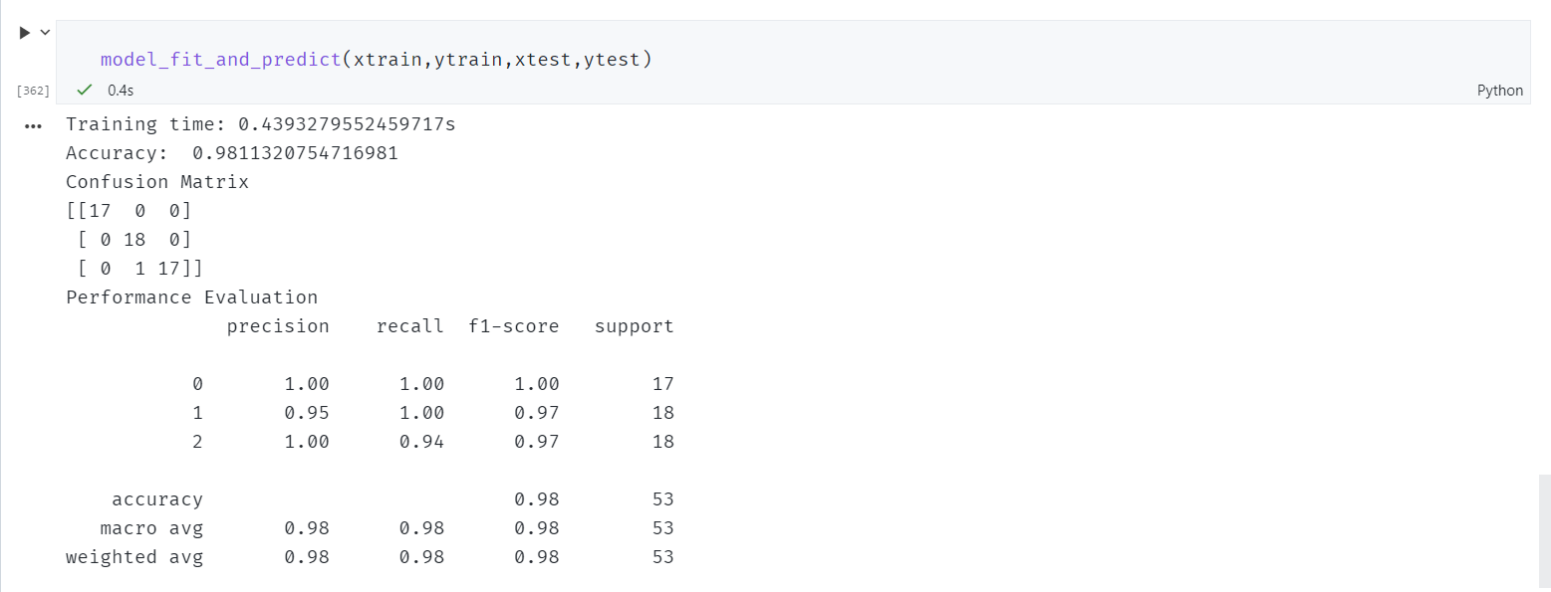

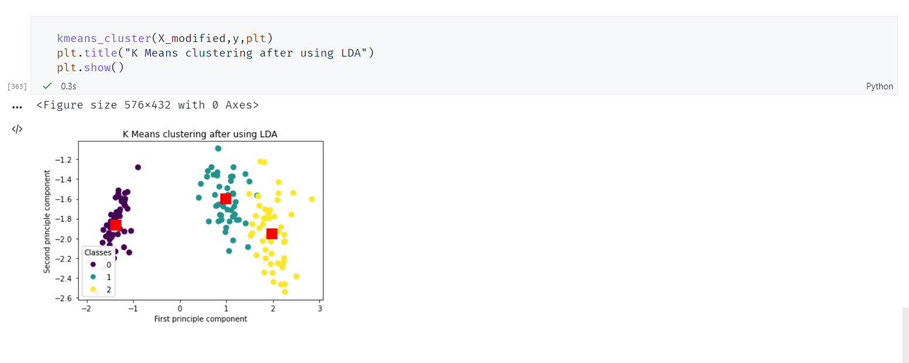

Similarly for LDA, the accuracy has also increased slightly while segregating the clusters better.