#### 2019103555 PRANAVA RAMAN B M S 22/11/2021

MACHINE LEARNING - LAB 12 - SPOT

Implementation of ID3 algorithm and the parameter for attribute selection is set to Gini index.

PARTY DATASET:-

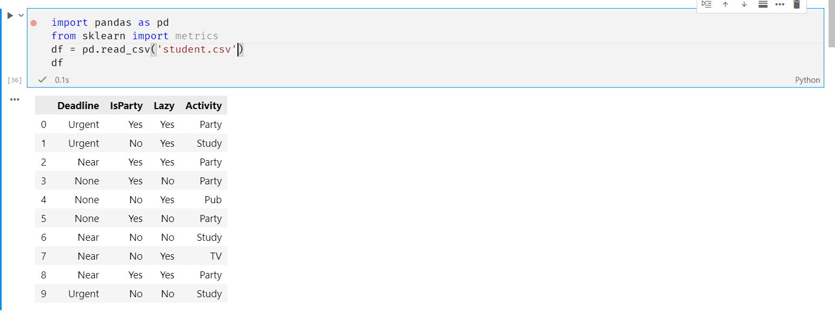

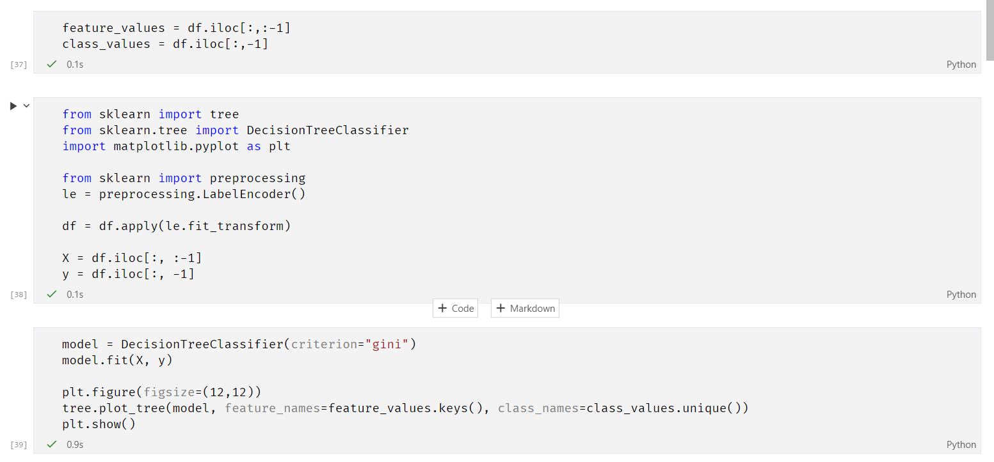

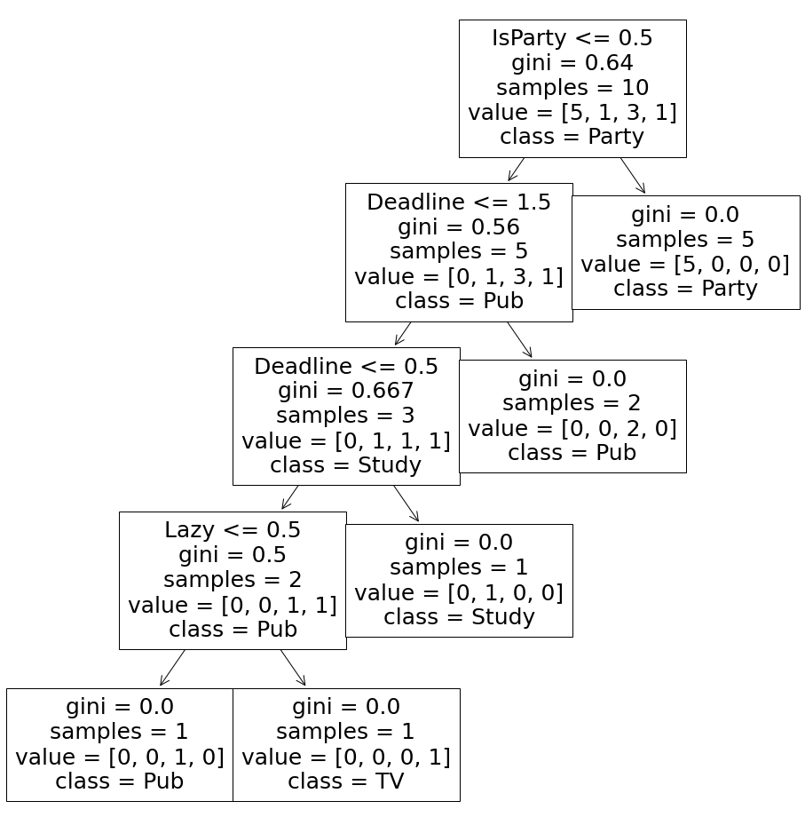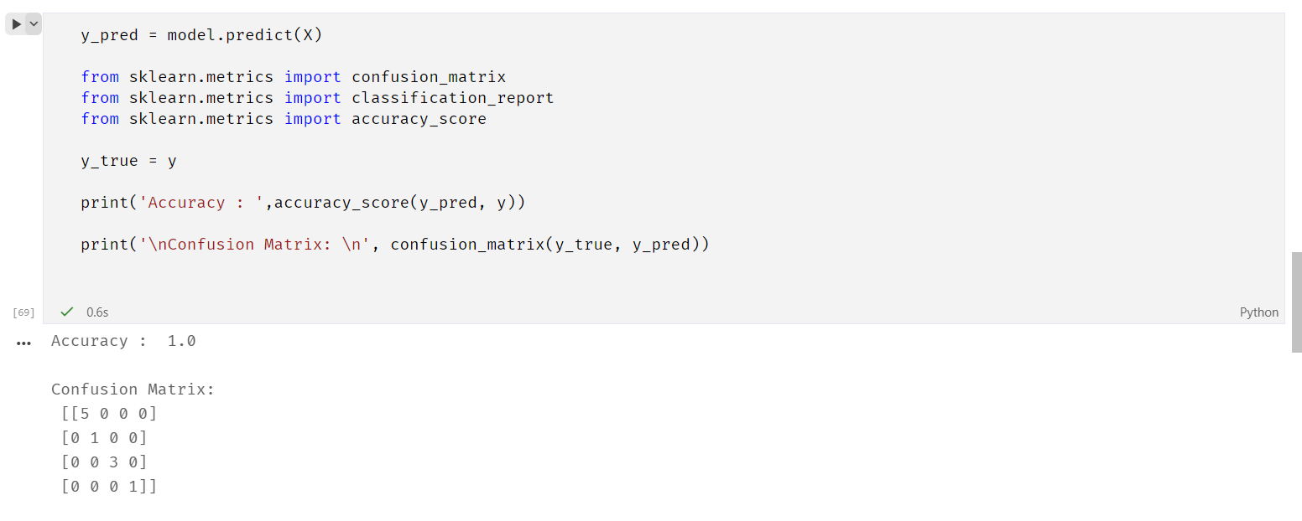

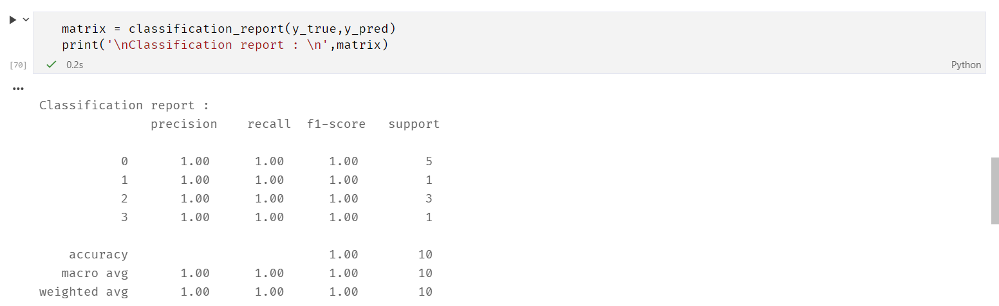

Using IRIS dataset

