2019103555 PRANAVA RAMAN B M S 25/10/2021

**WEEK - 08 - SPOT - MLP**

**Repeat Question 1 using a dataset with multiple classes.**

**Using Glass dataset:-**

[Index of /ml/machine-learning-databases/glass (uci.edu)](https://archive.ics.uci.edu/ml/machine-learning-databases/glass/)

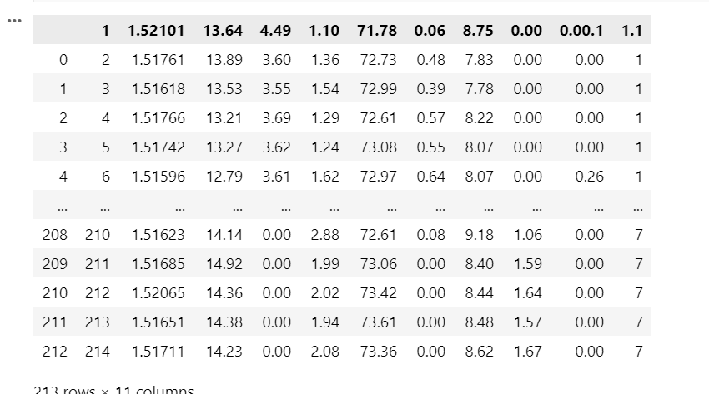

Using MLP code from execution:-

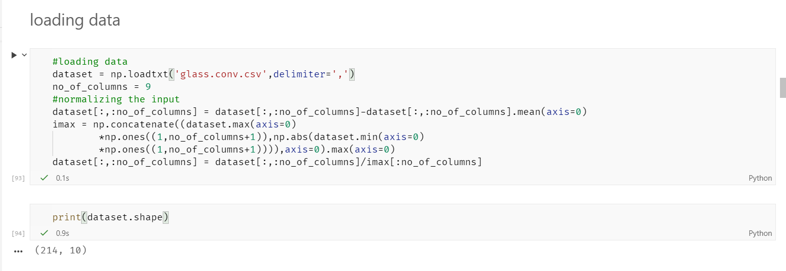

Changing targets to 2d array (if target is 3, it will now become [0 0 0 1 0 0 0])

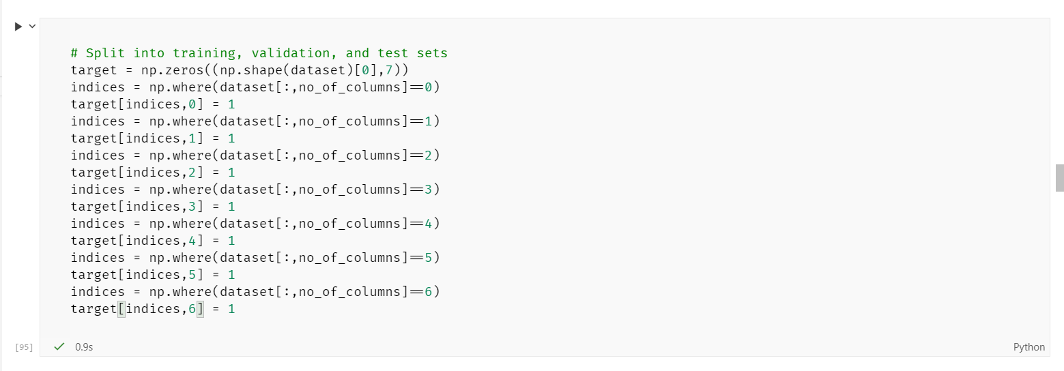

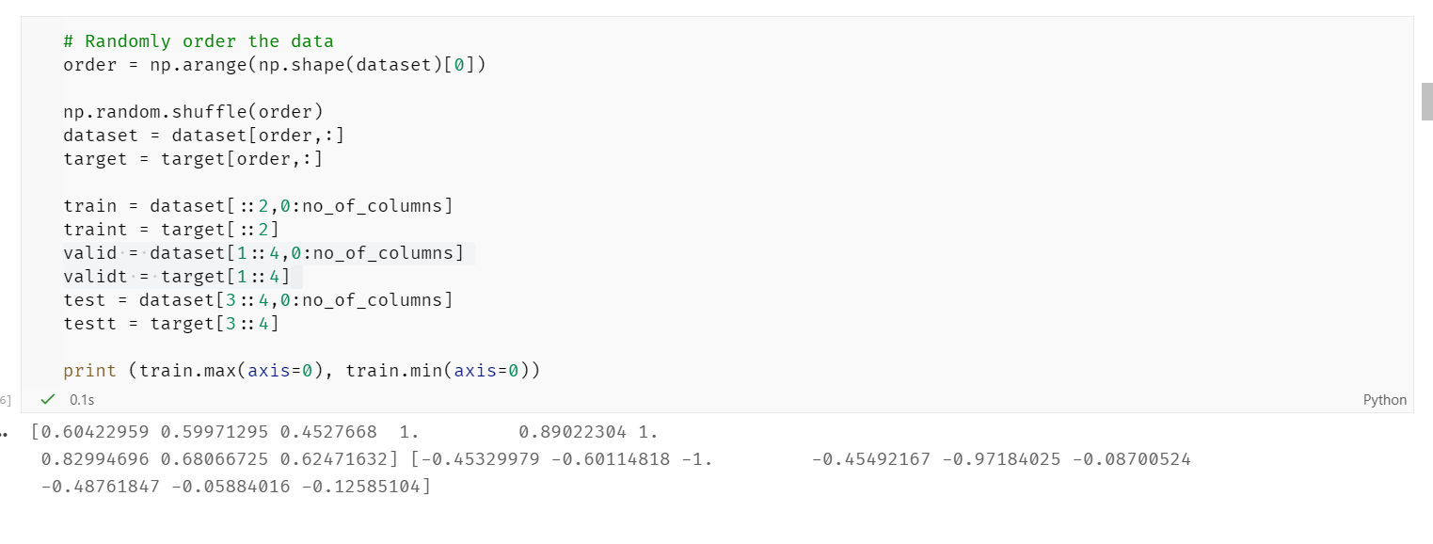

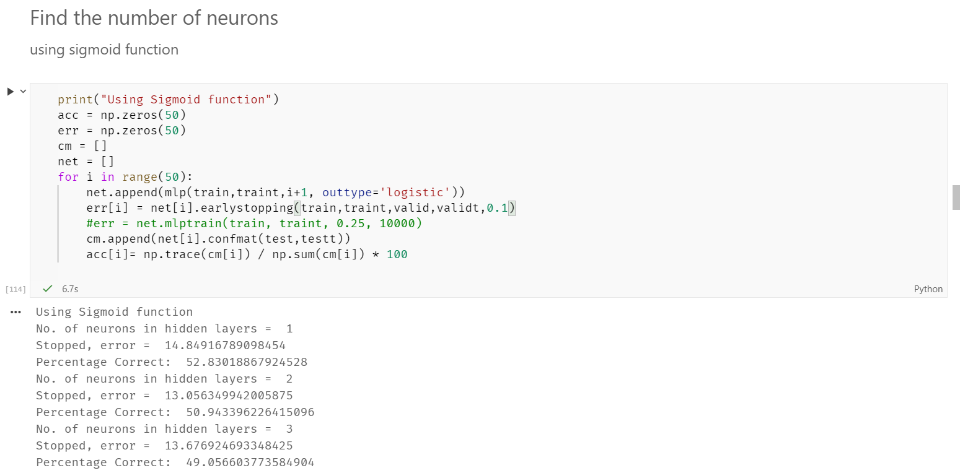

The accuracy varies very heavily with respect to the number of neurons

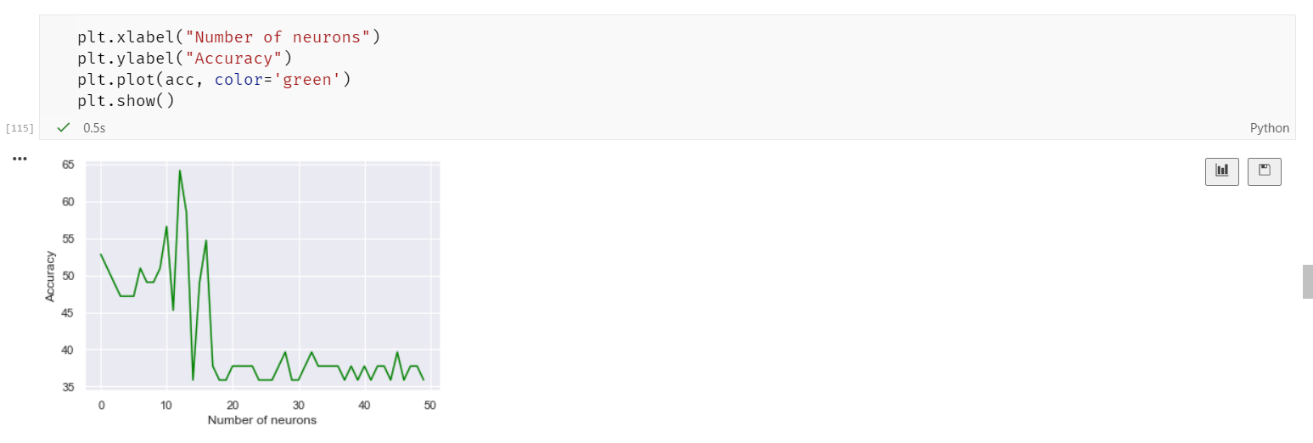

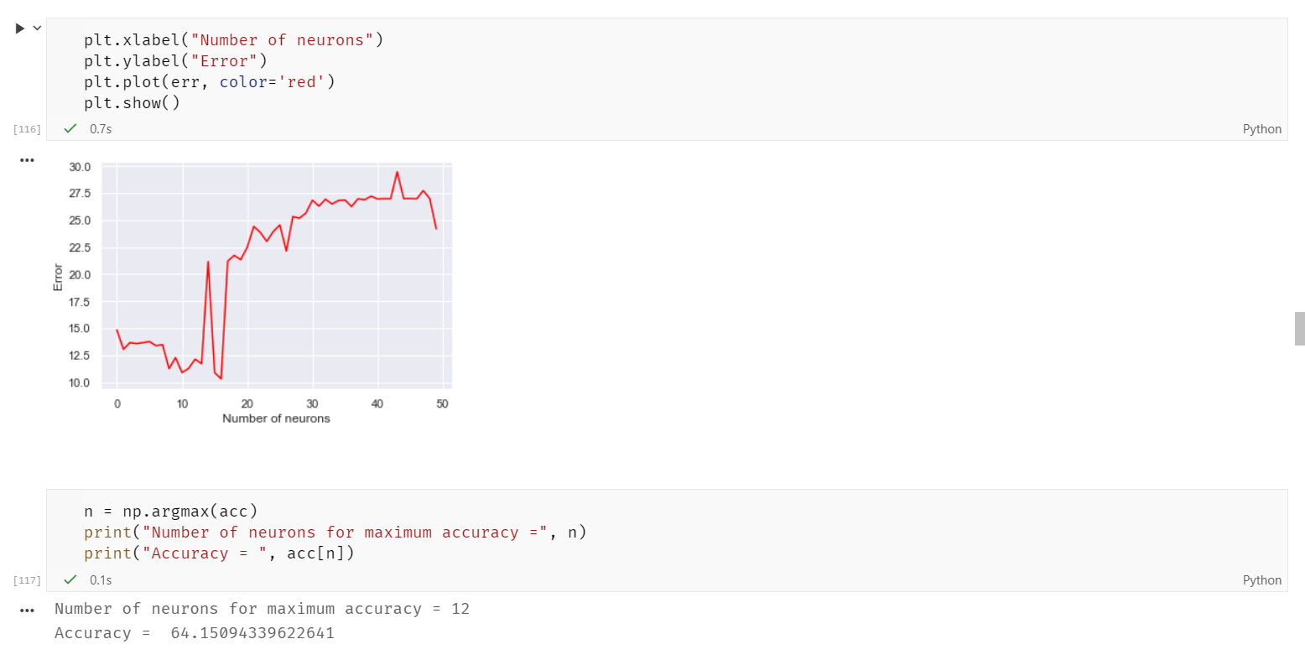

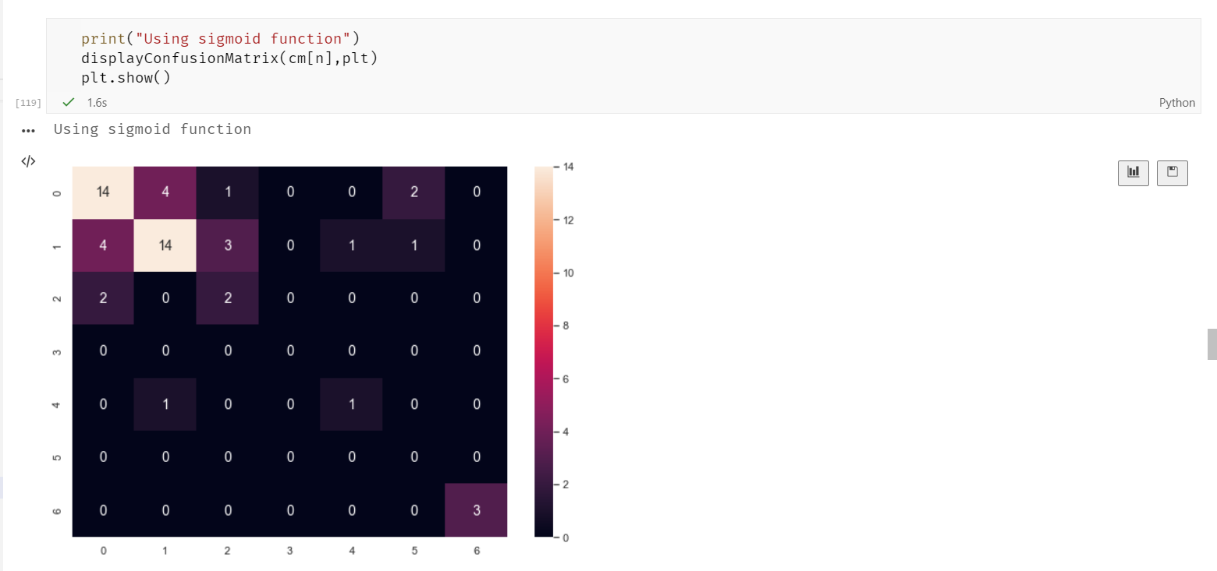

The model performs okish to classify multi class data.

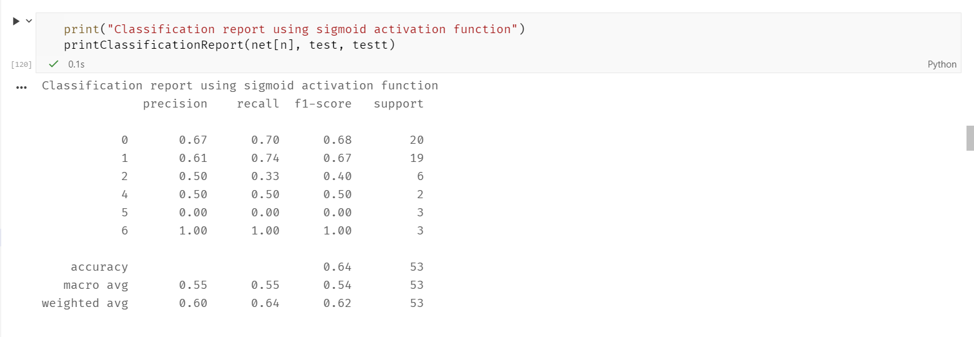

**Checking performance with other activation functions:-**

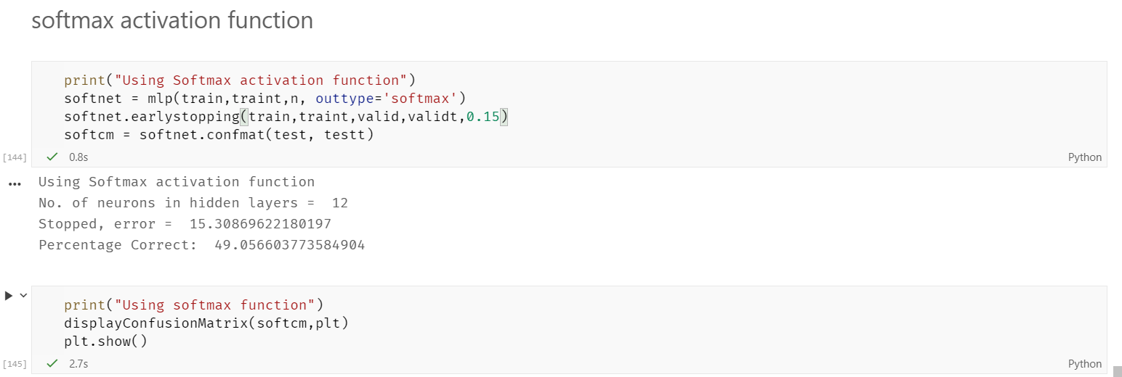

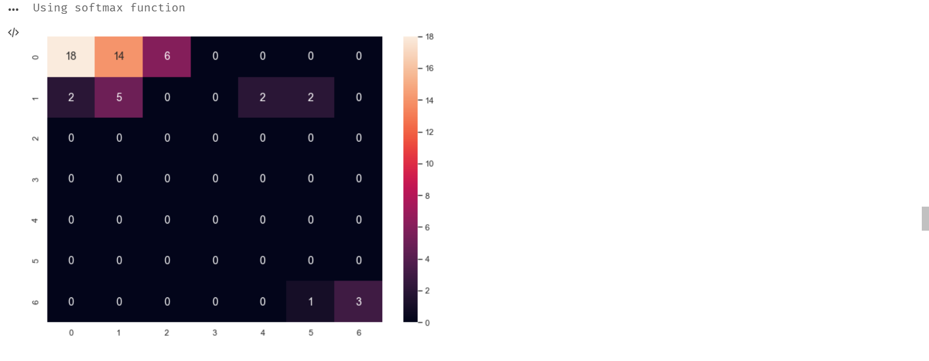

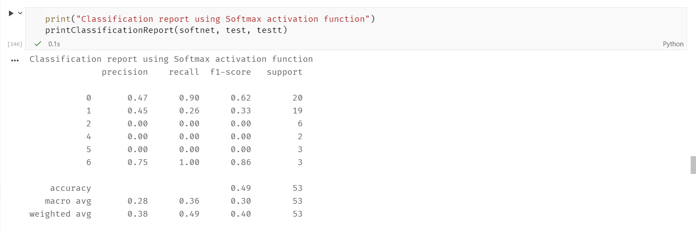

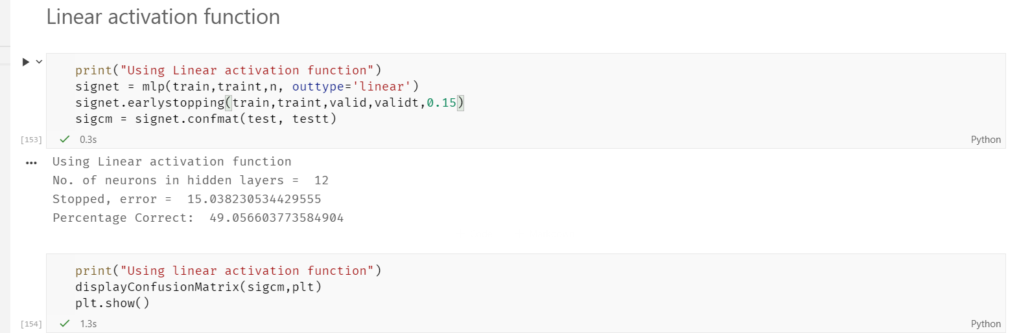

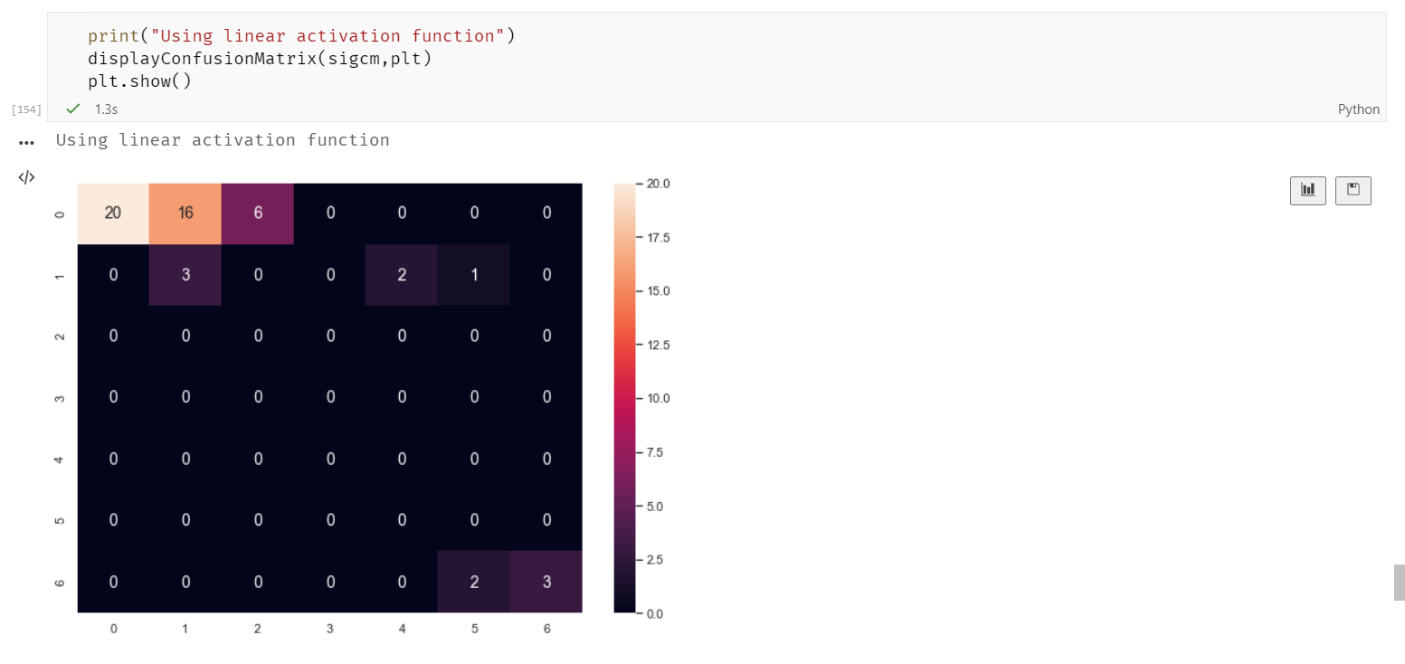

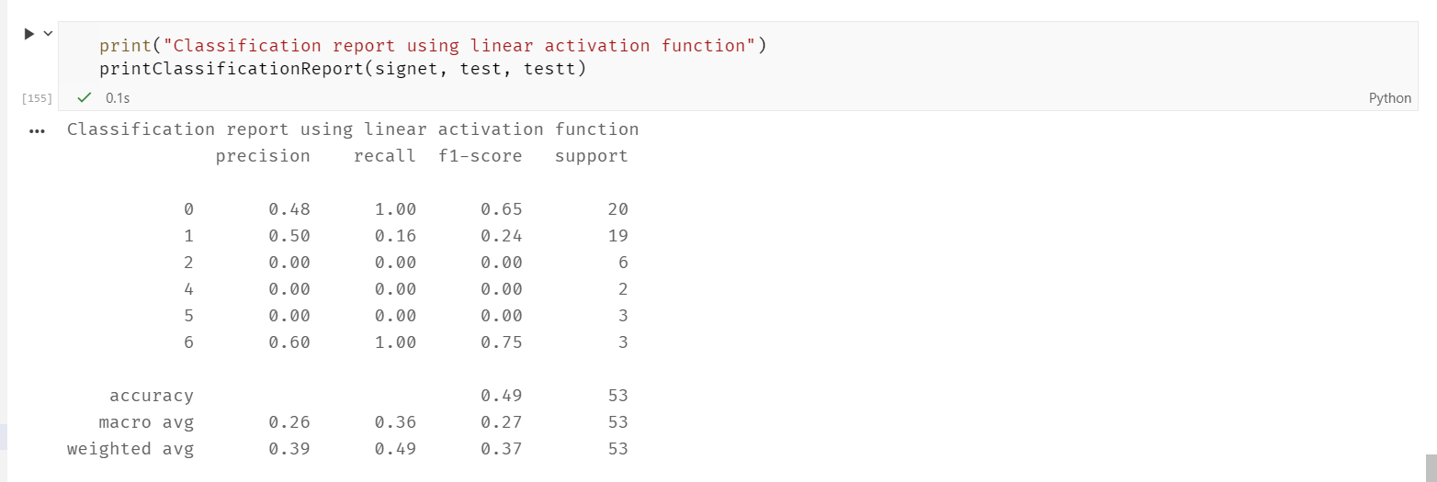

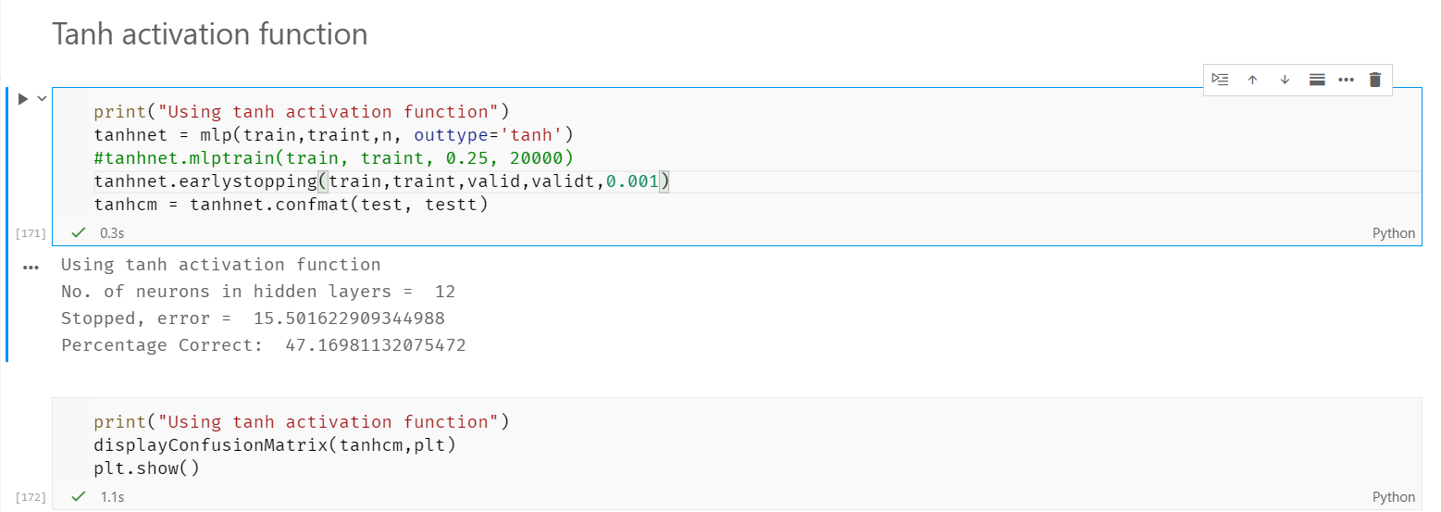

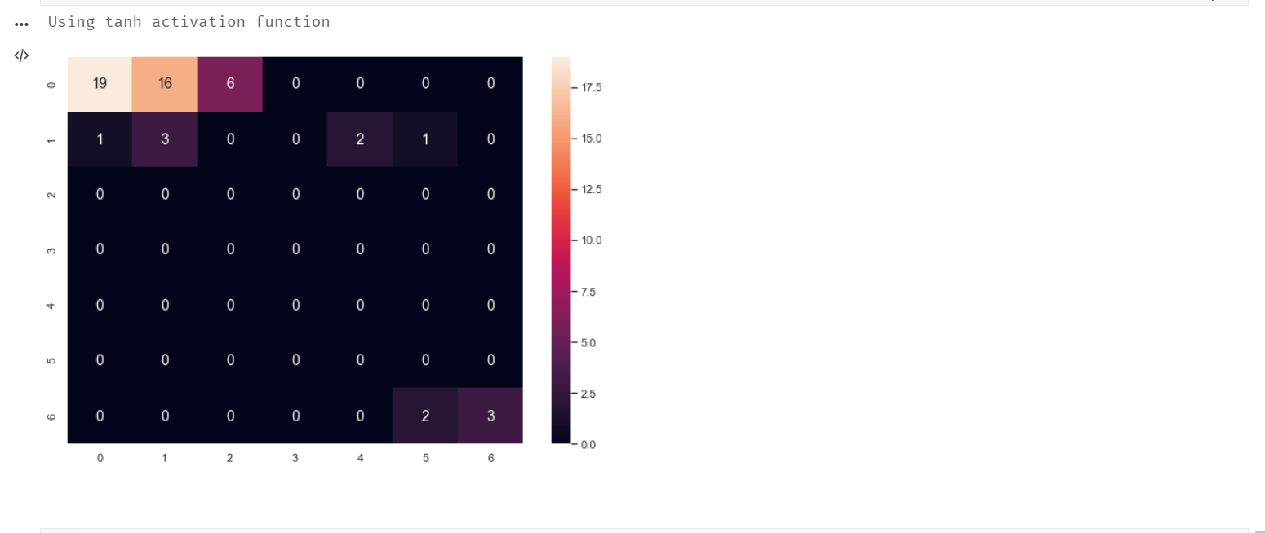

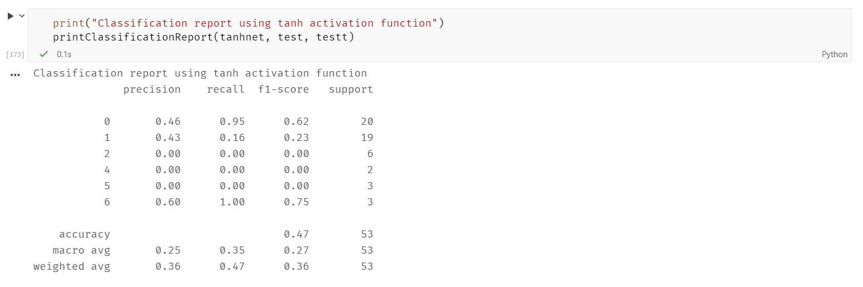

As we can see, all the activation functions worked poorly, but Sigmoid gave the best results amongst all. Using example of more data and perhaps more number of layers, could have significantly improved the accuracy.