# 2019103555 PRANAVA RAMAN B M S 01/11/2021

# LAB - 09 - EXECUTION - NAIVE BAYES AND KNN

# NAIVE BAYES ALGORITHM

# CODE:-

# 

# 

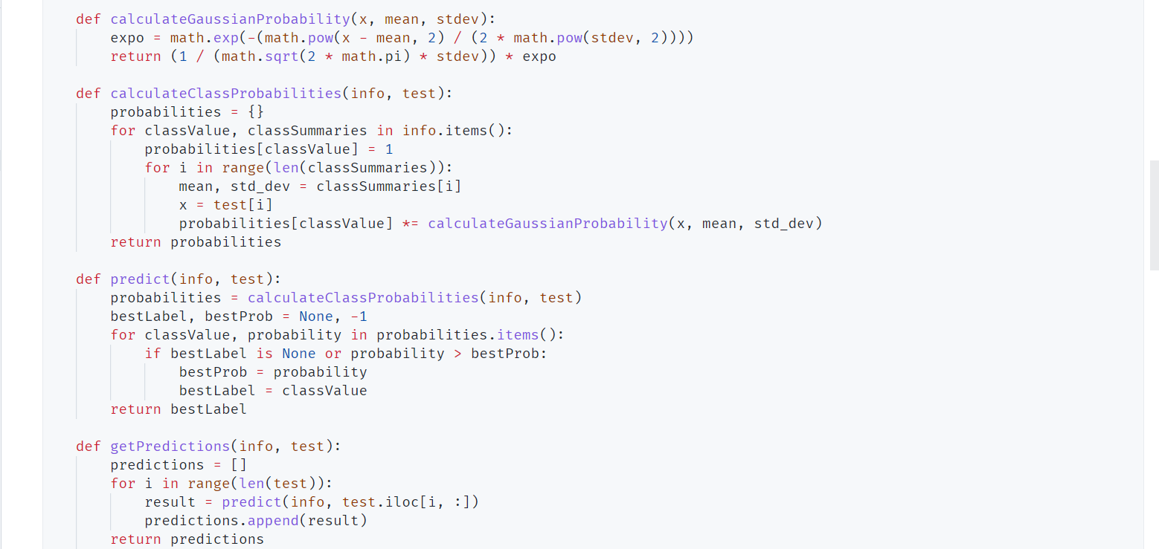

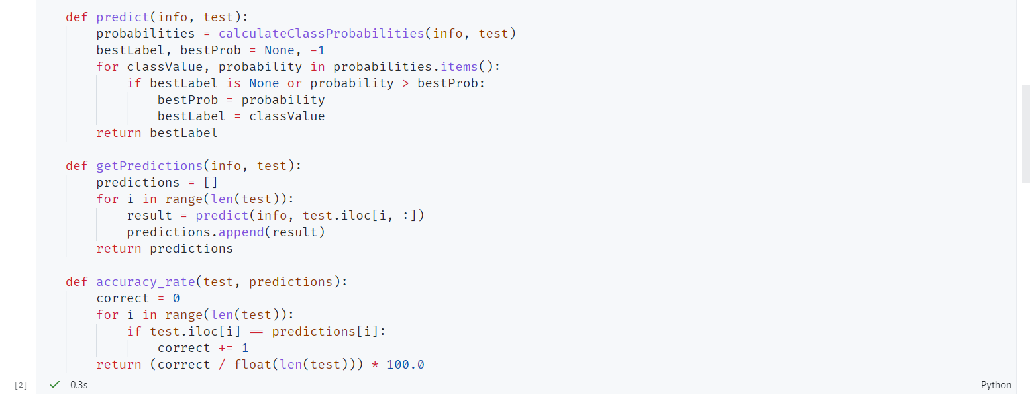

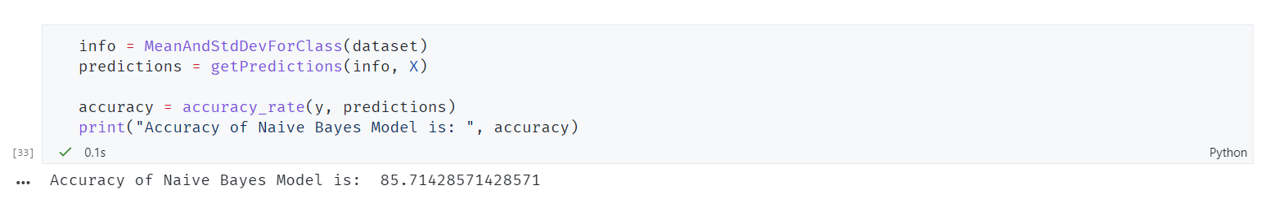

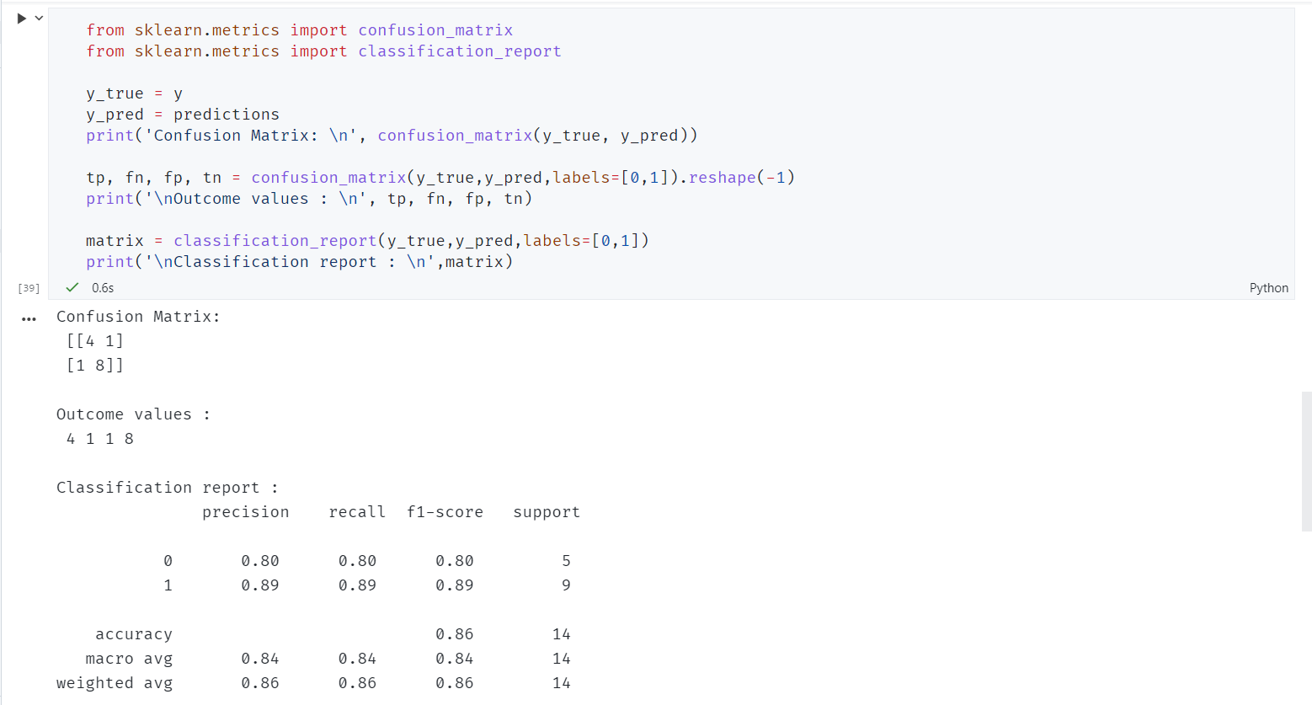

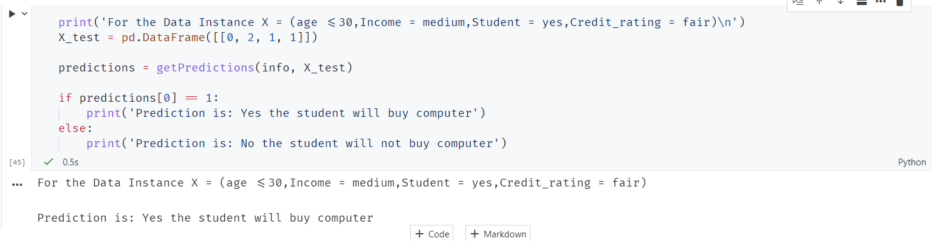

1. KNN - CLASSIFIER

