# 2019103555 PRANAVA RAMAN B M S 01/11/2021

# LAB - 09 - SPOT - NAIVE BAYES AND KNN

# NAIVE BAYES ALGORITHM

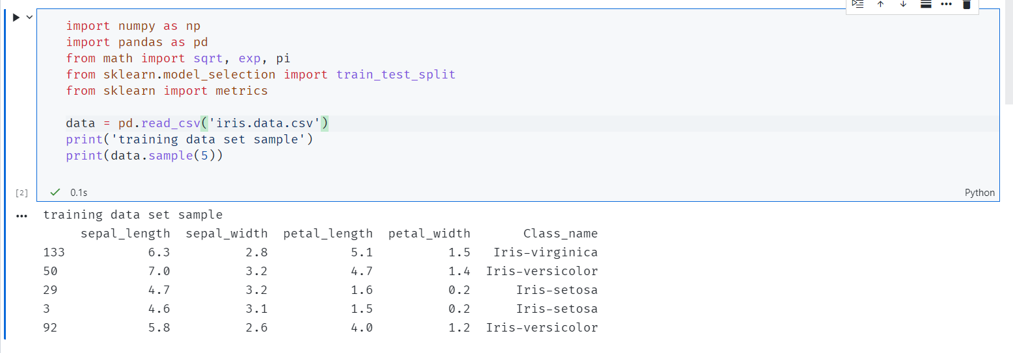

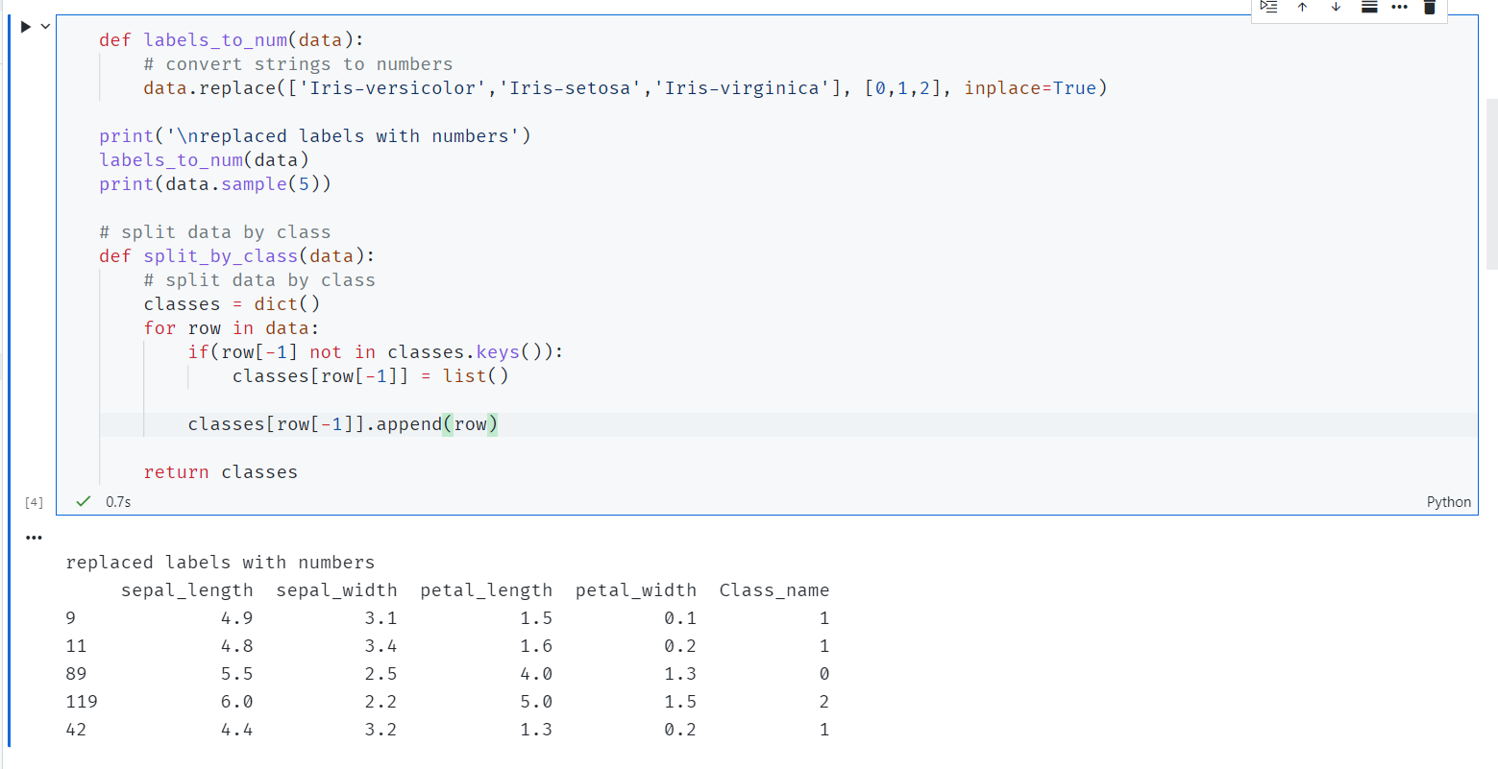

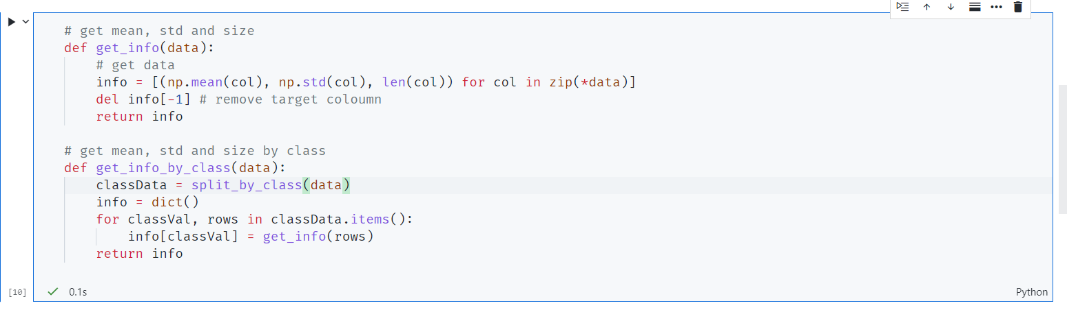

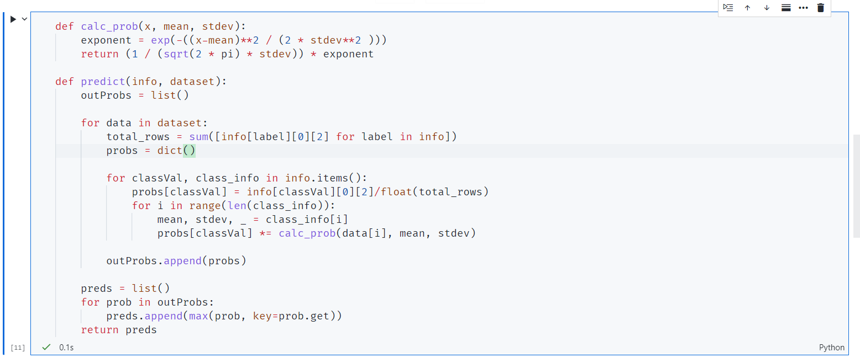

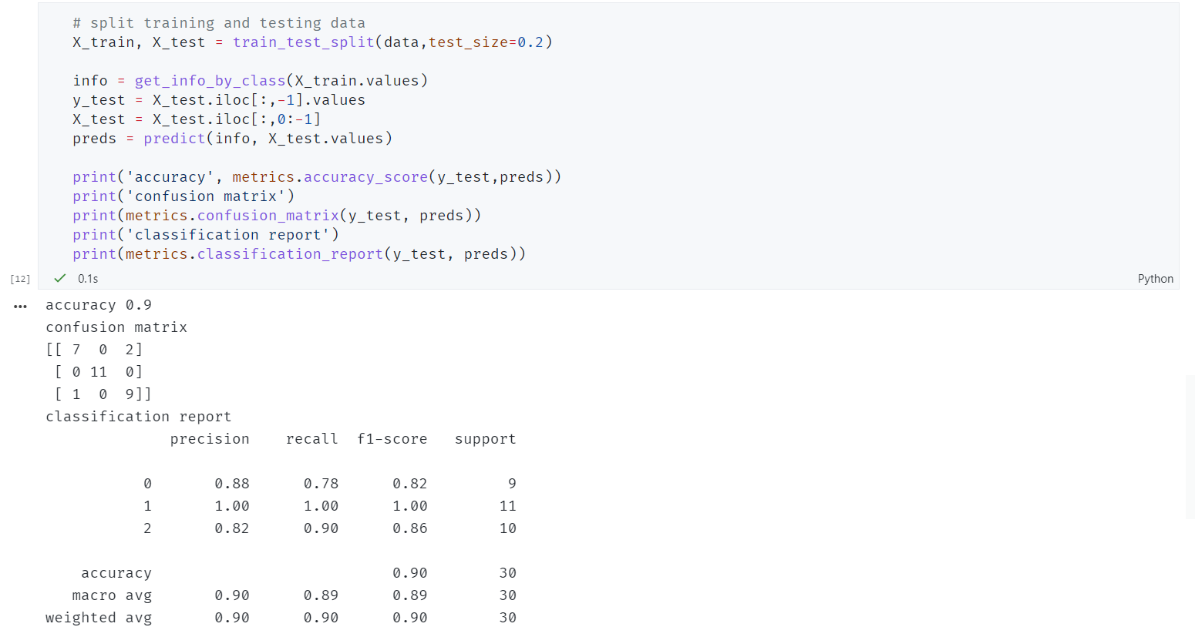

1. KNN CLASSIFIER

