Ben Simpson

CS5402

Homework 1

Task 1

1. Discrete, ordinal
2. Continuous, ratio
3. Discrete, ratio
4. Discrete, nominal
5. Continuous, ratio
6. Discrete, ordinal
7. Continuous, interval

Task 2

1. Euclidean distance would be better to use for grouping the boxes based on length to width ratio. This is because the square root of the squared difference of length and width values (the definition of Euclidean distance applied to this case) would always result in 0 if the box was square, yet would be greater as the ratio of length to the width (or vice-versa) increased.
2. Correlation

Task 3

1. Passenger ID, ticket class, sex, name, age, number of siblings and spouses, number of parents and children, ticket number, fare cost, cabin number, port of embarkation
2. Sex, name, cabin number, port of embarkation, passenger ID, ticket class
3. Age, number of siblings and spouses, number of parents and children, fare cost
4. Ticket number
5. Age, cabin number

|  |  |
| --- | --- |
| Passenger ID | Integer |
| Ticket class | Integer |
| Sex | String |
| Name | String |
| Age | Decimal |
| # siblings and spouses | Integer |
| # of parents and children | Integer |
| Ticket number | String |
| Fare cost | Decimal |
| Cabin number | string |
| Port of embarkation | string |

1. 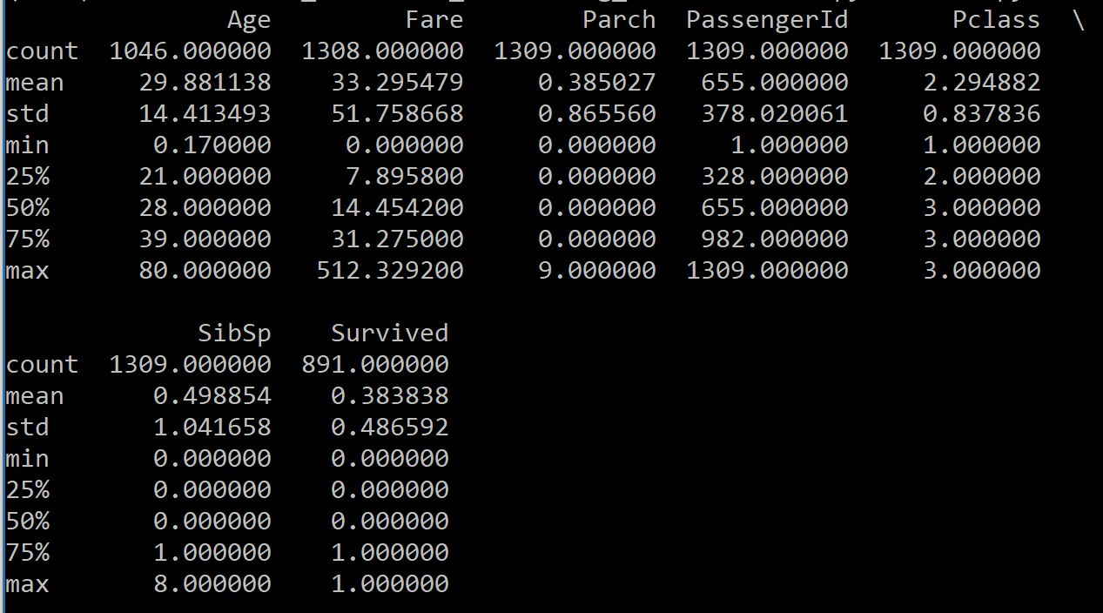
2. 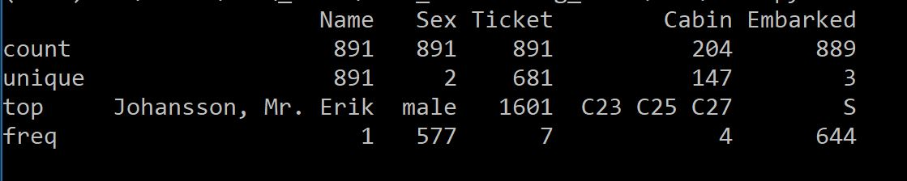
3. 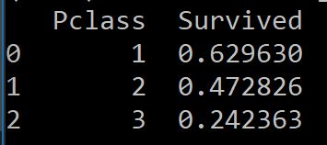  
     
   The correlation between Pclass 1 and survival rate is < 50%, so I will not include it in the predictive model.
4. 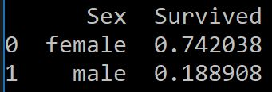  
     
   Yes, women are more likely to have survived.
   1. Relatively, yes they did. They had the highest survival rate of anyone under 15.
   2. Yes
   3. Yes
   4. Yes
   5. Yes
5. 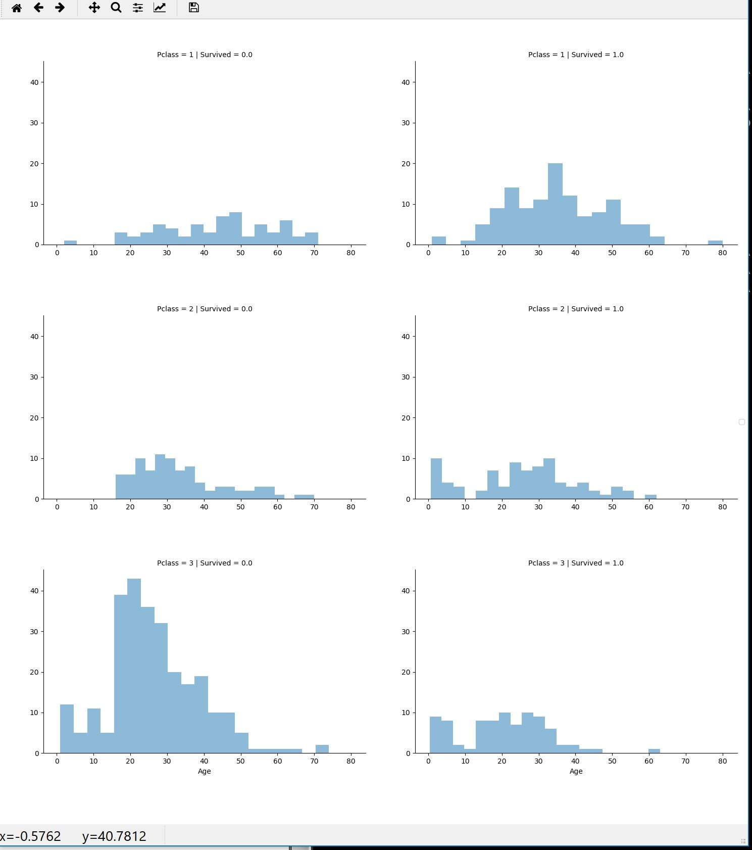
   1. Yes, Pclass = 3 had the most passengers and most did not survive.
   2. All infants survived in Pclass = 2. However, about the survival rate in Pclass = 3 was only about ~50%.
   3. Yes.
   4. Yes. Pclass = 1 seems to have mostly middle aged people, whereas the others tend to have slightly younger people.
   5. Yes.
6. 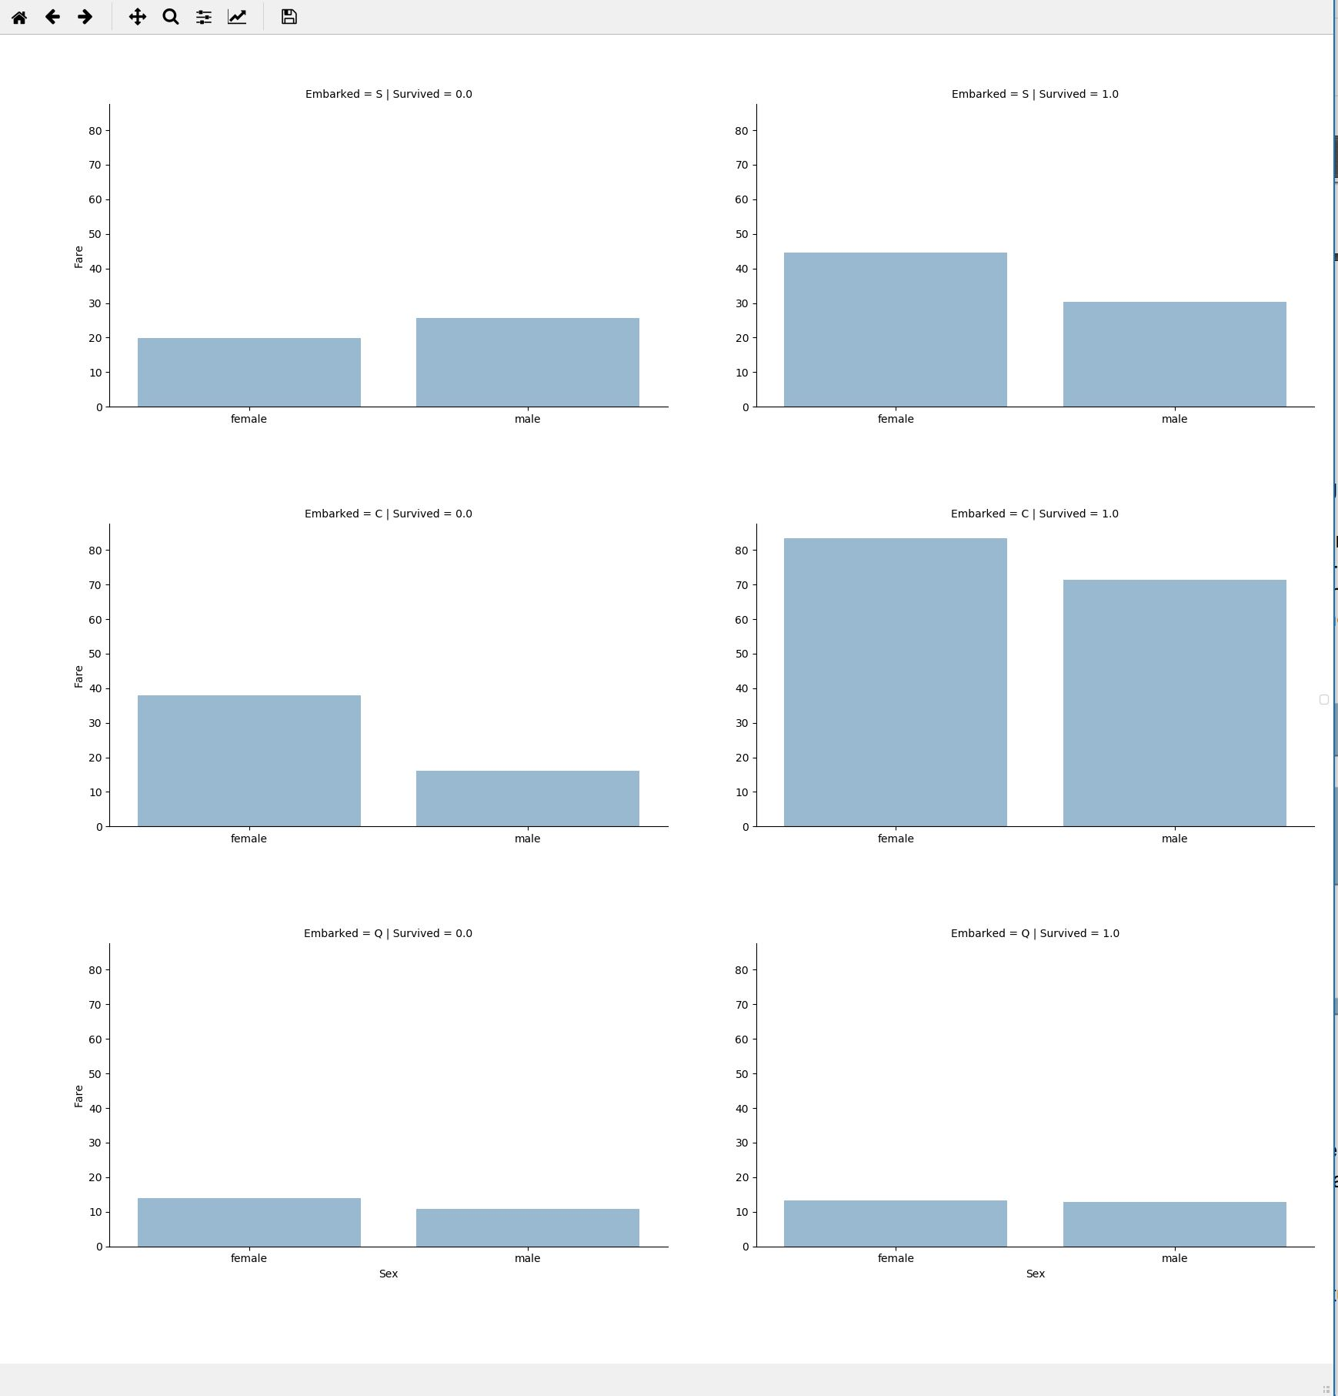
   1. For Embarked = {S, C}, yes they do. For Embarked = Q, no they do not.
   2. Yes, point of embarkation correlates to survival rates.