1. <https://quarry.wmflabs.org/query/786>

**USE plwiki_p;**

**SELECT log_title, COUNT(*)**

**FROM logging**

**WHERE log_type="thanks"**

**GROUP BY log_title**

**ORDER BY COUNT(*) DESC**

**LIMIT 600;**

User The_Polish is trying to find the top 600 users that are the most ‘Thanked’ users. So from Polish wiki database “plwiki_p”, the table log_title is selected along with COUNT(*). They are grouped by the field log_title. This ensures the usernames are displayed because log_title contains the logged username. The WHERE clause contains field value “thanks” on the field log_type and grouped by log_title. This retrieves entries from “logging” table that have log_type as “thanks” grouped by title (log_title) and ordered in the descending order of COUNT(*). LIMIT 600 ensures that only 600 entries are fetched.

2. <https://quarry.wmflabs.org/query/786>

**USE plwiki_p;**

**SELECT user_name, MAX(rev_timestamp) AS latest_edit**

**FROM user**

**join user_groups**

**on user_id = ug_user**

**join revision**

**on user_id = rev_user**

**where ug_group = 'sysop'**

**group by user_name;**

The user The_Polish is trying to find the Administrators by the latest performed edit (at the time the query is run). So from the database plwiki_p the fields user_name and the Maximum value of rev_timestamp labeled as latest_edit is selected. The MAX(rev_timestamp) ensures that biggest timestamp value i.e. the latest is selected. The tables selected are “user’ “user_groups” and “revision”. They are connected by JOINS connecting the user IDs where ug_group = ‘sysop’ which presumably is for system operations.

3. <https://quarry.wmflabs.org/query/13312>

**USE hewiki_p;**

**SELECT rc_title as Title, count(*) as Edits**

**FROM recentchanges**

**GROUP BY 1 ORDER BY 2 DESC**

**LIMIT 100;**

This is a query on the Hebrew wiki database. This query tries to get the list of titles with the highest number of recent edits. So rc_title and COUNT(*) is selected from the table “recentchanges” and grouped by rc_title and ordered in descending order by the COUNT(*). Only the top 100 entries are selected.

4. <https://quarry.wmflabs.org/query/13314>

**use hewiki_p;**

**SELECT**

**log_comment,**

**COUNT(log_id)**

**FROM logging**

**WHERE log_type = 'delete'**

**AND log_action = 'delete'**

**GROUP BY log_comment**

**ORDER BY COUNT(log_id) DESC**

**LIMIT 100;**

This is a query to find the most common deletion summaries by the user [אבנר](https://quarry.wmflabs.org/%D7%90%D7%91%D7%A0%D7%A8). The database is the same - hewiki_p. log_comment and COUNT(log_id) is selected from the table logging. This gets the log_comment i.e. the comment that was made and the count of the Log_id field. Where clause specifies only the ‘delete’ log type and action is selected and the results are grouped by the comments and in the descending order by COUNT(log_id). 100 entries are displayed.

5. <https://quarry.wmflabs.org/query/12906>

**use lvwiki_p;**

**Select page_title**

**from page where page_namespace=0**

This query by the users Edgars2007 is probably to find out all lvwiki namespace=0 titles in the Latvian Wikipedia database. It just selects page_title field from the table page where the page_namespace is 0. Namespace = 0 corresponds to the Main Article

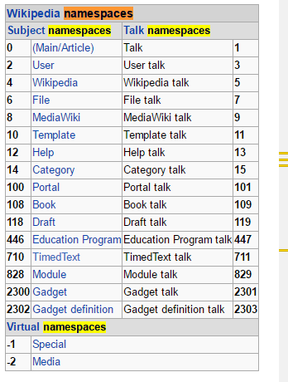

6. <https://quarry.wmflabs.org/query/4254>

**use lvwiki_p;**

**Select p.page_title, pl.pl_from, pl.pl_title**

**from pagelinks pl, page p**

**where pl.pl_from=p.page_id and pl.pl_title Like "%(%" and pl.pl_title Not Like "%(%)%"**

**and p.page_namespace=0**

The user Edgars2007 wants to find the pages in lvwiki_p database that have the titles starting with “ ( “ but do not have the closing parenthesis.

Word Count: 511