SOLSA HIMIP (Hyperspectral Image Manipulation, Interpretation and Processing) Software

User Manual (Version 1.5)

Thanh Bui, 19/09/2019

Eramet Group, France

Contents

1. Introduction 2

2. Reflectance and hull removal computation 3

3. Spectral manipulation 5

3.1. Open data, change spectral bands and adjust the intensities 5

3.2. Spectral manipulation 6

3.3. Spectral library generation 7

4. Hyperspectral unmixing 8

4.1. A typical unmixing process 9

4.2. Apply unmixing processing with a specific spectral library 12

5. Data registration 13

References 15

# Introduction

HIMIP (Hyperspectral Image Manipulation, Interpretation and Processing) is the software that has been developed for manipulating, interpreting and processing hyperspectral images for mineralogical analysis of drill cores. The main functionalities of HIMIP include: reflectance computation, hull correction computation, spectra manipulation, spectral library management, hyperspectral image registration and sparse hyperspectral unmixing associated with superpixel algorithms.

HIMIP implements a graphic user interface (GUI) to facilitate its use as presented in Figure 1.

Reflectance and hull removal computation

Hyperspectral data manipulation

Hyperspectral unmixing

Data registration

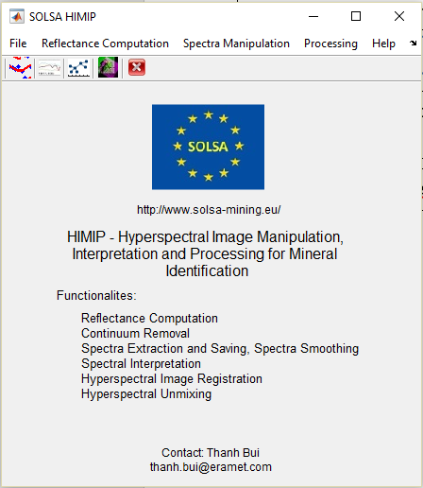

Figure 1. The main GUI of Solsa HIMIP

The GUI of HIMIP allows accessing to the following interfaces:

* Reflectance and hull removal computation
* Hyperspectral data manipulation
* Hyperspectral unmixing for mineral identification
* Data registration

The following sections briefly present the way to use those interfaces.

# Reflectance and hull removal computation

The acquired data consist of sample data, white and dark references. In order to obtain exploitable data, the reflectance needs to be computed from those data using the ‘Reflectance and Hull Removal Computation’ interface as Figure 3.

For reflectance computation, users have two modes: automatic selection and manual selection. In the automatic selection, users just need to select the path containing acquired data, and then specify the reflectance file name. The acquired data consist of sample, white and dark references. The reflectance file name should be similar to sample file name with an addition of _refl. For example, **if the sample file name is bauxite.raw, the white and dark reference file names must be WHITEREF_bauxite.raw and DARKREF_bauxite.raw,** **and** **the reflectance file name should be bauxite_refl.raw.** Finally, the computation will proceed by clicking “Execute” button. Users can see the status of the computation process by looking the bottom of the interface: if there is no computation in progress it shows “Free”, otherwise “Busy”. Figure 2 shows a typical data filename structure within a data folder, note that the *_reflCR.raw file contains hull removal data that will be computed using the guidance later.

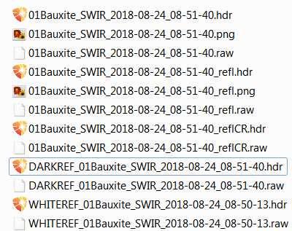

Figure 2. A typical data filename structure in the data folder

In the manual selection, users need to select appropriate sample, white and dark reference file names as well as specifying the reflectance file name. Similarly, the reflectance file name should be similar **sample file name with an addition of _refl.**

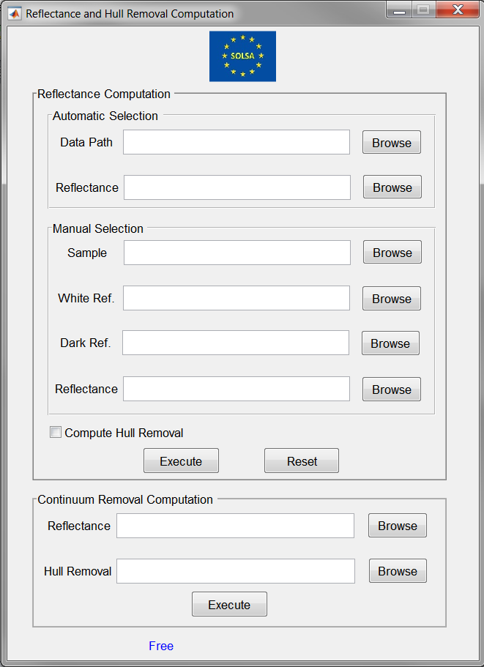

Figure 3. Interface for computing reflectance and hull correction

The users can check the checkbox named “Compute Hull Removal” to compute also the hull removal for the whole hyperspectral image. During hull removal computation, users can see a window showing the computation progress as in Figure 4. **Note that, hull removal computation takes time, especially for large hyperspectral images, therefore, if only reflectance data is needed, don’t check this checkbox.**

The ‘Reset’ button allows clearing all selected paths or file names to start a new selection.

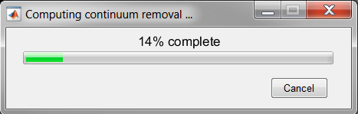

Figure 4. The window showing progress of hull removal computation, user can click cancel to discard the computation.

In case the reflectance data exist, users can compute corresponding hull removal data using the “Continuum Removal Computation” section at the bottom part of the interface in Figure 3.

# Spectral manipulation

The interface for manipulating spectra is shown in Figure 5.

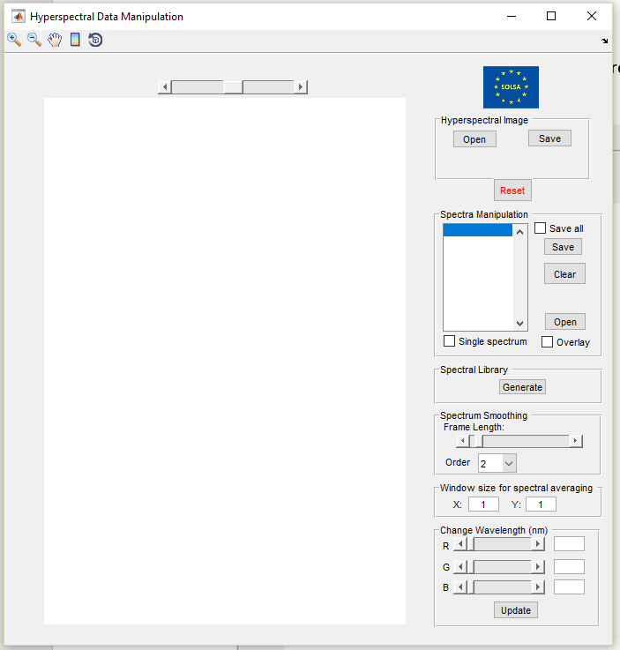

Figure 5. The interface for manipulating the hyperspectral data

## Open data, change spectral bands and adjust the intensities

In the “Hyperspectral Image” section of the interface, users can open hyperspectral image reflectance by clicking “Open” button. Click “Save” to save the false color image that is shown. The false color image is the concatenation of the data from three spectral bands (wavelengths). Therefore, in the “Change Wavelength (nm)” section, users can change the wavelengths of three bands (R, G, B) to obtain expected image. Furthermore, the slider on top of the image allows adjusting the intensity of the image.

## Spectral manipulation

Users can click on a location of the image to display reflectance spectrum at this location. The legend of the reflectance showing its position in the hyperspectral image is shown in the list box in the “Spectral Manipulation” section. The list will be appended if the users click several times on different locations of the hyperspectral image. Users can select spectra in the list box and save them by clicking “Save” button. In addition, if the “Save All” checkbox is ticked, all spectra in the list box will be saved when “Save” button is clicked. The “Open” button enables opening existing spectra that could come from spectral library. The opening spectrum will be displayed on the current figure or new figure by checking or unchecked the “Overlay” checkbox.

On the figure showing the spectrum, the wavelength position and intensity of each peak can be obtained by dragging the mouse to the peak.

If the reflectance is too noisy, users can filter the noise and smooth the spectrum using Savitzky-Golay filter by selecting appropriate frame lengths and order in the “Spectrum Smoothing” section.

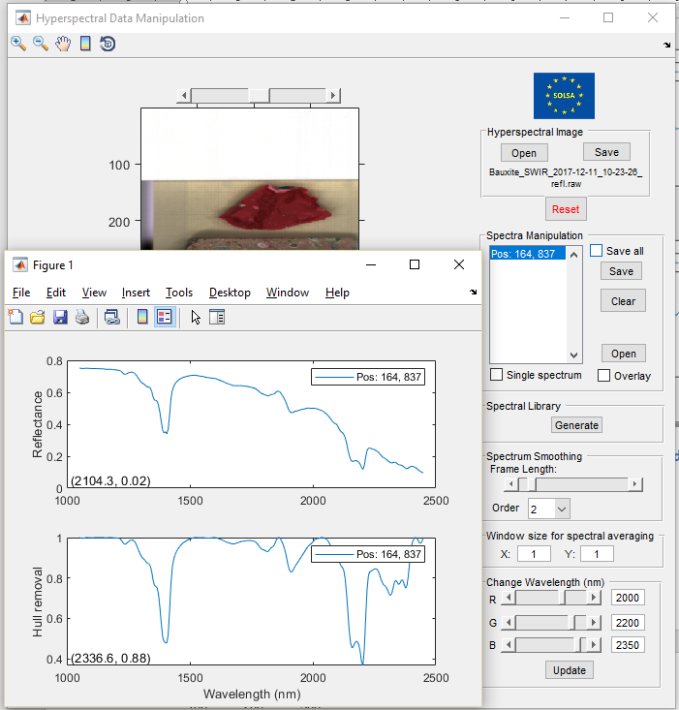

Figure 6. The window shows the reflectance, its hull correction and associated wavelength and intensity when pointing to each peak.

## Spectral library generation

Users can add new spectrum to the existing spectral library and generate a new spectral library. Each spectral file contains one spectrum followed the ENVI format. The name of the file should be mineralname_indexnumber.txt. For example, if there are three kaolinite spectra extracted, users should name: kaolinite_1.txt, kaolinite_2.txt, kaolinite_3.txt. The new spectral library can be loaded in the spectral unmixing process.

In order to generate the library, users can click “Generate” button in the “Spectral Library” section, then select the folder containing spectral files as shown in Figure 7. Subsequently, users specified the name of the library, laterite_lib.mat for examples. After the spectral library is generated successfully, the image of the spectral library will be displayed as in Figure 8. **Note that the spectral library file (i.e., laterite_lib.mat) must be stored outside the folder containing spectral files.**

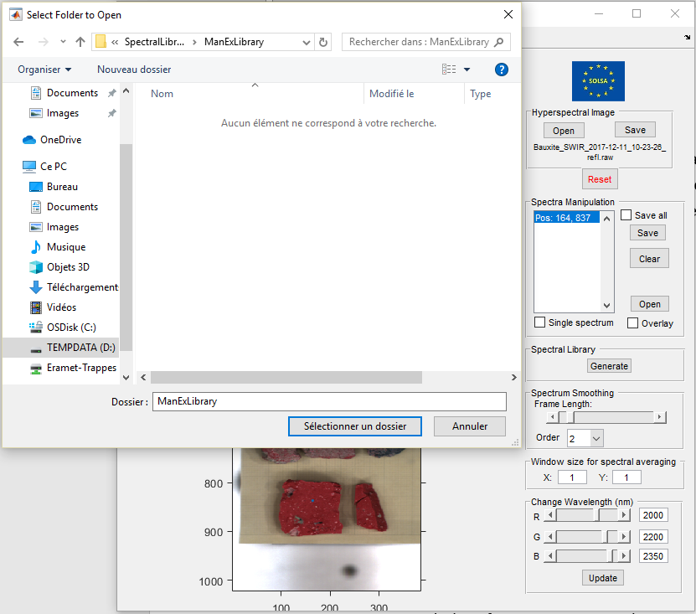

Figure 7. Generate spectral library from spectral files contained in a folder.

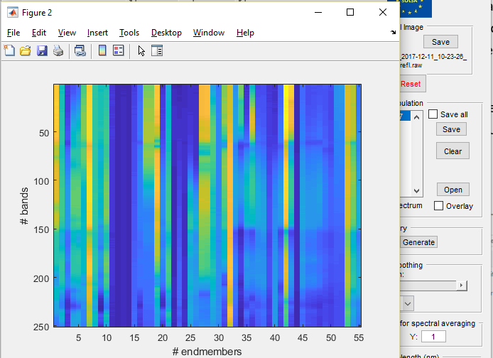

Figure 8. Spectral library image

# Hyperspectral unmixing

For automatic mineral identification, HIMIP implements three sparse unmixing techniques including full constrained least squares (FCLS), sparse unmixing by variable splitting and augmented Lagrangian (SUnSAL), and collaborative sparse unmixing by variable splitting (CLSUnSAL) [1], [2] with the incorporation of the under extension spectral library [3], [4]. The interface for doing unmixing is shown in Figure 7. The novelty of the software lies in its incorporation of spatial information using superpixel algorithms into sparse unmixing techniques, which significantly improves its accuracy and efficiency. In addition to applying unmixing computation on reflectance data, HIMIP implements the unmixing computation on two other kinds of data including logarithm of reflectance and continuum removal. The software also provides users necessary tools to explore the unmixing results. The technical details of HIMIP can be found in [5]

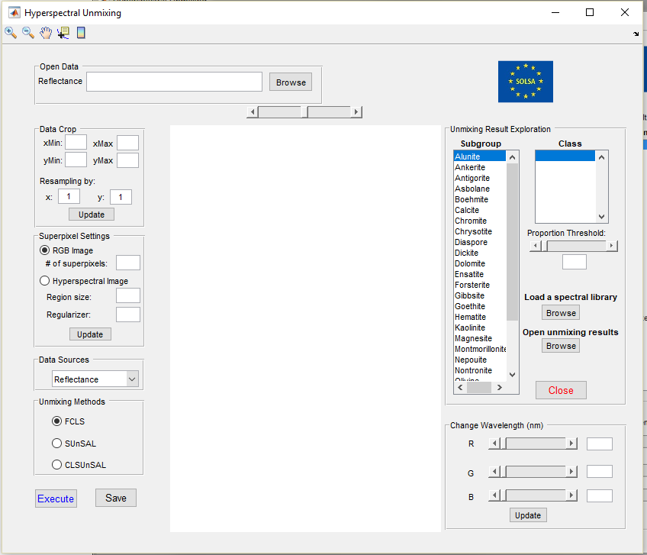

Figure 9. The interface for hyperspectral unmixing

## A typical unmixing process

The unmixing process consists of following steps:

**Step 1:** Click “Browse” button and select appropriate reflectance data file to open a hyperspectral image as Figure 10. Note that the x and y axes of the image are displayed in pixels, facilitating applying data cropping step afterward.

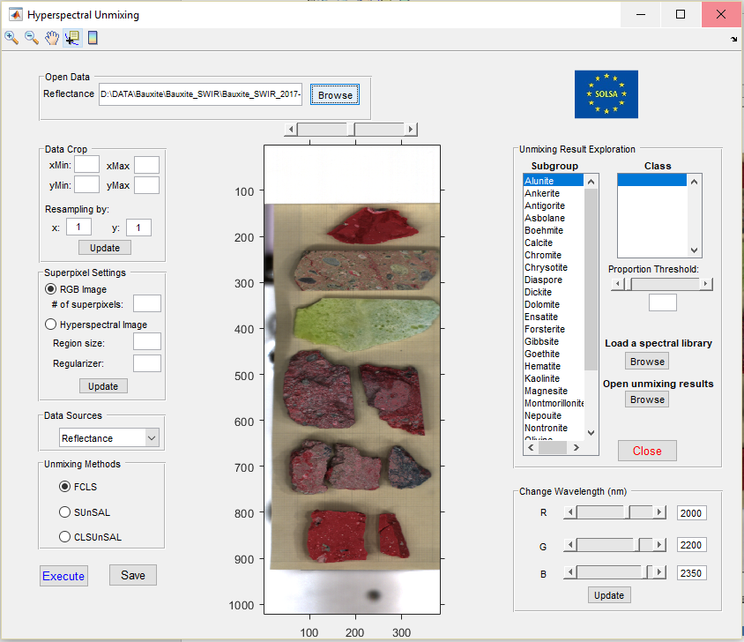

Figure 10. The interface with the display of a hyperspectral image

**Step 2:** To speed up the computation process, it is necessary to limit the unmixing process to the samples (not the holding plate) and apply down sampling the data. The “Data Crop” section makes this possible. Fill in the information as Figure 11 and then click “Update” to apply the settings. An image will be displayed to enable users to check whether the settings are correct or not. If not, change the filled information and click “Update” again.

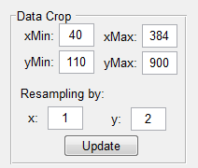 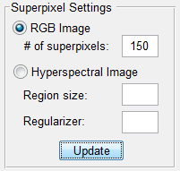

Figure 11. Apply data cropping and resampling (left) as well as superpixel detection.

**Step 3:** In the “Superpixel Settings” section, select “RGB Image”, and fill the number of superpixels is 150 as Figure 11, then click “Update” to apply the superpixel computation.

**Step 4:** Select data sources that will be applied unmixing process, three kinds of data sources exist: reflectance, log of reflectance and continuum removal data. Let select reflectance.

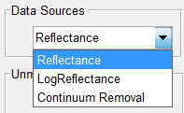

Figure 12. Data source selection

**Step 5:** Select one of the three existing unmixing methods: FCLS, SUnSAL, CLSUnSAL. Let select CLSUnSAL and then click “Execute” button to apply unmixing computation. A window indicates the progress of the unmixing process will be displayed as Figure 13.

**Step 6:** After the unmixing process finished, users can save the unmixing results for later use by clicking the “Save” button next to the “Execute” button. The unmixing result contain the estimated proportion of each minerals and associated spectral library.

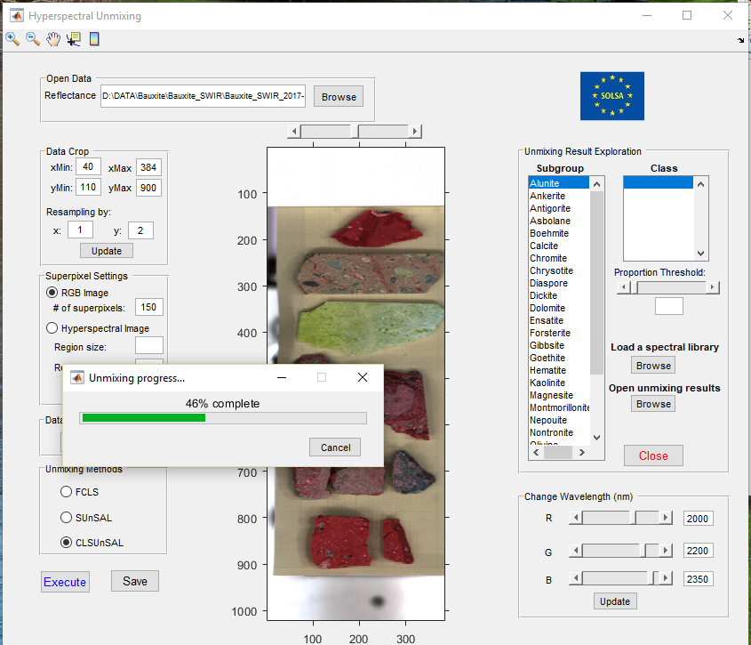

Figure 13. Unmixing process is ongoing, currently 20% complete.

**Step 7:** The “Unmixing Result Exploration” section allows exploring the unmixing results by displaying the proportion of each minerals present in the samples. Users can select appropriate minerals that they want to examine in the samples in the “Subgroup Names” list box. Note that in the spectral library, each mineral in the subgroup may contain more than one spectrum extracted from different reference samples; the “Class Names” list box displays the names of the spectra constituting a Subgroup Name. Users can select the spectra names in the “Class Names” list box to display their proportion.

By holding Control key, users can select several minerals from the list box as Figure 14. The root mean squared error (RMSE) of the unmixing process is also displayed to allow evaluating the accuracy of the unmixing results. For example, in Figure 14, the calcite which is detected on the top of the image is not correct because the RMSE is very high on this part of the image.

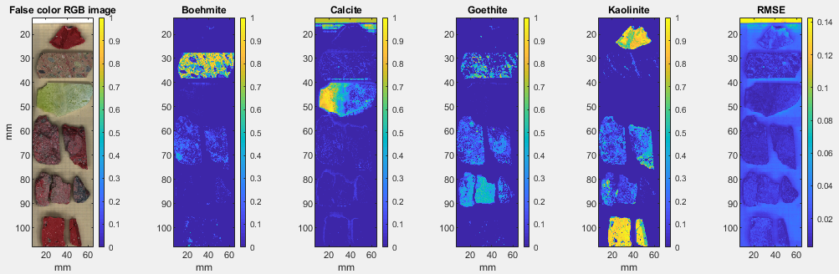

Figure 14. Proportions of boehmite, calcite, goethite and kaolinite next to the false color image of the samples. Note that as indicated by the color bar, the more yellow, the higher the proportion. The right image displayed the root mean squared error of the unmixing process.

**Step 8:** Users can explore the hyperspectral unmixing results that were saved by clicking “Browse” button in the “Open unmixing results” label and selecting appropriate unmixing result that was saved.

## Apply unmixing processing with a specific spectral library

Each type of ores may need a specific spectral library containing an appropriate set of minerals. Users can load a specific spectral library that has been built using the Spectral Manipulation interface of HIMIP, then applying the unmixing processing using the loaded spectral library. For example, users can load a small spectral library for bauxite as shown in Figure 15.

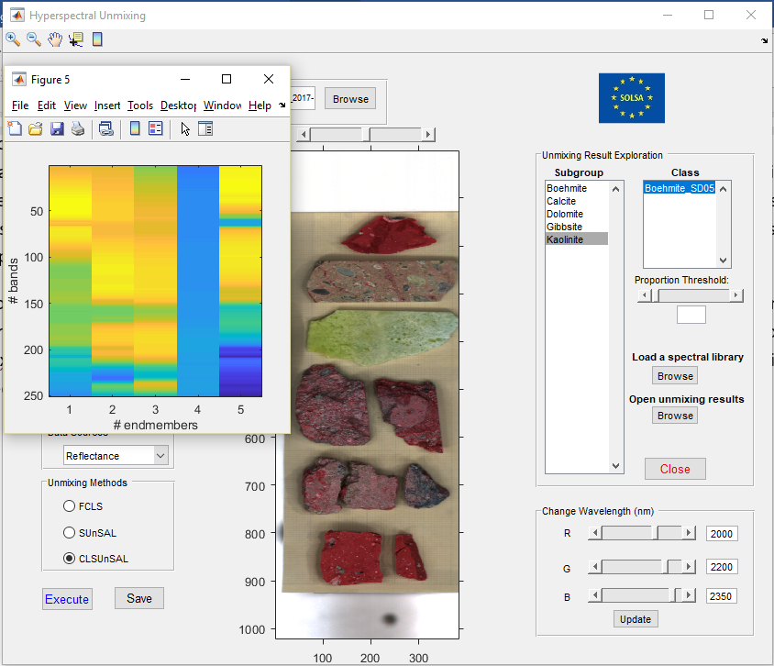

Figure 15. Load a specific spectral library for applying unmixing

# Data registration

As our analytical system consists of several sensors with different angles of view and resolutions, HIMIP implements a registration technique based on control points with different geometric transformations for registering VNIR and SWIR hyperspectral data. The software enables using existing control points, loading specific control points or selecting new control points. Different kinds of transformation can be selected to account for translation, rotation, scaling, local distortion.

If users apply registration process on hyperspectral images (i.e., VNIR and SWIR), the software allows to save the fused hyperspectral images by checking the “Fused data” check box in the “Save registered or fused data” section before clicking the “Save” button.

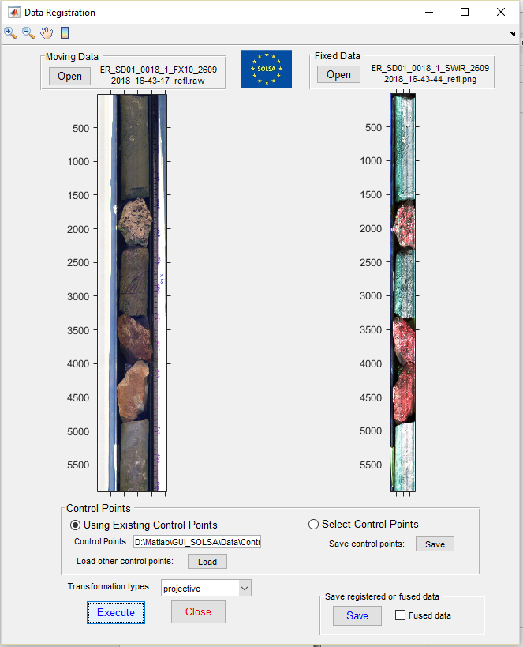

Figure 16. The interface for doing data registration. The moving (unregistered) data are registered to the fixed data. Note that the angle of view of the camera to obtain the fixed data is narrower than that of the moving data.

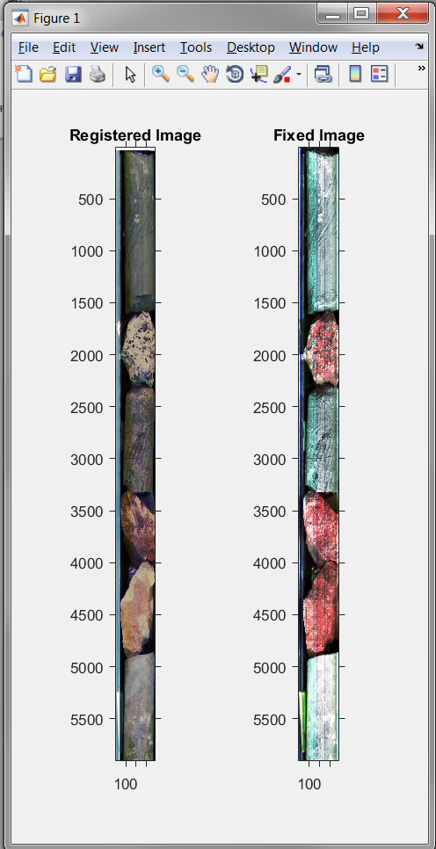

Figure 17. Display the registered data and the fixed data.

Furthermore, we have been developing other registration method based geometry-optic models to register all different kinds of data in our system. The integration of this method and the fusion of registered data are ongoing.

# References

[1] J. M. Bioucas-Dias and M. A. T. Figueiredo, “Alternating direction algorithms for constrained sparse regression: Application to hyperspectral unmixing,” *2nd Workshop Hyperspectral Image Signal Process. Evol. Remote Sens. Whisp. 2010 - Workshop Program*, 2010.

[2] M. Iordache, J. M. Bioucas-dias, and A. Plaza, “Collaborative Sparse Regression for Hyperspectral Unmixing,” *IEEE Trans. Geosci. Remote Sens.*, vol. 52, no. 1, pp. 1–14, 2014.

[3] T. Bui *et al.*, “Building a Hyperspectral Library and its Incorporation into Sparse Unmixing for Mineral Identification,” in *IGARSS 2018-2018 IEEE International Geoscience and Remote Sensing Symposium*, 2018, pp. 4261–4264.

[4] T. Bui *et al.*, “Mineral identification using a new hyperspectral library and sparse unmixing techniques,” in *EGU General Assembly Conference Abstracts*, 2018, vol. 20, p. 18279.

[5] T. Bui, T. Lefevre, B. Orberger, and M. Le Guen, “Sparse hyperspectral unmixing associated with slic superpixels in SOLSA HIMIP – The software for hyperspectral image manipulation, interpretation and processing,” presented at the 10th Workshop on Hyperspectral Image and Signal Processing: Evolution in Remote Sensing, Amsterdam, the Netherlands, 2019.