Date: 5/10/20

ORD:

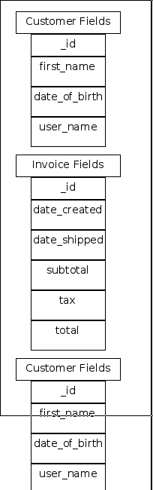

NOSQL Data Diagram:

