Article 1: Ivan Perez’s Full-Stack Portfolio: <https://github.com/Belzee10/personal-portfolio>.

The first portofolio project I reviewed was Ivan Perez Abreu's Portfolio. Here is a screen shot of the index.html file. 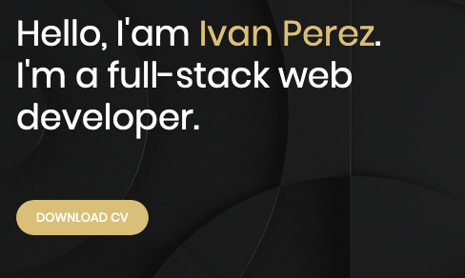After clicking on “Download CV” it brought me to his resume which looks like this: 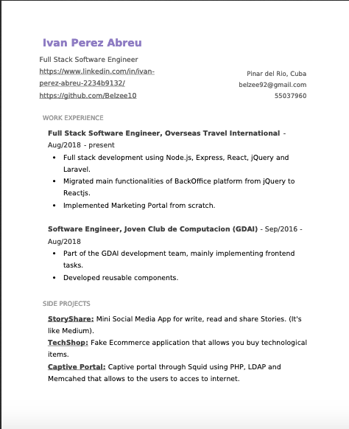. I think it’s a pretty good resume which shows a lot of his side-projects and work experience. I think I would like to implement a similar type of onclick method that would refer the user to my resume. It looks like from the Github page for this portfolio that he uses angular as the front-end framework. Overall I really liked this portfolio and I think I would like to implement a similar type of onclick-view-resume.

Article 2: Aashish Chakravarty’s Personal Portfolio: <https://github.com/AashishChakravarty/personal-portfolio>.

Again for this portfolio they used Angular. I found it interesting that in their profile.component.html file they have a bunch of components; similar to React in how one can make their own components. Then the main file is composed of all the components together; in one place. I understand the portfolio project is to be done with vanilla javascript; though I found it interesting that React so closely represents Angular in this way.

Article 3: mafutomo’s Personal-Portfolio-Website: https://github.com/mafutomo/Personal-Portfolio-Website

I was impressed by this portfolio just based upon the person’s skill section. I have included the screenshot here: 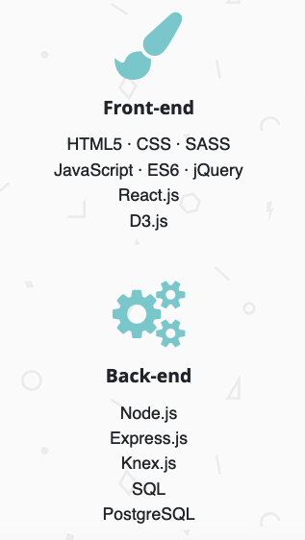 It seems she included her front-end and back-end skills including node.js and such. I would like to implement a similar section though I understand the personal project is only to reflect the work we’ve done in class so far. Overall I liked it and am considering implementing a similar type of layout!