Project 5: Multi-layer Perceptron
Artificial Intelligence
Bibhash Mulmi

Goal: To improve the accuracy of a multi-layer neural network.

Procedures:
Experiment 1: Change the learning rate hyperparameter with the following hyperparameters as default,
minibatch size = 100
Number of hidden layer neurons = 100
Function used = sigmoid
Topology used = two-layer neural network
Observations:
The accuracy increased simultaneously with the value of learning rate, however the accuracy graph diverged. This showed that there was overfitting of data. By observing the graph, the value of learning rate was altered accordingly. Finally, the optimal learning rate corresponding to a converging graph was found to be 0.00011.

Learning rate constant | Train accuracy (%) | Valid accuracy (%) | Test accuracy (%) | Graph (Converging/Diverging)
0.0005 | 99.28 | 97.98 | 97.54 | Diverging
0.002 | 99.76 | 98.22 | 97.89 | Diverging
0.0035 | 99.63 | 98.18 | 97.92 | Diverging
0.0002 | 98.13 | 97.58 | 96.92 | Diverging
0.0001 | 99.67 | 98.10 | 97.86 | Diverging
0.00015 | 97.57 | 97.38 | 96.61 | Diverging
0.00013 | 97.31 | 97.22 | 96.38 | Converging
0.00011 | 96.92 | 97.08 | 96.24 | Converging
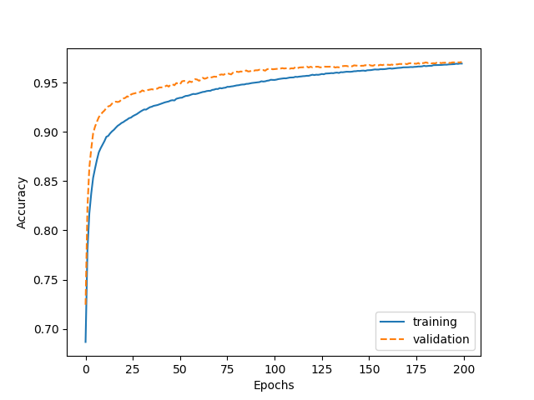
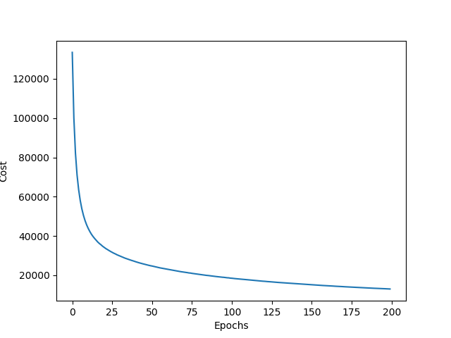
Conclusion: The accuracy of the network can be improved by changing the learning rate to 0.00011 which yields the optimal result.
Graph representing accuracy per epoch
Graph representing cost per epoch

Experiment 2: Changing the minibatch size with the following hyperparameters as default,
Learning rate = 0.00011
Number of hidden layer neurons = 100
Function used = sigmoid
Topology used = two-layer neural network
Observations:
The accuracy increased simultaneously with the increase in minibatch sizes. However, the accuracy started decreasing after one point. This point was determined as the local maxima in the graph. The optimal value of the minibatch size was found to be 3000.
Minibatch size | Train Accuracy (%) | Valid Accuracy (%) | Test Accuracy (%) | Graph (Converging/Diverging)
100 | 96.92 | 97.08 | 96.24 | Converging
50 | 96.79 | 97.04 | 96.18 | Converging
125 | 96.95 | 97.10 | 96.25 | Converging
150 | 96.95 | 97.08 | 96.26 | Converging
165 | 96.96 | 97.08 | 96.25 | Converging
700 | 97.02 | 97.06 | 96.33 | Converging
1400 | 97.05 | 97.00 | 96.26 | Converging
3000 | 96.97 | 97.10 | 96.38 | Converging
4500 | 96.84 | 96.92 | 96.12 | Converging
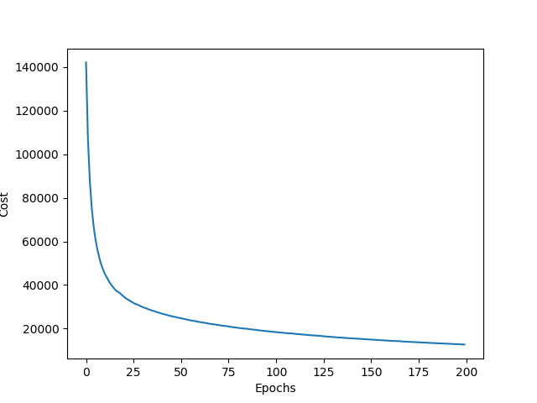
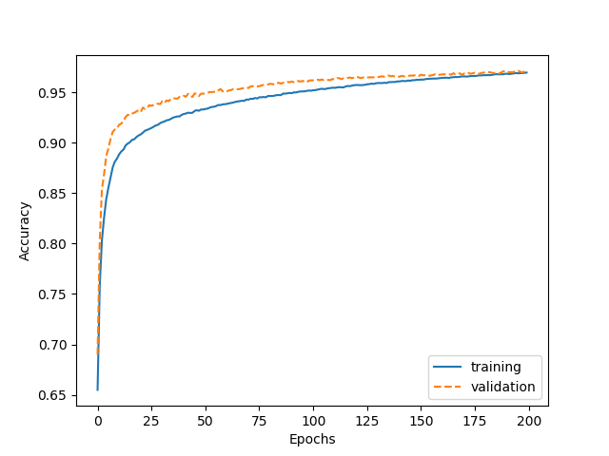
Conclusion: The accuracy of the network can be improved by increasing its value to 3000. Higher value than 3000 decreases the accuracy.
Graph representing cost per epoch
Graph representing accuracy per epoch
Experiment 3: Use tanh function with the following hyperparameters as default,
Number of hidden layer neurons = 100
Topology used = two-layer neural network
Observations:
The values for the learning rate and minibatch sizes were altered accordingly to get a converging graph by observing the accuracy graph. The optimal values for the learning rate and minibatch sizes, while using tanh function, were observed to be 0.0003 and 150 respectively.
The accuracy was less for the learning rate (0.00011) and minibatch size (3000) values that were optimal when using sigmoid function.
Additionally, the accuracy was observed to be highly fluctuating while using tanh function.
Learning Rate Constant | Minibatch Size | Train Accuracy (%) | Valid Accuracy (%) | Test Accuracy (%) | Graph observed
0.00011 | 150 | 94.25 | 95.60 | 93.75 | Diverging
0.0002 | 100 | 95.51 | 96.24 | 94.90 | Diverging
0.0004 | 100 | 96.18 | 96.36 | 95.34 | Converging with high fluctuation in accuracy
0.0004 | 150 | 95.76 | 96.32 | 94.74 | Diverging with fluctuation in accuracy
0.0003 | 150 | 95.53 | 95.56 | 94.50 | Converging with fluctuation in accuracy
0.00009 | 500 | 93.53 | 94.58 | 93.50 | Diverging
0.0003 | 500 | 92.54 | 93.62 | 92.16 | Converging with fluctuation in accuracy
0.00011 (optimal value for sigmoid) | 3000 (optimal value for sigmoid) | 87.49 | 90.36 | 88.17 | Extremely high fluctuating diverging graph
0.0001 | 3000 | 94.36 | 95.32 | 94.16 | Diverging
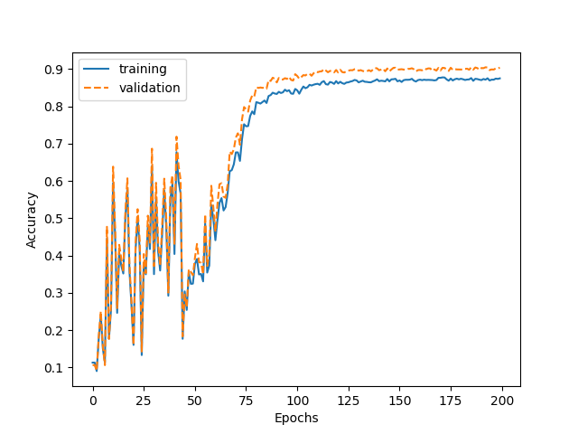
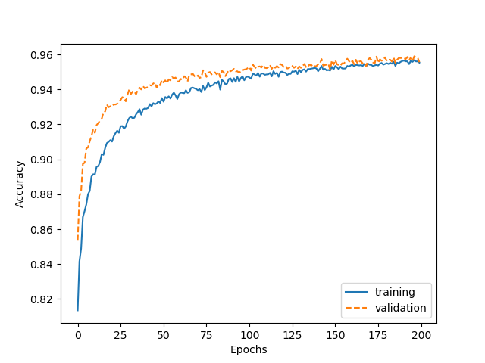
Conclusion: The accuracy does not improve when tanh function is used.
Graph representing accuracy per epoch using the optimal learning rate and minibatch size values of sigmoid function while using tanh function
Graph representing accuracy per epoch for the optimal values for learning rate and minibatch sizes using tanh function

Experiment 4: Change the number of hidden layer neurons with the following hyperparameters as default,
Learning rate constant = 0.00011
Topology used = two-layer neural network
Observations:
The accuracy increased with the increase of neurons in the hidden layer.
Number of neurons | Learning rate constant | Minibatch Size | Train accuracy (%) | Valid accuracy (%) | Test accuracy (%) | Graph observed
200 | 0.00011 | 500 | 97.67 | 97.66 | 98.87 | Converging
150 | 0.00011 | 500 | 97.45 | 97.42 | 96.75 | Converging
150 | 0.00011 | 500 | 97.45 | 97.42 | 96.75 | Converging
150 | 0.00011 | 300 | 97.43 | 97.44 | 96.72 | Converging
250 | 0.00011 | 3000 | 97.64 | 97.54 | 96.93 | Converging
1000 | 0.00011 | 500 | 99.96 | 99.90 | 98.17 | Converging
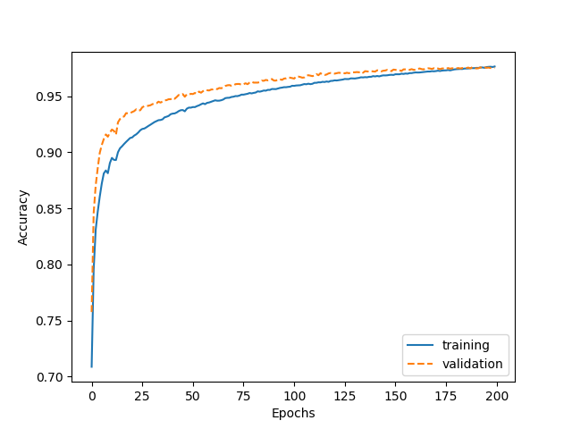
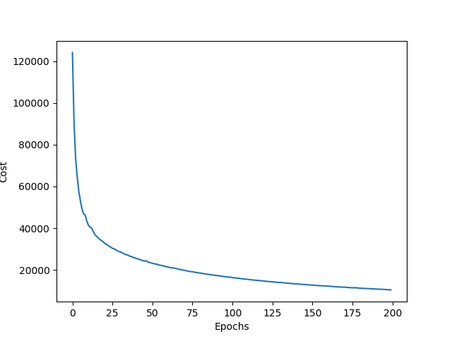
(*Note: The time taken to train the machine increased dramatically with the increase in number of neurons. So, it was concluded that the accuracy increased with the increase in number of neurons. *)
Graph representing accuracy per epoch
Graph representing cost per epoch
Conclusion: The accuracy of the network can by improved by increasing the number of neurons in the hidden layer. The number of neurons in each layer is directly proportional to the accuracy.
Experiment 5: Change the topology from one to two hidden layers neural network with the following hyperparameters as default,
Learning rate constant = 0.00011
Minibatch size = 3000
Function used = sigmoid
Python’s Scikit Learn Library’s MLP Classifier was used for this experiment.
Observations:
The accuracy increased with the addition of one hidden layer. Moreover, it also increased when the number of neurons in these layers were increased.
Number of Neurons in First Hidden Layer | Number of Neurons in Second Hidden Layer | Train Accuracy (%) | Valid Accuracy (%) | Test Accuracy (%)
100 | 100 | 99.80 | 98.14 | 97.89
250 | 100 | 99.97 | 98.42 | 98.14
250 | 500 | 99.98 | 98.54 | 98.05
550 | 500 | 99.98 | 98.56 | 98.13
1000 | 500 | 98.20 | 98.58 | 98.20

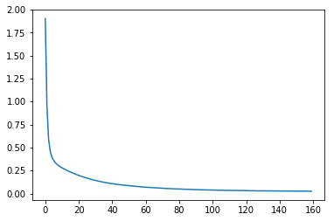
Conclusion: The accuracy improves when changing the topology from one to two hidden layers. The number of neurons in each layer is directly proportional to the accuracy. Thus, the best result is obtained when the number of neurons is maximum in each layer.
Graph representing loss per epoch
Loss
Epochs
Source Code for Experiment 5:

import os
import struct
import numpy as np
def load_mnist(path, kind='train'):
"""Load MNIST data from `path`"""
labels_path = os.path.join(path,
'%s-labels-idx1-ubyte' % kind)
images_path = os.path.join(path,
'%s-images-idx3-ubyte' % kind)

with open(labels_path, 'rb') as lbpath:
magic, n = struct.unpack('>II',
lbpath.read(8))
labels = np.fromfile(lbpath,
dtype=np.uint8)

with open(images_path, 'rb') as imgpath:
magic, num, rows, cols = struct.unpack(">IIII",
imgpath.read(16))
images = np.fromfile(imgpath,
dtype=np.uint8).reshape(len(labels), 784)
images = ((images / 255.) - .5) * 2

return images, labels

from sklearn.neural_network import MLPClassifier
import matplotlib.pyplot as plt

import sys
import gzip
import shutil

if (sys.version_info > (3, 0)):
writemode = 'wb'
else:
writemode = 'w'

zipped_mnist = [f for f in os.listdir('./') if f.endswith('ubyte.gz')]
for z in zipped_mnist:
with gzip.GzipFile(z, mode='rb') as decompressed, open(z[:-3], writemode) as outfile:
outfile.write(decompressed.read())

# Load training records
X_train, y_train = load_mnist('', kind='train')
print('Rows: %d, columns: %d' % (X_train.shape[0], X_train.shape[1]))

# Load testing records
X_test, y_test = load_mnist('', kind='t10k')
print('Rows: %d, columns: %d' % (X_test.shape[0], X_test.shape[1]))

np.savez_compressed('mnist_scaled.npz',
X_train=X_train,
y_train=y_train,
X_test=X_test,
y_test=y_test)

mnist = np.load('mnist_scaled.npz')
mnist.files

X_train, y_train, X_test, y_test = [mnist[f] for f in ['X_train', 'y_train',
'X_test', 'y_test']]

del mnist

X_train.shape

X_valid=X_train[55000:]
y_valid=y_train[55000:]
X_train=X_train[:55000]
y_train=y_train[:55000]

mlp = MLPClassifier(hidden_layer_sizes=(250,500), #250 neurons, 500 neurons
activation='logistic', #logistic = sigmoid function
max_iter=200, #epochs
alpha=0.01, #l2 term
solver='adam', #solver for weight optimization
batch_size=100, #minibatch size
verbose=10, #to print no. of progress messages
tol=1e-4, #tolerance for optimization
shuffle=True,
random_state=None, #if None, the random number generator is the RandomState instace used by np.random
learning_rate_init=.00011 #learning rate
)

mlp.fit(X_train, y_train)
print("Training set score: %f" % mlp.score(X_train, y_train))
print("Test set score: %f" % mlp.score(X_test, y_test))
print("Valid Training set score: %f" % mlp.score(X_valid, y_valid))

plt.plot(loss_curve_)
plt.show()

Source code:
import os
import struct
import numpy as np

def load_mnist(path, kind='train'):
"""Load MNIST data from `path`"""
labels_path = os.path.join(path,
'%s-labels-idx1-ubyte' % kind)
images_path = os.path.join(path,
'%s-images-idx3-ubyte' % kind)

with open(labels_path, 'rb') as lbpath:
magic, n = struct.unpack('>II',
lbpath.read(8))
labels = np.fromfile(lbpath,
dtype=np.uint8)

with open(images_path, 'rb') as imgpath:
magic, num, rows, cols = struct.unpack(">IIII",
imgpath.read(16))
images = np.fromfile(imgpath,
dtype=np.uint8).reshape(len(labels), 784)
images = ((images / 255.) - .5) * 2

return images, labels

# unzips mnist

import sys
import gzip
import shutil

if (sys.version_info > (3, 0)):
writemode = 'wb'
else:
writemode = 'w'

zipped_mnist = [f for f in os.listdir('./') if f.endswith('ubyte.gz')]
for z in zipped_mnist:
with gzip.GzipFile(z, mode='rb') as decompressed, open(z[:-3], writemode) as outfile:
outfile.write(decompressed.read())

# Load training records
X_train, y_train = load_mnist('', kind='train')
print('Rows: %d, columns: %d' % (X_train.shape[0], X_train.shape[1]))

# Load testing records
X_test, y_test = load_mnist('', kind='t10k')
print('Rows: %d, columns: %d' % (X_test.shape[0], X_test.shape[1]))

X_train, y_train, X_test, y_test = [mnist[f] for f in ['X_train', 'y_train',
'X_test', 'y_test']]

del mnist

X_train.shape

class NeuralNetMLP(object):
""" Feedforward neural network / Multi-layer perceptron classifier.

Parameters
------------
n_hidden : int (default: 30)
Number of hidden units.
l2 : float (default: 0.)
Lambda value for L2-regularization.
No regularization if l2=0. (default)
epochs : int (default: 100)
Number of passes over the training set.
eta : float (default: 0.001)
Learning rate.
shuffle : bool (default: True)
Shuffles training data every epoch if True to prevent circles.
minibatche_size : int (default: 1)
Number of training samples per minibatch.
seed : int (default: None)
Random seed for initalizing weights and shuffling.

Attributes
-----------
eval_ : dict
Dictionary collecting the cost, training accuracy,
and validation accuracy for each epoch during training.

"""
def __init__(self, n_hidden=30,
l2=0., epochs=100, eta=0.001,
shuffle=True, minibatch_size=1, seed=None):

self.random = np.random.RandomState(seed)
self.n_hidden = n_hidden
self.l2 = l2
self.epochs = epochs
self.eta = eta
self.shuffle = shuffle
self.minibatch_size = minibatch_size

def _onehot(self, y, n_classes):
"""Encode labels into one-hot representation

Parameters
------------
y : array, shape = [n_samples]
Target values.

Returns
-----------
onehot : array, shape = (n_samples, n_labels)

"""
onehot = np.zeros((n_classes, y.shape[0]))
for idx, val in enumerate(y.astype(int)):
onehot[val, idx] = 1.
return onehot.T

def _sigmoid(self, z):
"""Compute logistic function (sigmoid)"""
return 1. / (1. + np.exp(-np.clip(z, -250, 250)))

def _tanh(self, z):
e_p = np.exp(z)
e_m = np.exp(-z)
return (e_p - e_m) / (e_p + e_m)

def _forward(self, X):
"""Compute forward propagation step"""

# step 1: net input of hidden layer
# [n_samples, n_features] dot [n_features, n_hidden]
# -> [n_samples, n_hidden]
z_h = np.dot(X, self.w_h) + self.b_h

# step 2: activation of hidden layer
#a_h = self._sigmoid(z_h)
a_h = self._tanh(z_h)

# step 3: net input of output layer
# [n_samples, n_hidden] dot [n_hidden, n_classlabels]
# -> [n_samples, n_classlabels]

z_out = np.dot(a_h, self.w_out) + self.b_out

# step 4: activation output layer
a_out = self._sigmoid(z_out)
a_out = self._tanh(z_out)

return z_h, a_h, z_out, a_out

def _compute_cost(self, y_enc, output):
"""Compute cost function.

Parameters
----------
y_enc : array, shape = (n_samples, n_labels)
one-hot encoded class labels.
output : array, shape = [n_samples, n_output_units]
Activation of the output layer (forward propagation)

Returns
---------
cost : float
Regularized cost

"""
L2_term = (self.l2 *
(np.sum(self.w_h ** 2.) +
np.sum(self.w_out ** 2.)))

term1 = -y_enc * (np.log(output))
term2 = (1. - y_enc) * np.log(1. - output)
cost = np.sum(term1 - term2) + L2_term
return cost

def predict(self, X):
"""Predict class labels

Parameters
-----------
X : array, shape = [n_samples, n_features]
Input layer with original features.

Returns:
----------
y_pred : array, shape = [n_samples]
Predicted class labels.

"""
z_h, a_h, z_out, a_out = self._forward(X)
y_pred = np.argmax(z_out, axis=1)
return y_pred

def fit(self, X_train, y_train, X_valid, y_valid):
""" Learn weights from training data.

Parameters
-----------
X_train : array, shape = [n_samples, n_features]
Input layer with original features.
y_train : array, shape = [n_samples]
Target class labels.
X_valid : array, shape = [n_samples, n_features]
Sample features for validation during training
y_valid : array, shape = [n_samples]
Sample labels for validation during training

Returns:
----------
self

"""
n_output = np.unique(y_train).shape[0] # number of class labels
n_features = X_train.shape[1]

########################
# Weight initialization
########################

# weights for input -> hidden
self.b_h = np.zeros(self.n_hidden)
self.w_h = self.random.normal(loc=0.0, scale=0.1,
size=(n_features, self.n_hidden))

# weights for hidden -> output
self.b_out = np.zeros(n_output)
self.w_out = self.random.normal(loc=0.0, scale=0.1,
size=(self.n_hidden, n_output))

epoch_strlen = len(str(self.epochs)) # for progress formatting
self.eval_ = {'cost': [], 'train_acc': [], 'valid_acc': []}

y_train_enc = self._onehot(y_train, n_output)

# iterate over training epochs
for i in range(self.epochs):

# iterate over minibatches
indices = np.arange(X_train.shape[0])

if self.shuffle:
self.random.shuffle(indices)

for start_idx in range(0, indices.shape[0] - self.minibatch_size +
1, self.minibatch_size):
batch_idx = indices[start_idx:start_idx + self.minibatch_size]

# forward propagation
z_h, a_h, z_out, a_out = self._forward(X_train[batch_idx])

##################
# Backpropagation
##################

# [n_samples, n_classlabels]
sigma_out = a_out - y_train_enc[batch_idx]

# [n_samples, n_hidden]
#sigmoid_derivative_h = a_h * (1. - a_h)
tan_derivative_h = ( 2 / (np.exp (a_h + np.exp(-a_h) ) ) ) **2

# [n_samples, n_classlabels] dot [n_classlabels, n_hidden]
# -> [n_samples, n_hidden]
#sigma_h = (np.dot(sigma_out, self.w_out.T) *
# sigmoid_derivative_h)

sigma_h = (np.dot(sigma_out, self.w_out.T) *
tan_derivative_h)

# [n_features, n_samples] dot [n_samples, n_hidden]
# -> [n_features, n_hidden]
grad_w_h = np.dot(X_train[batch_idx].T, sigma_h)
grad_b_h = np.sum(sigma_h, axis=0)

# [n_hidden, n_samples] dot [n_samples, n_classlabels]
# -> [n_hidden, n_classlabels]
grad_w_out = np.dot(a_h.T, sigma_out)
grad_b_out = np.sum(sigma_out, axis=0)

# Regularization and weight updates
delta_w_h = (grad_w_h + self.l2*self.w_h)
delta_b_h = grad_b_h # bias is not regularized
self.w_h -= self.eta * delta_w_h
self.b_h -= self.eta * delta_b_h

delta_w_out = (grad_w_out + self.l2*self.w_out)
delta_b_out = grad_b_out # bias is not regularized
self.w_out -= self.eta * delta_w_out
self.b_out -= self.eta * delta_b_out

#############
# Evaluation
#############

# Evaluation after each epoch during training
z_h, a_h, z_out, a_out = self._forward(X_train)

cost = self._compute_cost(y_enc=y_train_enc,
output=a_out)

y_train_pred = self.predict(X_train)
y_valid_pred = self.predict(X_valid)

train_acc = ((np.sum(y_train == y_train_pred)).astype(np.float) /
X_train.shape[0])
valid_acc = ((np.sum(y_valid == y_valid_pred)).astype(np.float) /
X_valid.shape[0])

sys.stderr.write('\r%0*d/%d | Cost: %.2f '
'| Train/Valid Acc.: %.2f%%/%.2f%% ' %
(epoch_strlen, i+1, self.epochs, cost,
train_acc*100, valid_acc*100))
sys.stderr.flush()

self.eval_['cost'].append(cost)
self.eval_['train_acc'].append(train_acc)
self.eval_['valid_acc'].append(valid_acc)

return self

n_epochs = 200

nn = NeuralNetMLP(n_hidden=100,
l2=0.01,
epochs=n_epochs,
eta=0.00011,
minibatch_size=3000,
shuffle=True,
seed=1)

nn.fit(X_train=X_train[:55000],
y_train=y_train[:55000],
X_valid=X_train[55000:],
y_valid=y_train[55000:])

import matplotlib.pyplot as plt

#cost per epoch graph
plt.plot(range(nn.epochs), nn.eval_['cost'])
plt.ylabel('Cost')
plt.xlabel('Epochs')
plt.show()

#accuracy graph
plt.plot(range(nn.epochs), nn.eval_['train_acc'],
label='training')
plt.plot(range(nn.epochs), nn.eval_['valid_acc'],
label='validation', linestyle='--')
plt.ylabel('Accuracy')
plt.xlabel('Epochs')
plt.legend()
plt.show()

y_test_pred = nn.predict(X_test)
acc = (np.sum(y_test == y_test_pred)
.astype(np.float) / X_test.shape[0])

print('Test accuracy: %.2f%%' % (acc * 100))

