DAT 405

Air Pollutant - Report

One of the first pieces of work that grabbed my attention was Peter Crnokrak’s “Love will tear us apart again”. The poster represents the number of covers of Joy Division’s “Love will tear us apart” that have been covered around the world. The work uses the length of lines protruding out of the circle to reflect. I have mimicked the way Crnokrak uses visual data to represent information, making the number of circles correlate with the increase of air pollution. Contrary to the black background here which arouses feelings of negativity and darkness, my choice of a white canvas background colour gives a clean feel and connotes purity, reflecting the environment. In cities where the air pollution count is low, we are able to see more of the white canvas which is a positive thing. The pollutants blacken the background in the same way they do the air quality and environment.

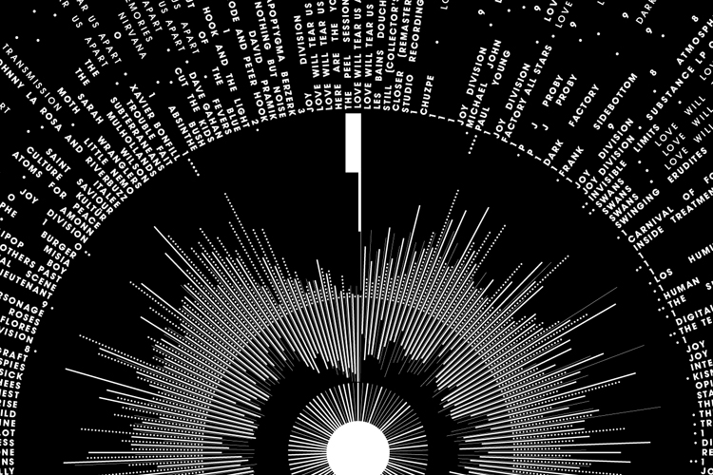

Mark Napier’s work as shown below uses circular motion as the main focus which influenced my own work as I chose to represent air molecules through circles of varying different sizes. The shades of grey used in his work give depth and definition which I have adopted in my work, making the particles different shades of grey to accommodate the negativity of pollution. I also added a transparency to them to create a layering effect and give depth, making the canvas more interesting to look at.

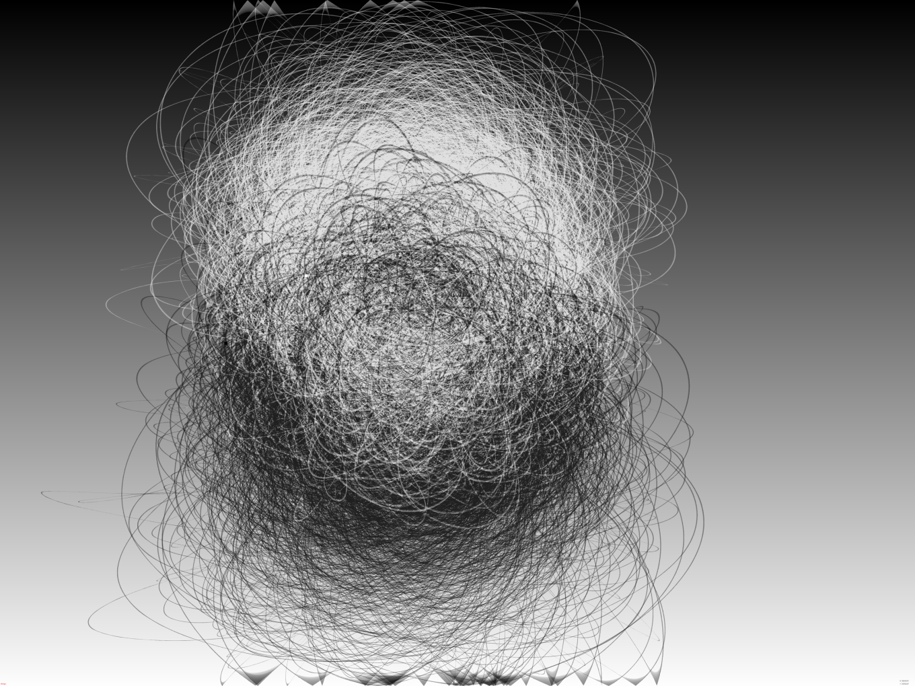

Sol Lewitt’s Example 3.1 inspired the motion of the particles as the circles move in the same pathway pattern as the lines do in Lewitt’s work. Similarly the way the lines rebound off the edges of the canvas, the circles do too which maintains the particles within a confined space. This emphasizes the visual levels of air pollution which creates a more intensified aesthetic of the pollutant levels, evoking a sense of urgency to make the viewer think about their impact on the environment.

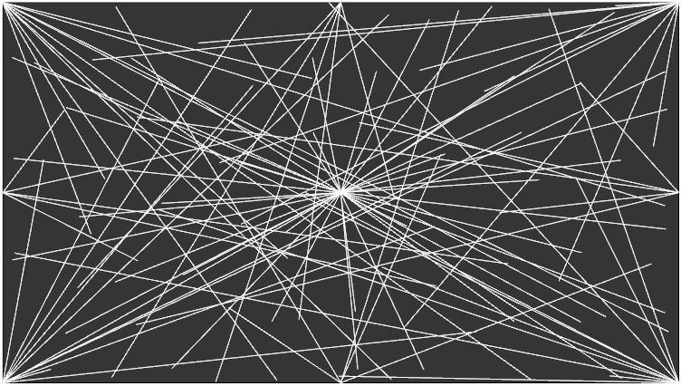

To begin the development process I thought about what interests me such as the environment and our carbon footprint. I used this as a starting point to look for a API key relating to pollution.

To link the data with the class array I controlled the array size with the pollutant count however because the pollutant count in certain cities was so high, I divided the count by 1000 so that the visual data was on a more appropriate scale. Unfortunately this slightly compromised the representation of data as the counts between 1- 471 were represented with the same number of particles despite them being different. If I were to do this project again I would change the size of the circles between these numbers so as to show a more accurate representation.

Another problem I encountered was that certain letters within the city names show up as question marks instead of the letters. This is because those specific letters aren’t recognised within the array. The only way I would be able to change this would be to find a different API key which I would do in future upgrades. A final improvement I would make would be to convert the pollutant count to percentage figures so that they would be easier to understand in comparison to the surrounding cities.

**References**

Grugier, M. (2016) *The digital age of data art.* [Online] Available from:

<https://techcrunch.com/2016/05/08/the-digital-age-of-data-art/> [accessed 10 January 2018].

Crnokrak, P. (2018) *Peter Crnokrak.* [Online] Available from: <http://www.petercrnokrak.com/love-will-tear-us-apart-again/> [accessed 10 January 2018].

Napier, M. (2003) *Mark Napier*. [Online] Available from: <http://marknapier.com/black_and_white> [accessed 10 January 2018].

Lewitt, S. (2014) *Procedural Art, Example 3.1.* [Online] Available from: <https://generativelandscapes.wordpress.com/2014/08/14/procedural-art-sol-lewitt-example-3-1/> [accessed 10 January 2018].

**Github Links**

Link to github repository:

[**https://github.com/bmulvey2017/Dat-405-Pt.2-.git**](https://github.com/bmulvey2017/Dat-405-Pt.2-.git)

Link to website:

[**https://bmulvey2017.github.io/**](https://bmulvey2017.github.io/)