**Readme**

* The data used for analysis is hosted at <https://www.dallasopendata.com/api/views/qv6i-rri7/rows.csv>.
* As it would take more time to download the data which is 566 MB, we are working with a filtered dataset that contains only the year 2018. The package contains the data file ***Police_Incidents_2018.csv*** that was used to generate the charts.
* The original data file that was downloaded from the above URL contains all the years is renamed to ***Police_Incidents.csv*** and included as well as part of the package. In case Police_Incidents_2018.csv is not present in the working directory, but contains the original file ***Police_Incidents.csv***, the script intelligently detects it and use it to filter it to the year 2018 to proceed further.
* Even if no data is present in the working directory, the script can download the data from the URL provided and filter it to the year 2018 to carry out the analysis and it also writes the filtered data into a csv file for later use.
* The script cleans the data and creates a data frame named “*Police_Incidents*” containing **54240** rows and **34 columns** to start the analysis.
* The script is grouped into several sections (Libraries, Utility Functions, Data Functions, Plot Functions) containing various functions and a Main section.
* Please use "Code->Show Document Outline" menu to view the sections and functions under them for easy navigation.

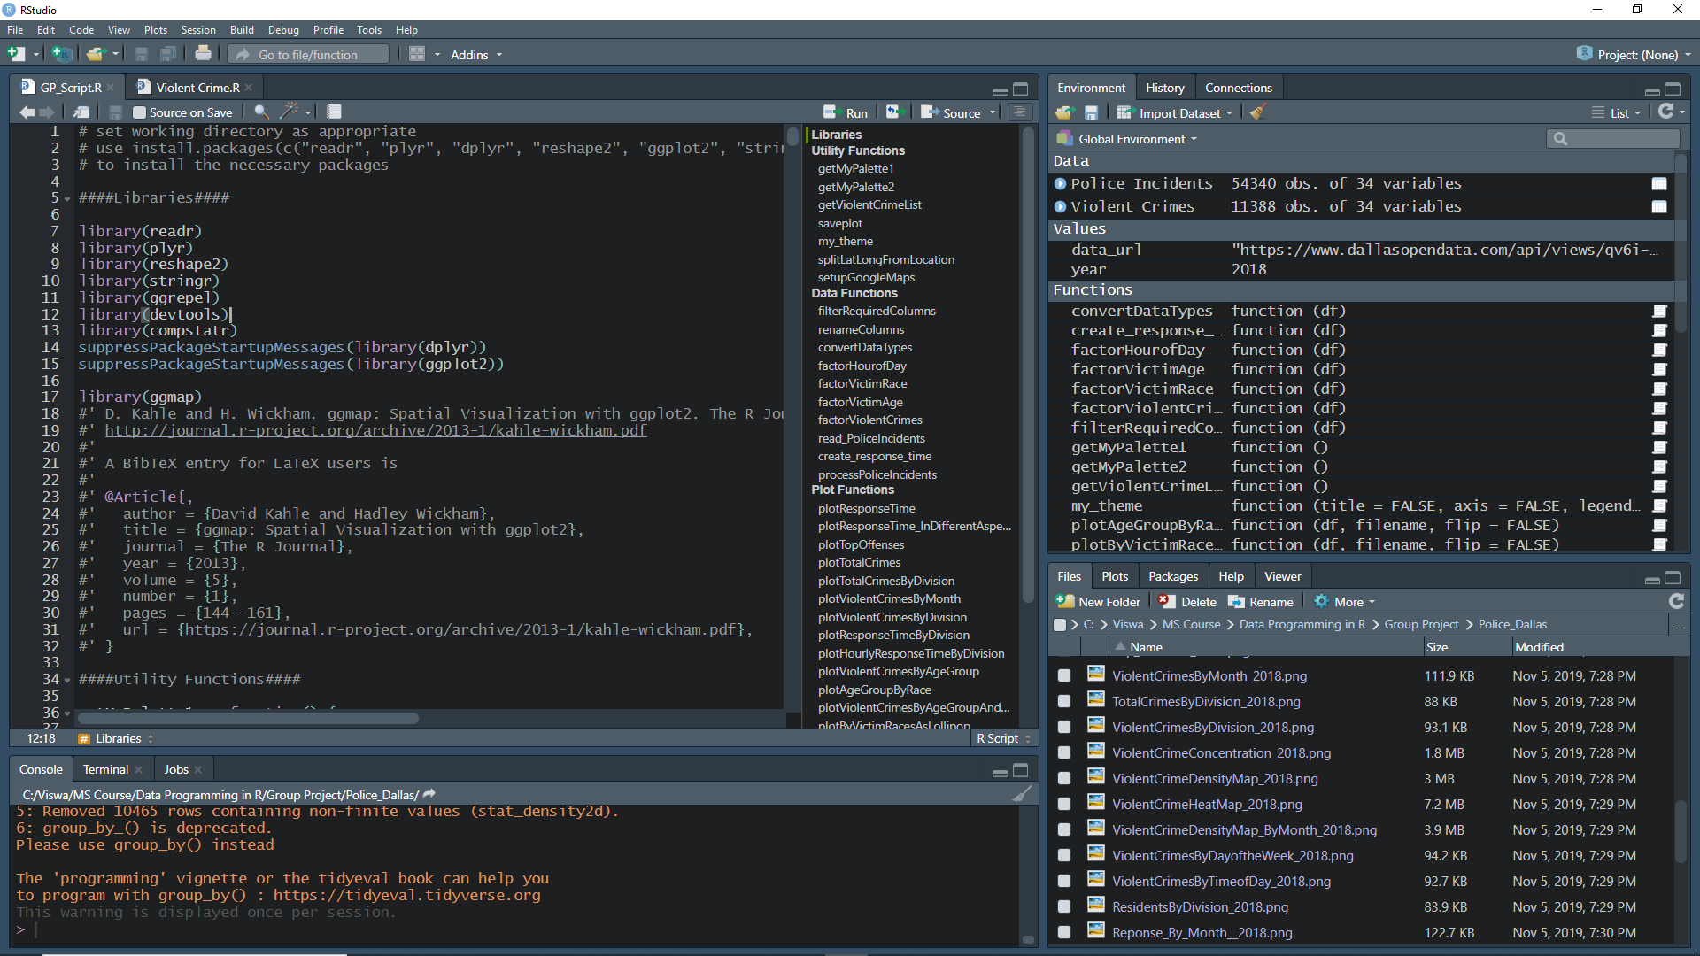

* The Main section is the entry point for the script. When sourced, with the proper API Key for Google Maps and a Year is supplied, the script analyzes the data and generates various charts.
* The script is designed to work with any year. If the Year supplied is 2018, it uses the filtered data file present in the working directory for analysis, and if a different year is supplied then it uses the original file present to filter the data and use it for analysis and generates the charts for that year
* There script generates around **26 charts** which are included in our presentation.

Note:

* In case if the attached file Police_Incidents_2018.csv is not used to generate charts, and instead if it is downloaded from the URL, the charts may look different as the current version of download has little more data included as oppose to what we have started with.
* There may be a warning due to the usage of a deprecated function group_by_().
* The charts will not include a title in order to use it in our presentation.