
GREENBIRD’S ASTROWARS TOOL
Comments by Brasier – 01/05/2009

The player named Greenbird created an excellent tools system that complete the Astrowars game native interface. This tools system is called « brownie ».
Greenbird wrote a short presentation of his tools here : http://aw.lsmod.de/manual.html, but some friends of mine asked for a more complete tutorial.

To use these tools, you have to connect to the game, using this URL : http://aw21.zq1.de/

After entering your login and password, you come on the Astrowars « News » page ; but the « normal » menu line of the game :

is completed by a second menu line (in green) :
(1) (2) (3) (4) (5) (6) (7) (8)

The AWTools option links to a specialized tools page ; they will be listed in Chapter IV.
Some tools can be accessed through the green links shown above in the Astrowars pages.

More, the other usual pages of the Astrowars game are completed by very useful informations, especially about ships movements on planets owned by your allies.

NOTE : You have to pay a small amount of money to Greenbird to get access to the complete version of the brownie. A login and a password will be given to you.
If you don’t want to pay, you can nevertheless use a limited version, by using “guest” as login and password.
Tool Access Policy (and so, payment conditions !) are there: http://aw.lsmod.de/manual.html#policy

I – The tools that you can access directly from the game pages :

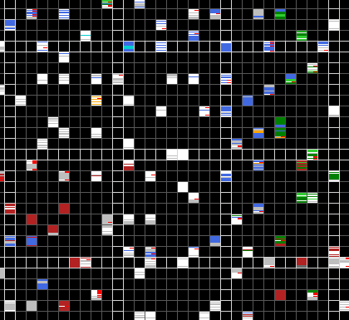
(2) preferences2 :
Allows to modify some game options. Not the most useful tool ☺

(3) tacmap :
Shows the entire galaxy. When a square contains a system, different colors show if it is occupied by an ally, a friend, a foe, and so on, depending the status you and your allies gave to another player or alliance.
Each status has a different color (for example : red for foes, green for allies, blue for a NAPped player or alliance, and so on.)
By clicking on a square, you can see the players in the system (even if they are too far for your Biology level).

(4) Tlarge :
Similar to tacmap, but provides some settings :
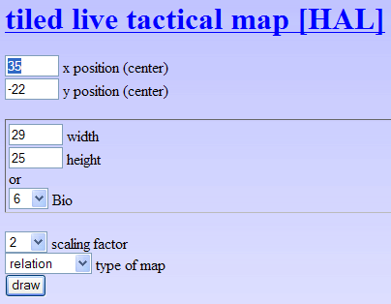

- You can center the map on a specified system, designed by its coordinates. By default, the map is centred on your home system.
- You can define the map size, either by the number of square by side, or (and it is the easiest way) by simply giving a Biology level (even greater than yours). In the example above, Bio 6 will display a map with 7 squares by side (3 squares for each direction from the center of the map, plus the system in the center of the map).
- You can set the scaling factor and the type of map shown : the default map shows relations ; there is also a map with fleets, and one with population density.

(5) system :
This tool allows you to show the planets for a certain system, with the players there, and your alliance ships, even if your Biology level should not allow it.
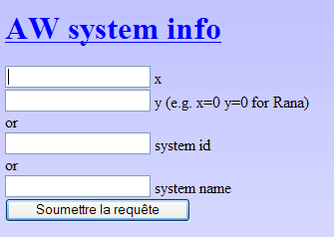

- Either by its coordinates (for example : x=37 and y=-19 shows Minkar system)
- Either by its number (for example : 559 shows Minkar system)
- Or by its name (just enter « Minkar » to see the Minkar system).

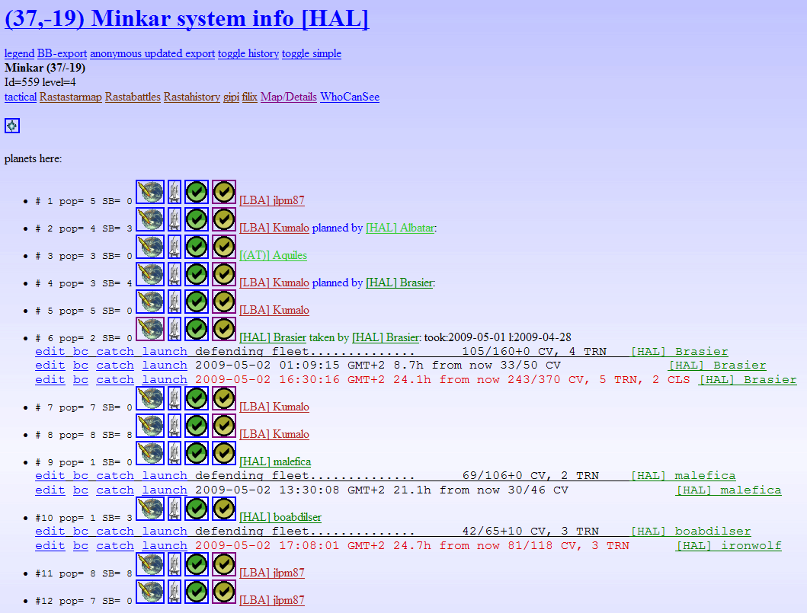

IMPORTANT : Use this option to inform your allies using the brownie of your intentions, by clicking the button or the edit link.

(6) player :
This tool allows you to see a synthetic presentation for a given player. :
You just have to enter his user ID, or more simply his name.
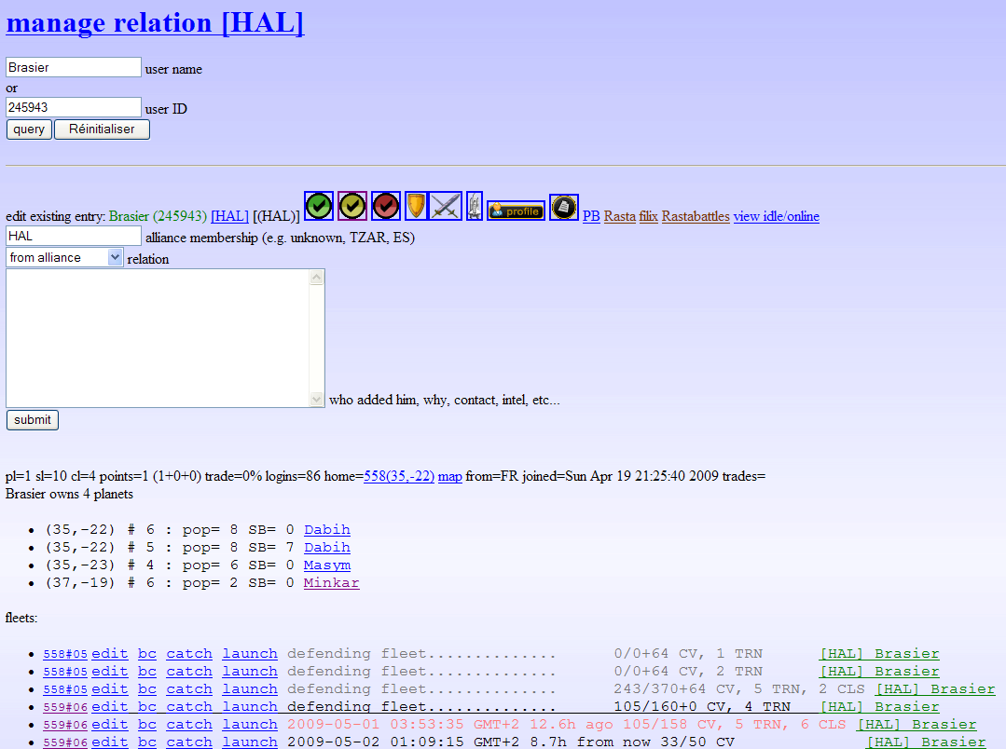
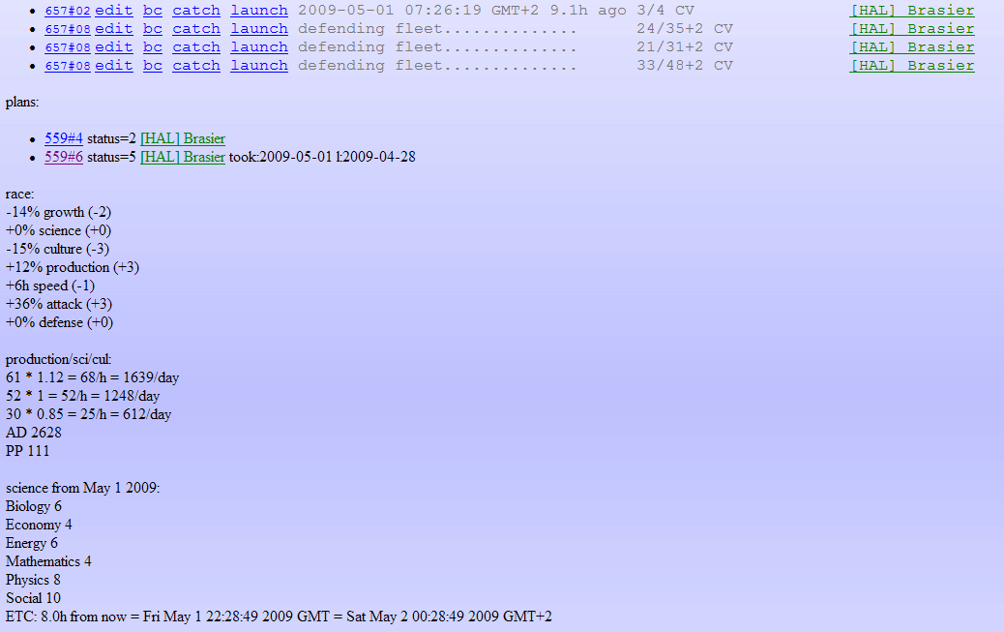

(7) alliance :
This tool allows you to see all the players from a given alliance, with their different levels (columns titles are explained in the page bottom) and, if your Biology level allows it, their race values, the remaining time to reach the next culture level (ETC) and the past time since their last connection to the game (idle).

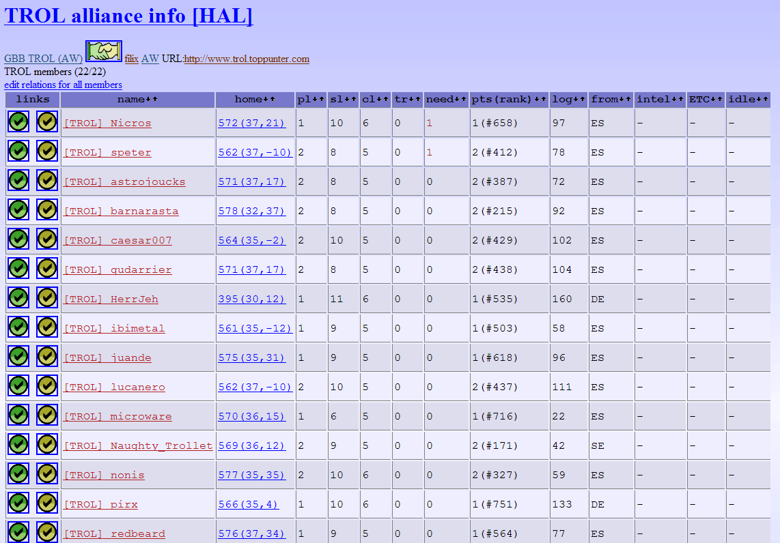

(8) fleets :
This tool shows every fleet for every members from your alliance using the brownie.
II – Notes about icons in the « player », « system » et « alliance » pages :

or edit : allows you to add a comment about a player, an alliance or a planet. This comment will appear in the « player » page, the « alliance » page or the « system » page.

VERY IMPORTANT :
Use this tool to inform your allies of your intentions. For example, if you intend to conquer a planet, use « planned by » and your name (and eventually a comment). The « planned by [yourname] » warning will appear in the « system » page. It will avoid some collision between allied fleets.

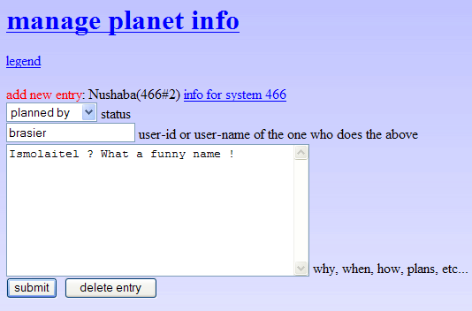
Click on « Submit » to enter your comment ; you can go back to the « system » page by clicking the link « info for system xxx ».
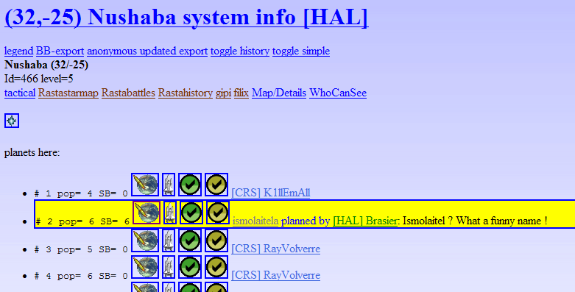

Shows basic informations about the player.
Shows basic informations about the player and, if your Bio level allows it or this is a player from your allance, sciences and race informations. (in that case, your Bio level must be 6 levels above its own Bio level).
Shows every information concerning a member from your alliance.
Activates the Battle Calculator. If your Biology allows it, the BC will be pre-filled with the player characteristics in defense, and your own characteristics in attack.
Activates the Battle Calculator. If your Biology allows it, the BC will be pre-filled with the player characteristics in attack, and your own caracteristics in defense..
Shows the player’s profile as shown in the Astrowars forum.
Accesses the personal message (PM) board from Astrowars.

III – Increasing Astrowars launch fleet sceen.
If you well used the « manage planet info » option as described above, the launch fleet screen will be easier and more gentle to use.

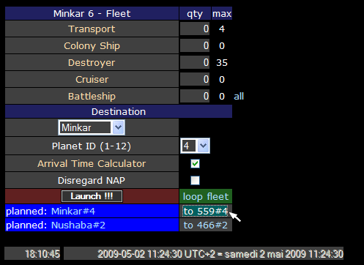

In this example, two planets have been marked as « planned by » the player named « Brasier » (it’s me !) You can see this information is shown in the launch fleet screen.
To fill-in the board, you just have to click on the aimed planed reference (here : to 559#4). The destination system and the planet number will be automatically set in.
On the top of the board are shown :
- the Travel Time (18h, 10 minutes, 45 seconds)
- the arrival date and time .
If you just want to calculate a travel time, then it is useless to click on the « launch » button (and to risk a mislaunch !).

If you click on the planet name, then you are linked to the Astrowars « system » screen ; the name of the aimed planet is displayed in bigger letters.
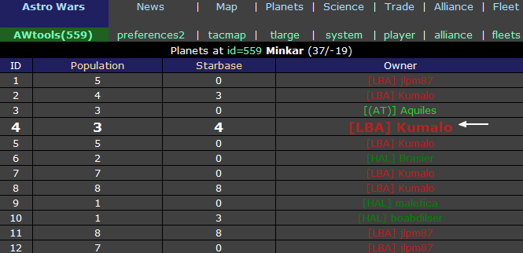

IV – Other tools :

Greenbird provides numerous other tools. The best way to understand them is to try them !
To access these tools, click on the (1) Awtools link.

(1)

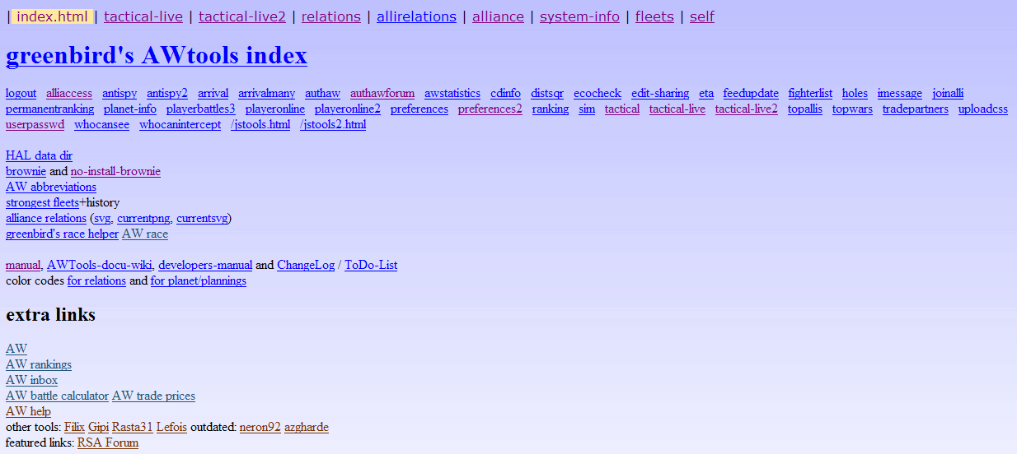

Here are the most interesting tools, that have not been described before. Below I marked in red the most important ones (in my opinion ;-)

- antispy et antispy2 show a list of the players who look at your profile ;

- arrival et arrivalmany allow to calculate the flight time. Because it is also possible through the launch fleet screen, in an easiest way, these tools are useful only for systems that you cannot see because of your too low bio level – or when you do not have fleet at the launch point (e.g. because it is still traveling there) [Added by Greenbird – thanks, Master]. A little bit hard to use : « Planet difference » is the difference between the number of the start planet and the number of the arrival planet. For example, between Minkar 6 et Rana 1, « Planet difference » = 5 (6-1). Concerning « Distance square », Another tool allows to calculate it (click on the Distance squared link). NOTE : the website www.astrowars-tools.com gives a simpler tool to do that.

- cdinfo : gives informations during countdown (CD) : it is the time, at the end of the round, when a player reaches 500 points, or an alliance reaches 360 points. These scores must be maintained 7 consecutive days (for a solo player) or 3 consecutive days (for an alliance), that’s why it’s called countdown.

- distsqr : Calculate the « Distance square » value needed for the flight time calculation (see arrival and arrivalmany)

- ecocheck : useful for players that wish get the economy bonus.

- fighterlist : Show your alliance players, with all their characteristics, including CVs.

- hole : Shows systems with free planets, or planets with resigned players (leaving UNKNOWN planets), or with players that don’t belong an alliance.
- imessage : Allows to send or receive personal messages (BIM) using the brownie internal PM system. You are notified that you received a BIM by a special message appearing on every screen of the game.

- joinalli : allows you to be set in the brownie as an alliance member, before you are tagged. Unavailable until you belong to an alliance.

- playerbattles3 : Shows the battles results for a player. Not very understandable !

- playeronline et playeronline2 : shows player idle concerning a player

- ranking : shows player ranking for your alliance members

- sim : An economic simulation tool. I’m not sure to have understood how it works !

- topalli : Shows the alliance ranking

- topwars : shows the total CVs won or lost for the 50 first alliances

- tradepartners : shows your alliance members, with they financial capacities. Useful to choose a good trade partner.

- whocansee : shows your alliance players having a suffcient Biology level to see the given system (enter the system number – SID).

- whocanintercept : similar to whocansee, but shows only players having fleet able to intercept another fleet. This option is available from the « system-info » page, by clicking on the « catch » link.

