**Problem 10**

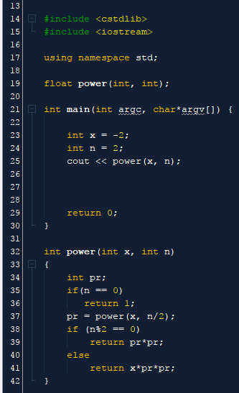

**Problem 13**

**Code : Ended up just changing the for loops instead of removing. Utilized Maps and Sets**

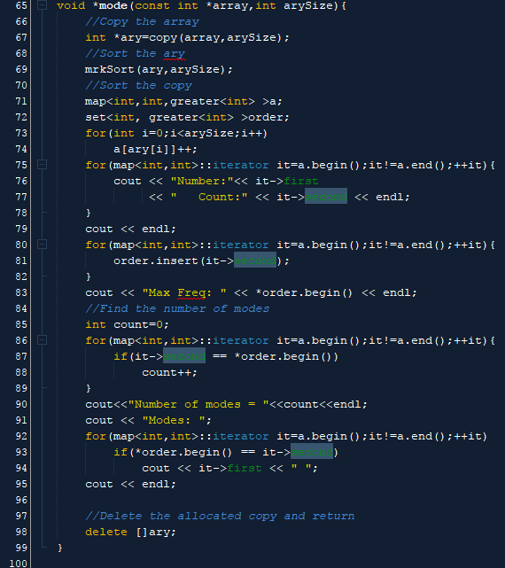

**No Modes**

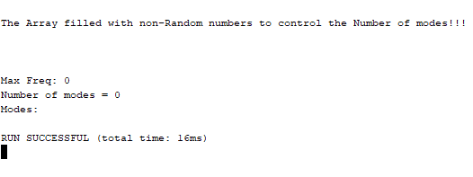

**One Mode**

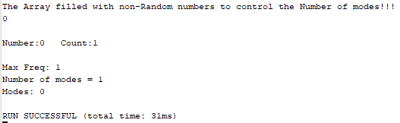

**Multiple Modes**

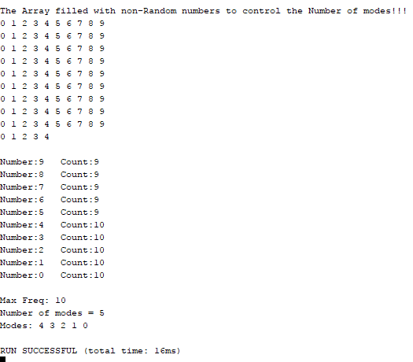

**Problem 11**

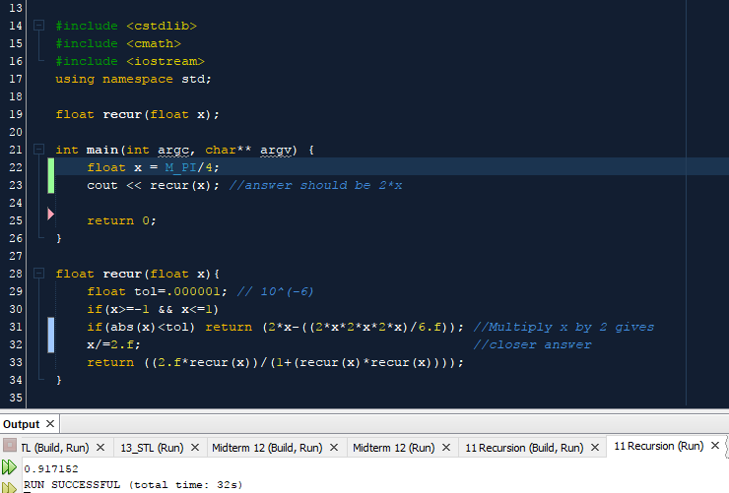

**Problem 12**

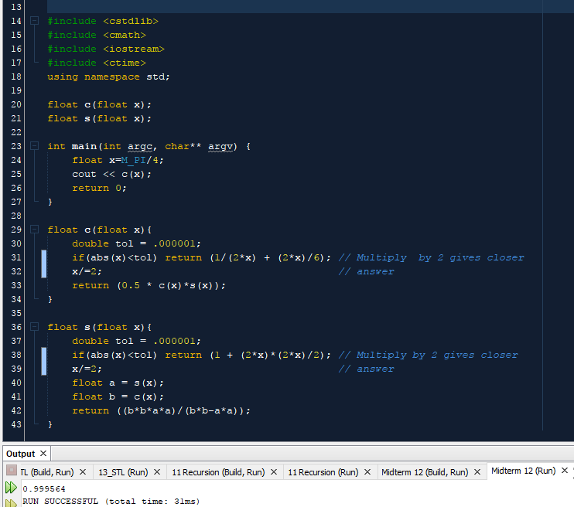

**Problem 8 Main Function + Simulation**

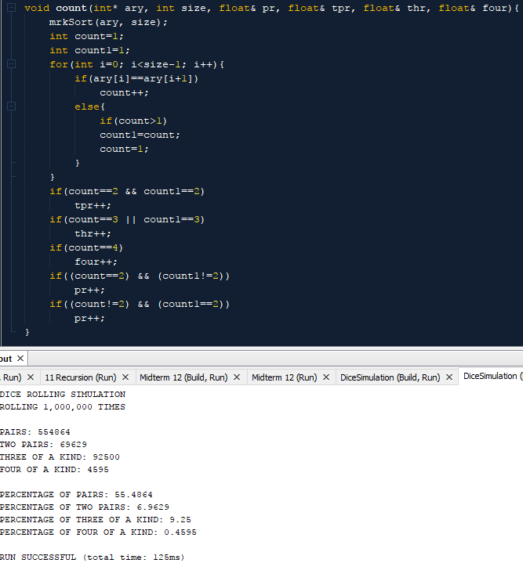

**Problem 9 Functions + Simulation**

