**Name: Nguyễn Lâm Văn**

**SE130680**

Nowadays, the demand for traffic is increasing, so we can see a lot of vehicles on the street. However, the more gasoline engine, the more polluted the environment is. This is also the main reason for me to make a website that is use to sell either bike or motorbike that run by electricity. I’m sure that when people use them our environment will be better, because they are the safe and friendly vehicle to environment, no air, no sound. And the customer I work towards is everyone especially student in high school because they are not enough age to drive moto so electric bike is the best choices. With the elder it also works because it very easy to opera and use. And in this system include the address of stores, show clearly what kind of vehicles we sell with some attributes like: model, color, price, capacity,.. it will help customer easy to compare to pick out the best .. Not only that, i also want to bring to customer the best service that I can like: take care, guarantee, shopping advice, deliver to home, and rescue in case of emergency. All of I do just make the customer can choose the right bike with the reasonable price easily.

**Danh sách các đối tượng dữ liệu:**

1. PegaBike (ProID, model, type)
2. showroom (showroomNo, name, address)
3. eBike (model, color, price, capacity, distance)
4. eMoto (model, color, price, capacity, distance)
5. Service (serviceNo, serviceName, price)
6. Customer(CusNum, name, address, phone, sex, birthdate)

**Hoạt động:**

Buy product:

1. Choose product
2. Choose amount
3. Pay money

Find showroom:

1. Click “tìm cửa hang”
2. Choose Showrom’s name
3. View the status of product

**SƠ ĐỒ ERD:**

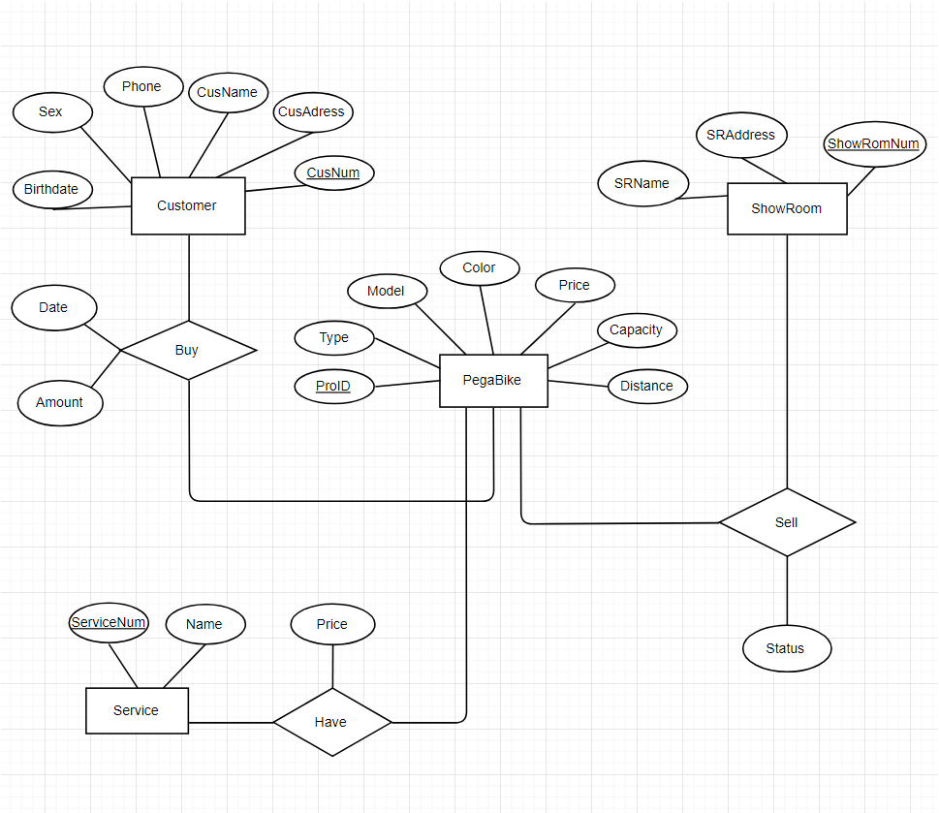

**Relational Model:**

Customer(CusNum, CusName, CusAddress, Sex, Phone, Birthdate)

BuyProduct(CusNum, ProID, Amount, Date)

PegaBike(ProID, Type, Model, Color, Price, Capacity, Distance)

ShowRoom(ShowRomNum, SRName, SRAddress)

ShowRoomStt(ShowRoomNum, ProID, Status)

Service(ServiceNum, Name)

PriceService(ServiceNum, ProID, Price)