

DURAK Meryem Canan

GURKAN Rabia

SENER Öyku

UNVER Cahit Caner

JANUARY 2018

EVALUATION of ENERGY PERFORMANCE of BUILDING

IN ANKARA-FRANKFURT-PIACENZA

TECHNICAL ENVIRONMENTAL SYSTEMS

PROFESSOR MARCHESI RENZO

PAGE

1_ INTRODUCTION 1

2_ BUILDING DEFINITION 2-3

3_ EVALUATION and RESULTS of ENERGY PERFORMANCE of the BUILDING 4-16

CONTENTS

While designing a building, sustainability should always be one of the most important considerations. In order to achieve this objective, energy performance of a building should be thought in the process of design. In this research, in order to evaluate a building in three different conditions, we applied the design in three different cities: Ankara, Turkey; Piacenza, Italy and Frankfurt, Germany. We observed that the weather conditions have a great impact on a building’s energy performance.

Firstly, we designed a café and drew its plan in AutoCAD. Then, we modeled it in SketchUp with Open Studio plugin. We defined exterior of building for the analysis. Then, the area of the windows and doors on the façade were calculated in Open Studio. We also defined the space types of the building, then the thermal zones accordingly. Then, by adding the weather conditions of the three different cities, we obtained buildings energy evaluation by using Open Studio.

1 INTRODUCTION

2 BUILDING DEFINITION

The building was planned to be used as a café. Footprint of the building is 144 sqm which consists of 5 sub-spaces. The height of a floor is 4 meters. There is a kitchen (14.4 sqm), a storage (11.5), two bathrooms (4.3 sqm each) and the cafe & service area (110 sqm). In bathrooms, there are openings with the dimension of 60cmx40cm (one per each) and the kitchen and the storage has no openings. Whereas, there are three openings in cafe part, which has the dimensions of 360cmx210cm, 1200cmx400cm and 720cmx400cm. There are also 2 openings for the entrances, 150cmx210cm and 90cmx210cm. Thus, the total area of the openings is 89.88 sqm. The exterior wall surface in total is 102.12 sqm. These values were used in Open Studio software for the analysis.

As the first step, we drew the plan. Then, by using the command of ‘create space from diagram’ we transferred it to 3D model. We selected all the volumes and used surface matching command. Then we set the window to wall surface ratio, as the openings were defined. By using ‘Render by space type’ the functions of the inner spaces were defined. Also, with the help of ‘Render by thermal zone’ the thermal zone of all spaces were defined, as well.

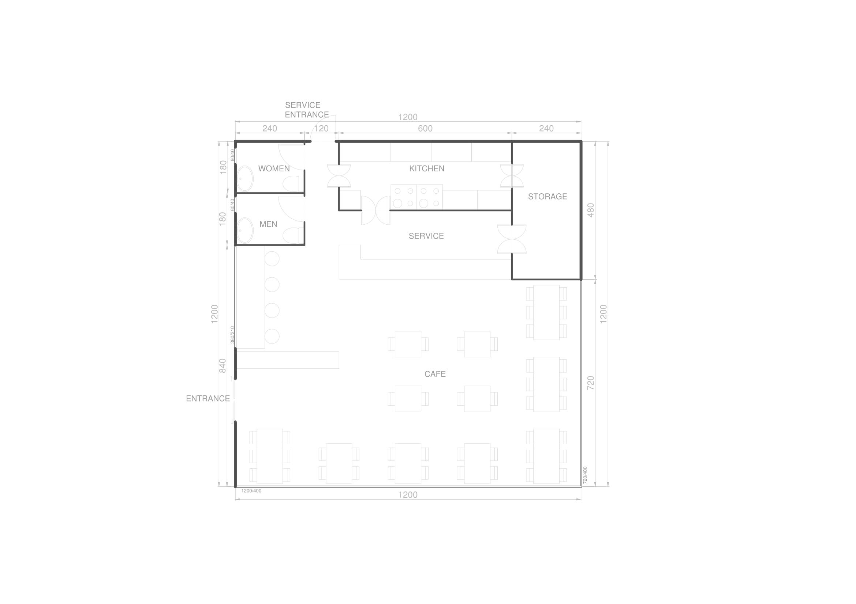

(The results and graphics taken from 'Open Studio' were evaluated and compared between 3 cities Frankfurt, Ankara and Turkey.)

3 EVALUATION and RESULTS of ENERGY PERFORMANCE of the BUILDING-BEFORE MATERIAL CHANGE-

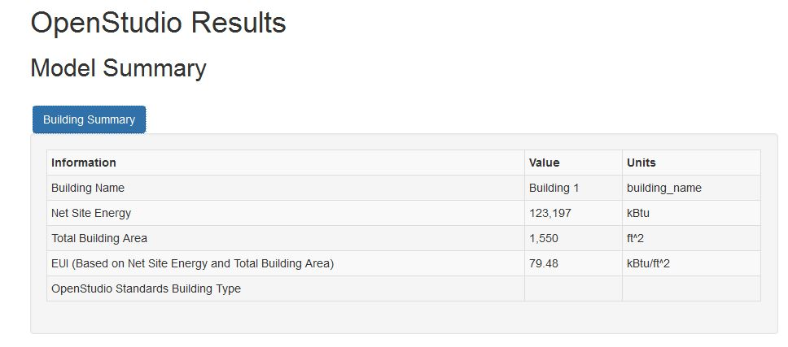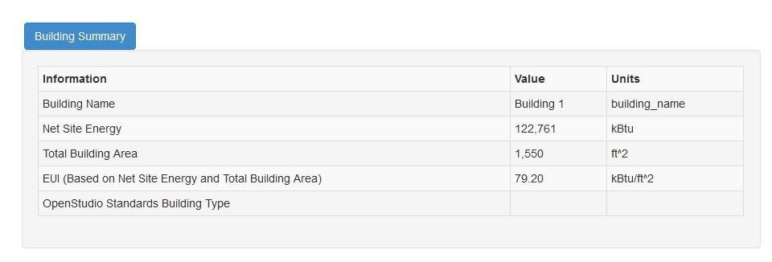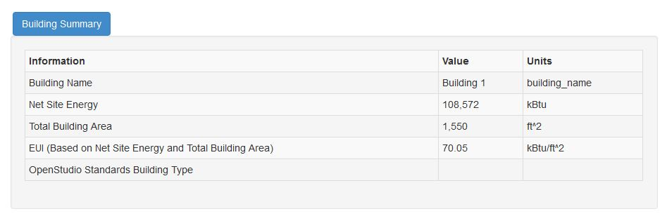

As it is seen in the tables, with the same building plan different 'Net Site Energy' results were obtained for different cities. Total building area is 1550 ft² for each but Net Site Energy values are 123,2 kBtu for Ankara, 122,8 kBtu for Frankfurt and for 108,6 kBtu for Piacenza.

Amount of heat and electricity consumed by the building is reflected as Net Site Energy. Because the building material and total area are same for all of type the reason behind the differences of the results can be understood by different geographical conditions of the cities.

EUI-energy use intensity- results shows the energy use per square. So as it is noted above EUI outcomes are different for each city.

ANKARA

FRANKFURT

PIACENZA

Figure 2 Building Summary Table

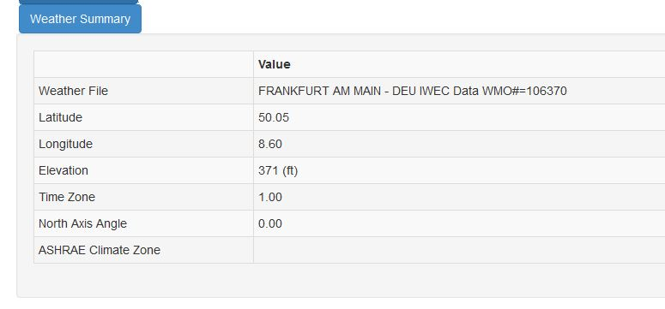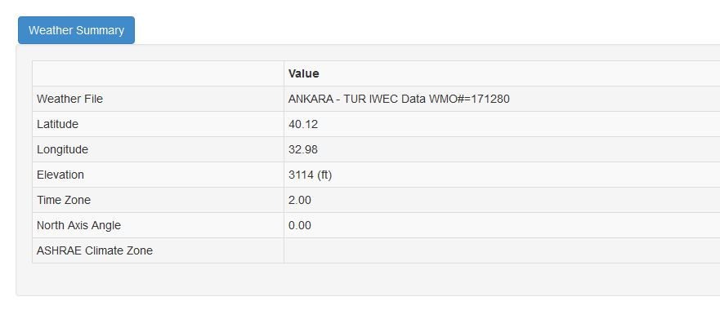

Figure 3 Weather Summary Table

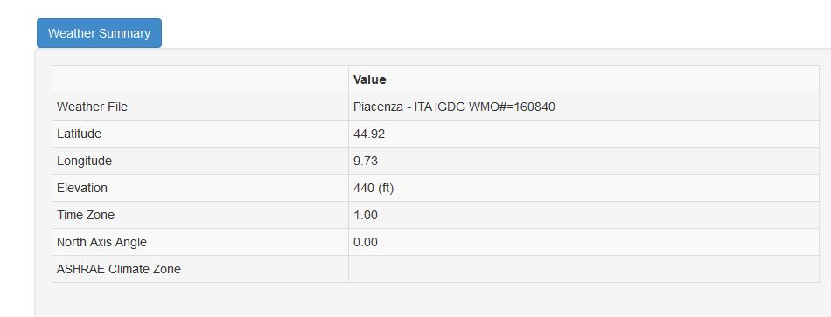

ANKARA

FRANKFURT

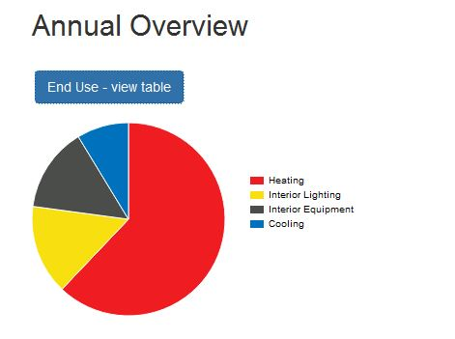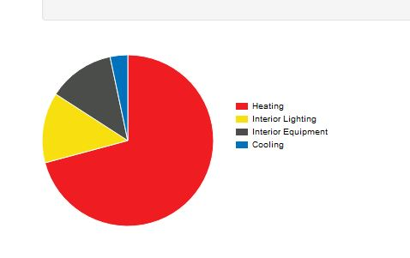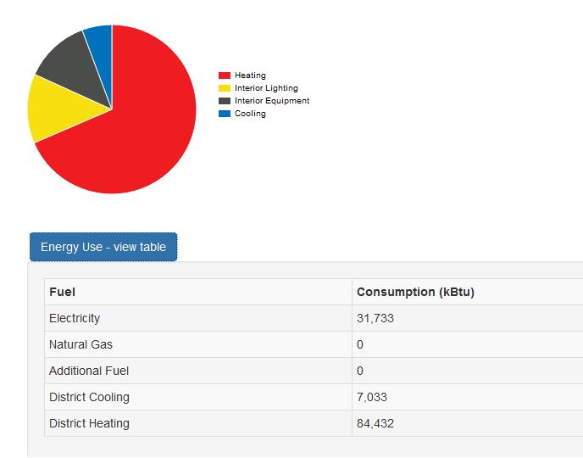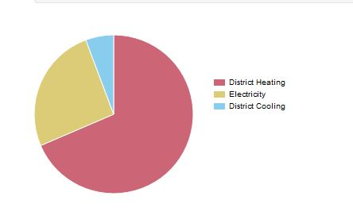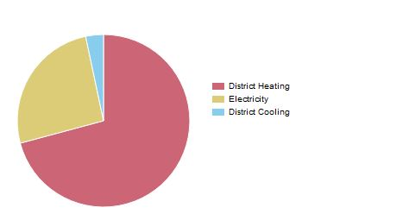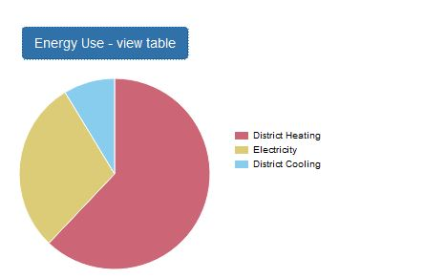

PIACENZA

FRANKFURT

ANKARA

Incrementally the point arrived these pie charts shows the percentages of energy usage for same building in different cities. As it is seen heating, lighting, cooling amounts are different for each city. The points at weather summary table effect the amount of energy in the cities.

Figure 4 End Usage and Energy Usage

Figure 3 Weather Summary

These weather tables for each city are evidential reasoning for different net site energy and EUI results from Figure 2. The variation between 'latitude, longitude, elevation and time zone' of three cities are bring about different weather conditions which cause different amount of energy use.

PIACENZA

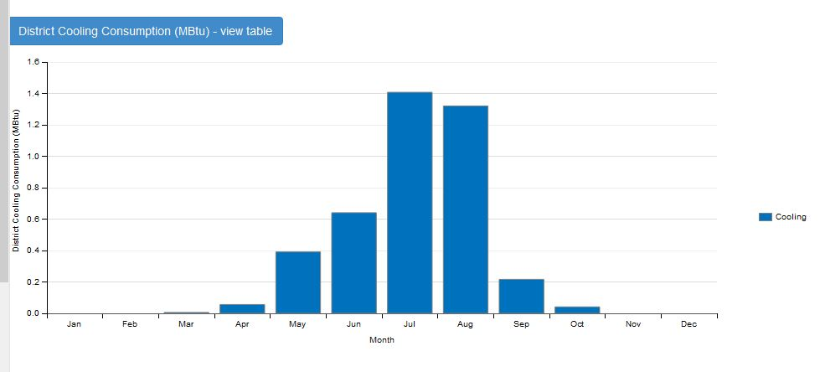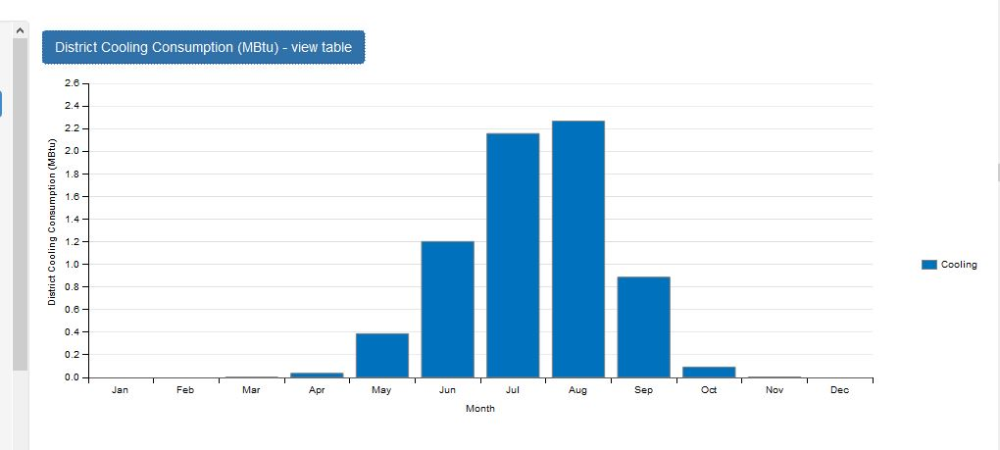

FRANKFURT

ANKARA

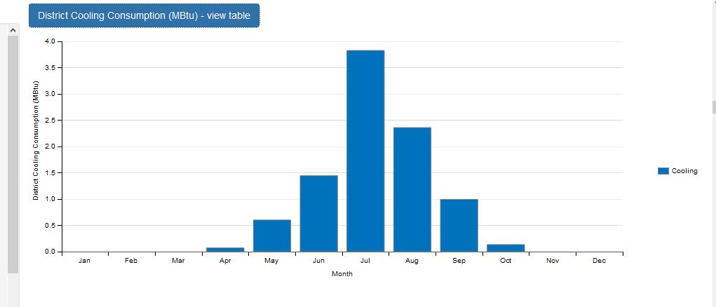

PIACENZA

Figure 5 District Cooling Consumption

These 3 cities located at south hemisphere so the warmest months are June, July and August. Used energy amount for cooling are highest at these months for each city. But because their longitude, latitude and elevation changes for each of them their warmth changes. At summer times warmest city is Piacenza then Ankara and Frankfurt so the most energy for cooling consumed at Piacenza. In August while cooling consumption is 2,36 MBtu in Piacenza, it is 2,27 MBtu for Ankara and 1,32 MBtu for Frankfurt.

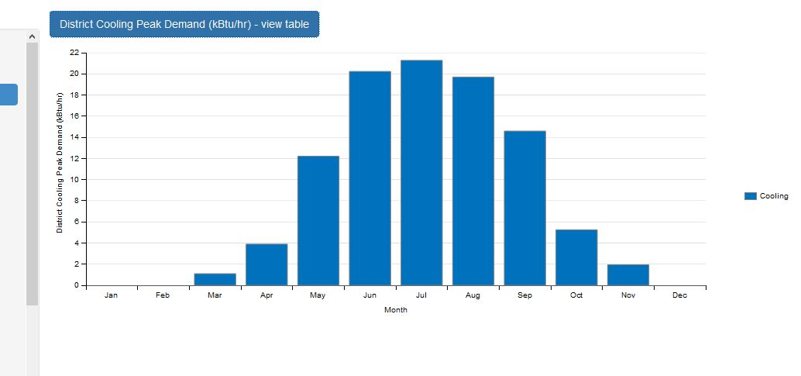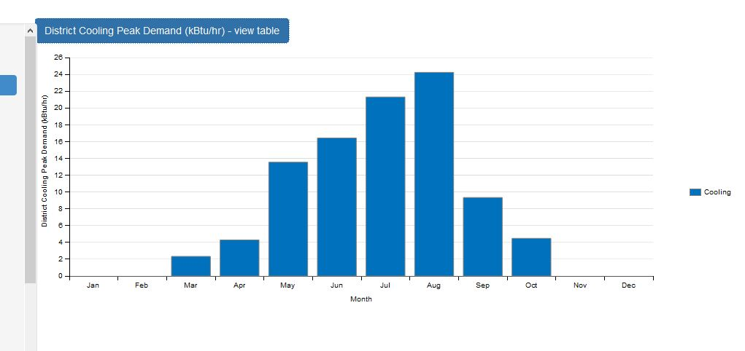

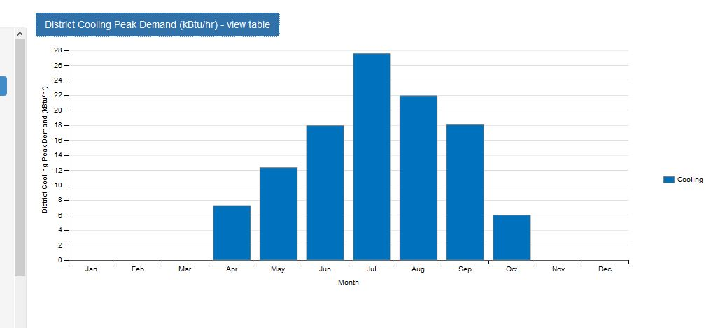

Figure 6 District Cooling Peak Demand

PIACENZA

ANKARA

FRANKFURT

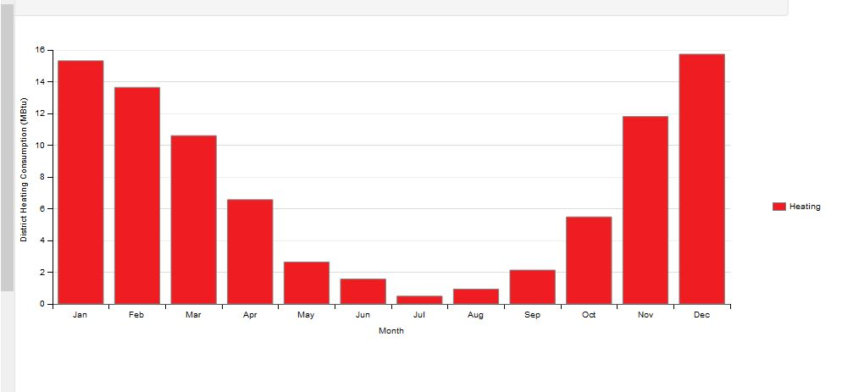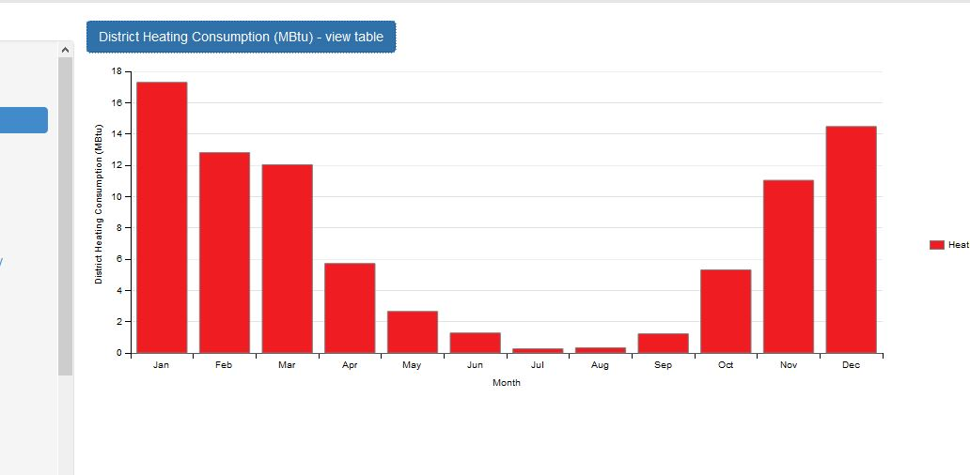

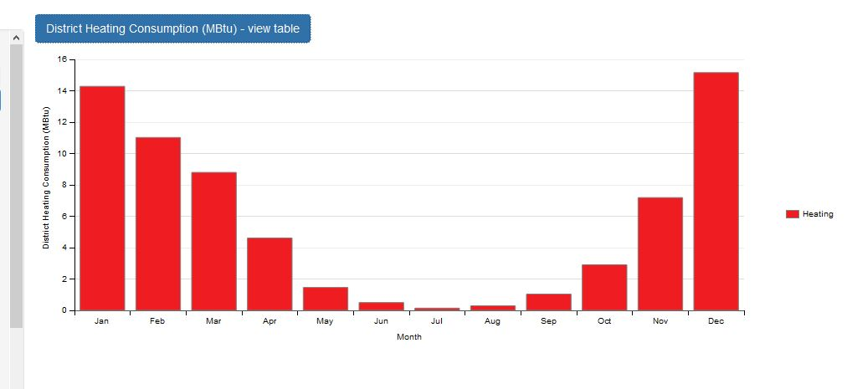

FRANKFURT

ANKARA

PIACENZA

Figure 7 District Heating Consumption

Along the same line heating consumption distribution is hinge on longitude, latitude and elevation of the cities because each city are in the same hemisphere. The coolest month is January for each of them but the heating consumption is 17,3 MBtu for Ankara which is the highest among Frankfurt and Piacenza. For Frankfurt it is 15,31 MBtu and 14,28 MBtu for Piacenza.

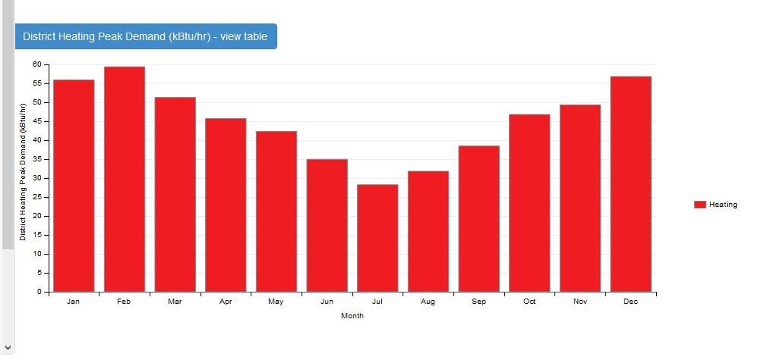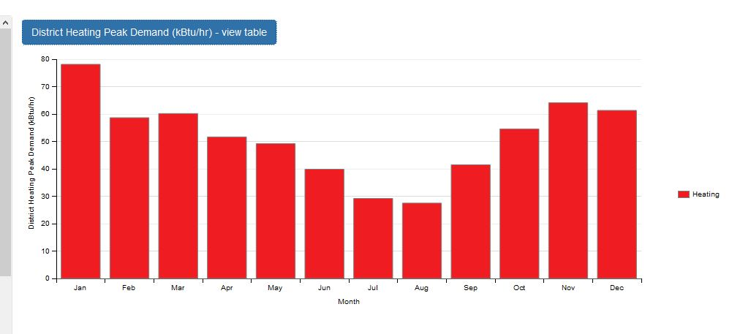

PIACENZA

ANKARA

FRANKFURT

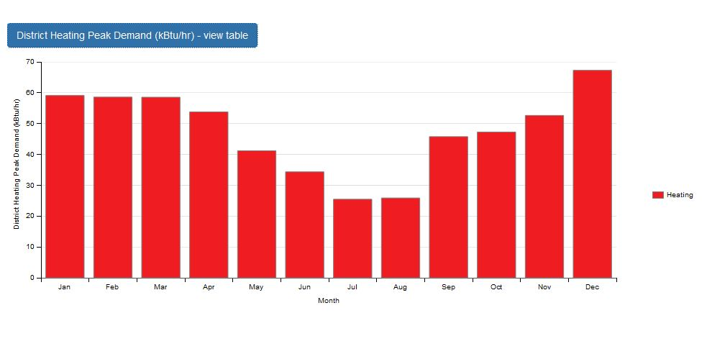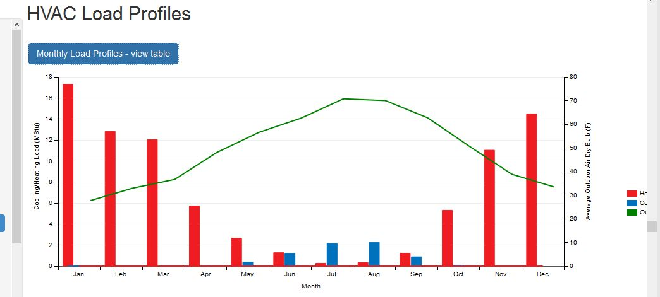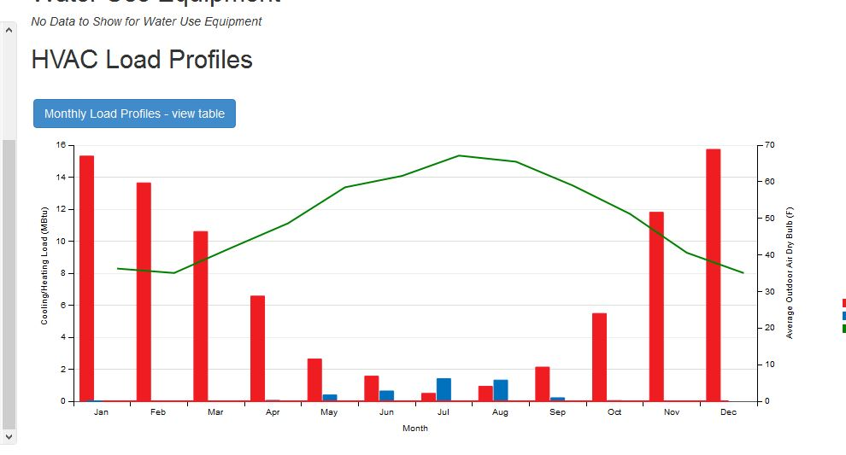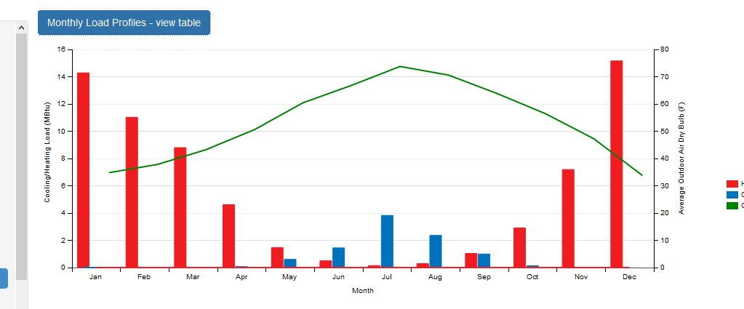

Figure 8 District Heating Peak Demand

Figure 9 Monthly Load Profiles

Figure 9 shows monthly heating and cooling demand. As it is seen the relation between temperature per months are directly proportional with the monthly demand of heating and cooling. Everything aforementioned before about the weather and consumption of heating, cooling connection is summarized and proved in this table one more time. Frankfurt has the less temperature degree at winter time so the demand for heating is higher. The highest temperature at summer time is seen at Piacenza so the demand for cooling is the highest.

4 EVALUATION and RESULTS of ENERGY PERFORMANCE of the BUILDING

- AFTER MATERIAL CHANGE-

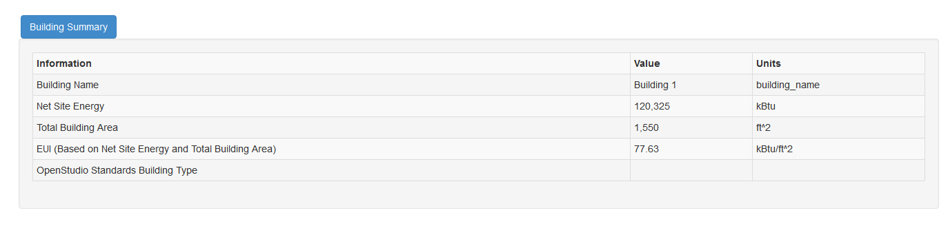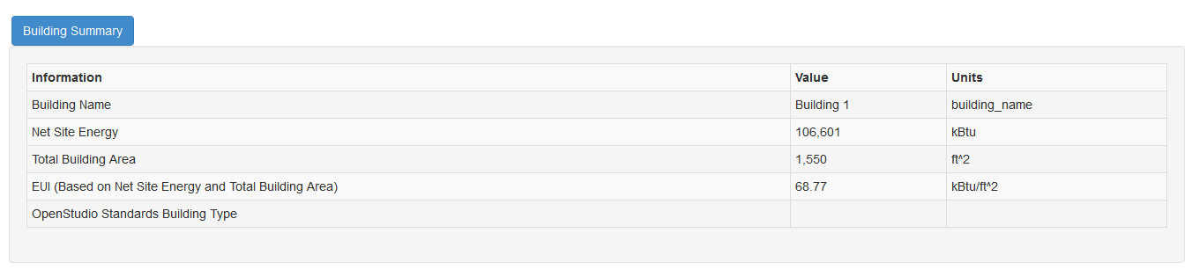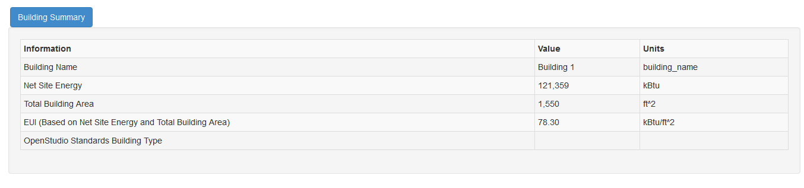

ANKARA

FRANKFURT

PIACENZA

Figure 10 Building Summary Table

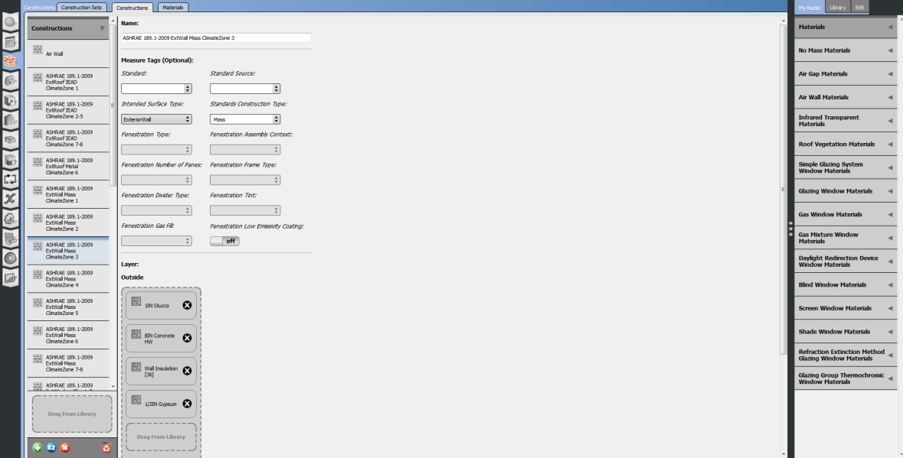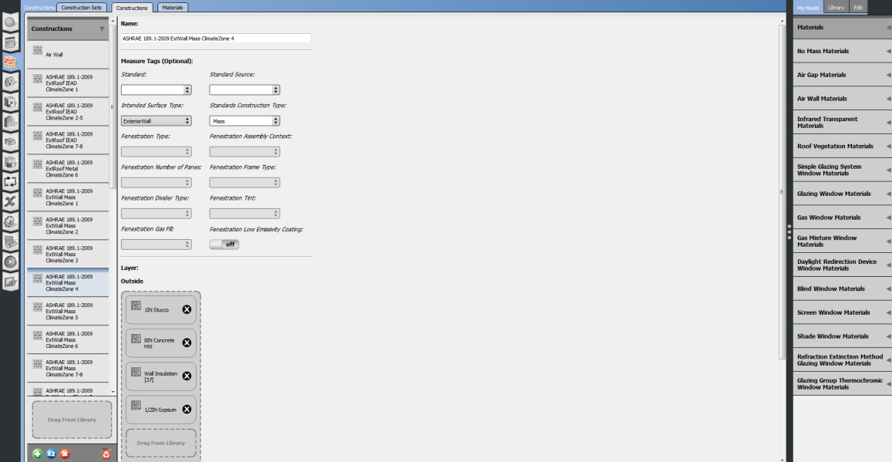As it is seen in the tables, with the same building plan different 'Net Site Energy' results were obtained for different cities. Total building area is 1550 ft² for each but Net Site Energy values are 120,3 kBtu for Ankara, 121,3 kBtu for Frankfurt and for 106,6 kBtu for Piacenza. The reason behind the differences of the net site energy results and EUI can be understood by different geographical conditions of the cities and the different building materials used for all.

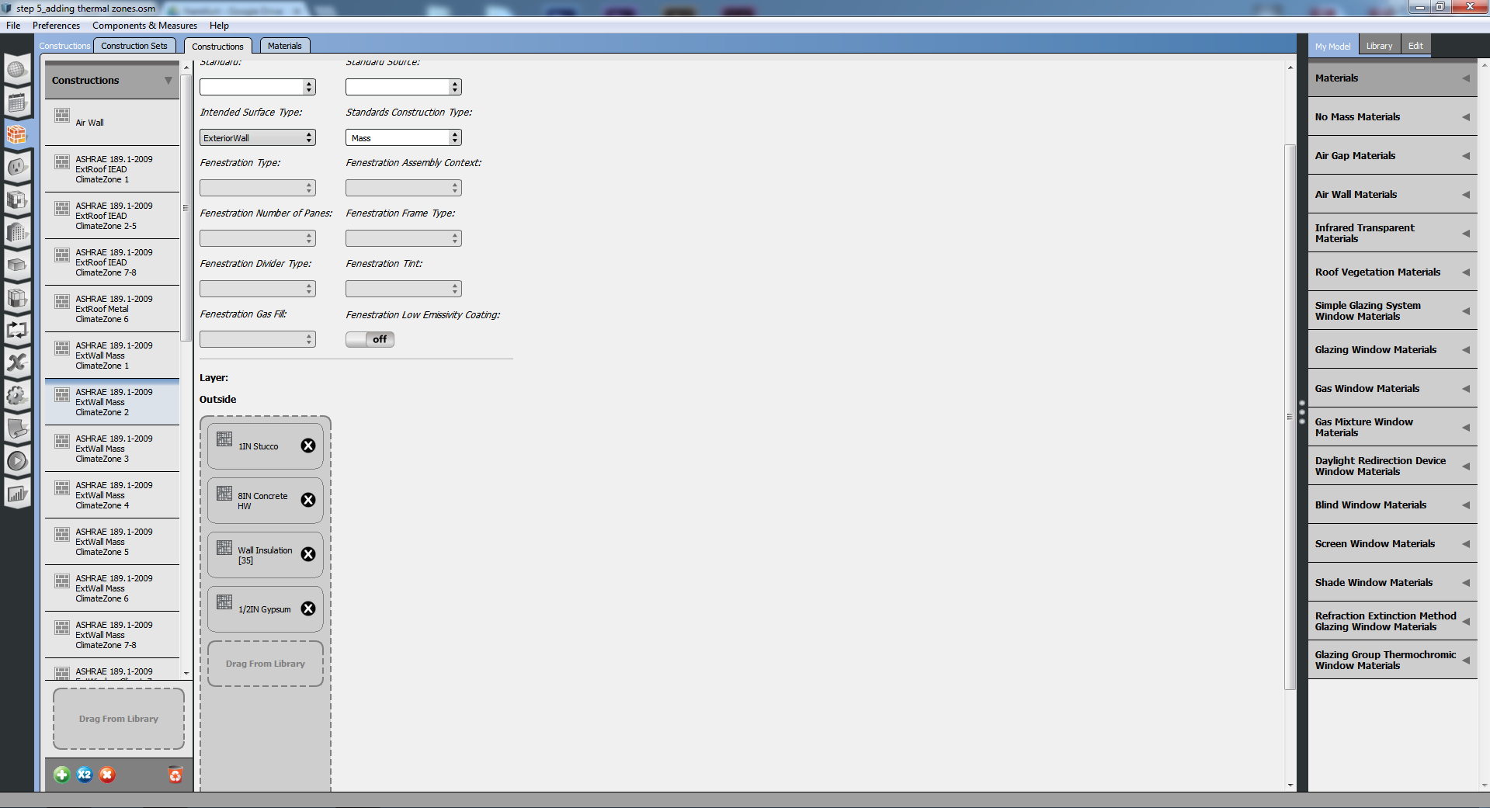

Figure 11 Different Construction Materials

The same processes done with the same building plan in same cities but in this instance different building materials used for each city. One of the most important element of the building in order to cope with weather conditions is the wall insulation material at external wall. Therefore in this part of the report different thickness of insulation material is used and new diagrams are constituted (Figure 11). For Ankara 37, for Frankfurt 35 and for Piacenza 36 mm wall insulation material is used. Before material change wall insulation thickness was 31mm for each city. It can be observed now how the thicken insulation material can affect the energy consumption.

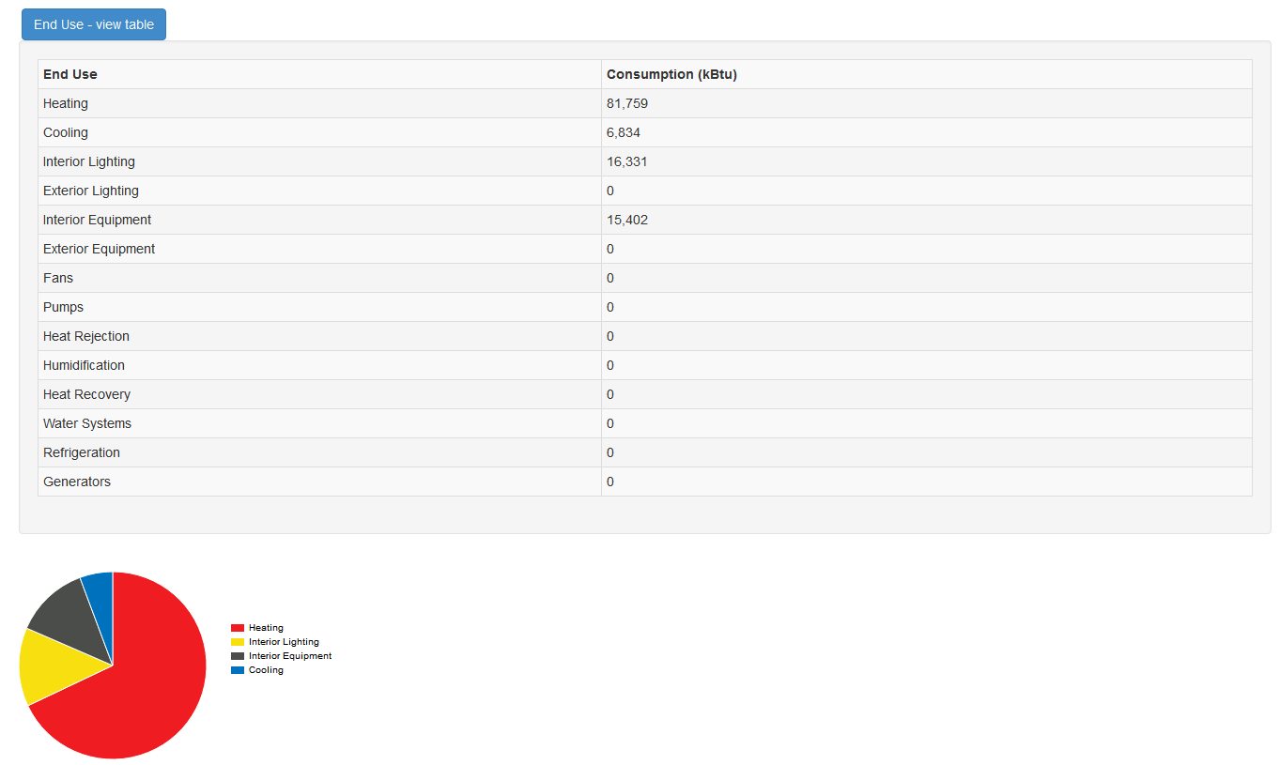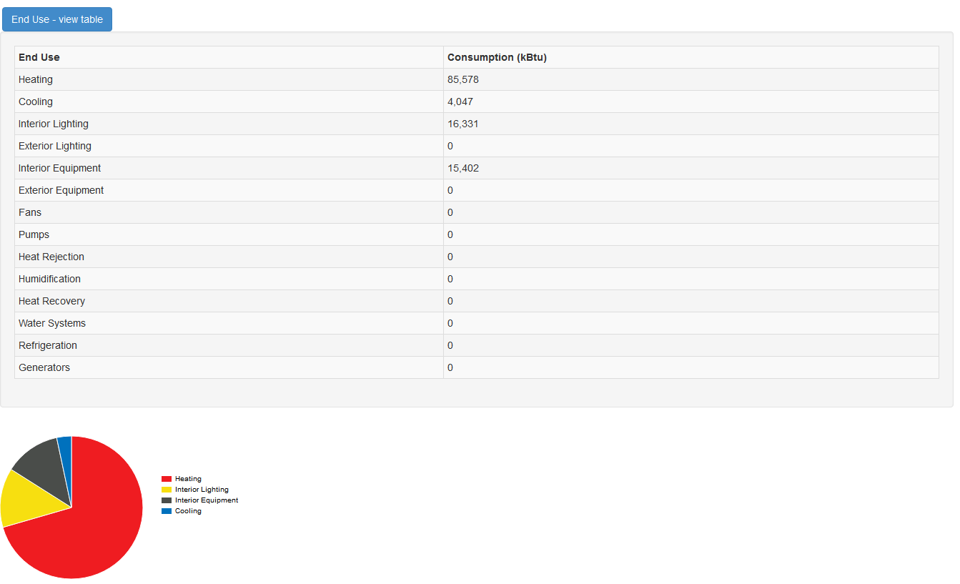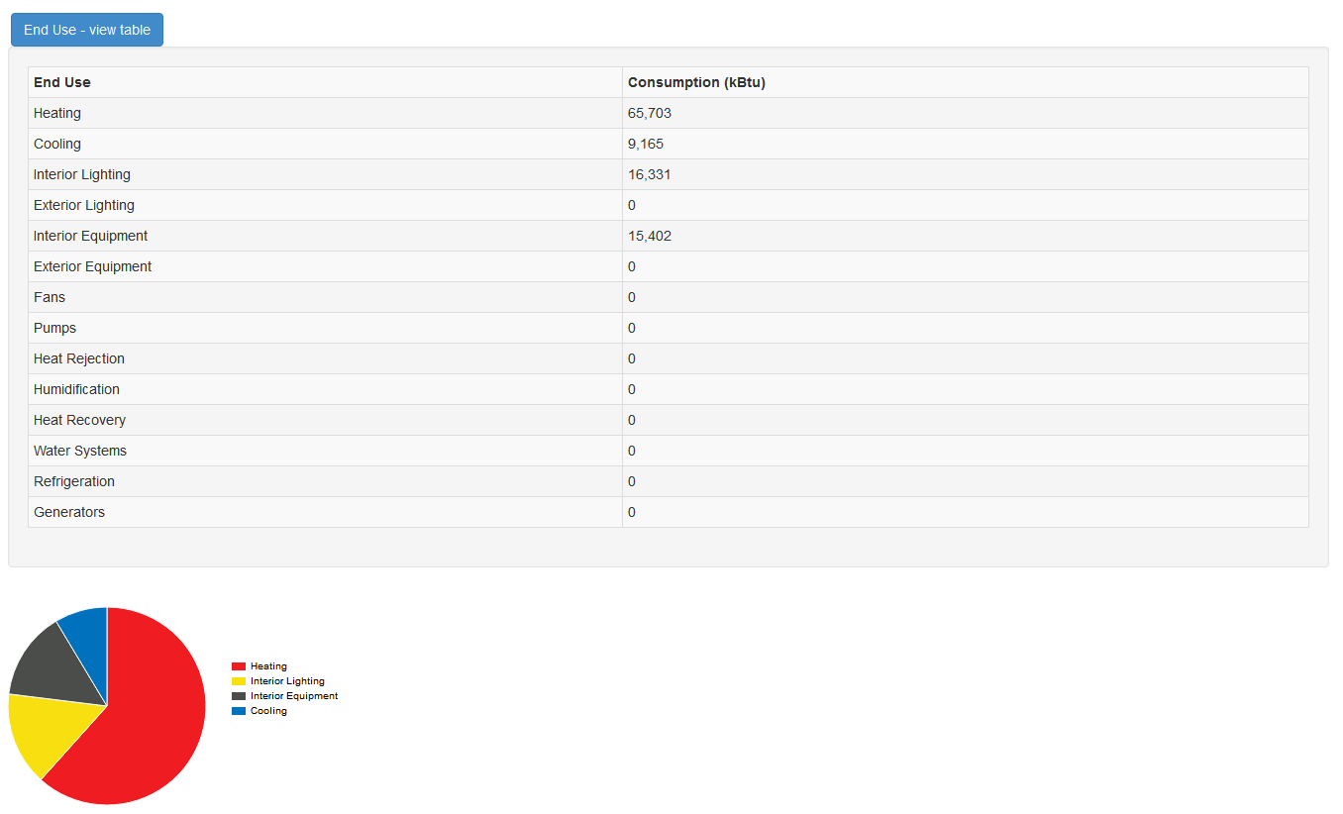

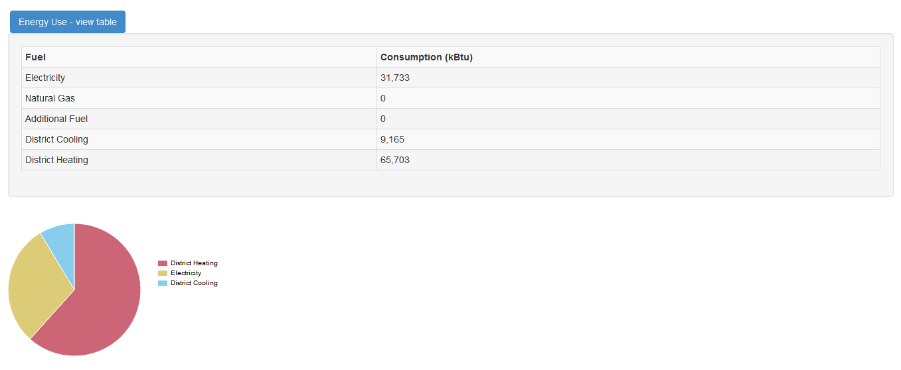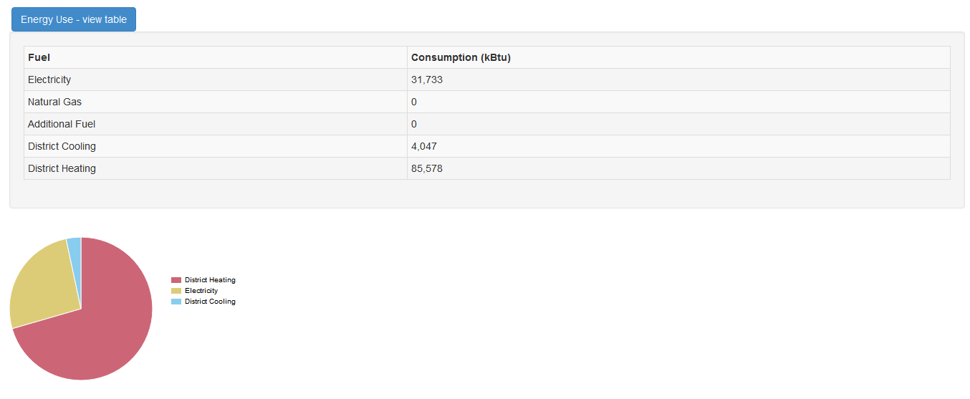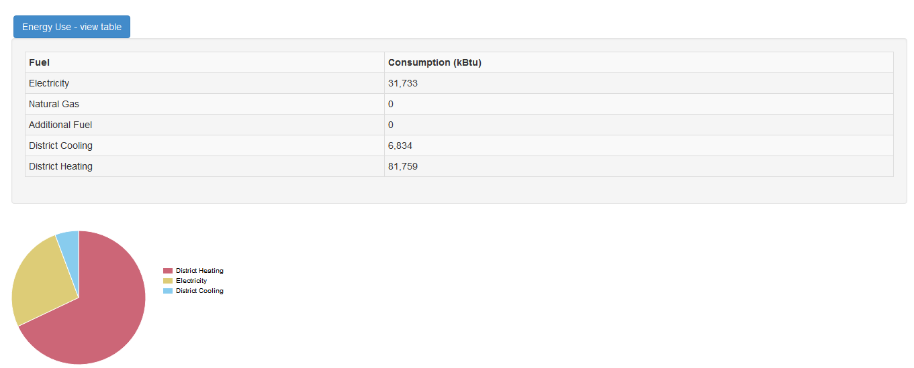

ANKARA

PIACENZA

FRANKFURT

Figure 12 End Usage and Energy Usage

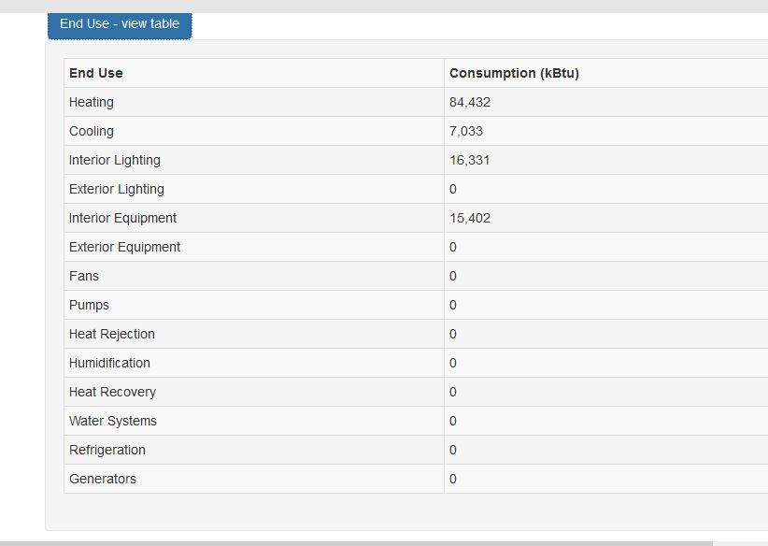

ANKARA

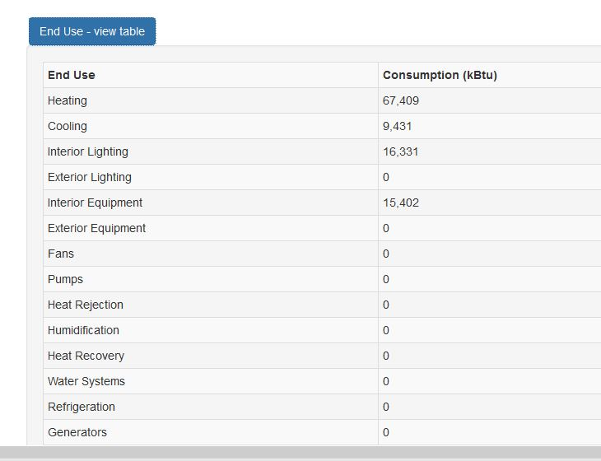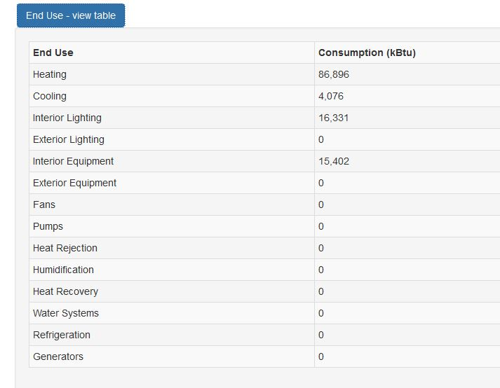

This table and the pie charts show the energy consumption value before and after material change. As is seen because the thickness of wall insulation is increased consumption of heating and cooling amount decrease in each city.

BEFORE

AFTER

PIACENZA

FRANKFURT

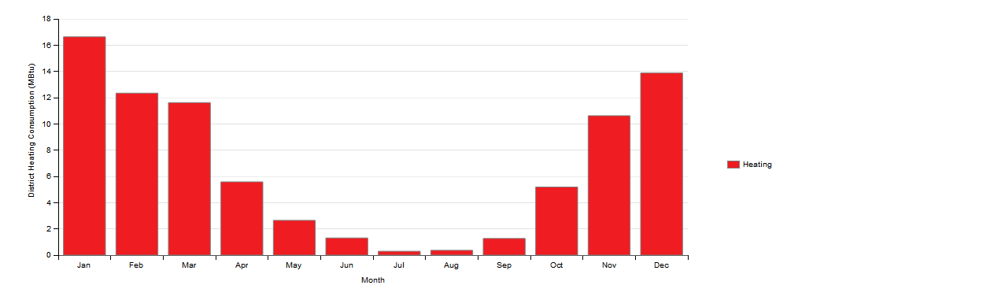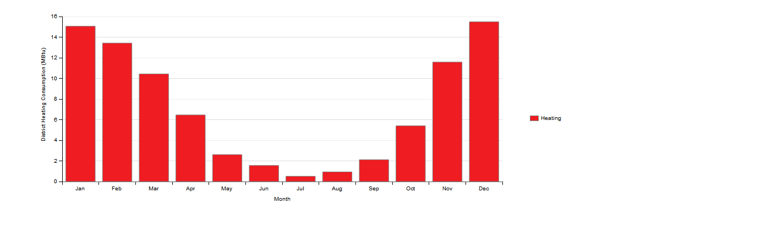

FRANKFURT

ANKARA

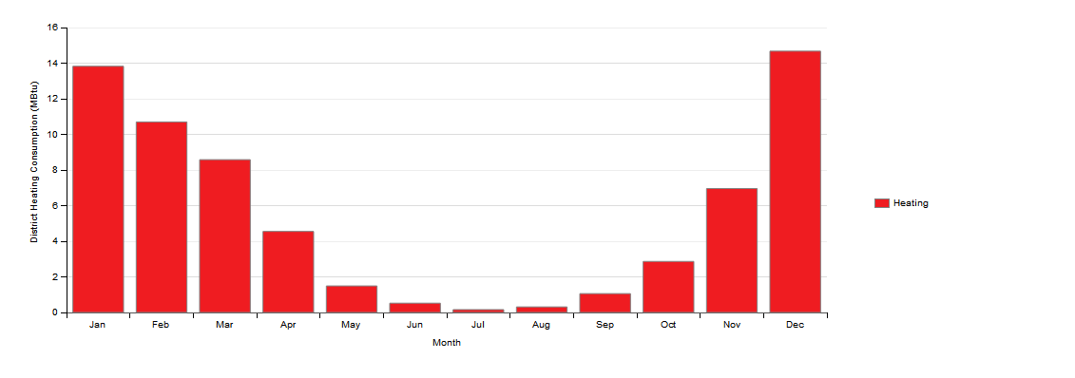

PIACENZA

Figure 13 District Heating Consumption

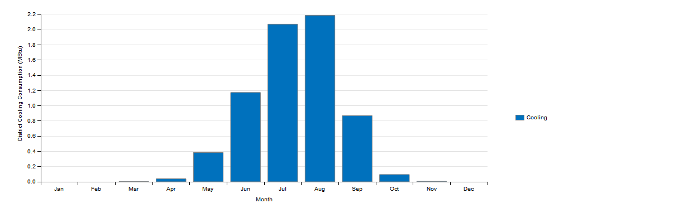

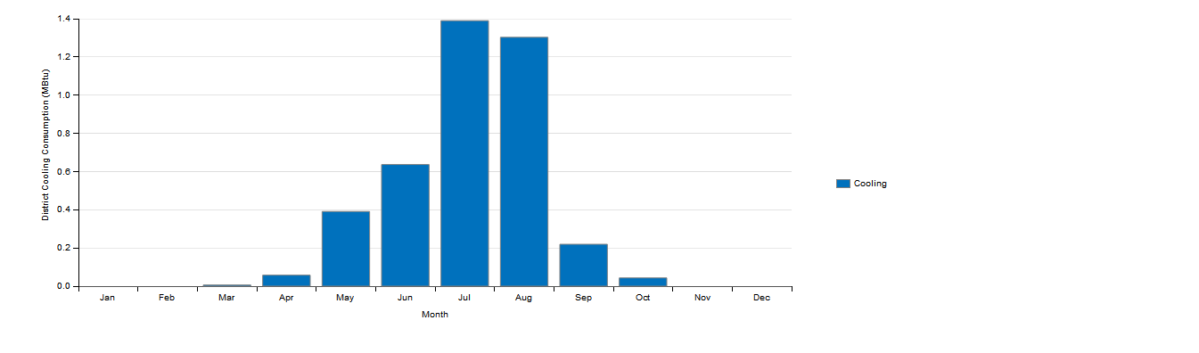

FRANKFURT

ANKARA

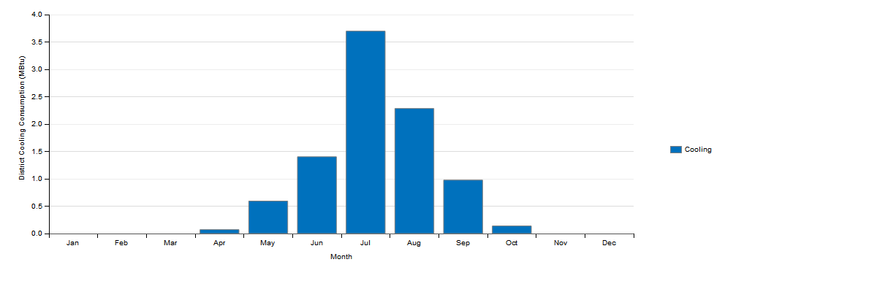

Figure 15 District Cooling Consumption

PIACENZA

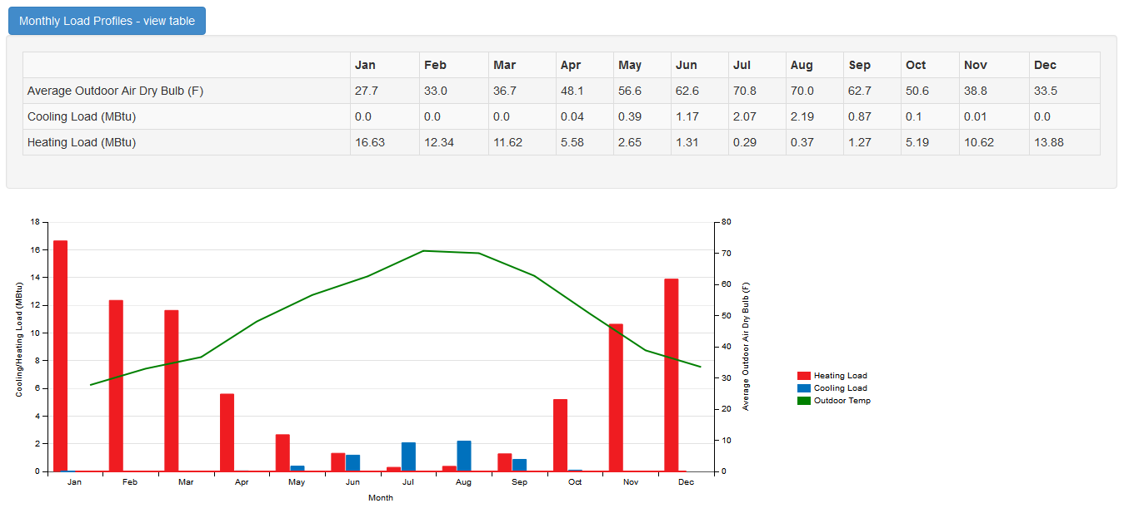

ANKARA

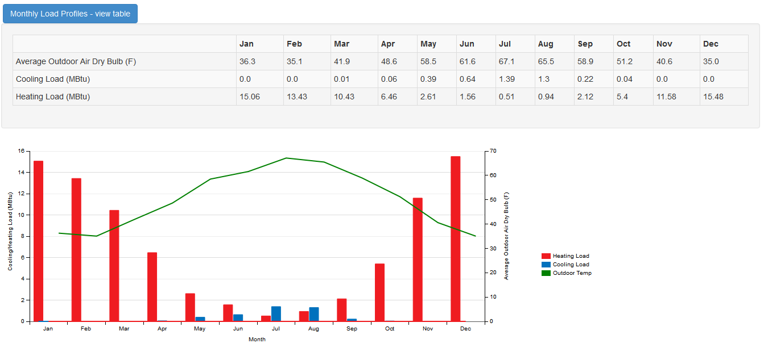

FRANKFURT

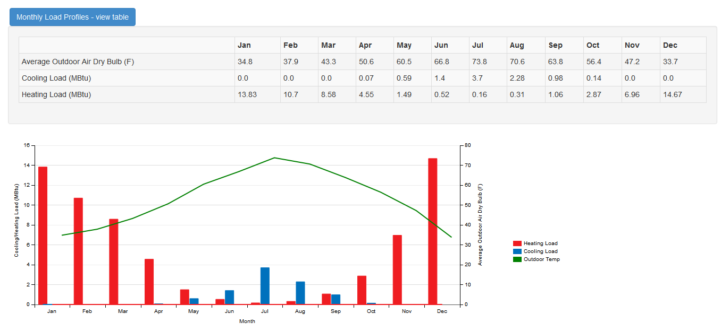

Figure 17 Monthly Load Profiles

PIACENZA

5 RESULTS

-BEFORE MATERIAL CHANGE-

ANKARA

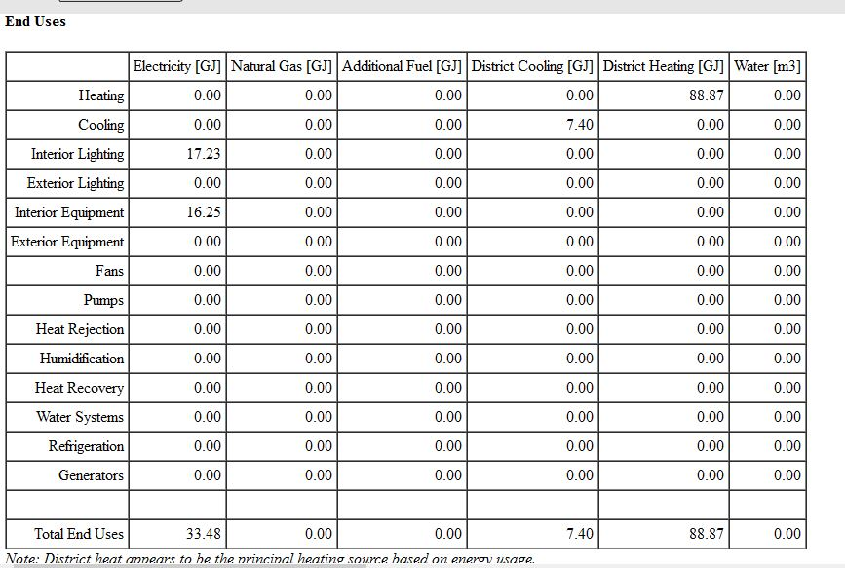

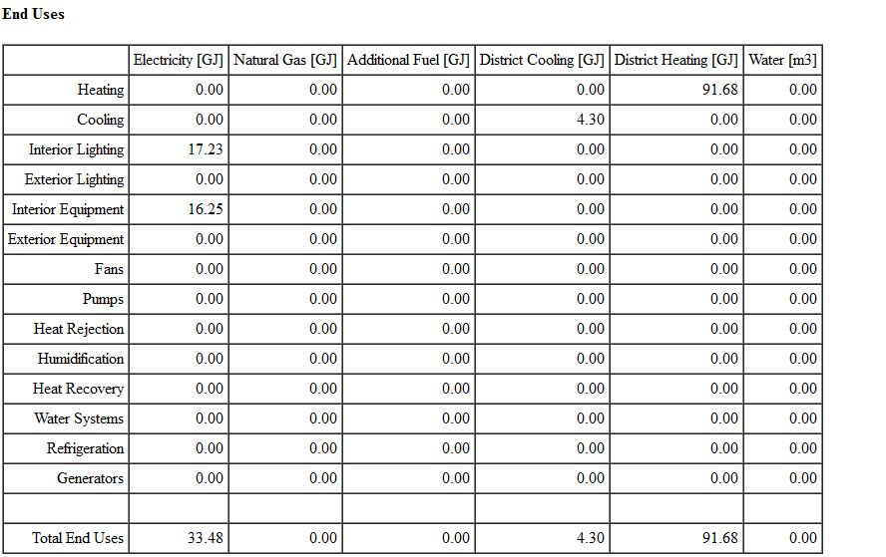-

FRANKFURT

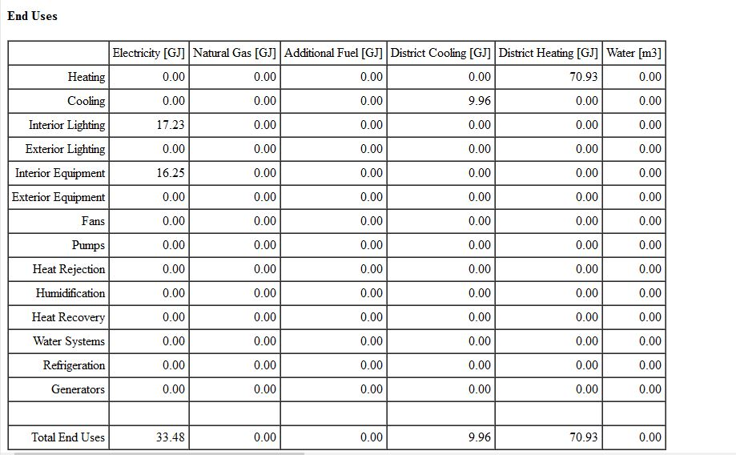

PIACENZA

As a conclusion there are three different end uses results showing how much energy is being used for electricity, district cooling and district heating according to the Energy Plus results. These results fluctuating when the city changes. For example the use of energy for heating is too high in Frankfurt since it is cooler than Ankara and Piacenza in the winter time whereas the use of energy for cooling is too low in Frankfurt since it is warmer than Ankara and Piacenza in the summer time. Besides the lowest value for district heating and the highest value for district cooling belong to Piacenza while Ankara has the average energy consumption value for both district cooling and district heating so it is in between Piacenza and Frankfurt.

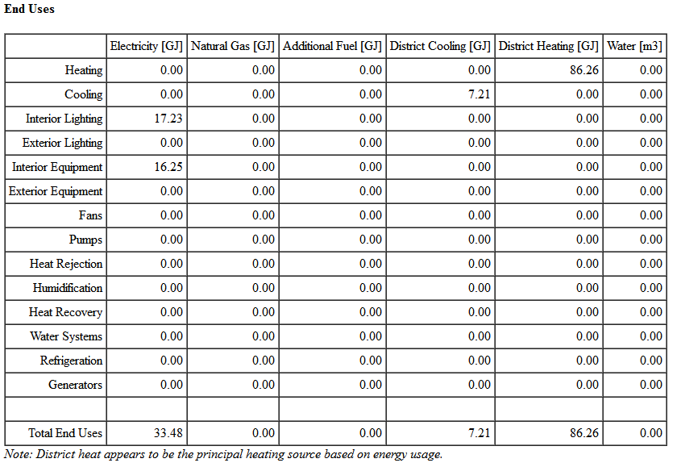

ANKARA

-AFTER MATERIAL CHANGE-

FRANKFURT

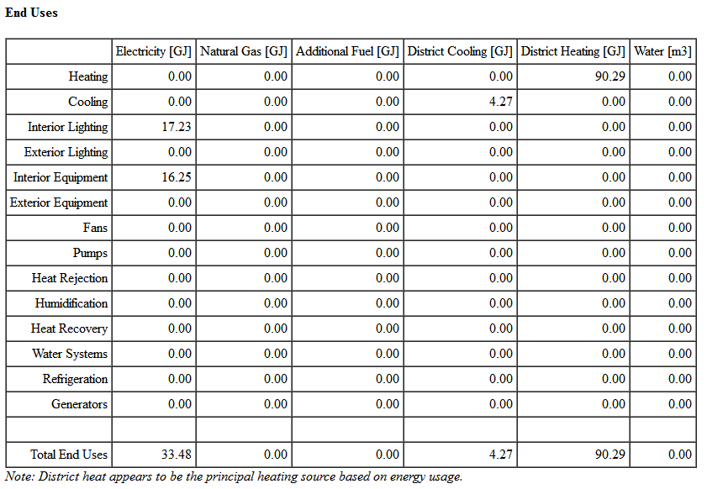

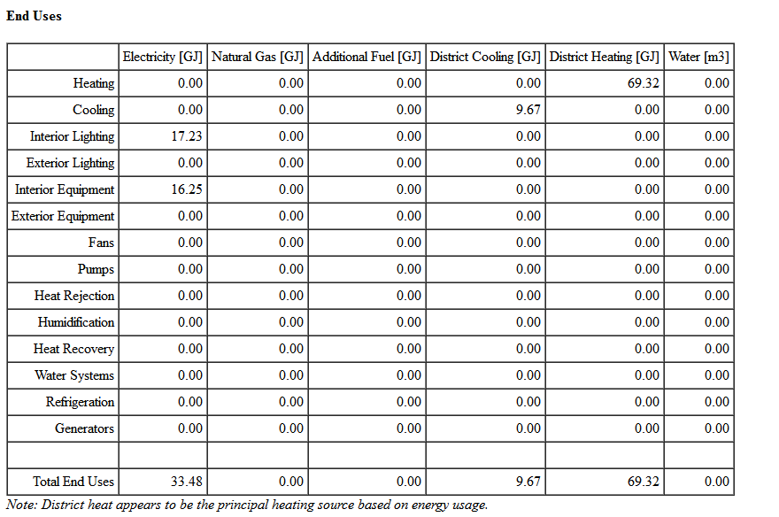

PIACENZA



When we have changed the wall material the results have changed in these cities. We considered three different wall materials for three different cities to compare the district cooling and district heating values separately. For instance the first material was the same in Ankara, Frankfurt and Piacenza which is 31 mm wall insulation. That’s why we have compared three cities among each other in terms of their end use energy. Then we have used wall insulation material with different thicknesses for each city in order to compare the city in itself in terms of how much energy is used in respect to the thickness of wall insulation material. According to the Energy Plus results we have lower energy consumption values for both district heating and district cooling in three different cities since the thickness of wall insulation material is greater than the first material. We have used 37 mm wall insulation material in Ankara, 35 mm wall insulation material in Frankfurt and 36 mm wall insulation material in Piacenza in the second phase. The biggest change is in Ankara since the thickest wall insulation material is used there. Other than Ankara, Frankfurt and Piacenza have a remarkable amount of change. In this way we can assume that the wall insulation material has an essential role for the end use of energy to benefit from district cooling and district heating in a better way.