**TECHNICAL ENVIROMENTAL SYSTEMS**

**Stole Stoichevski**

**Hasan Debes**

**Emin Sahin**

**Introduction:** First of all the model of a building is created in sketchUP to represent a designed building in reality. City of Piacenza is selected in the first place to experiment the different thicknesses of insulation layers in different walls. Using internet the weather condition in Piacenza is found and recorded. The first wall contains no insulation layer, where the second wall contains 3 and third wall contains 8cm of it. Then the program gave us the data about the energy issues for each type of wall so we can compare them to choose the optimum thickness for insulation. Than the same model is experimented for different cities with different weather conditions. The main differences are compared in next parts of this report.

**The Picture of the Created Model The Wall Detail**

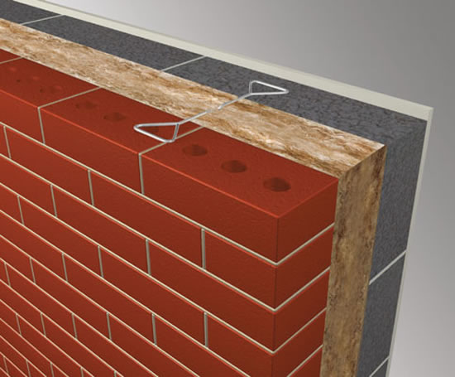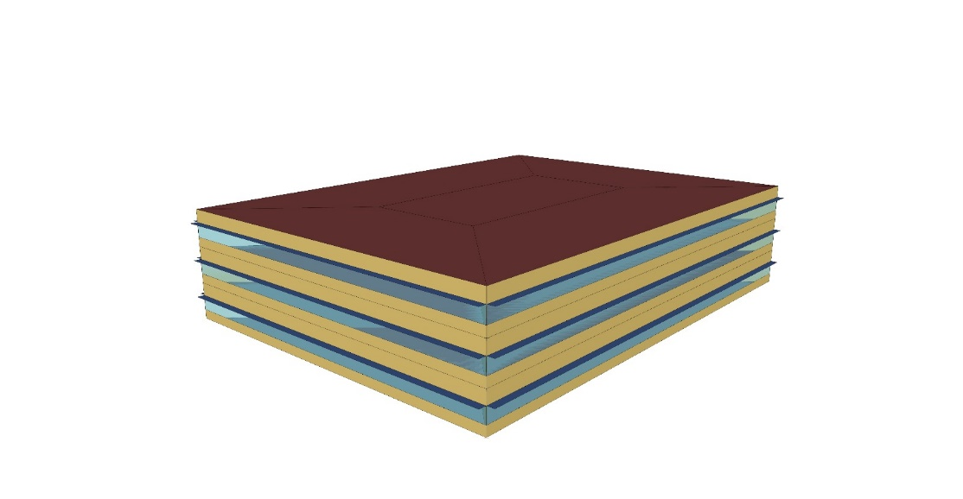

**Wall 1( no insulation )**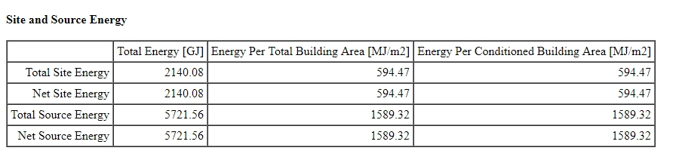

**Wall 2( 3cm insulation )**

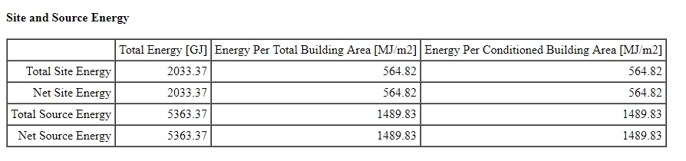

**Wall 3( 8cm insulation )**

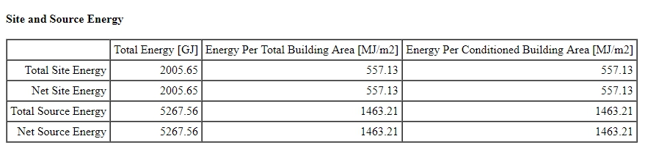

From the values in tables it is clear to see that the walls including a thicker insulation decreases the total energy needed. For example net source energy for wall 3 is 5268 GJ where it is 5722 GJ for wall 1 with a great difference.

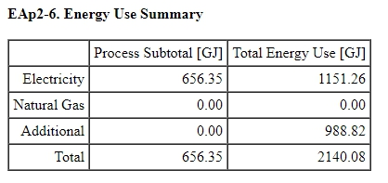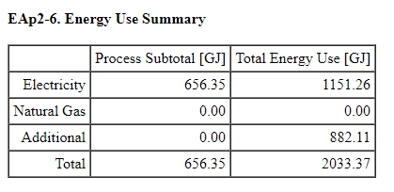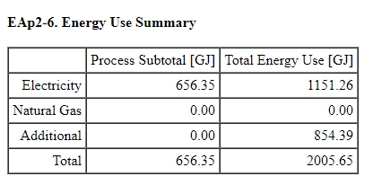

In these tables of energy use summaries, the importance and efficiency of insulation is visible as the total energy use for wall 1 is much greater than wall 3, as more energy is lost to the environment due to lack of insulation.

New York

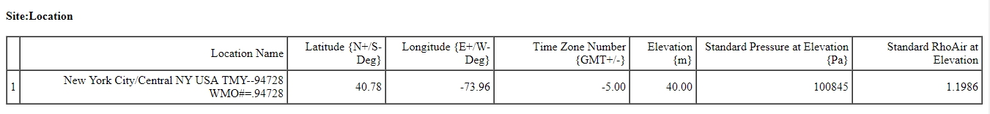

Piacenza

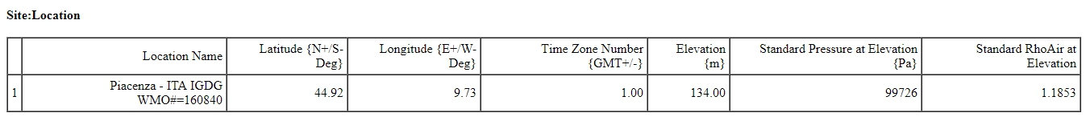

Tokyo

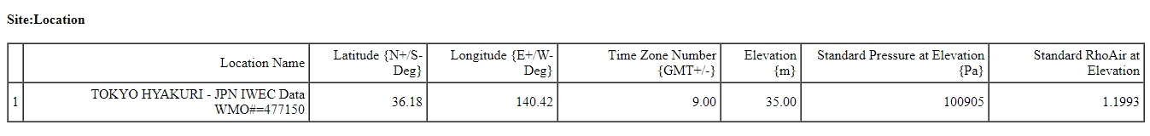

For 3 different cities in different places on the world these are the selected ones which are New York, Piacenza and Tokyo. Three of this cities has different weather conditions. The exact location of the cities are given in the tables as latitude, longitude and elevation values.

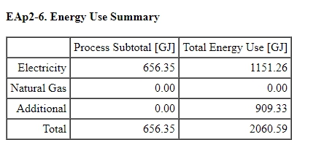 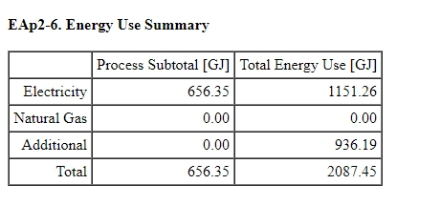

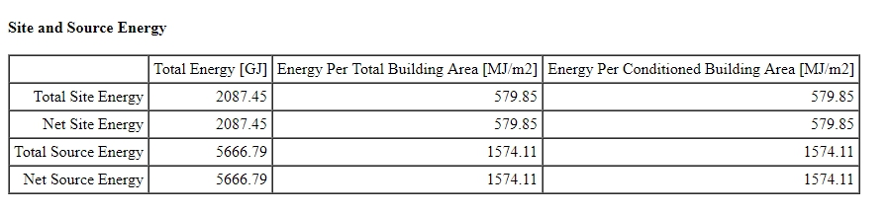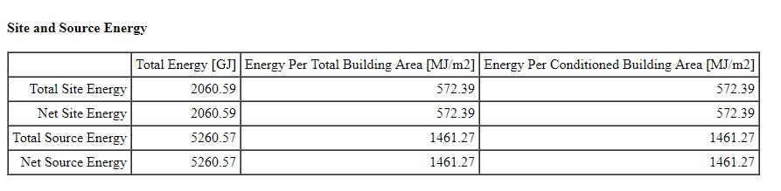

**Conclusion:** The 3 case studies gave us different interesting results that can be progressed on defining each different step related with environment. Different locations which are Piacenza New York and Tokyo generates different environments which requires sensitive solutions related with conditions. Also different materials and thicknesses creates different results in terms of energy and energy usage. All the results are clearly visible in the reports created for different variations.