Scotti Michele – Tagliabue Camilla



Energy and environmental technologies for building system

1. Goal of the project

The purpose of the project is to create a commercial building and study its consumption of energy. The energy needed is function of several parameters, the main are:

* Type of each room (dimension, utilization)
* Number of occupants (it has an important influence on latent and sensible loads)
* Internal thermal production (given by lights and machineries)
* Windows (type of glass, dimensions, shadings)
* Walls (composition of the stratigraphy)
* Solar exposition

The project is articulated in 3 parts:

* 1. Create a model of the building using Sketchup, defining the different thermal zones and the parameters above mentioned
  2. Fix a random city, decide the type of walls and make an energy consumption simulation using the software Openstudio; this will be the “Base case”
  3. Change the city and the composition of external walls, obtaining different scenarios with different consumptions

1. Building

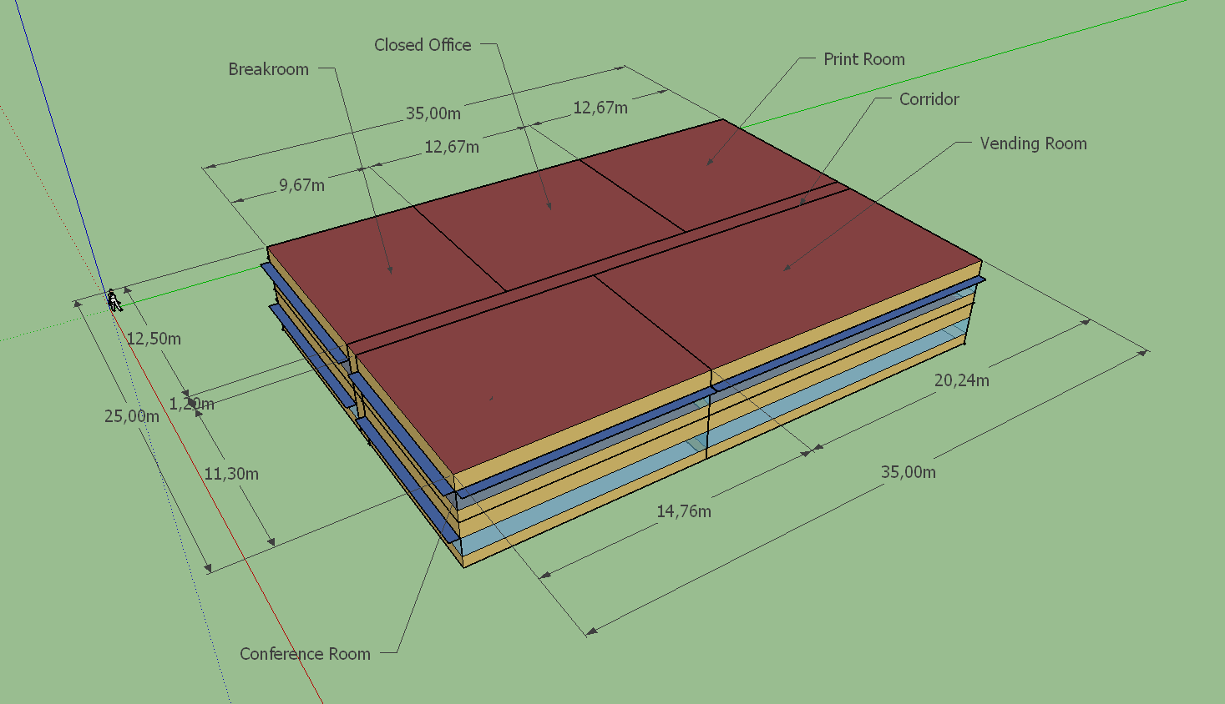

The building is a commercial structure with 2 identical floors: there is a breakroom, a closed office, print room, vending office and conference room.

Windows characteristics:

* Window to wall ratio (fraction) : 0.4
* Offset : 0.76 m

Shading factor:

* Projection factor (fraction) : 0.5
* Offset : 0

1. Thermal zones

There are 6 thermal zones determined by the utilization of the room (2 rooms with the same function are into a single thermal zone). The settings are:

* Space type : 189.1 – 2009 – Office – “type room” – CZ1-3
* Building Story : Building story 1
* Construction Set : 189.1 – 2009 – CZ1 – Office

1. Climate zone

The study is conducted considering 3 cities into the Climate Zone 1 following the ASHRAE directives:

* Palermo (Italy)
* Madrid (Spain)
* Porto (Portugal)

1. Wall composition

The other parameter we change is the composition of the external walls. We have 3 different composition:

* ASHRAE 189.1 – 2009 ExtWall Mass Climate Zone 1, formed by:
  + 1 inch stucco
  + 8 inch concrete HW
  + wall insulation 31
  + 0.5 inch gypsium
* Mywall 1, formed by:
  + 1 inch stucco
  + M11 100 mm lightweight concrete
  + Wall insulation 35
  + 0.5 inch gypsium
* Mywall 2, formed by:
  + 1 inch stucco
  + i01 25 mm insulation board
  + wall insulation 40
  + 0.5 inch gypsium

1. Work hypothesis

During the study, there are some fixed parameters. The classification follows the list of parameters written in point 1

* Type and dimension of rooms is every time the same
* Number of occupants is determined by tables and it varies for the utilization of the room. It’s defined as “people on square meter” and will not change
* Number of lights is function of dimension of the room and is pre-calculated by the program using table; the same is true for internal machineries

1. Results
   1. Madrid - ASHRAE 189.1 – 2009 ExtWall Mass Climate Zone 1 – Annual Overview

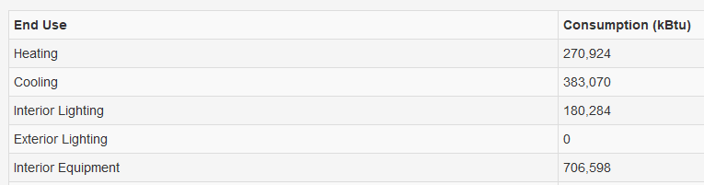

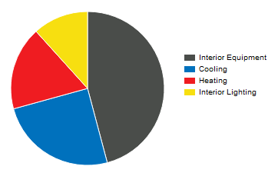 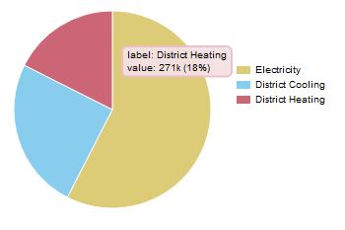

* 1. Madrid – Mywall 1 – Annual Overview

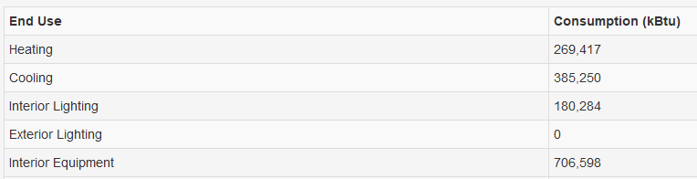

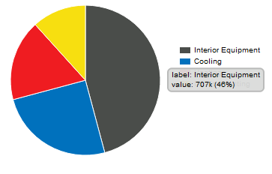 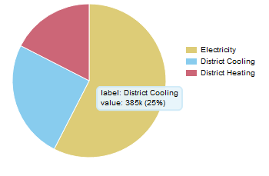

* 1. Madrid – Mywall2 – Annual Overview

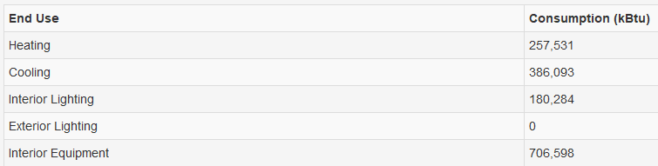

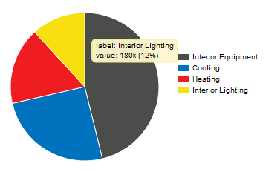 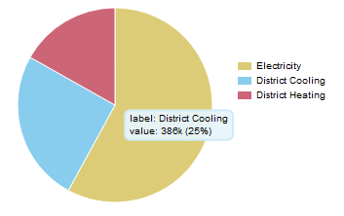

In Madrid the energy required for cooling and heating is around the same during one year

* 1. Palermo - ASHRAE 189.1 – 2009 ExtWall Mass Climate Zone 1 – Annual Overview

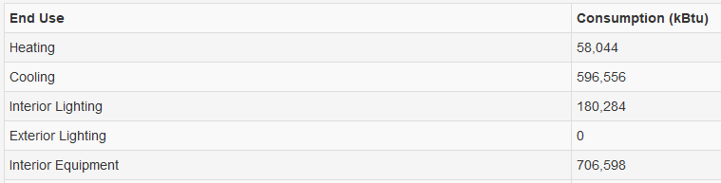

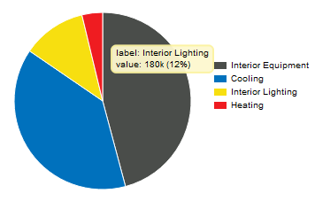 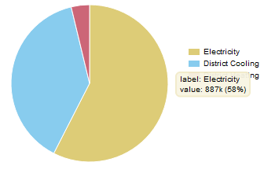

* 1. Palermo – Mywall 1 – Annual Overview

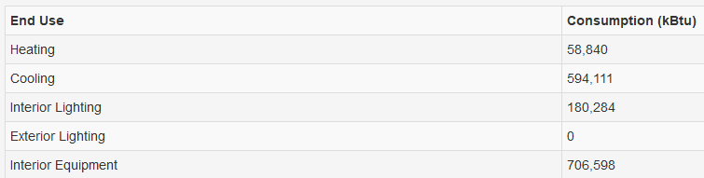

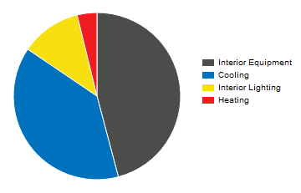 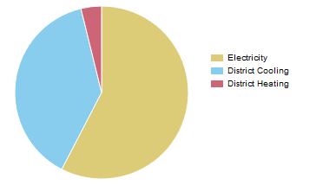

* 1. Palermo – Mywall 2 – Annual Overview

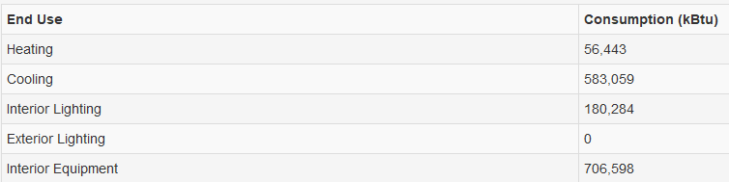

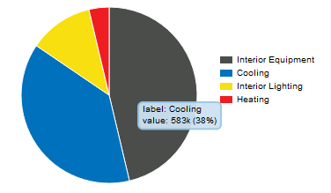 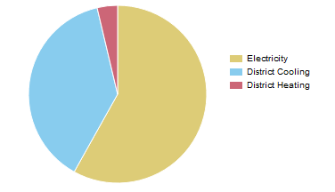

In Palermo the high temperatures permit to have a very low consumption for heating during winter; the drawback of this is that during summer consumption of electricity for air conditioning is high. The total consumption between the two cities is similar.

* 1. Porto - ASHRAE 189.1 – 2009 ExtWall Mass Climate Zone 1 – Annual Overview

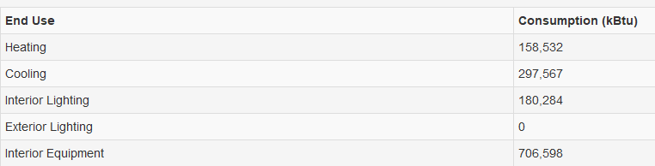

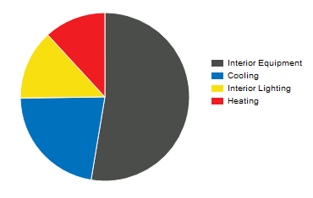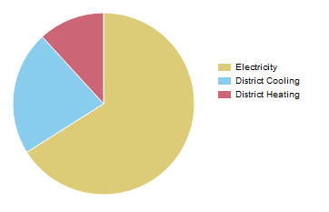

* 1. Porto – Mywall 1 – Annual Overview

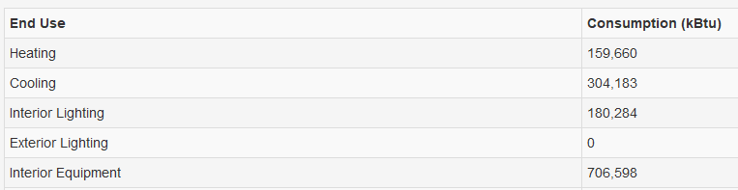

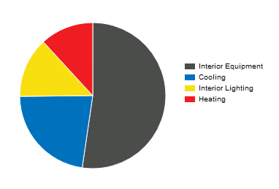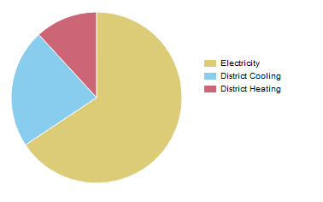

* 1. Porto – Mywall 2 – Annual Overview

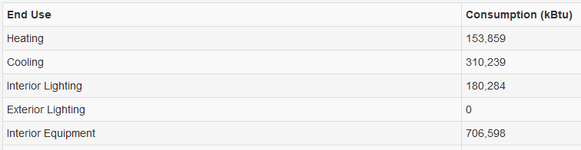

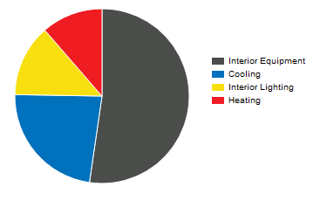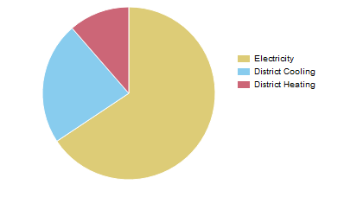

The last city considered is Porto. The consumption for cooling air is around the double of the energy required for heating. Looking at the table, it’s possible to see that consumption is lower respect Palermo and Madrid ( around 150-170 kBtu less).