**Brown University Simulation of the United Nations XXII**

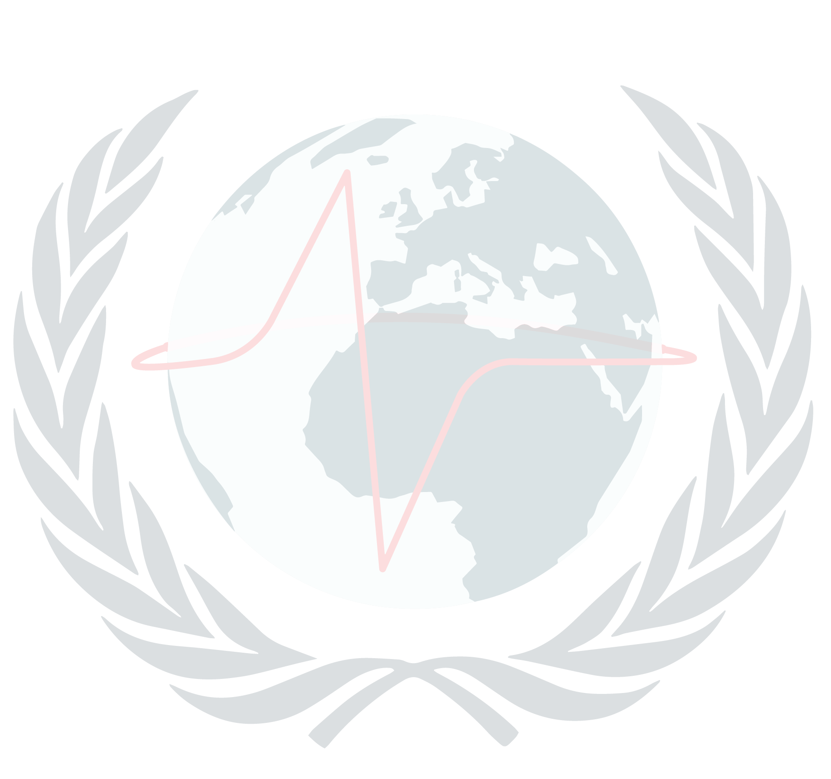

*On behalf of the BUSUN 2018 secretariat, chairs, directors, and staff, we are pleased to present the award for*

**$AWARD$**

*to*

**$DELEGATE$**

*of* ***$SCHOOL$***

*as* ***$POSITION$*** *in* ***$COMMITTEE$***

*___________________________ ___________________________*

*Jourdan Smithwick Colette Bare*

*Co-Secretary General Co-Secretary General*