HOMEFIRST AI LENDING
Mac — AI Mortgage Advisor
Scope, Requirements, Solution Design & Recommendations
Executive review
Based on an assessment of the current prototype (mortgage module, Google ADK + Gemini Live)
November 2026 · Draft for discussion · Confidential
Contents
1. Executive summary
2. Business context
3. Scope
4. Reference call: how Mac handles it
5. Functional requirements
6. Technical requirements
7. Solution design
8. Compliance and risk
9. Findings and recommended changes
10. Roadmap, success measures and decisions
Appendix: glossary

1. Executive summary
Mac is an AI voice agent that answers home-buyer and homeowner calls, explains mortgage options, checks eligibility against state rules and hands qualified callers to a licensed loan officer. It is the front door of the HomeFirst proposition: by automating the origination process with AI, borrowers save 0.5% to 1% in interest compared with traditional lenders.
A working prototype already exists. It holds a natural, interruptible voice conversation and completes the reference Texas HELOC call end to end: it detects that a HELOC is not allowed on the rental property, detects the existing cash-out mortgage, offers the alternatives and moves to a loan officer transfer.
Key messages
- The core is sound. Compliance rules live in code (a "policy door" every action passes through), not just in the AI prompt. That is the right foundation for a regulated product.
- It is a prototype, not a product. Phone calls, real loan-officer transfer, persistent data and production hosting are not built yet.
- Two requirement gaps. Mac does not yet learn regulations from documents and websites (rules are hard-coded for 3 states), and it does not yet compare options or prove the 0.5–1% saving.
- One critical defect found in testing. If the AI describes the property as a "rental" instead of "investment", the Texas block is skipped and Mac would say a HELOC is allowed. This must be fixed before any customer use.
- Recommendation: fund a 4-week hardening phase, then an 8-week Texas pilot limited to HELOC and cash-out refinance enquiries, gated by compliance sign-off.

Status at a glance
Capability | Status | Comment
Natural voice conversation with interruption | Working | Gemini Live via Google ADK; caller can talk over Mac
Reference call script (Texas HELOC) | Working | Passes when the AI uses the expected wording; see defect below
Texas HELOC rules | Defect | "rental" wording bypasses the investment-property block
Regulation knowledge from documents / websites | Gap | Rules hard-coded for TX, CA, FL; no scraping or document ingestion
Best-option comparison & savings proof | Gap | Rate estimates come from static ranges; no market comparison
Transfer to licensed loan officer | Partial | Simulated: creates a record, does not connect a call
Phone (PSTN) channel | Gap | Browser only today
Automated tests for mortgage rules | Gap | 42 tests pass, all for the earlier clinic agent; none for Mac
Production hosting, data and security | Gap | Single process, in-memory data, no authentication

2. Business context

2.1 The requirement
Build Mac, an AI mortgage lender that enables home buyers to get the best mortgage options and save 0.5% to 1% in interest compared with traditional lenders, because AI automates the origination process. Mac is an AI voice agent. Its knowledge comes from documents and website content (including regulations); web-scraping tools may be used.

2.2 What the saving means for a borrower
Illustration on a $400,000, 30-year fixed loan against a 6.50% traditional-lender rate (principal and interest only):
Rate reduction | Rate | Monthly payment | Saved per month | Saved per year | Saved over 30 years
Baseline | 6.50% | $2,528 | — | — | —
0.5% | 6.00% | $2,398 | $130 | $1,561 | $46,825
1.0% | 5.50% | $2,271 | $257 | $3,085 | $92,562
Illustrative only; lifetime figures assume the loan is held to term. Before this claim is used in any customer conversation or advertising it must be backed by documented pricing data (see section 8).

2.3 Mac's role in the value chain
The saving comes from lower origination cost across the whole process. Mac contributes by handling first contact around the clock at low cost per call, qualifying the caller and screening out ineligible scenarios (such as Texas HELOC restrictions) before a loan officer spends time on them, and handing over a complete summary so the loan officer starts where Mac stopped.

3. Scope

3.1 Phased scope
Phase | Objective | In scope
Phase 1  Prototype  (built) | Prove the voice experience and rule-checking pattern | Browser voice call · 10 tools · Texas / California / Florida HELOC rules · rate estimates from static ranges · simulated transfer · demo customer data
Phase 2a  Harden  (4 weeks) | Make the prototype safe and testable | Fix defects · mortgage test and call-scenario suite · regulation knowledge pipeline with citations · persistent storage · deployable container · security basics
Phase 2b  Texas pilot  (8 weeks) | Prove value with real callers under supervision | Phone number · warm transfer to loan officers with call summary · HELOC and cash-out refinance enquiries in Texas · consent and recording disclosures · CRM lead hand-off · monitoring dashboard
Phase 3  Scale | Expand coverage and automation | More states and products · live pricing engine and option comparison · document upload and pre-qualification · Spanish · loan origination system (LOS) integration

3.2 Out of scope (all phases unless approved)
- Mac approving, denying or committing to any loan, or locking a rate.
- Taking a formal loan application. Mac collects enquiry details only; applications go to a licensed loan officer.
- Legal or tax advice.
- Underwriting decisions, credit pulls or collecting full Social Security numbers by voice.
- Outbound marketing calls (these bring separate consent obligations).

4. Reference call: how Mac handles it
The required calling script was traced through the code and run against the rule engine. Each turn maps to a tool (a capability Mac calls) and a policy check.
Turn | Caller / Mac | What happens in the system | Status
1 | Mac greets: "Hi, this is Mac, your AI Mortgage advisor…" | Greeting is set in the persona and sent automatically when the call connects | Built
2 | Caller: two Texas properties, wants a ~$40k HELOC, asks about the rental | Mac calls check_heloc_eligibility(state TX, property investment) | Built
3 | Mac: Texas doesn't allow HELOCs on investment properties; asks about the primary residence mortgage | Rule returns not eligible plus alternatives. Defect: if the AI passes "rental", the rule says eligible | Defect
4 | Caller: $100k balance, worth ~$550k, existing cash-out | Mac calls check_heloc_eligibility(TX, primary, existing cash-out, 550,000, 100,000). Loan-to-value 18% | Built
5 | Mac: Texas doesn't allow a HELOC with an existing cash-out mortgage; offers refinance-then-HELOC or another cash-out refinance; offers a transfer | Rule returns not eligible with both alternatives; policy adds "offer a loan officer" | Built
6 | Caller agrees; transfer | transfer_to_loan_officer selects Lisa Chen (Texas lending specialist) if available that day; otherwise promises a call back | Partial

Regulatory note for compliance review
- The script reflects Texas Constitution Article XVI, Section 50: home equity lending, including HELOCs, is only available on a homestead, combined loan-to-value is capped at 80%, and only one home equity loan (a Texas cash-out refinance counts as one) may exist on a homestead at a time.
- Mac's wording should be confirmed by compliance counsel, including the 12-day notice before closing (currently called a "cooling off period" in the code) and the 3-day right of rescission.

5. Functional requirements
Priority uses MoSCoW: Must for the Texas pilot, Should for the pilot if feasible, Could for later phases. Status reflects the current code.
ID | Requirement | Priority | Status
FR-01 | Greet the caller, state that Mac is an AI advisor, and give a call-recording disclosure | Must | Partial
FR-02 | Hold a natural voice conversation; stop when interrupted and resume the thread | Must | Built
FR-03 | Capture the enquiry: product, amount, state, property use (primary / second / investment), value, balance, existing loan type | Must | Partial
FR-04 | Check HELOC eligibility against state rules, including Texas homestead and existing cash-out restrictions | Must | Defect
FR-05 | When not eligible, explain why in plain language and present alternatives | Must | Built
FR-06 | Calculate equity, loan-to-value and maximum borrowing | Must | Built
FR-07 | Describe products: conventional, FHA, VA, jumbo, HELOC, cash-out refinance | Must | Built
FR-08 | Give rate estimates only with the required disclaimer | Must | Built
FR-09 | Answer regulation questions from approved documents and website content, citing the source | Must | Gap
FR-10 | Refresh regulation knowledge on a schedule by scraping approved sites and ingesting documents, with legal approval before publishing | Must | Gap
FR-11 | Refuse to say a product is allowed in a state Mac has no approved rules for; transfer instead | Must | Gap
FR-12 | Transfer the caller to an available licensed loan officer with the right specialty, or book a call-back | Must | Partial
FR-13 | Hand the loan officer a structured call summary | Must | Gap
FR-14 | Capture leads with explicit consent to be contacted | Must | Partial
FR-15 | Escalate to a human on request, for complaints, legal or tax questions, or distress | Must | Partial
FR-16 | Accept calls on a phone number | Must | Gap
FR-17 | Compare suitable options and show estimated savings against typical market rates | Should | Gap
FR-18 | Verify existing customers securely before discussing their accounts | Should | Partial
FR-19 | Supervisor view of live and past calls, actions and policy decisions | Should | Partial
FR-20 | Later phases: Spanish-language calls; pre-qualification with document upload and LOS hand-off | Could | Partial

6. Technical requirements
ID | Requirement | Target | Today
TR-01 | Responsiveness | Mac starts speaking within 1 second; stops within 300 ms when interrupted | Met
TR-02 | Availability | 99.9% during business hours; graceful "call you back" on failure | Not met
TR-03 | Scale | 100 concurrent calls in pilot; autoscaling | Not met
TR-04 | Data persistence | Leads, transfers, call records and audit trail stored durably | Not met
TR-05 | Security | Secrets in a secret manager; TLS; authenticated sessions; least-privilege service accounts | Partial
TR-06 | Privacy (GLBA) | Personal data minimised, redacted in logs, encrypted, retained per policy | Partial
TR-07 | Auditability | Every action, policy verdict and rule version recorded per call | Partial
TR-08 | Rule accuracy | 100% pass on a regulated-scenario test suite before every release | Not met
TR-09 | Conversation quality | Automated call-scenario evaluations (including the reference script) in CI | Not met
TR-10 | Observability | Latency, errors, transfers, cost per call on a dashboard; alerts | Partial
TR-11 | Cost control | Token use and cost tracked per call | Met
TR-12 | Deployment | Container build and CI/CD for the Mac service | Not met
TR-13 | Model governance | Pinned, generally available model version; regression tests before upgrades | Partial
Current technology: Python 3.11, FastAPI, Google Agent Development Kit (ADK), Gemini Live API (preview model gemini-3.1-flash-live-preview), browser client using WebSocket audio streaming.

7. Solution design

7.1 Current architecture
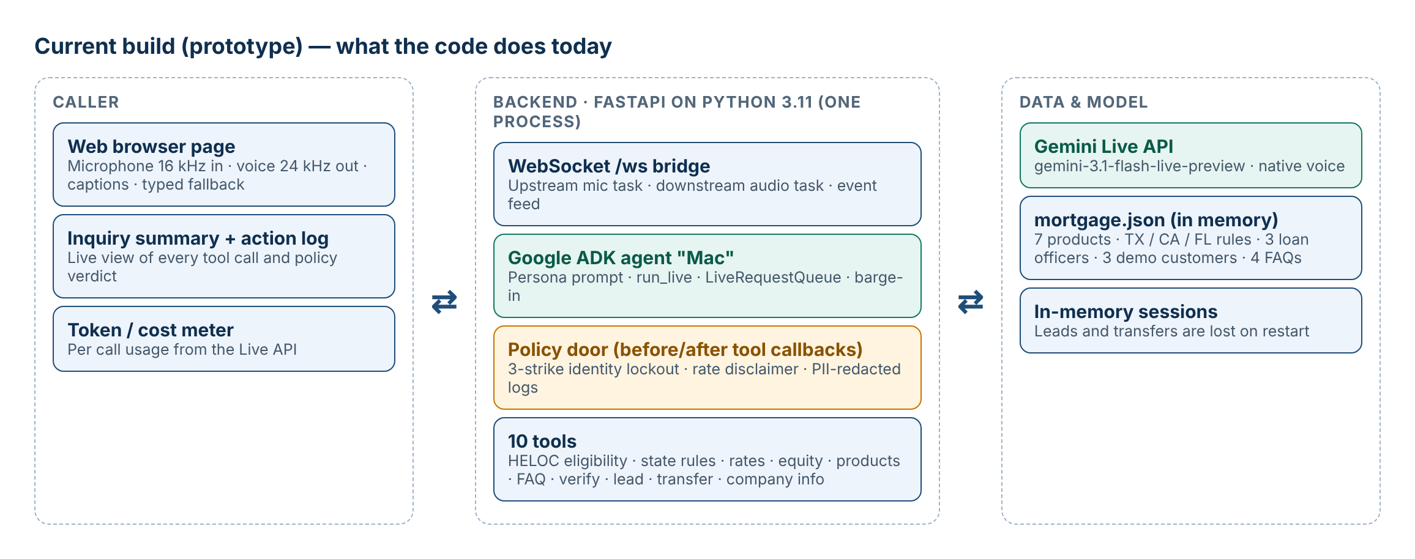
Figure 1. The prototype as built
A browser streams microphone audio over a WebSocket to a FastAPI service. The service runs a Google ADK agent connected to the Gemini Live API, which listens and speaks in real time. When Mac needs a fact or an action, it calls one of ten tools. Every tool call passes through the policy door first and is reported back to the caller's screen.

7.2 Design decisions worth keeping
- Rules in code, not in the prompt. The AI decides what to ask; deterministic code decides what is allowed. This makes compliance testable and auditable.
- Tools return instantly. No tool waits on a slow system, so the voice never stalls mid-sentence.
- Swappable back office. All data access sits behind one store class, so the demo JSON file can be replaced by real systems without changing the agent.
- Call state on the server. Identity checks and lockouts are tracked per call on the server, out of the AI's reach.

7.3 Target architecture
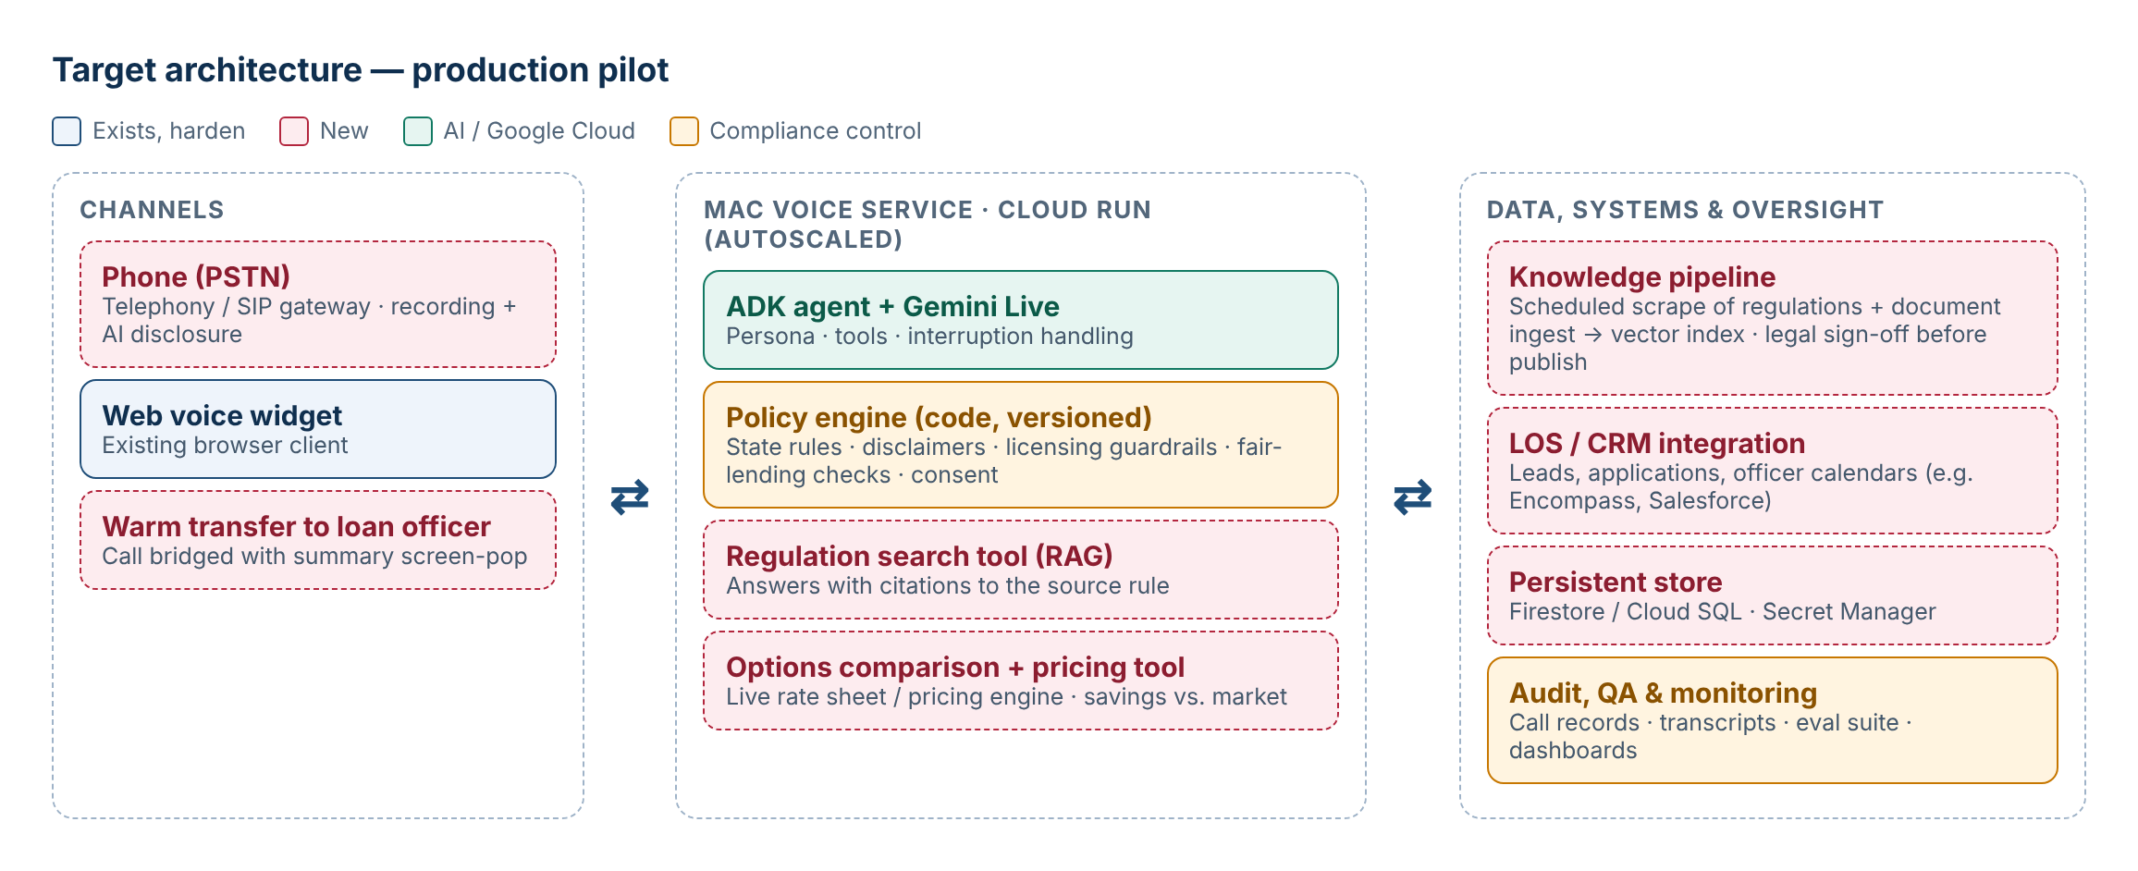
Figure 2. Target architecture for the Texas pilot and beyond

7.4 Regulation knowledge pipeline (closes FR-09, FR-10)

- Collect. Scheduled scrapers fetch an approved list of sources: Texas Constitution Art. XVI §50, Texas Finance Commission and OCCC home-equity interpretations, CFPB Regulation Z (TILA) and RESPA guidance, and agency selling guides. Internal policy documents are uploaded.
- Process. Pages are cleaned, split into passages and indexed (for example Vertex AI Search or a vector database) with source URL and retrieval date.
- Approve. Changes to any source raise a review task. Compliance approves before new content goes live; structured rules (such as the eligibility table) are updated and versioned at the same time.
- Answer. A new search_regulations tool returns passages with citations. Eligibility decisions keep using the approved, structured rules, never free-text search alone.

7.5 Tool catalogue
Tool | Purpose | Status
check_heloc_eligibility | State rule check plus maximum HELOC amount | Defect
check_state_regulations | Returns the state rule set | Built
calculate_equity | Equity, loan-to-value, borrowing power at 80% / 85% | Built
get_mortgage_products / answer_faq / get_company_info | Product, FAQ and company facts | Built
get_rate_estimate | Estimate from static ranges, credit and LTV, with disclaimer | Partial
verify_customer | Name plus last 4 phone digits; 3-strike lockout | Partial
register_lead / transfer_to_loan_officer | Create lead or transfer record and pick an officer | Partial
New: search_regulations · compare_options · send_call_summary | Cited regulation answers · ranked options with estimated savings · structured hand-off to loan officer and CRM | Gap

8. Compliance and risk
This section flags areas for review by compliance counsel. It is not legal advice.
Area | Why it matters | Mitigation
State lending rules | A wrong "yes" on Texas home equity could create an unenforceable lien and consumer harm | Structured, versioned rules approved by counsel; default to "transfer" when unsure; regulated-scenario test suite
Loan originator licensing (SAFE Act) | Only licensed loan originators may take applications or offer and negotiate terms | Keep Mac to education and pre-screening; counsel to approve the boundary for rate discussions; transfer before application
Advertising and UDAAP | "Save 0.5–1%" is a claim regulators expect to be substantiated; rate statements trigger Reg Z advertising rules | Document the pricing evidence; approved wording and disclaimers; log every rate statement
Fair lending (ECOA, Fair Housing Act) | AI must treat callers consistently and never use protected characteristics | No protected-class questions; same rules for every caller; outcome monitoring by segment
Privacy (GLBA) and recording consent | Calls contain personal financial data; several states need all-party consent to record | Disclosure at greeting; redaction; encryption; retention policy
Contact consent (TCPA) | Call-backs and texts need documented consent | Capture and store consent with each lead
AI accuracy | The model may misstate facts | Facts only from tools; scenario evaluations; human transfer for anything uncertain
Identity | Name plus last 4 phone digits is weak and currently reveals property and credit details | One-time passcode before account details; reveal minimum data
Model dependency | Preview model may change or be withdrawn | Pin a generally available version; regression suite before upgrades

9. Findings and recommended changes
Findings come from reading the code and running the reference scenario against it. Each one has a matching Claude Code prompt in the companion file.
# | Finding | Recommendation | Priority
1 | Texas investment block is skipped when the property type is "rental" (verified: returns eligible) | Normalise property use (rental, rent out, investment → investment); reject unknown values; add tests | Critical
2 | States with no rules on file return "eligible" (verified with New York) | Return "needs loan officer review", never eligible, when rules are missing | High
3 | No regulation knowledge from documents or websites | Build the pipeline in 7.4 and a cited search_regulations tool | High
4 | No option comparison or savings evidence | Add compare_options backed by a rate sheet now and a pricing engine later | High
5 | No tests for Mac; 42 existing tests cover the clinic agent only | Unit tests for every rule and tool; scripted live call tests including the reference call | High
6 | Transfer is simulated; no phone channel; no hand-off summary | Telephony gateway with warm transfer and send_call_summary | High
7 | Policy door promises more than it enforces (transfer suggestions and verification lists are defined but unused) | Enforce disclaimers, transfer prompts and verification in code; remove dead settings | Medium
8 | Texas rules are written into both the AI prompt and the data file | Keep rules only in data; the prompt says "always check the tool" | Medium
9 | Customer verification is weak and over-shares | Passcode verification; return only what the caller needs | Medium
10 | Loan officer availability ignores time of day and time zone | Use working hours in the officer's time zone | Medium
11 | Not deployable: in-memory data; Dockerfile builds the clinic app; project still named live-dj | Mac Dockerfile, persistent store, secrets manager, rename project | Medium
12 | Business-hours answer is always a hard-coded sentence (code bug) | Read hours from the data file | Low
13 | State names echoed inconsistently ("TEXAS" vs "TX"); only 3 state names recognised | Normalise to 2-letter codes for all 50 states | Low
14 | "Cooling off period" wording for the Texas 12-day notice | Use counsel-approved wording | Low

10. Roadmap, success measures and decisions

10.1 Roadmap
Phase | Timing | Deliverables | Exit criteria
2a Harden | Weeks 1–4 | Findings 1–14 fixed · test and evaluation suite · regulation pipeline (Texas sources) · persistent storage · Cloud Run deployment | 100% rule-test pass; compliance sign-off on scripts and wording
2b Texas pilot | Weeks 5–12 | Phone number · warm transfer with summary · CRM leads · consent and disclosures · dashboard | Pilot KPIs met for 4 consecutive weeks; zero compliance incidents
3 Scale | Next quarter | More states and products · pricing engine and comparison · Spanish · LOS integration | Business case confirmed by pilot data

10.2 Success measures
Measure | Pilot target (proposed)
Rule accuracy on the regulated-scenario suite | 100%
Calls resolved or correctly routed without human help | ≥ 70%
Time from "yes, transfer me" to a loan officer | < 60 seconds in business hours
Loan officer rating of hand-off summary | ≥ 4 out of 5
Caller satisfaction | ≥ 4.3 out of 5
Cost per call (AI + telephony) | Tracked weekly against human-handled cost
Rate saving delivered on funded loans | 0.5–1.0% versus documented market benchmark
Compliance incidents | Zero

10.3 Decisions requested

- Approve Phase 2a hardening and the Texas pilot scope (HELOC and cash-out refinance enquiries).
- Assign compliance counsel to approve rules, scripts, disclosures and the licensing boundary.
- Choose the pricing data source used to evidence the 0.5–1% saving.
- Choose the telephony provider and CRM / LOS systems for hand-off.
- Confirm the pilot loan-officer team and their availability for transfers.

Appendix: glossary
Term | Meaning
HELOC | Home equity line of credit: a revolving credit line secured by the home
Cash-out refinance | Replacing the mortgage with a larger one and taking the difference in cash
LTV / CLTV | Loan-to-value / combined loan-to-value: loan balances as a percentage of the home's value
Homestead | The owner's primary residence; Texas home equity rules apply only to homesteads
LOS | Loan origination system, such as Encompass
ADK | Google's Agent Development Kit, the framework Mac is built on
Gemini Live | Google's real-time voice model API
RAG | Retrieval-augmented generation: the AI answers from retrieved, approved source passages
Policy door | The code every Mac action passes through, which can allow, block or annotate it
NMLS | Nationwide Multistate Licensing System, which licenses loan originators

