Create the K8s EKS,further you have to do the deployment of the Nginx application and access the application outside the cluster.

Ec2
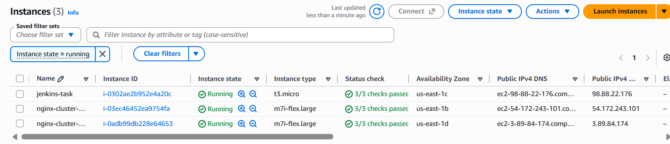
Tools Used
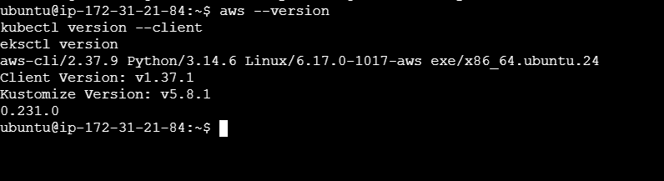
IAM details
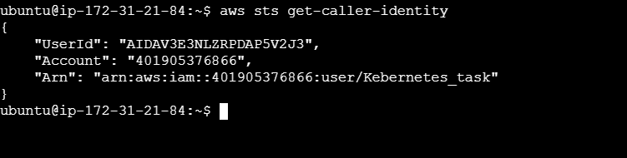
Nginx cluster
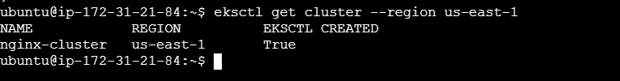
Worker nodes
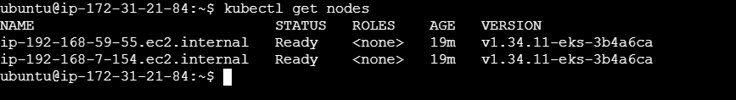

Deployments
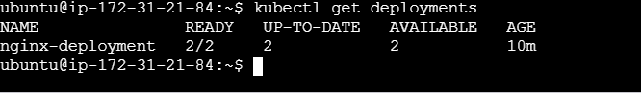
PODS status
Load balancer
Nginx page
