Fourier Series and Transforms

109611099顏彥臣

109611024 陳于安

109611090 劉椗桁

Part 1: Synthetic Signals:

(a)

We can assume the cosine signal as

$$g\left(x\right)=1*\cos\left(ωt\right)=cos⁡(20πx)$$

We assume the signal is periodic and being a cosine wave.so the ω=2 $πf$ =20 $π$

Then the Fourier Transform of it becomes

(b)

$$\hat{g}\left(f\right)=\frac{1}{\sqrt{2π}}\int_{-∞}^{∞}{g(x)e^{-ifx}dx}$$

$$=\frac{1}{\sqrt{2π}}\int_{-∞}^{∞}{\frac{e^{i20πx}+e^{-i20πx}}{2}}e^{-ifx}dx$$

$$=\frac{1}{2\sqrt{2π}}\int_{-∞}^{∞}{e^{ix(20π-f)}+e^{-ix(20π+f)}}dx$$

From Euler’s Formula, we know that

$$e^{ix\left(20π-f\right)}=\cos\left(20π-f\right)x+i\sin\left(20π-f\right)x$$

$$e^{-ix\left(20π+f\right)}=\cos{-\left(20π+f\right)}x+i\sin{-\left(20π+f\right)}x$$

$$=\cos\left(20π+f\right)x-i\sin\left(20π+f\right)x$$

Therefore, the original Fourier Transform becomes

$$\hat{g}\left(f\right)=\frac{1}{2\sqrt{2π}}\int_{-∞}^{∞}{e^{ix\left(20π-f\right)}+e^{-ix\left(20π+f\right)}}dx$$

$$=\frac{1}{2\sqrt{2π}}\int_{-∞}^{∞}{\cos\left(20π-f\right)x+i\sin\left(20π-f\right)x+}\cos\left(20π+f\right)x-i\sin\left(20π+f\right)x dx$$

$$=\frac{1}{2\sqrt{2π}}\left[\frac{2}{20π-f}\lim_{a→∞}{\sin\left(1-f\right)a+ \frac{2}{20π+f}}\lim_{b→∞}\sin\left(1+f\right)b\right]$$

(c)Below is the spectrum. We can see that the peaks at the frequency field is $±10$, which meets the previous result.

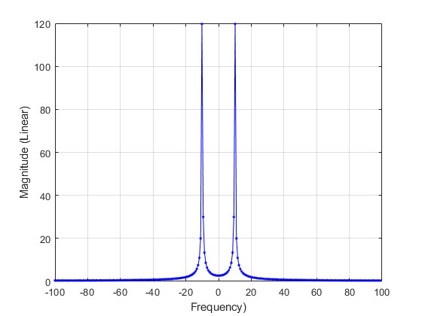

(d) 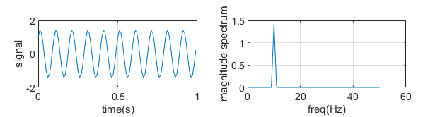

Yes.it agree with your hand-derived solution

(2)Phasing signal：

The new signal and it’s spectrum looks like this

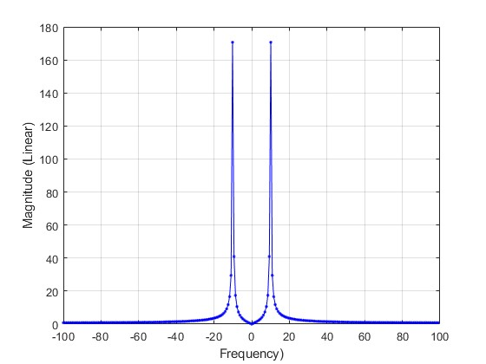

We can see that the frequency of the peaks remains at $±10Hz$, which is the same as the previous one.

the amplitude of the peaks is greater than the previous one.

Below are the two signal plots：

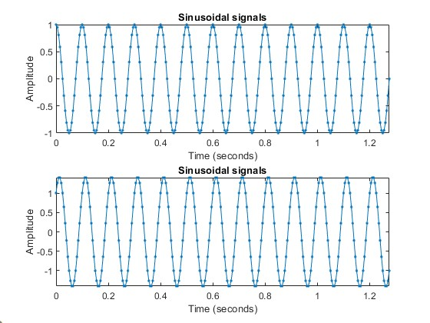

If we superpose the new signal, we can get a cos function：

$$\cos\left(20πx\right)+\sin\left(20πx\right)$$

$$=\sqrt{2}\left(\frac{1}{\sqrt{2}}\cos\left(20πx\right)+\frac{1}{\sqrt{2}}\sin\left(20πx\right)\right)$$

$$=\sqrt{2}cos⁡(20πx-\frac{π}{4})$$

Then we can see the amplitude is $\sqrt{2}$ times of the previous one, and the frequency is the same as the previous function.

The phase plots are as below：

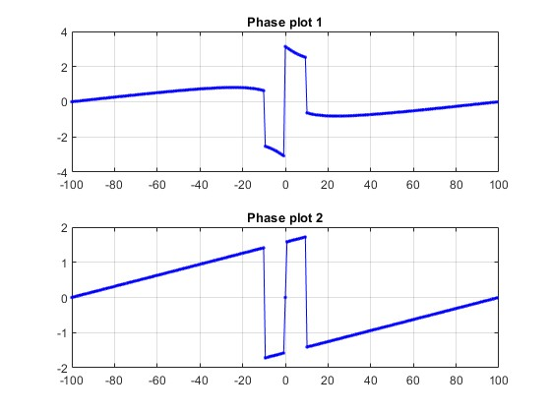

We can see that, at frequency $±10Hz$, the decrements for the latter signal are larger than the former one.

Part 2: Audio Manipulation

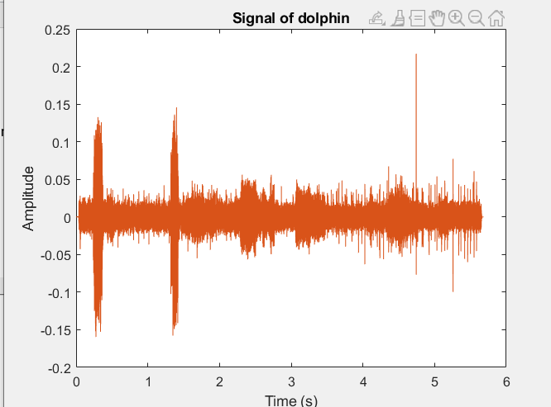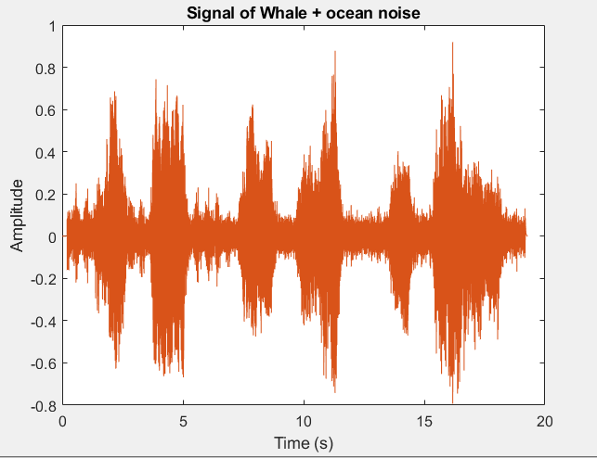(b)draw the signal

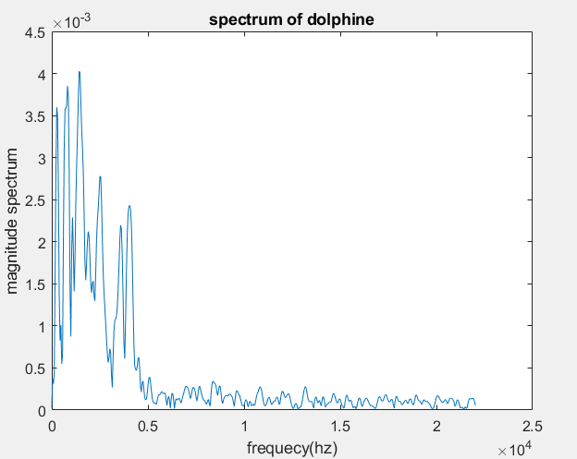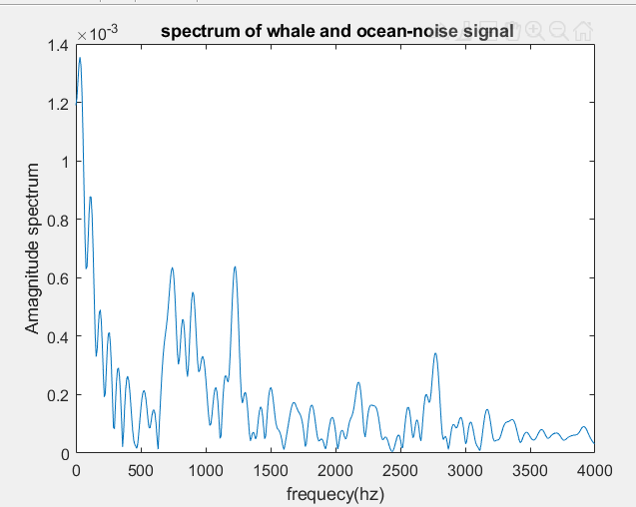(c) Plot the spectrum of these audio signals

We find that the higher energy distribution scope is different.

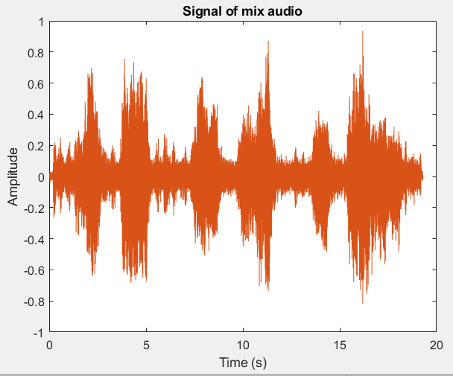(d) Plot the signal and spectrum of the mix audio

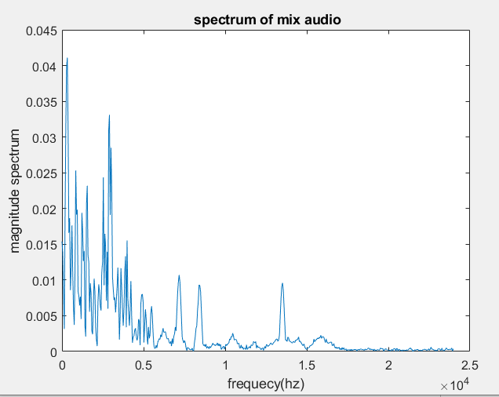

(e)

Yes,we can. First, we find several point on the maximum spectrum, so we can find the frequency of dolphin is higher than 2500 hz, the frequency of the whale lies between 60 to 1300 hz，so we can separate these audio by frequency.

(f)

we select the data points between some frequencies of the whale's sound (600Hz to 1300Hz), and use these data point to reconstruct the sound of the whale with ifft function. But unfortunately, we just created a wav file without any sound. We think the problems might lie at the sample frequency or the magnitude of the ifft function. We will also upload our failed code and failed wav file. And we will try to find the solution.