**Manual on Postman**

**How to Download and Install Postman?**

Figure 1 represents a webpage from the URL "postman.com/downloads/," which is the download page for Postman, an API platform. The page provides options to download the Postman application. The primary focus is on the "Windows 64-bit" download button. By this button you can easily download postman.

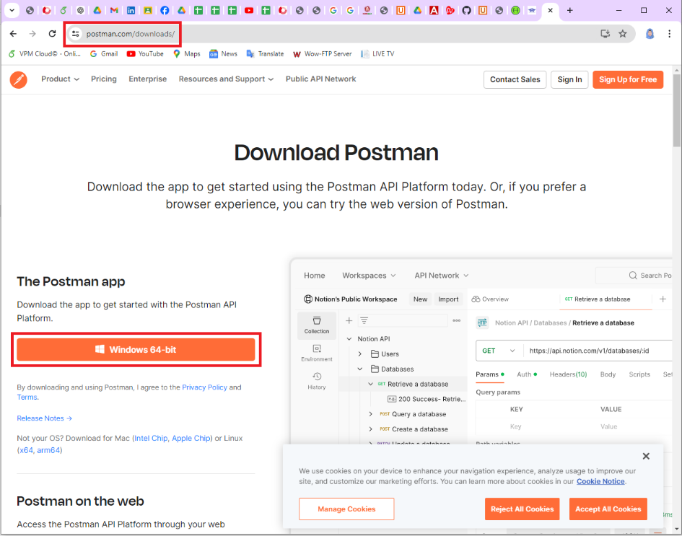

Figure 1: Download Postman

Figure 2 shows the downloaded file of postman. From here you can install it easily.

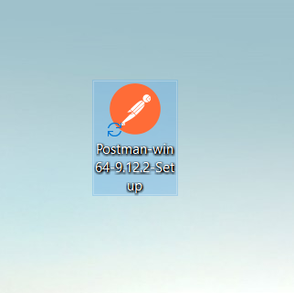

Figure 2: Downloaded File

Now installing process start and it will take a minute to install in the system. Figure 3 represents the installing process.

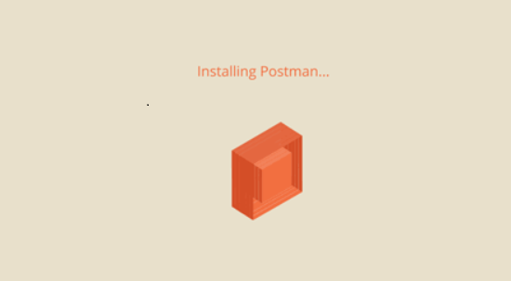

Figure 3: Installing Postman

After installing postman’s interface will be appeared in front of you. Figure 4 represents the interface of postman.

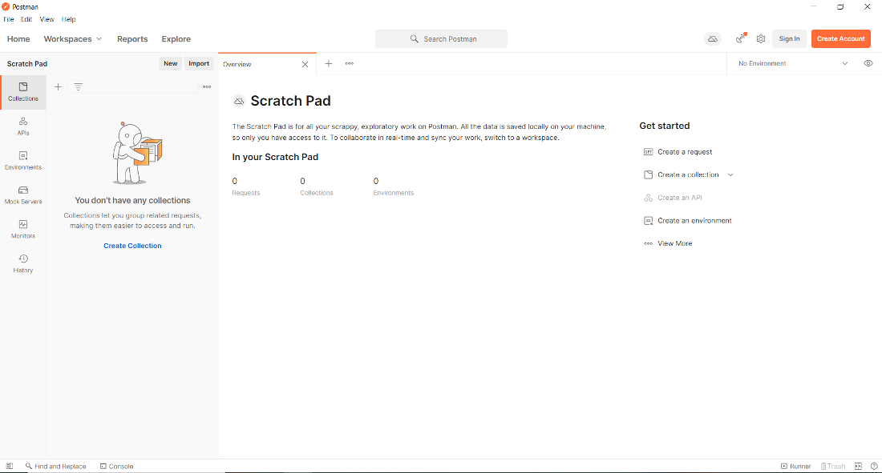

Figure 4: Interface of Postman

Figure 5 depicts the desktop icon of postman. When postman is installed successfully then this icon will be created.

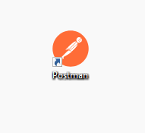

Figure 5: Postman Desktop Icon

**New Collection Creation**

In Figure 6, it is evident that a new collection has already been created. To create a new collection, click on the Collections icon and then click the ‘+’ button. This will create a new collection.

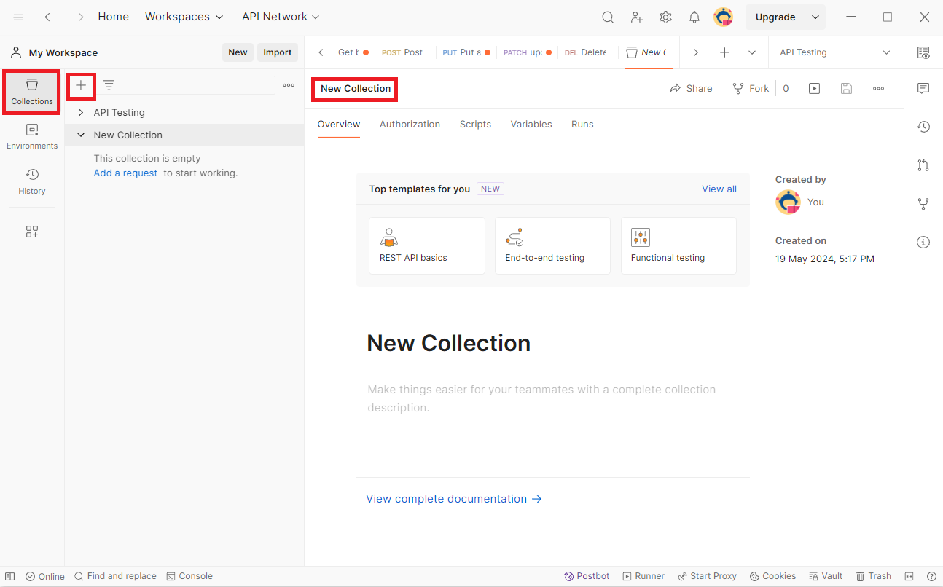

Figure 6: Adding New Collection

Figure 7 shows the interface for adding a new request. Simply click the ‘Add a request’ button to create a new request. Here, I gave the collection name as Test.

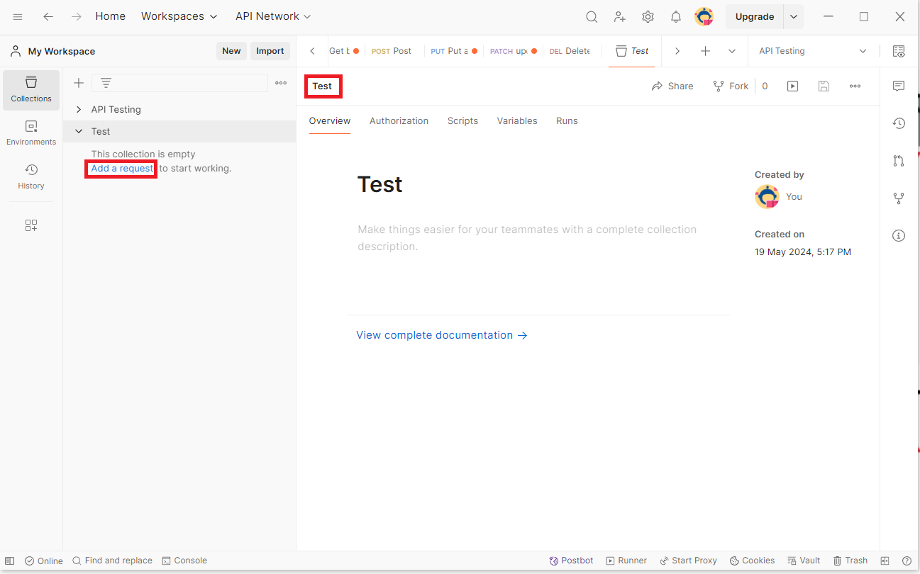

Figure 7: Adding New Request

After clicking the ‘Add a request’ button, a new request is created. This is illustrated in Figure 8.

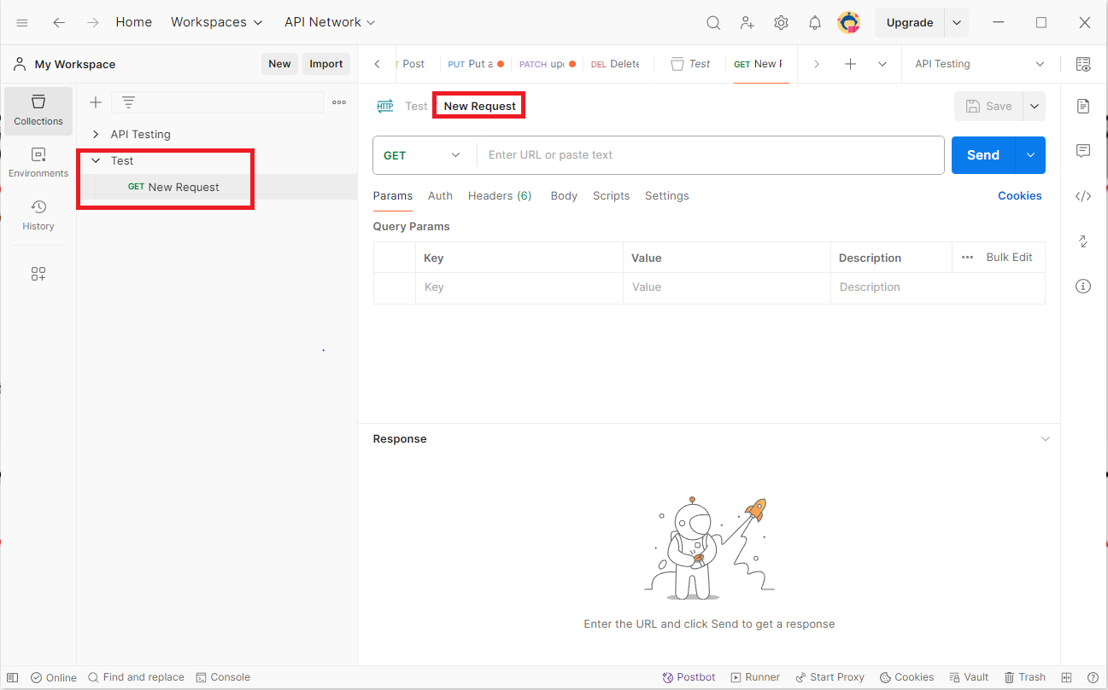

Figure 8: Adding New Request

**Adding New Environment**

To create a new environment, click on the ‘Environments’ button and then click the ‘+’ button. This will create a new environment. In this example, the environment is named ‘Test’. You also need to fill in the Variable, Initial value, and Current value fields. Here, the variable is named ‘URL’, and the Initial value and Current value are set to the link from Swagger.

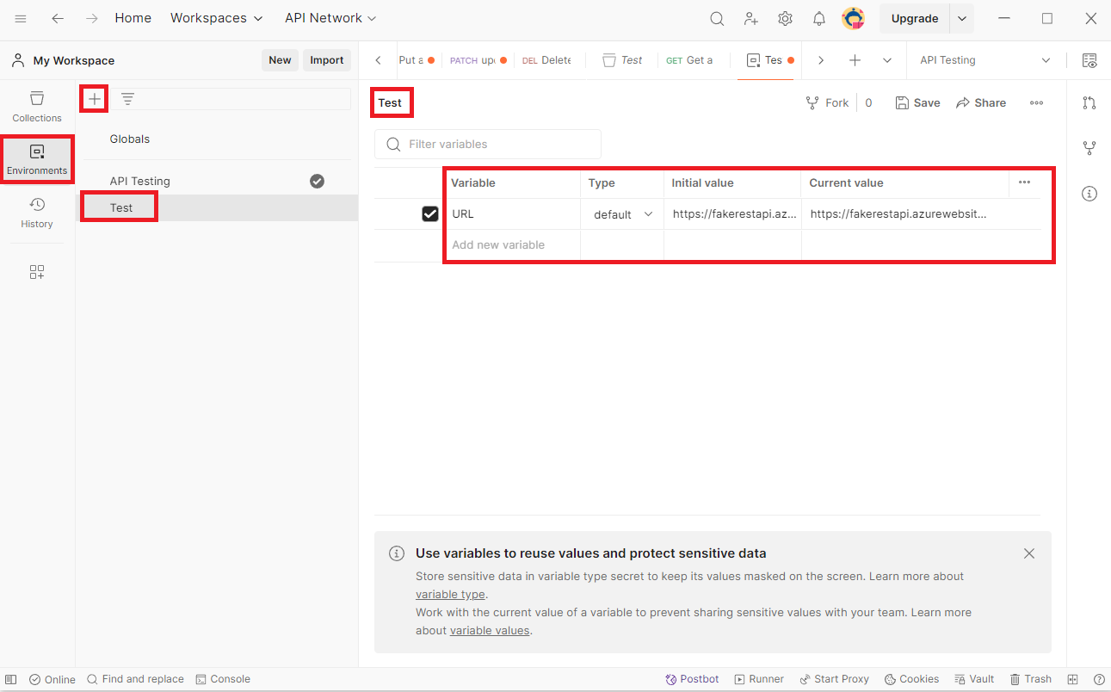

Figure 9: Adding New Environment

**Swagger**

<https://fakerestapi.azurewebsites.net/index.html> this is the link to access Swagger. For rest of the API testing, I used Swagger’s Books part. Figure 10 represents the Swagger’s book’s part.

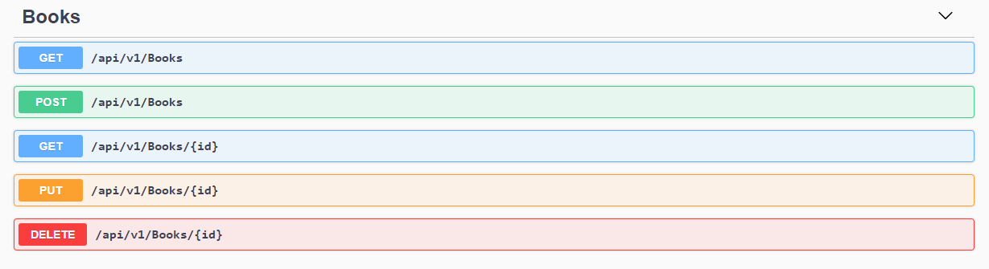

Figure 10: Swagger Fake Rest API

**Get Books**

In Postman API testing, the GET method is used to retrieve information from the server. It is one of the most commonly used HTTP methods. The GET request method requests data from a specified resource and should not affect the state of the server. Figure 11 demonstrates how to retrieve all books using the GET method. In this example, I saved the GET request as "Get all books." The figure shows the information for all the books, allowing you to see the complete list of book details.

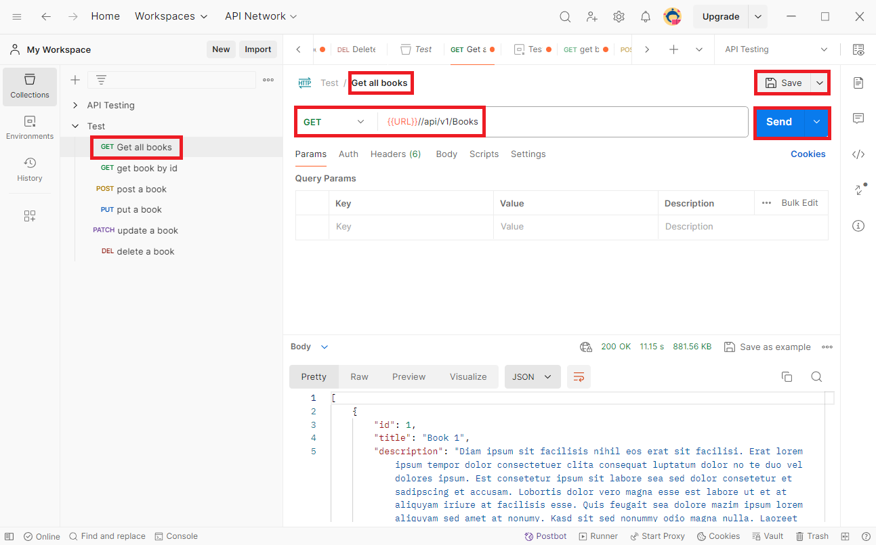

Figure 11: Get All the Books

In this process you need to follow some steps:

1. First of all, you need to create a new request. In Figure 11 I named it ‘Get all books’.
2. If you want to rename it then simply click on the request name located on the top and rename it.
3. After that, select the GET method and set the http request.
4. Then save the request using the ‘Save’ button.
5. Finally, send the request and you will able to see all the books information.

**Get Book by ID**

Figure 12 demonstrates how to retrieve a book by its ID using the GET method. I saved this request as "Get Book by ID." This allows you to search for any book by its ID. In this example, I searched for the book with ID 25, and the figure shows the information for book number 25.

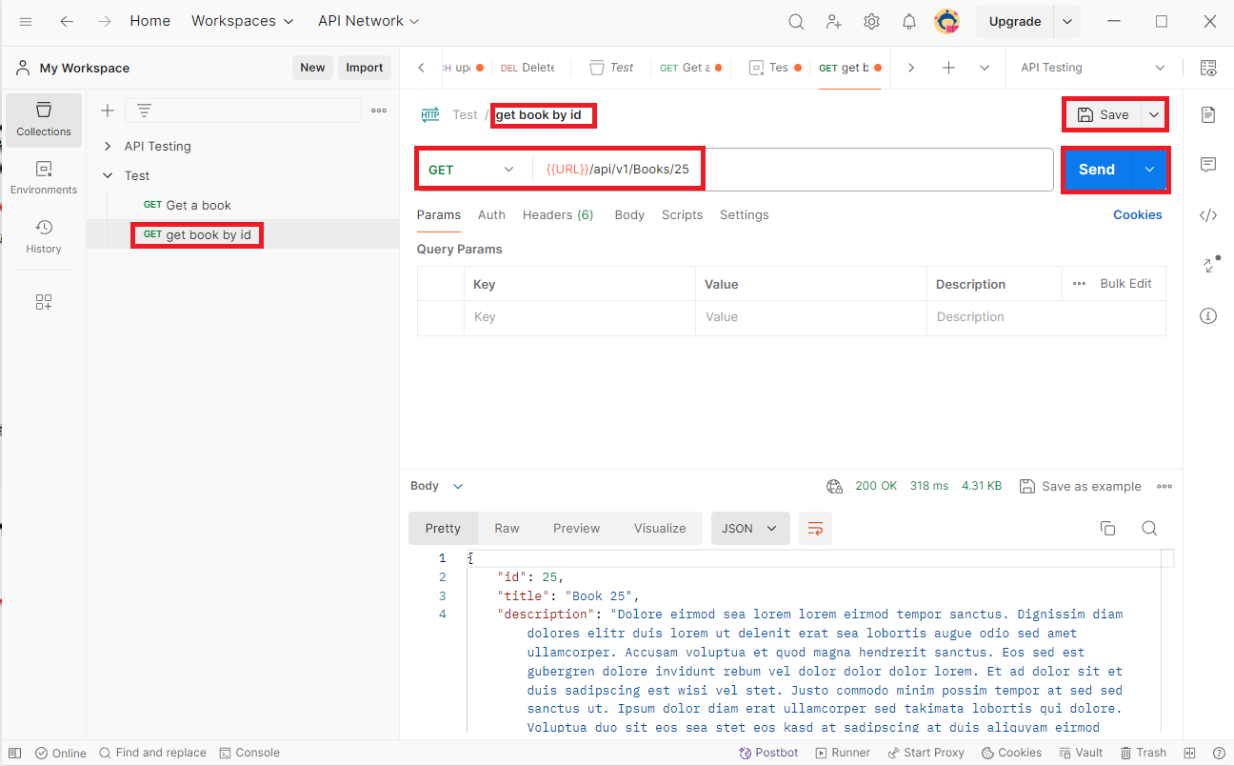

Figure 12: Get Book by ID

This process requires some steps:

1. Firstly, you need to create a new request. In Figure 12 I named it ‘Get book by id’.
2. If you want to rename it then simply click on the request name located on the top and rename it.
3. After that, select the GET method and set the http request.
4. Then save the request using the ‘Save’ button.
5. Finally, send the request and you will able to see the book by id.

**Post Book**

In the context of API testing with Postman, the **POST method** is a request type used to send data to a server to create a new resource. Figure 13 illustrates how to add a new book using the POST method. Here, I collect the example value from Swagger.

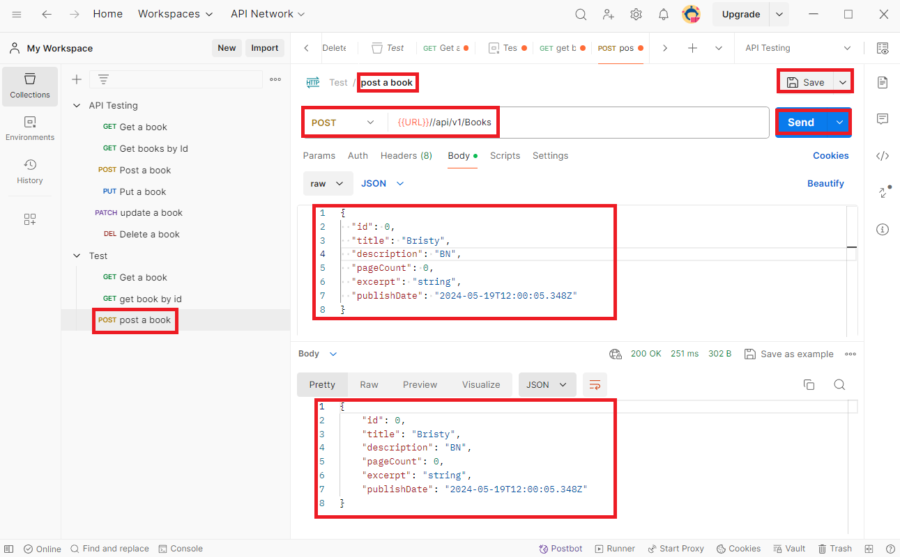

Figure 13: Post a Book

Here, you have to follow some steps:

1. Firstly, you need to create a new request. In Figure 1 I named it ‘post a book’.
2. If you want to rename it then simply click on the request name located on the top and rename it.
3. After that, select the Post method and set the http request.
4. In the Body set the book which you wanted to uploaded.
5. Then save the request using the ‘Save’ button.
6. Finally, send the request and the book will be uploaded.

**Put / Update a Book**

In Postman API testing, the **PUT method** is a type of HTTP request used to update or replace an existing resource on the server. Figure 14 demonstrates how to update a book using the PUT method in Postman. In this example, the description of the book has been modified to "BNB".

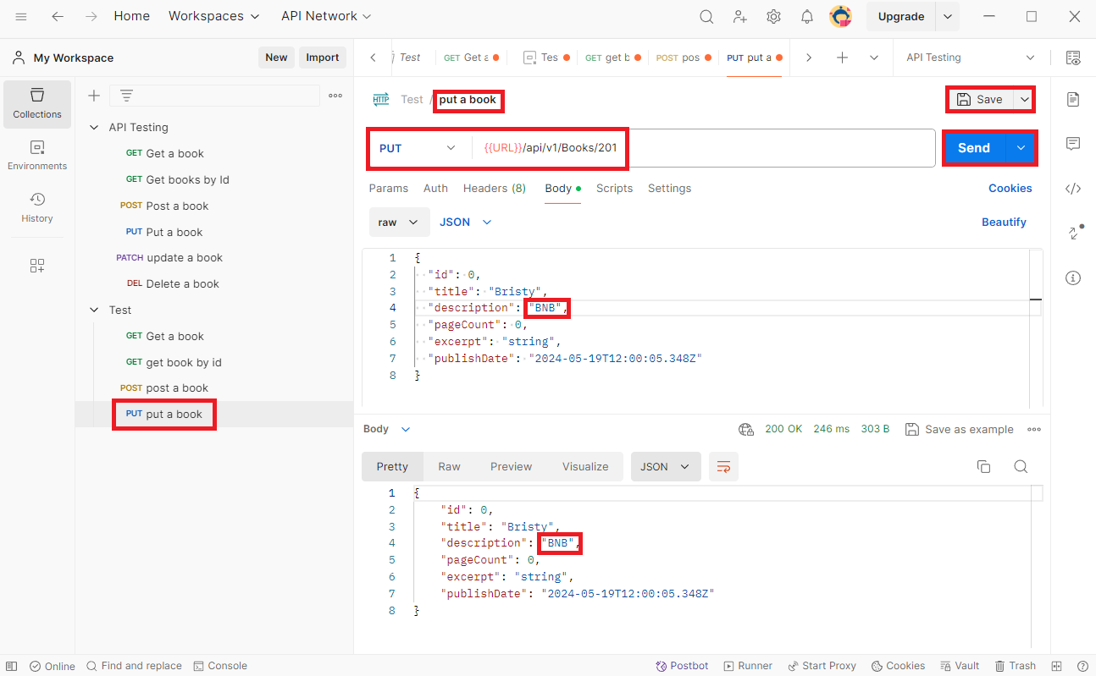

Figure 14: Put a Book

The steps of the process are given bellow:

1. Firstly, you need to create a new request. In Figure 14 I named it ‘put a book’.
2. If you want to rename it then simply click on the request name located on the top and rename it.
3. After that, select the Put method and set the http request with book id.
4. In the Body set the specific book which you wanted to update and update the existing information.
5. Then save the request using the ‘Save’ button.
6. Finally, send the request and the book will be updated.

**Patch a Book**

In Postman API testing, the **PATCH method** is an HTTP request type used to apply partial modifications to a resource. It allows you to update specific fields or properties of an existing resource without having to send the entire representation of the resource. In Figure 15, you can see how to update specific field by using patch method. In this example, I updated only the tittle field.

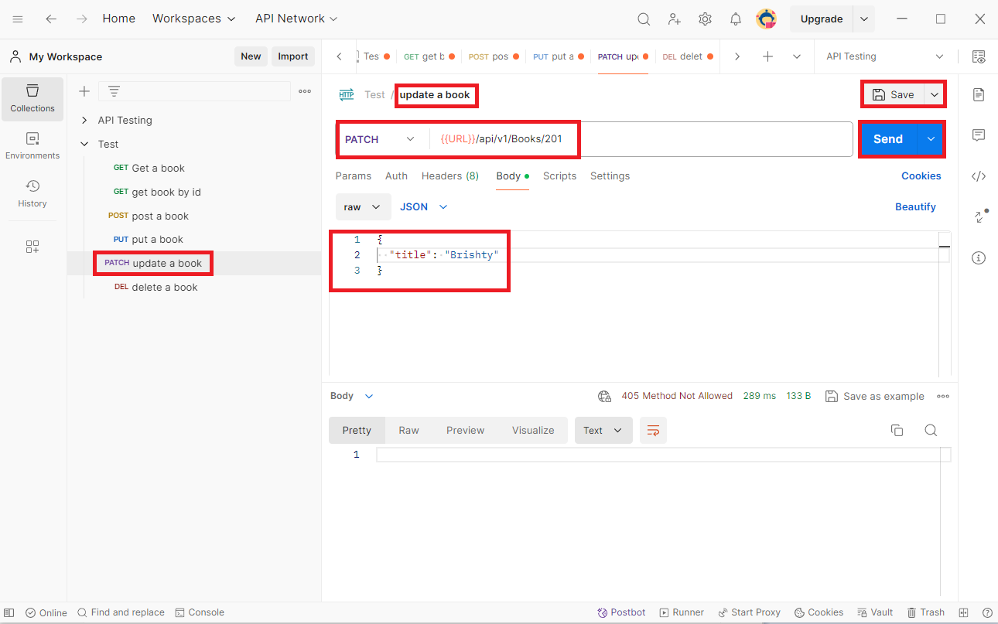

Figure 15: Patch a Book

This process requires some steps:

1. Firstly, you need to create a new request. In Figure 15 I named it ‘patch a book’.
2. If you want to rename it then simply click on the request name located on the top and rename it.
3. After that, select the Put method and set the http request with book id.
4. In the Body set the specific field which you wanted to update and update it.
5. Then save the request using the ‘Save’ button.
6. Finally, send the request and the field will be updated.

**Delete a Book**

In Postman API testing, the **DELETE method** is an HTTP request type used to remove a specified resource from the server. Figure 16 demonstrates the process of deleting a book using the DELETE method in Postman. In this example, the book with ID 201 has been deleted.

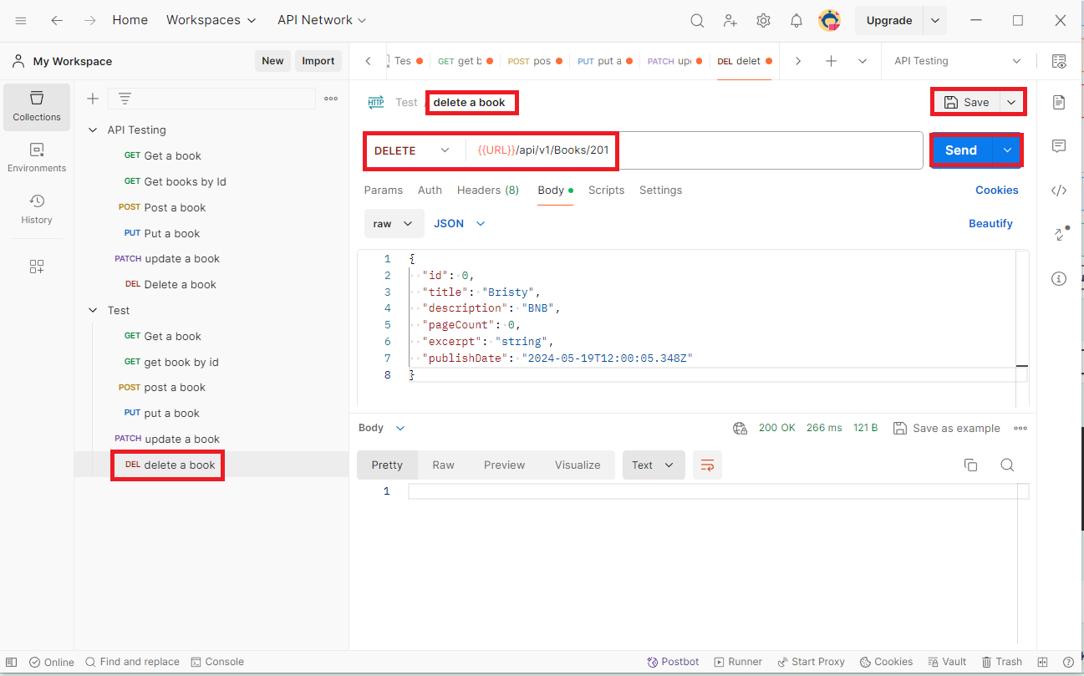

Figure 16: Delete a Book

1. Firstly, you need to create a new request. In Figure 16 I named it ‘delete a book’.
2. If you want to rename it then simply click on the request name located on the top and rename it.
3. After that, select the Delete method and set the http request with book id.
4. In the Body set the specific book which you wanted to delete.
5. Then save the request using the ‘Save’ button.
6. Finally, send the request and the field will be deleted.