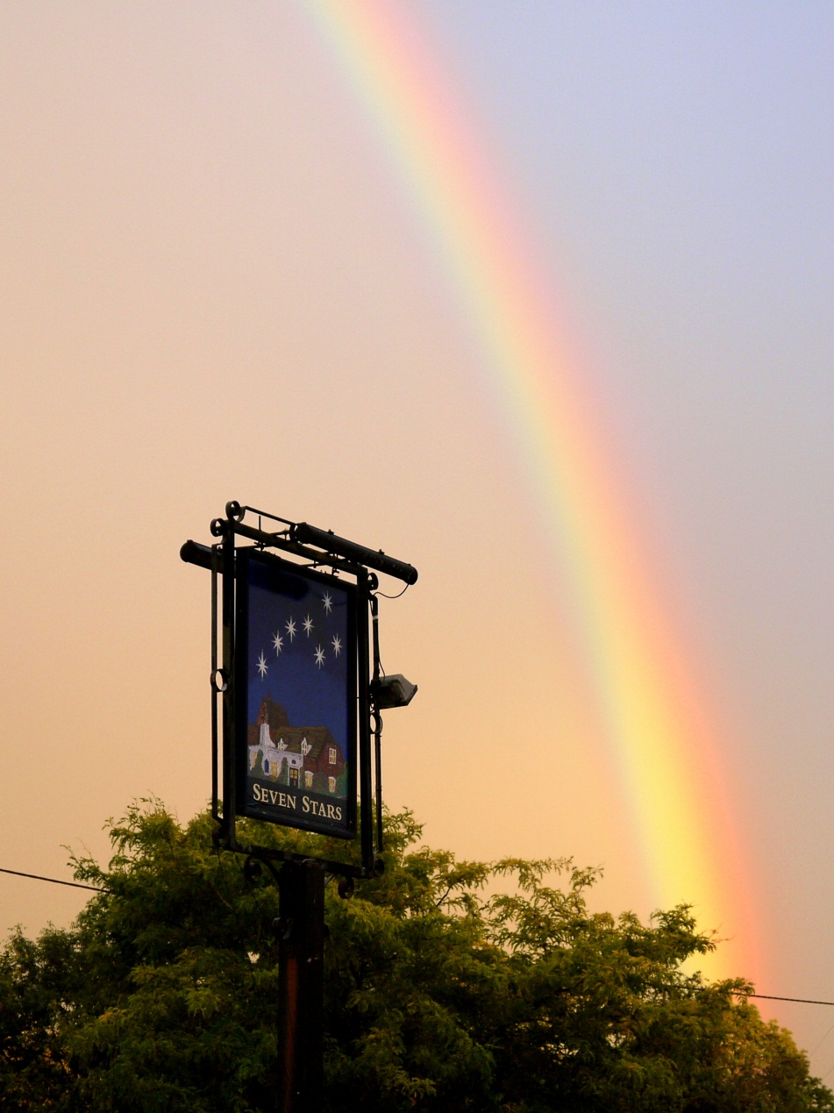
Ask not what can the pub do for you? Ask what can you do for the pub!

Tenant Application
As part of the selection process for a Licensee for the Seven Stars, we require any prospective applicant to complete this template.

Please use all of the information received, including the Briefing Document, Village Feedback and Opportunity Document. We are looking for a response in bullet point format and in as much detail as possible at this stage. Supplementary information is welcomed, so please provide as applicable and where available.

Please assume the current size of the premises when completing this document except in the section that is specific to expansion.

Vision Statement
Please outline your overall vision for the business, including how the business will integrate with the community

Background, Experience & Financial Capacity
Please provide an overview of experience to date, relevant to this project, as well as your current financial capacity and commitment (outline any items for consideration or circumstances we should be aware of)

Method of Operation
As a tenanted business, please provide details of who will run the business on a day to day basis as well as how you will and who will deliver the customer experience

Village Feedback
Based on the Village Feedback, please outline the priorities to address this feedback, methods by which you will do so and how you will source and utilise village feedback on an ongoing basis
3 Year Projections / P&L – attachment required
Please provide a full 3 year projection (breakdown by month for the first two years would be preferable) including:
- Sales Revenue (with Food / Beverage breakdown, covers & average check)
- Cost of Sale (breakdown raw materials by revenue stream, wages)
- Gross Operating Profit (projected GOP margin)
- Other Costs (estimated where necessary)
- Net Operating Profit (projected NOP margin)
Please outline any assumptions that were used in the above, however for the purpose of this stage, please assume in these numbers that the size of the premises is as per the current size, i.e. no extension.

Revenue Generation
Please provide the key strategies and actions to deliver the revenue outlined in the 3 year projection. Provide specific information of revenue streams by meal period, day of week and seasonality as necessary.

Revenue Optimisation
Given the current capacity of the business, please provide how revenue will be optimised through the week and based on anticipated meal period demand.

Payroll Structure
Please outline the staffing strategy, in order to deliver the customer experience and projections outlined.

Profit Delivery
Please provide details of your plans to deliver the profit as outlined in the projections.

Rental Terms
The current terms aim to provide a financial model that requires a licensee to pay a pre-determined rent on a monthly basis. Please provide any feedback and requirements with regards to rent payments based on the financial projections.

Investment & Capital
Based on the above, please feedback with regards to any capital investment that you would deem to be necessary to deliver the projections outlined. Please also provide an outline of initial working capital available and the priorities of how this would be utilised.

Expansion
Based on the plans that have been drawn up for the building (link is in the briefing document), please outline the key opportunities that you see this presenting, as well as any changes to the sections above as a result.

Further Information
Please share any further information that is not applicable to any of the sections above
Further Questions
Please outline further questions you have or points of discussion you would like to cover

