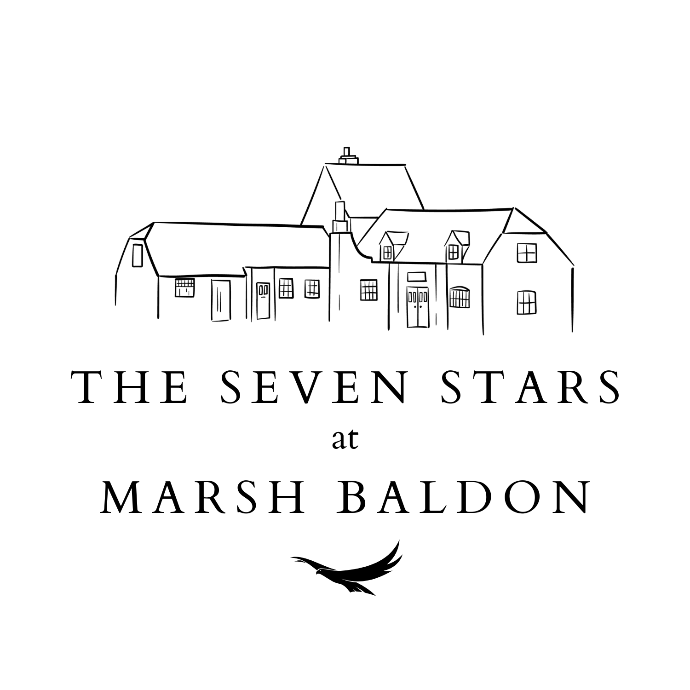

Baldons and Nuneham Community Society Limited

Report of the Management Committee to the AGM in relation to the period to 24th March 2023

Society Address
Yew Tree Cottage, Toot Baldon, Oxford, OX44 9NE

Core Purpose
The Baldons and Nuneham Community Society Limited (“BNCS”) is a Community Benefit Society established and managed by the community for the benefit of the Community of the Baldons and Nuneham Courtenay.

Committee
The committee members for the period ending 24 March 2023 were:
Chris Lake (Chair)
Phil Collins (Vice Chair)
Catherine Rohll (Secretary)
Phil Gardner (Treasurer)
Dave Greenaway
Robin Timms
Sally-Anne Williams

Phil Collins, Phil Gardner and Dave Greenaway are standing down as it is the end of their three-year term however are all standing for re-election. There will be an election for the management committee at the AGM. The committee invited anyone who wished to stand to identify themselves by Tuesday 1 August. A secret ballot will take place at the AGM if required. Statements by all those standing will be available at the AGM.

It is the responsibility of the committee to oversee and have governance of the activity undertaken on behalf of the members of BNCS. There were 8 ordinary meetings of the BNCS Committee in the financial year 2022-23.

Independent Financial Auditor
The auditor is Mercer Lewin of 41 Cornmarket, Oxford, OX1 3HA. Re-election of the auditors is one of the matters of business for the AGM. The Management Committee recommends the re-election of Mercer Lewin.

Structure, Aims & Objectives of the Society
BNCS was registered with the Financial Services Authority (“FSA”) (now renamed the Financial Conduct Authority) on 10 December 2012. BNCS is a Community Benefit Society, a modern form of the historic Industrial and Provident Society. It has withdrawable shares and legal personality, and members have limited liability. The objectives of BNCS, as articulated in the Rules of BNCS, are to carry on any business for the benefit of the community and in particular by acquiring the freehold premises of the Seven Stars, to provide a venue for the community which:

- Promotes social gathering, employment and tourism
- Provides facilities and services for the community
- Provides event facilities.

The Rules of BNCS define its structure, management and operation. They are available on the website at www.bncsltd.com. Copies of the Rules are also available from any member of the committee. If you have any question about the Rules, please raise them with any member of the committee.

Overview of the Year’s Activities
The main focus of activity over the last year has been working with the tenant in him reassigning the lease, which was finalised in June 2023.
In terms of work on the pub premises, there is little to report as the terms of the new lease provide that the tenant is responsible for all maintenance except for the roofs and chimneys which BNCS remains responsible for.
In the last year, BNCS has carried out work to the flat roof costing £7,960. It also contributed £1,800 to the track fund for the resurfacing of the track on the south side of the green, which included some more suitable provision for parking on the green, often used as an overflow for the pub at busy times.

Trading
Trading of the Seven Stars in the year to 24th March 2023 on which we collected rent was £527,543.78 (previous year £619,958.43)

Shares
In the year 2022/23 there was £1,662 additional share capital raised which included £162 of rolled up share capital from the 2021/22 interest payments. £6,600 of share capital was repaid to 3 shareholders. This puts the current share capital at £155,417 as at end of the year (24th March 2023).

Assignment of the Lease
Towards the end of 2022 Mark Higgs (owner of Free Spirit Pubs) made the reluctant decision to assign his lease of the Seven Stars as the turnover and profit had not reached his expectations following the Covid pandemic. He informed the BNCS Committee of his decision and marketed the lease through Fleurets, an agent specialising in property in the leisure and hospitality sector. In early 2023, the BNCS Committee was introduced to Namit Julka and Sunit Bansode who wanted to incorporate a company (Hi Baldon Limited) together to take on the assignment of the lease. After meeting Namit and Julka and carrying out its own due diligence, BNCS granted permission for the assignment. The legal process of the assignment took longer than was hoped, but finally completed on 23 June 2023 and, much to their credit, Namit and Sunit opened the doors that evening! The BNCS Committee is delighted to have Namit and Sunit on board and look forward to working with them.

Community use and vision
Namit and Sunit are very keen continue to fulfil the BNCS vision of providing a welcoming place for the community, serving good food and drink, and providing opportunities for villagers to meet and socialise.

They are keen to hold events and have already hosted a very well attended opening event on 30 June 2023 just a week after their soft opening. They also have plans to hold or support classic car meets on the Green, the home cricket matches, a beer festival and possibly even an Indian food festival.

Reviews
The pub is now rated as #36 out of 405 for restaurants in Oxford. 552 of the 625 reviews are at Good or Excellent (this is the same percentage as last year at 88%). There is only one review which post dates the assignment, but that was 5 star.

Membership & Membership Strategy
We currently have 150 members with a total shareholding: £155,417 (2022/23 End of Year).

£6,600 worth of shares have been redeemed and there was £1,662 of new investment.

Our core strategy regarding investment is:
- To encourage existing shareholders to maintain or increase their investment.
- To generate new investment to replace any that may be withdrawn in future.
- In order to achieve the above, to maintain a competitive return on investment for existing and new members. During the period of the loan from David Harding this is restricted to the amount being paid under that loan (1.5% above base). This continues to be very competitive compared to other investments of this scale.
Membership recruitment aims are:
- To inform new villagers about buying shares in the pub and the benefits.
- To encourage greater engagement between the Seven Stars and the Baldon and Nuneham Courtenay community.

It is hoped that we will encourage those who are relatively new to the village i.e. since our last fund raising in 2019, to participate in shares in the pub.

We are of course mindful that with the increase in interest rates, the interest payments are more costly, therefore shareholding is more centred around inclusivity and breadth of membership versus the overall value of shares capital.

Finance Report
The audited accounts presented today show that the Society is in good health financially, supported by an increase in rent payments post COVID, albeit still building to reach the pre-COVID peaks.

The profit for the year was therefore £13,841 before paying Corporation Tax due of £3,337.
There are full details included in the audited accounts, however £9,760 has been spent on repairs and maintenance, which includes flat roof works and contribution to the track fund.

£1,662 money was raised from Share Subscriptions, however £6,600 was redeemed (attributable to 4 members), leaving the balance of Share Capital at £155,417.

In addition, rent plus interest generated £40,848. This includes the long-term release of the CIF grant at £799 per year.

Additionally, there have been other day to day running costs, capital and interest costs for the loan from David Harding as well as the allowance for interest on investors’ share capital, and this makes up the rest of the expenditure.

As at 24th March 2023 the Society had £115,084 in cash (including £10,015 previous tenant’s deposit with some accrued interest), which together with the quarterly rental payments from the pub and any further share subscriptions, will be used to pay the running costs of BNCS, make the loan repayments and provide funds for future development. As at 22nd July 2023, there was £98,170 cash in the bank (including petty cash) which also includes £10,000 held in a deposit account which is the tenant’s deposit.

The committee recommends the payment of interest on shares out of the trading surplus to date at a rate of 3.74% (i.e. 1.5% above base rate). This will total £5,930 and has been provided for in the accounts.

Interest will be paid out following the AGM if approved. Shareholders can roll up interest if they wish to, however interest will be paid as a default.

BNCS will continue to strive to realise the community’s original vision for the Seven Stars.

We would like to thank everyone who continues to support BNCS and make the Seven Stars a success year on year.

The Management Committee
27th July 2023

