UFC_ B PCBA Review

## SCHEMATIC

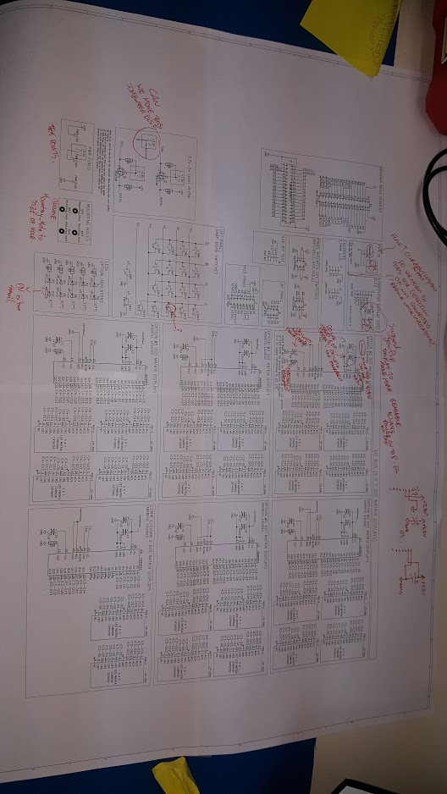

Other notes not on the schematic,

One item of preference for me, If we are all good with it going forward can we limit the size of the sheets to 11x17 and try to normally use 8.5x11 multiple sheets to make add more space. I like to print of schematics to review, and taping them together sucks :p

Also are people ok if take a stab at some reorganization of the above? (but please review the following questions before hand)

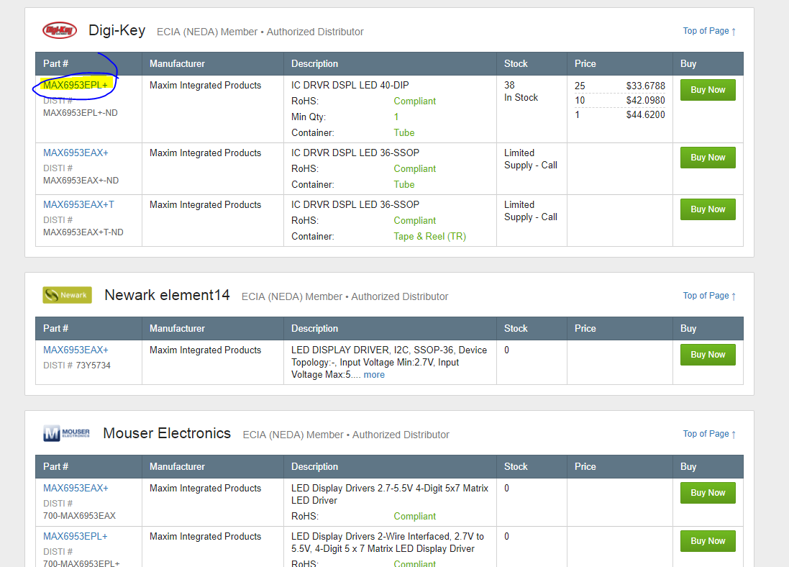

There is very poor availability for the MAX6953 (this is a standard problem with maxim chips ☹), and holy shit is it expensive. $33 in qty. Are we sure that is what we want to use? (clip above is from findchips)

You can do it with a row and coloum driver (I have done it before while working on DIY pinball (diypinball.ca) with my friends) see below image. What the current supply does is guarantee the leds will be almost exactly the same brightness. This compared to just providing a voltage is better because the forward voltage of LED’s is what varies during manufacturing. Ive only noticed a problem when you have multiple leds on the same backlight etc… Its also a bigger problem when you order more then one lot of LED’s (different manufacturing dates) Schematic sheet shown below for 12V LED’s from a 3V3 control circuit (I did the design just not the schematic capture).

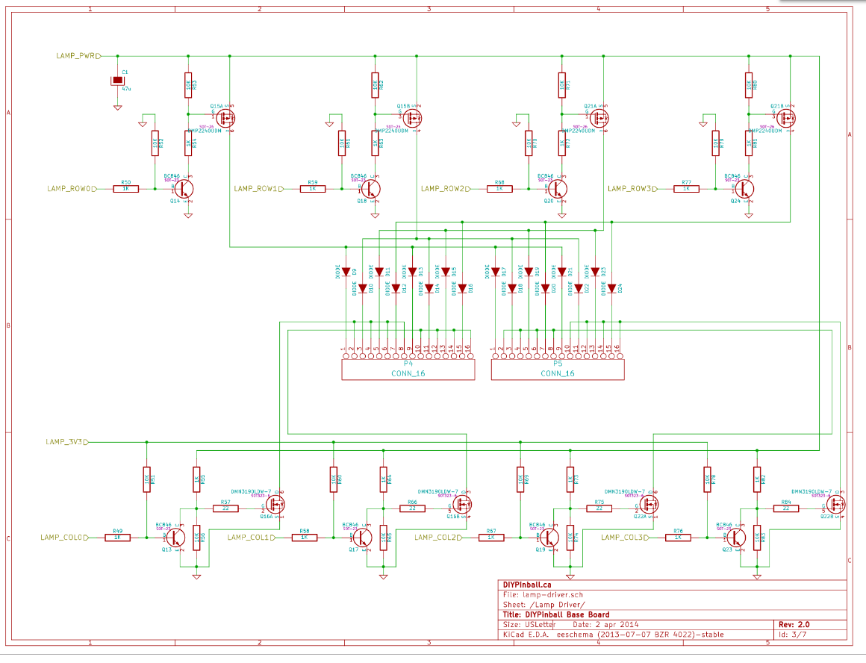

Do we want to add a fuse to the board or do we have one upstream, I still need to review the system documentation so im more familiar with it.

## PCB

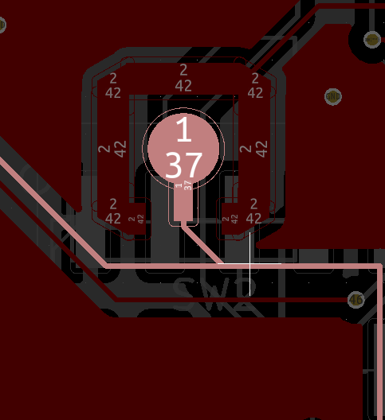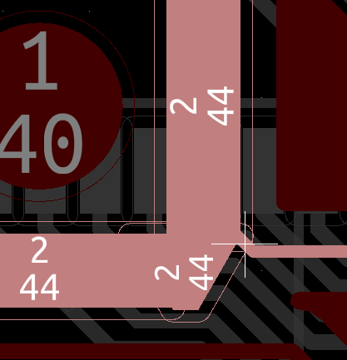

Acid Traps found on a couple traces, this is more of a problem if you are dealing with low quality manufactures.

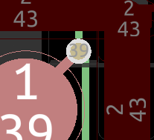

This via may cause issues if the button metal is not held correctly, can it be taken off the bottom like the others?

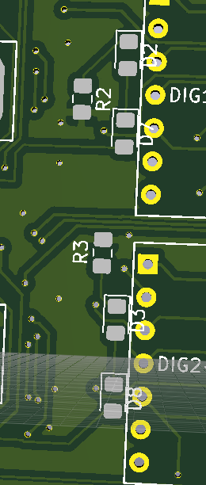

Silkscreen over led pads

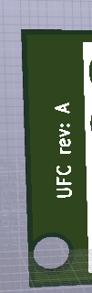

This is rev B, same issues appears in frame.

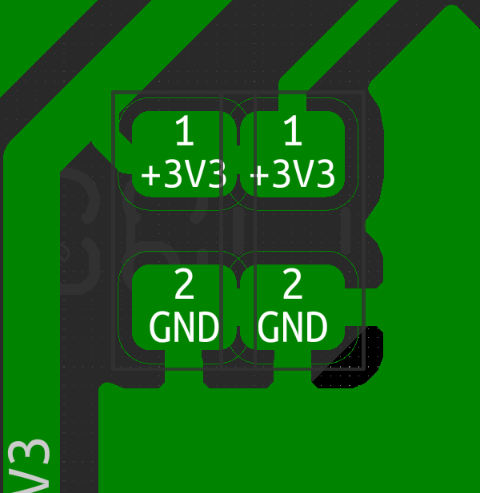

There are some connections like this that will be too tight for a pick and place machine, (difficult for people)

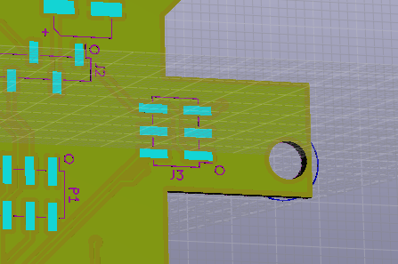

When the board flexes J3 might tear the copper or become unbound, can it be moved or rotated 90DEG?

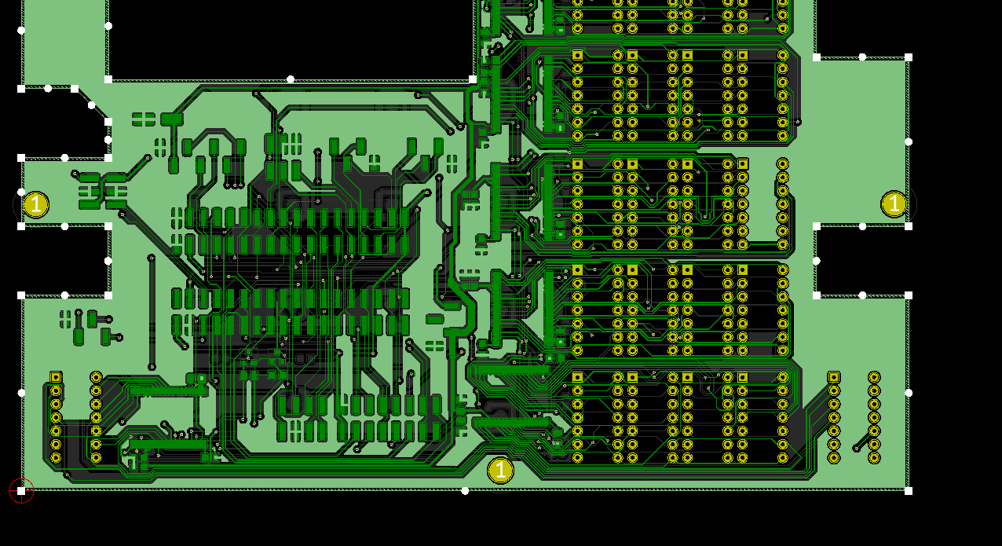

There are a bunch of ground plane connections that just seem to make it buy (“ive had a board shop over etch this disconnecting them in the past) I recommend dropping a bunch of ground via’s to connect the bottom plane to the top plane and reduce the impedance of the connection.

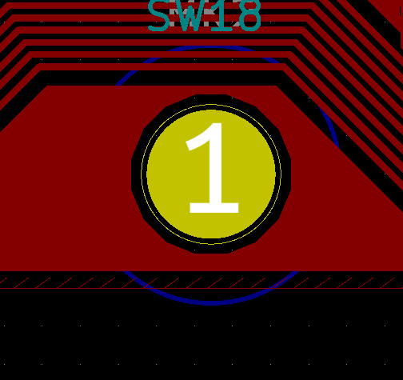

I know its basically impossible to fix but screws can go through the traces and damage or destroy them, Maybe add a warning on the board and/or manual “Do not over tighten”



No Openhornet logo ☹