# DDI and AMPCD boards

This document contains information about the hardware design for DDI and AMPCD panels.

# Modular vs non modular

## Option A: Modular DDI

A modular approach allows for simpler hardware thanks to the reuse of parts, this approach requires a total of 8 DDI/4 PCBs + four AMPCD/4 + three (3) Nano shields made for this purpose.

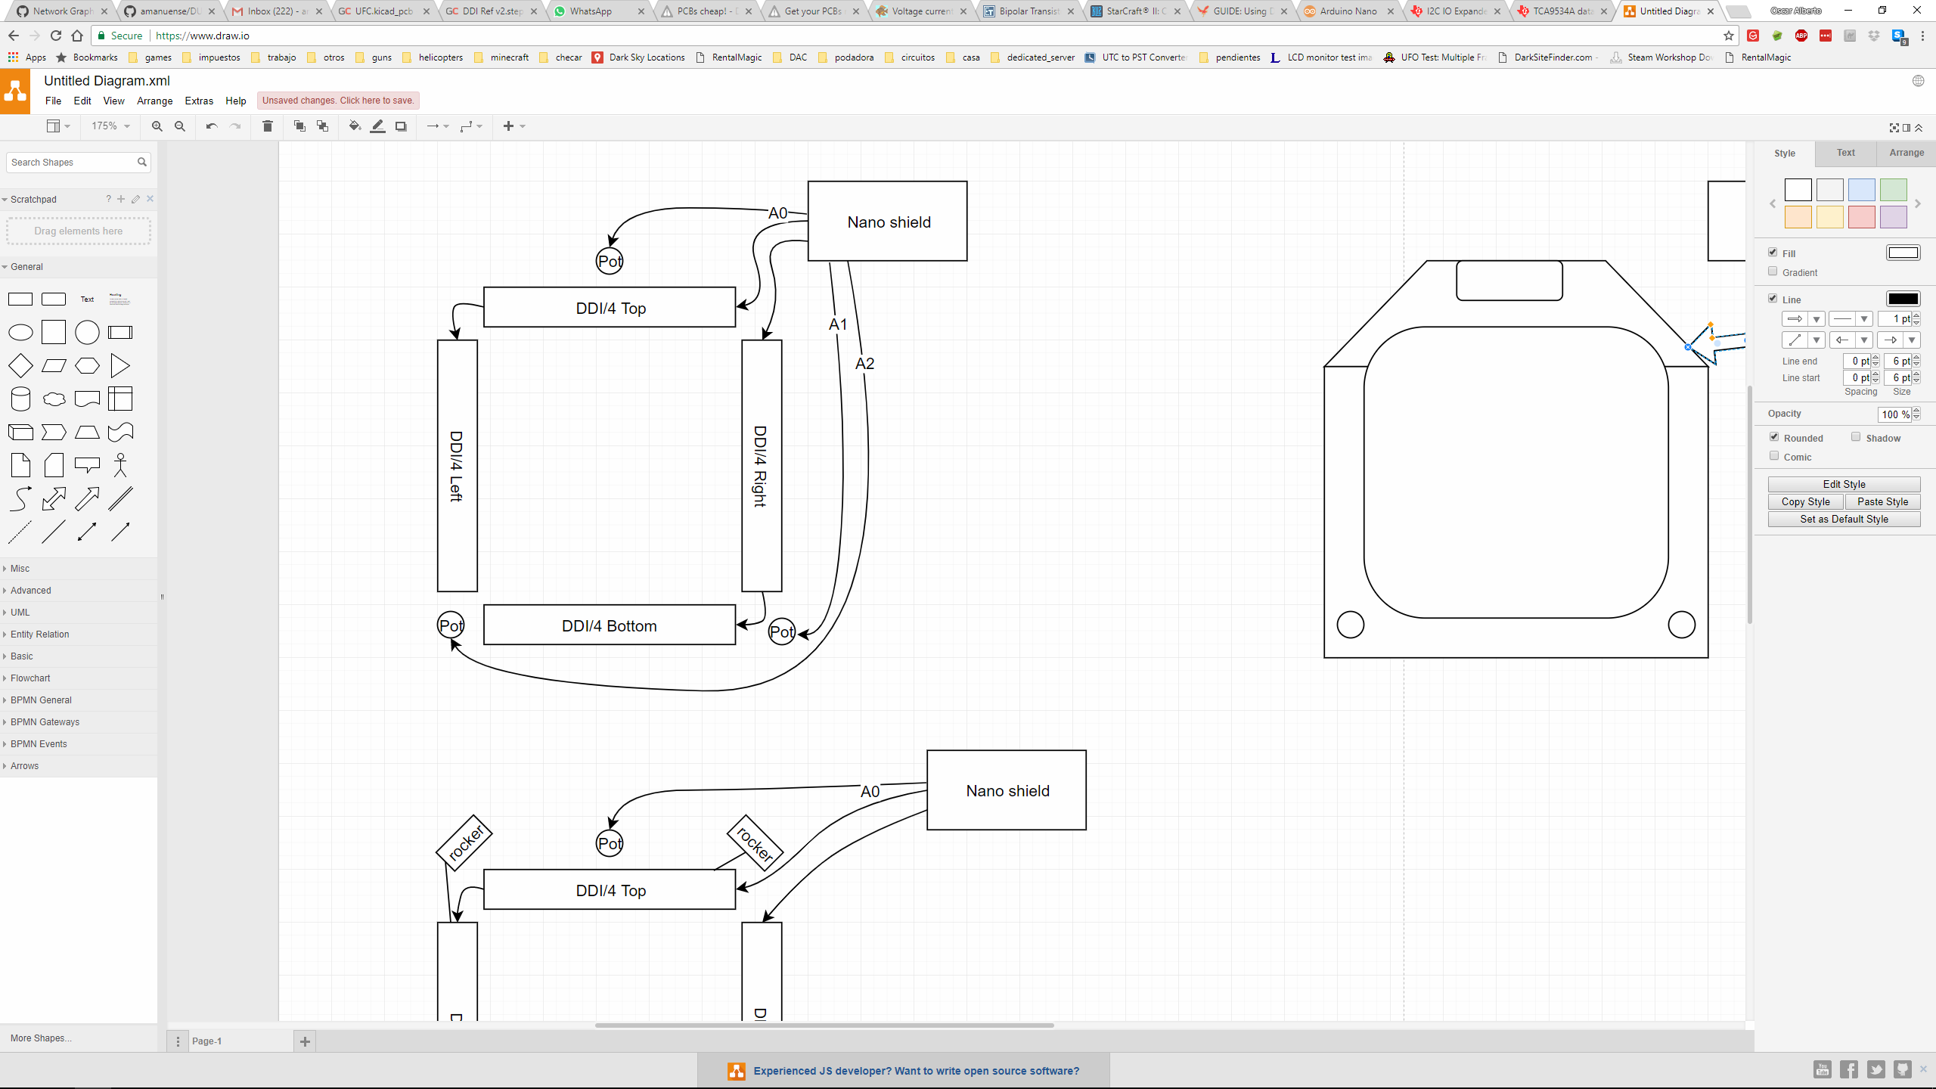

## Option B: Full board

This approach reuses 100% schematic from modular DDI but two different boards need to be created, one for LEFT/RIGHT DDI panels and one for AMPCD. One thing to consider is that this approach requires three boards of approximately 158mm (6.23in) x 167mm (6.59in) in size.

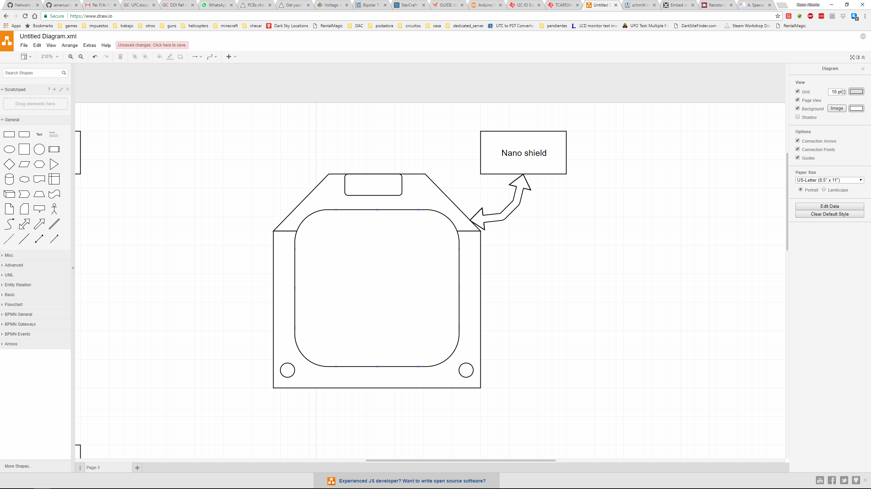

# Modular detailed

## Left and Right DDI panels



Left and right panels are identical, the only way to differentiate between these two panels is what option is installed on the Nano shield (see Nano shield options for more information)

## AMPCD panel

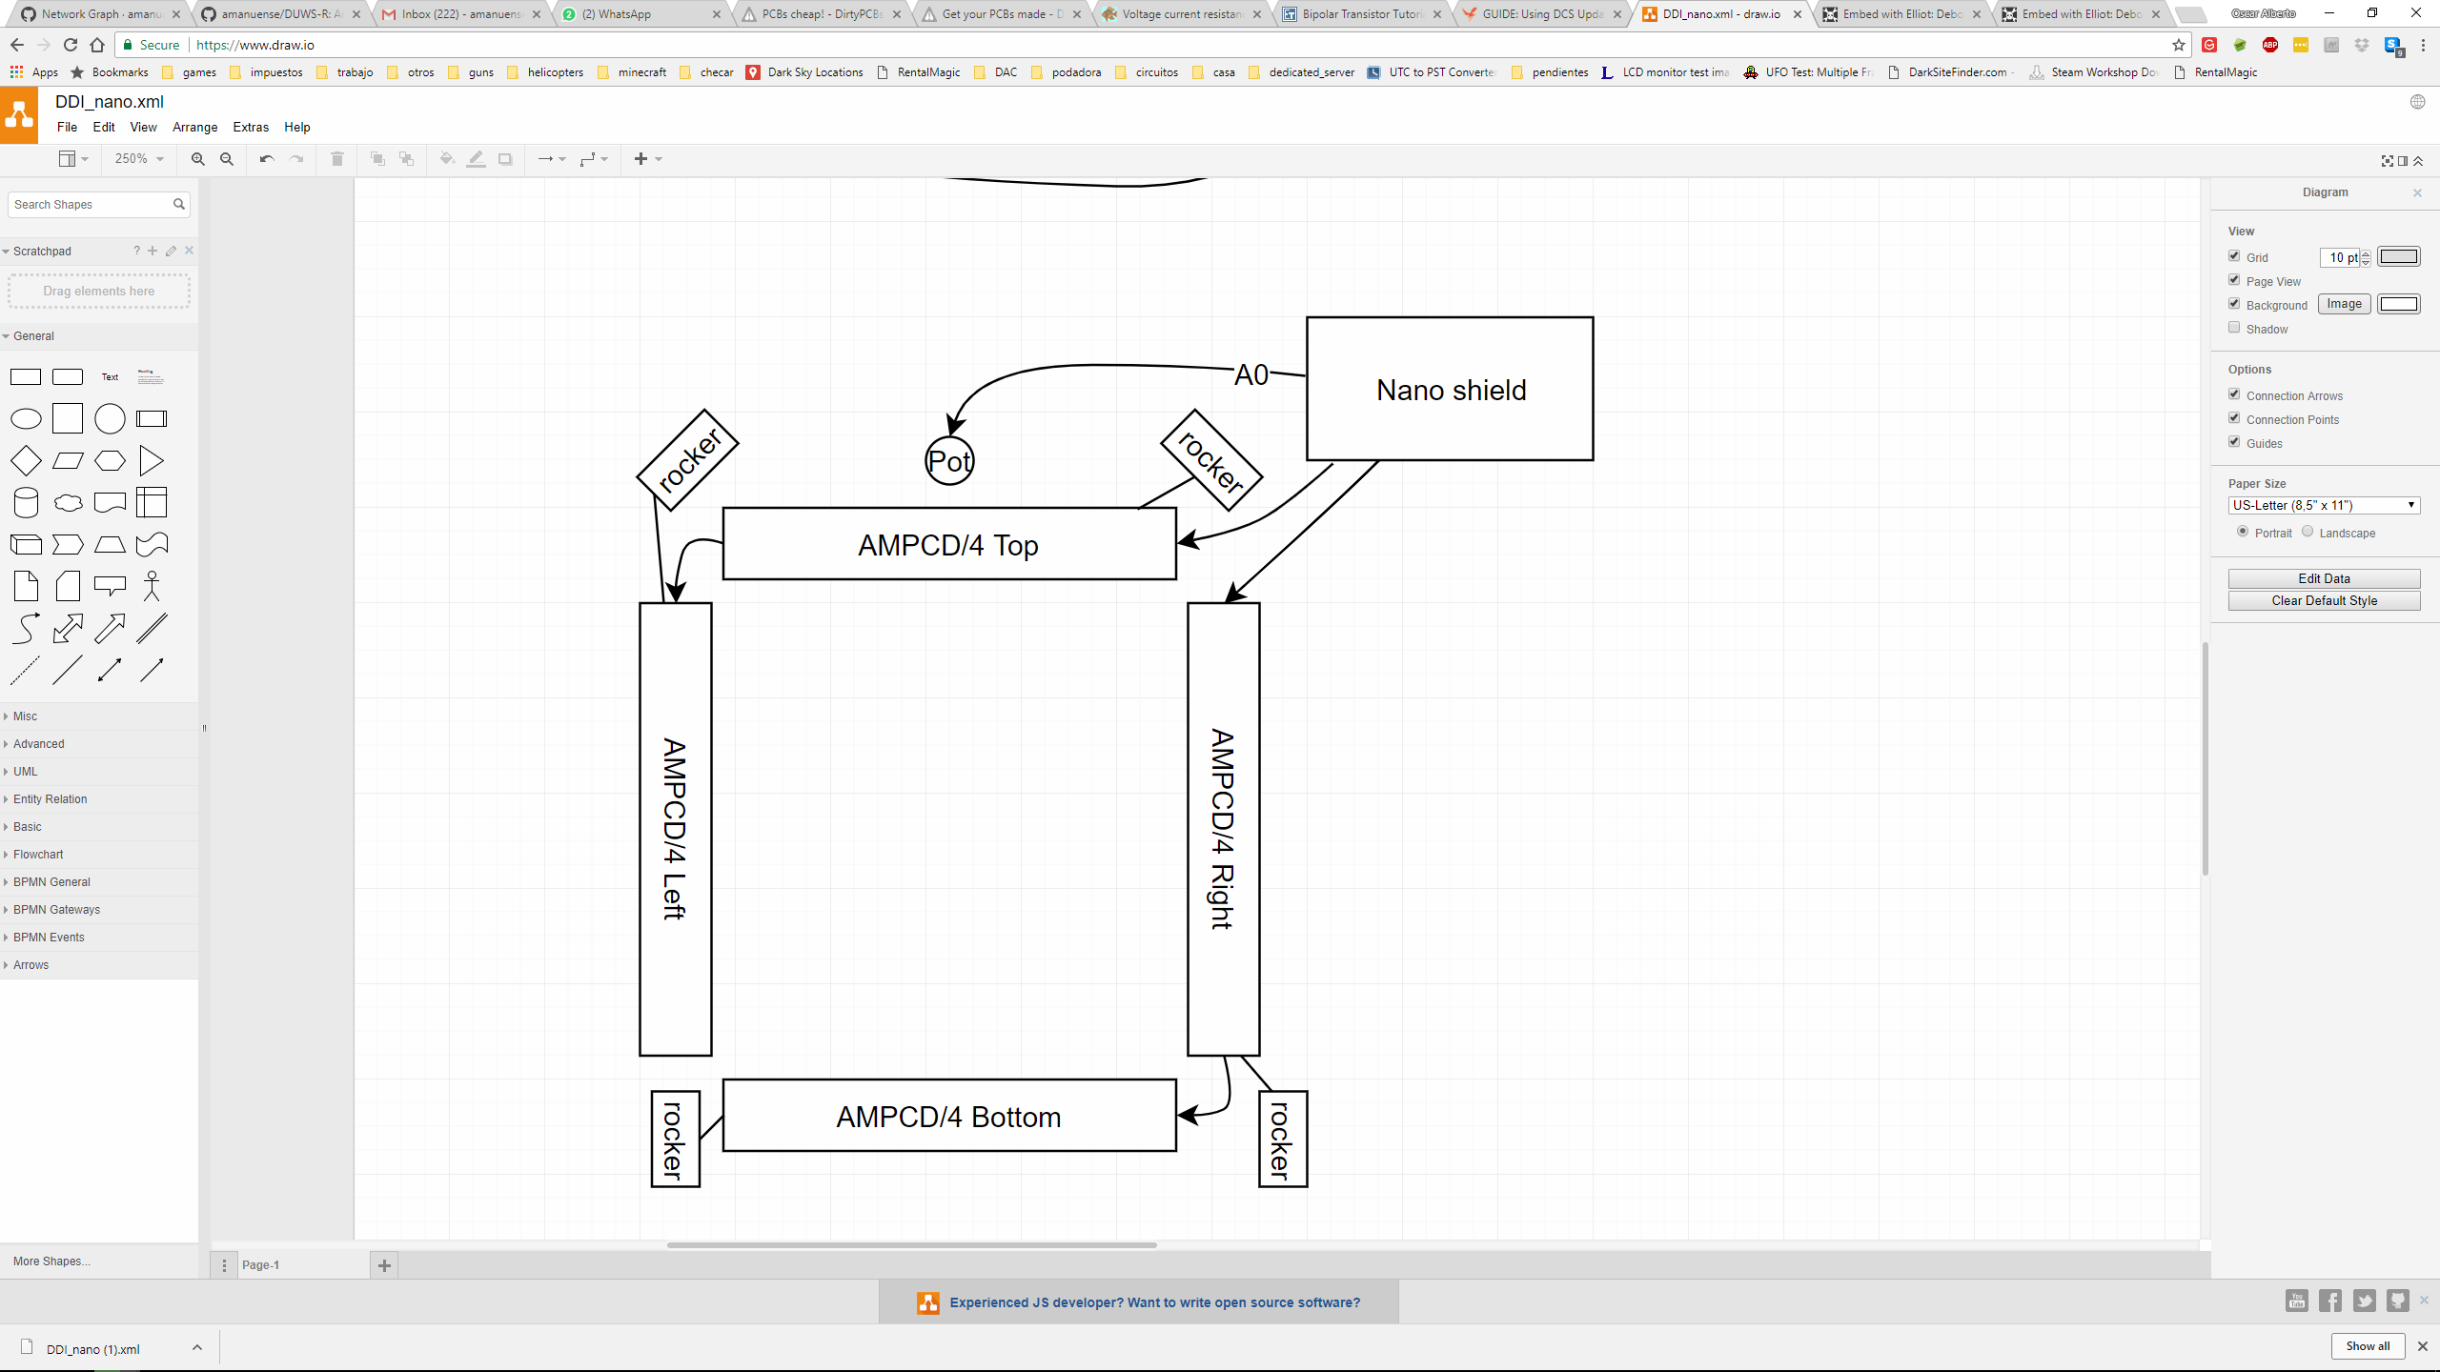

The AMPCD panel differentiates from the DDI panels thanks to the use of rocker switches, the rocker switches are handled the same way as the OSBs.

## Nano shield options

The Nano shield boards allow for software to recognize the position in the cockpit, this is done by configuring the pull-ups and pull-downs according to the following table.

|  |  |
| --- | --- |
| Option | Requires |
| Left DDI | d1 Pull down, d0 Pull up |
| Right DDI | d1 Pull up, d0 Pull down |
| AMPCD | d1 pull up, d0 pull up |

## DDI/4 and AMPCD/4 Addressing

Each one of the boards contains a TCA9534A IO expander, this device can be configured with up to 8 different I2C addresses, upon boot, and Software shall poll all 8 addresses in order to identify what modules are installed. The address assignation is done according to this table.

|  |  |
| --- | --- |
| Location | I2C Address |
| DDI/4 Top | 0b0111000 |
| DDI/4 Left | 0b0111001 |
| DDI/4 Right | 0b0111010 |
| DDI/4 bottom | 0b0111011 |

## Button press handling

Each DDI/4 board uses IO expander capable of generating an interrupt when any button is pressed, the PCB provides two button debouncing mechanisms in order to prevent fake interrupts or multiple interrupts in a short period of time.

The debouncing mechanism consists of:

* 6 hysteresis triggered inverted mechanism with <5ms detection delay. These circuits provide full debouncing capabilities and are intended to be used for the five OSBs + an extra button. These inputs filter most of the fake interrupts created by button bouncing by allowing only 0v or 5v outputs. One important distinction is that the values of the switch are inverted and software needs to take this into account.
* 2 non inverted switches with ~5ms detection delay intended for rockers (AMPCD only). These inputs provide medium debouncing capability by smoothing any glitches, fake interrupts may be triggered depending on the receiving IC specific thresholds.

Any change of any of these inputs will cause an interrupt to be fired and software can now read the status of all four DDI/4 blocks in order to determine which button was pushed. If necessary software might add extra debouncing time to compensate for flaky connections and bouncy switches.

The following pictures represent a simulation of the debouncing hardware please notice that the RC constant has been calculated for 10ms leading to a sub 5ms detection delay in most cases.

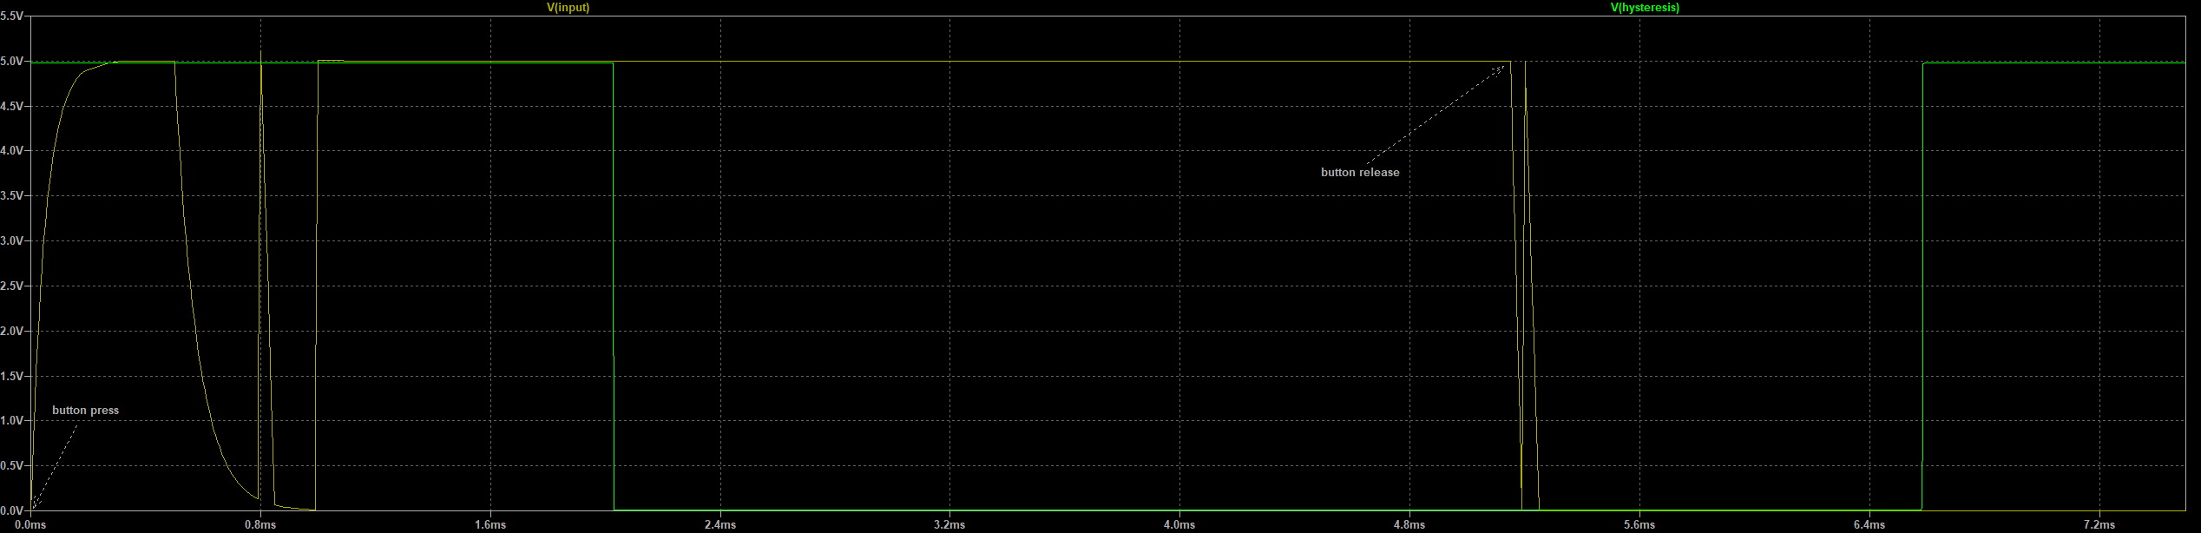

Figure 1 Button press detection with hysteresis

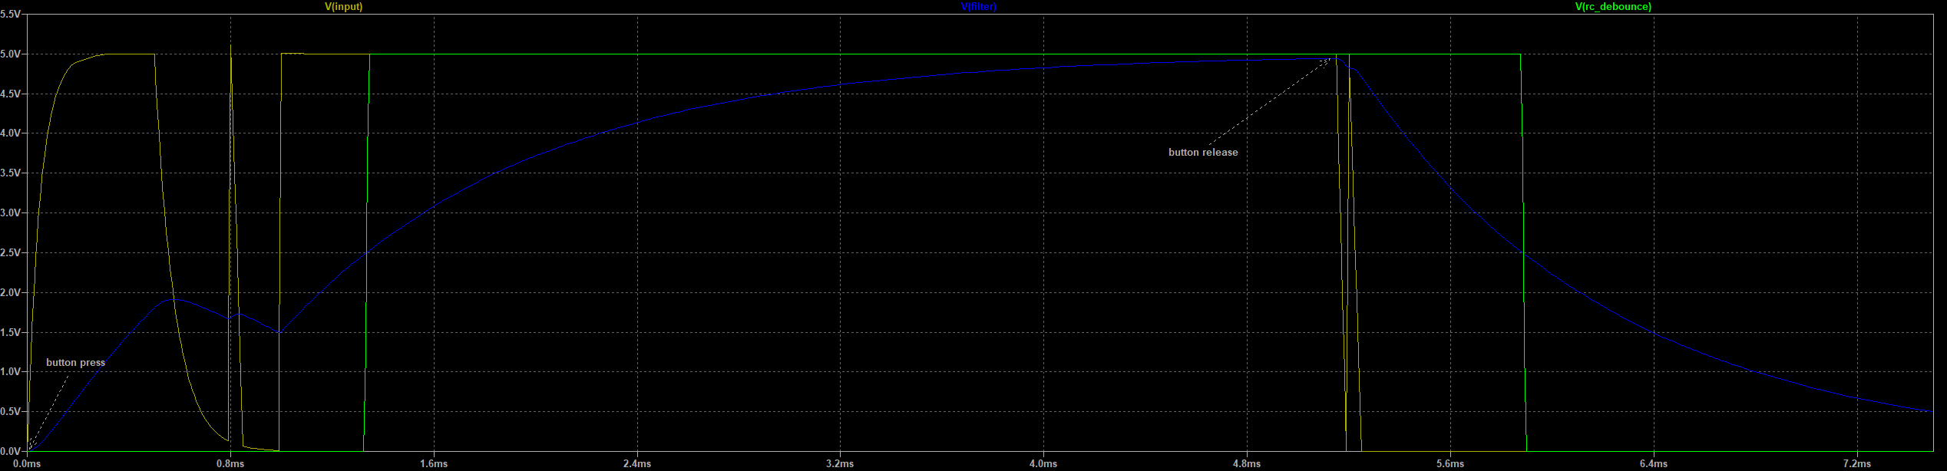

Figure 2 low pass detection using a 2.5v threshold example

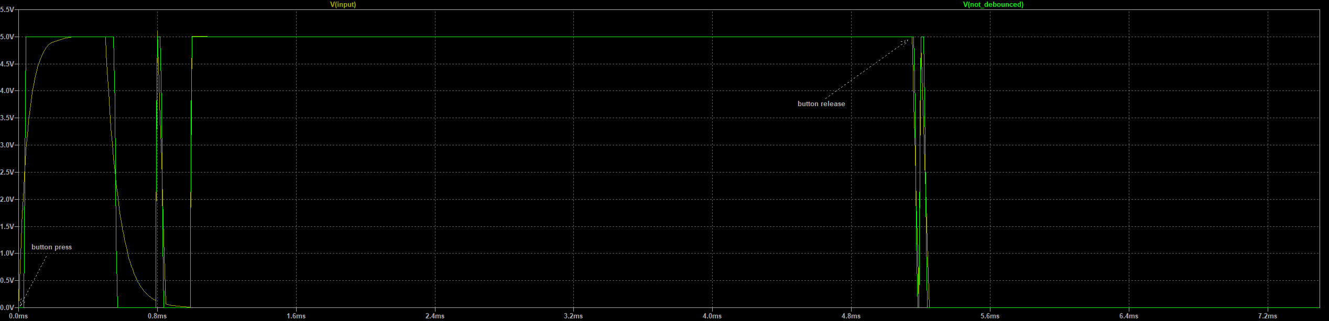

Figure 3 Raw signal detection (no debouncing)

## Potentiometer handling

The potentiometers installed in each DDI are read from A0-A2 pins from Arduino according to this table:

|  |  |
| --- | --- |
| potentiometer | Pin |
| <<find names>> | A0 |
|  | A1 |
|  | A2 |