**Texas Tech University. Applied Mathematics Seminars.**

**A New Discovery Reveals Signs of Advance Math in Ancient Islamic Architecture**

**Rima A. Al Ajlouni, *Texas Tech University***

**Wednesday, May 2, 2012**

**Room: MATH 016. Time: 4:00pm**

**Abstract:** The emergence of quasi-periodic tiling theories in mathematics and material science is revealing an exciting new class of symmetry that has never been explored before. The interest in these mysterious symmetries was triggered mainly by the discovery of quasicrystals in the 1984. This new state of matter exhibits forbidden symmetries, which were thought to be impossible for the crystalline matter in classical crystallography. The atoms in these complicated structures are not arranged according to regularly spaced intervals, similar to traditional crystals, instead, they exhibit a complicated long-range translational order that is not periodic. Since their first discovery, the number and variety of quasicrystals has become quite extensive, however, the unique long-range signature of quasi-crystalline symmetries, is still posing a perplexing puzzle.

Recently, the discovery of ancient ornaments in Islamic architecture with similar quasi-crystalline symmetries has triggered significant investigations into understanding their mathematical laws and generating principles. Astonishingly, eight centuries before their discovery in modern times, ancient artists had constructed patterns with perfect quasi-crystalline formations. Examples of these patterns can be found on the external walls of Gunbad-I Kabud tomb tower in Maragha, Iran (1197 C. E.) (Figure 1a), the walls of the Madrasa of al-'Attarin (1323 C.E.) in Fez, Morocco (Figure 1b), and the walls of Darb-i Imam shrine and the Friday Mosque in Isfahan (1453 C.E.) in Isfahan, Iran (Figure 1c).

The investigations into these complex and chaotic formations is revealing a deeper connection between contemporary theories and traditional mathematics; providing enough evidence to suggest that ancient designers had made a conceptual breakthrough in mathematics, as early as the 12 century, by constructing complex geometry far more mathematically advanced than we ever thought before. By using the most primitive tools (a compass and a straightedge) ancient designers, have resolved the complicated long-range principles of quasi-periodic formations. Derived from these principles, Al Ajlouni (2012) proposed the first global multi-level hierarchical framework model (HFM) that is able to describe the long-range translational and orientational order of quasi-periodic formations. This model provides the only available global-long-range structural method that is able to construct infinite patches of perfect quasi-crystalline formations, including Penrose tilings, without the need for confusing tiling strategies or complicated mathematics (Al Ajlouni 2011).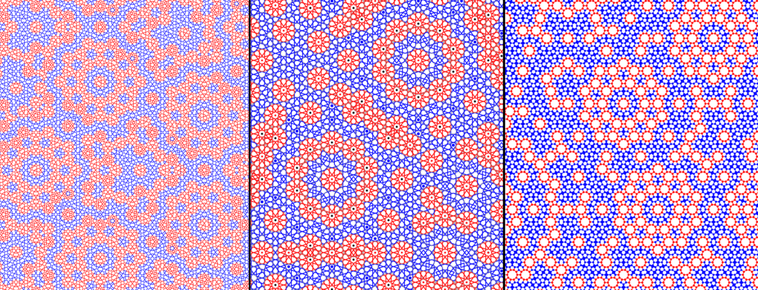

(*a*) (*b*) (*c*)

Figure 1. (a) The Quasi-periodic empire of the pattern on the external walls of Gunbad-I Kabud tomb tower in Maragha, Iran (1197 C. E.). (b) The Quasi- periodic empire of the pattern of the pattern on the walls of the Madrasa of al-'Attarin (1323 C.E.) in Fez, Morocco. (c) The Quasi- periodic empire of the pattern on the walls of Darb-i Imam shrine and the Friday Mosque in Isfahan (1453 C.E.) in Isfahan, Iran.

The use of simple proportional principles, present a paradigm shift in the way that scientists perceive and generate these complicated quasi-crystalline formations. This new method, which can be used as a general guiding principle for constructing new quasi-periodic formations, could possibly provide a deeper understanding of the structure of quasicrystals at an atomic scale, allowing scientists to achieve improved control over their composition and structure, potentially leading to the development of new materials and devices. In addition, this novel method provides an easy tool for mathematicians, teachers, designers and artists, to generate and study these complicated quasi-periodic symmetries.

References:

Al Ajlouni, R. (2011). A Long-Range Hierarchical Clustering Model for Constructing Perfect Quasi-Crystalline Formations. *Philosophical Magazine* **91**, 2728-2738.

Al Ajlouni, R. (2012). The Global Long-Range Order of Quasi-Periodic Patterns in Islamic Architecture. *Acta Crystallographica*. A**68**, 235-243.