Christopher Liu

3/2/16

ENEE359F – FPGAS

Wallace Tree Multiplier with Signed Complement System

Implementation and Design

To implement this system in the most ergonomic way possible, I left the Wallace tree intact and instead manipulated the multiplicand and product result to get my desired outputs. If I were to redesign the Wallace tree, it would include many changes such as increasing the width of most of the adders. It would also involve a lot of 1 padding which can become confusing and very hard to keep track of in a large 16 bit system. I can implement the system simply because I know if the leading bit of the multiplicand is 1 that it is a negative number. If multiplicand is negative, take the 2’s complement of it, and multiply as if it were a normal positive times positive multiplication. Then at the end of the calculation, 2’s complement it again to set the answer to be the correct sign. The utilization report shows that the complemented system is only about 1% more costly than the uncomplemented system. It is obviously larger because of the extra hardware needed to implement a 2’s complement, however the 2’s complementing hardware is very small and insignificant compared to the 16-bit multiplier.

Non Complemented System

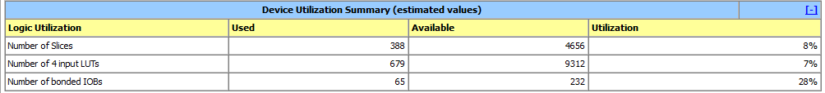

Complemented system.

