Geospatial Operations
Group 20

ABSTRACT
In this paper, we described the implementation of Geospatial operations namely Geometry Union, Geometry Convex Hull, Geometry Farthest Pair, Geometry Closest Pair, Spatial Range and Spatial Join using Apache Spark and Hadoop distributed framework. Also, we analyzed the performance in terms of memory, CPU Load and Network Utilization of our Geospatial operations on multi-node cluster using Ganglia by varying number of nodes. We extended the implementation of project to find number of required objects in a given space.
Keywords
HDFS, Spark, Distributed Database System, Geospatial

INTRODUCTION
Geospatial data has explicit Geographic positioning information and huge amount of data. Centralized Systems and relational algebra often fails to give accurate results in limited time because of single point of failure, memory and scalability issues. We made of distributed database system to create our environment which helps us to scale to required number of nodes depending on requirement and to avoid single point of failures. We used Hadoop to store data and spark to perform map reduce task by reading data from Hadoop and writing data to Hadoop which helped us to take care of memory and scalability issues.

SYSTEM ARCHITECTURE
Architecture of the project that we developed. We created a three node cluster with one master and three workers.
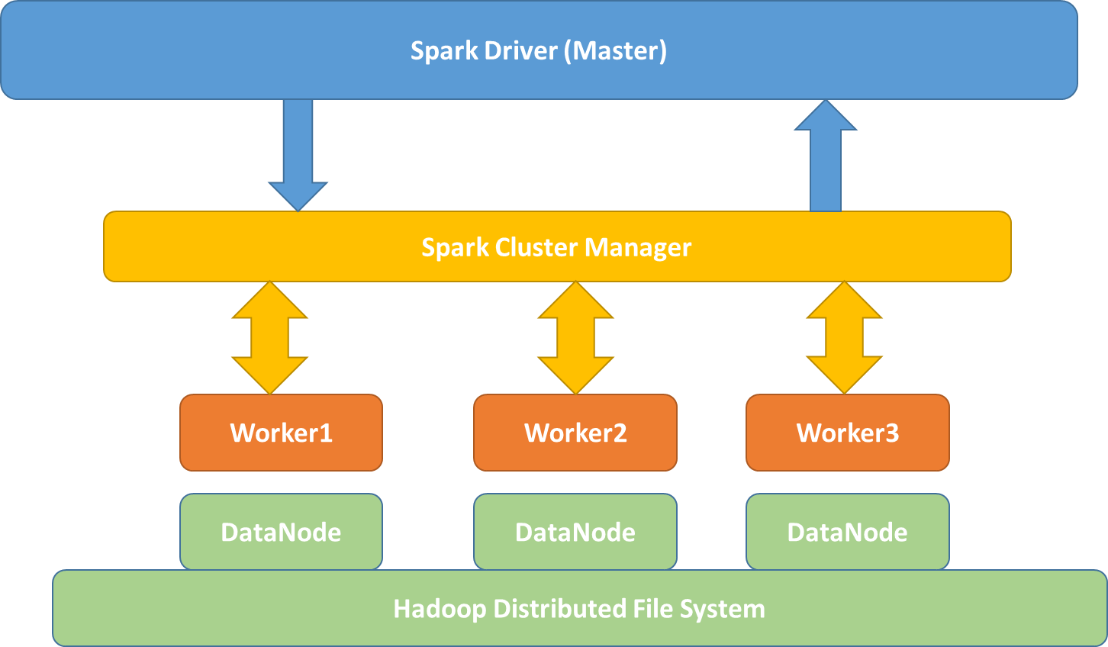
Figure 1. System Architecture

HDFS and DataNode
“HDFS has master-slave architecture. HDFS cluster consists of single NameNode, a master that manages file system namespace and regulates access to files. There are three DataNodes one per node in the cluster which manages storage attached to the nodes they run on” [1]. In our project we used HDFS to store data. Application reads data from spark. After performing map-reduce using spark, data is stored into output file in Hadoop.

Master

Worker

Spark

Geospatial Application
The six implemented functions are independent, except the Geometry Farthest Pair is dependent on the algorithm in the Geometry Convex Hull function to calculate the upper and lower hulls.
Several classes were created that were used across the six functions implemented in this package:
GeoPoint – Implementation of a basic X, Y point class. This class provides the ability to manage points and calculated the distance between two points, the slope between two points, if the point lies within a given rectangle, and if two points are geometrically equal.
GeoPointPair – This builds on the GeoPoint class to provide a pair of points.
Rectangle – Similar to GeoPointPair, this function provides implementation of a rectangle and functions for containsRectangle and containsPoint.
GeoSpatialUtils – This class provides a function that removes an hdfs files. This is useful for running tests on a system to delete the output file before trying to write to it.
HullResult – This class contains two RDD’s. It is used as an intermediate value in the Geometry Convex Hull algorithm prior to writing the results to the required file. This is useful as the implementation of the Geometry Farthest Pair function uses upper and lower hulls from Convex Hull. With this intermediate results, the Farthest Pair Implementation saves time by not writing and then reading the results from a file.

IMPLEMENTATION

Pre-requisites
We used virtual machines to create node of a cluster. Each node contains the following software
- Operating System: Ubuntu 14.04.1 LTS 32-bit
- OpenJDK 1.7.0
- Hadoop 2.6.0
- Spark 1.2.0
- SSH
- Maven2
- Eclipse Luna
- Ganglia

System Configuration
Configuration of our system is as follows
- Master
- Worker1
- Worker2
- Worker3
- Virtual Machine
- Host Machine

Geospatial Operations

Geometry union

Geometry convex hull
Definition: The convex hull of a set of points P is the smallest convex polygon that contains all points in P. The output of the convex hull operation is the points forming the convex hull ordered in a clockwise direction.
Example: The figures below show the input and output of a convex hull operation. The input is a set of points and the output is the points which compose the convex hull.
Function Name: GeometryConvexHull
Arguments:
(1) String InputLocation: the location of the input in HDFS
(2) String OutputLocation: the location of the output in HDFS
Return Value: Boolean: If the function works well, return True otherwise return False.
Requirement: Load a set of points, output the convex hull of this set.
Input Dataset Schema:
x, y: Every row is a point (longitude, latitude). This dataset has a bunch of points.
Output Dataset Schema:
x, y: Every row is a point (longitude, latitude). This dataset has a bunch of points. A convex hull is composed of all these points.
Algorithm/ Pseudocode:
The algorithm was developed use Apache Spark based on the convexHull algorithms in the papers by AndrewError: Reference source not found.
The implementation provided for two layers of interfaces. The outer layer is
- Sort the points by X, then Y in ascending order
- Until no points are removed,
  - Add first point to upperHull
  - If pnt1 to pnt2 is vertical and pnt1 to pnt3 then
    - Add pnt2 to upperHull
    - Replace pnt1 with pnt2
  - If slope of pnt1 to pnt2 is greater than slope of pnt1 to pnt3
    - Add pnt2 to upperHull
    - Replace pnt1 with pnt2
  - Replace pnt2 with pnt3, get new pnt3
- Sort the points by X, then Y in descending order
- Until no points are removed,
  - Add first point to lowerHull
  - If pnt1 to pnt2 is vertical and pnt1 to pnt3 then
    - Add pnt2 to lowerHull
    - Replace pnt1 with pnt2
  - If slope of pnt1 to pnt2 is greater than slope of pnt1 to pnt3
    - Add pnt2 to lowerHull
    - Replace pnt1 with pnt2
  - Replace pnt2 with pnt3, get new pnt3
- Combine upper and lower hulls
- Remove non-unique points
- Sort the results
How to run:
./spark-submit \
--class edu.asu.cse512.convexHull \
--master <Spark Master IP> \
--jars convexHull-0.1.jar \
hdfs://<HDFS Master IP>/inputFile \
hdfs://<HDFS Master IP>/outputFile

Geometry farthest pair

Geometry closest pair

Spatial range query

Spatial join query
Definition: Spatial join operation is used to combine two or more datasets with respect to a spatial predicate. Given a set of rivers and set of locations, spatial join returns all the rivers that lie inside or on the particular location.
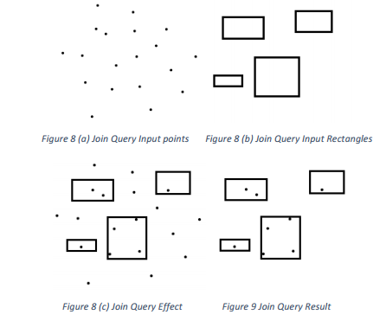 Figure 2. Spatial join query
Function Name: SpatialJoinQuery
Arguments:
- String InputLocation1: location of the input1 in HDFS
- String InputLocation2: location of the input2 in HDFS
- String OutputLocation: location of the output in HDFS
- String input1Type: indicates input1 is point or rectangle.
Requirement: Load two sets of polygons, output the join query result of these sets.
Input1 Dataset Schema:
- A-id, x1, y1, x2, y2: Every row is a pair of points which defines a rectangle. This set has bunch of rectangles. Both contained and overlapped are considered.
(or)
- A-id, x1, y1: Every row defines a point. This set has bunch of points. Points on and inside the rectangle are considered.
Input2 Dataset Schema:
B-id, x1, y1, x2, y2: Every row is a pair of points which defines a rectangle. This set has bunch of rectangles.
Output Dataset Schema:
B-id, A-id₁, A-id₂… A-id_{n}: Every row has one B-id and 0~ n A-id. This dataset has bunch of rows.
Algorithm/ Pseudocode:
- Creates a spark configuration
- Creates java spark context using spark configuration
- Reads the inputfile2 from Hadoop and creates JavaRDD of type Rectangle (class defined to map points to create a rectangle). Rectangle Definition: Bottom Left, Top Right.
- Sorts the inputfile2 rectangles by overriding the default sortBy function
- If input type is “point” then
  - Reads the inputfile1 from Hadoop and creates JavaRDD of type GeoPoint (class defines to map points)
  - Creates of broadcast variable of list of GeoPoint
  - Then the inputfile2 JavaRDD is partitioned to different nodes in cluster and inputfile1 is broadcasted.
  - On each node: For every rectangle in inputfile2 JavaRDD, GeoPoint Ids in broadcasted points are taken.
  - Code to check if Rectangle contains GeoPoint:
this.x >= input2Rectangle.getX1() &&
this.x <= input2Rectangle.getX2() &&
this.y >= input2Rectangle.getY1() &&
this.y <= input2Rectangle.getY2()
  - GeoPoint Ids are sorted.
  - String of inputfile2 Rectangle id and set of inputfile1 GeoPoint ids are returned as a result from mapped partitions.
  - Result is combined using coalesce function and output is saved to Hadoop.
- If input type is “rectangle” the
  - Reads the inputfile1 from Hadoop and creates JavaRDD of type GeoPoint (class defines to map points)
  - Creates of broadcast variable of list of Rectangles
  - Then the inputfile2 JavaRDD is partitioned to different nodes in cluster and inputfile1 is broadcasted.
  - On each node: For every rectangle in inputfile2 JavaRDD, Rectangle Ids in broadcasted rectangles are taken.
  - Code to check if Rectangle contains Rectangle:
this.x1 <= rectangle.x2 &&
this.y1 <= rectangle.y2 &&
this.x1 >= rectangle.x1 &&
this.y1 >= rectangle.y1 &&
this.x2 <= rectangle.x2 &&
this.y2 <= rectangle.y2 &&
this.x2 >= rectangle.x1 &&
this.y2 >= rectangle.y1
  - Rectangle Ids in broadcasted rectangles are sorted.
  - String of inputfile2 Rectangle id and set of inputfile1 Rectangle ids are returned as a result from mapped partitions.
  - Result is combined using coalesce function and output is saved to Hadoop.

How to run:
- If input type is “rectangle”
./spark-submit \
--class edu.asu.cse512.Join \
--master <Spark Master IP> \
--jars convexHull-0.1.jar \
joinQuery-0.1.jar hdfs://<HDFS Master IP>/inputFile1 \
hdfs://<HDFS Master IP>/inputFile2 \
hdfs://<HDFS Master IP>/outputFile rectangle
- If input type is point
./spark-submit \
--class edu.asu.cse512.Join \
--master <Spark Master IP> \
--jars convexHull-0.1.jar \
joinQuery-0.1.jar hdfs://<HDFS Master IP>/inputFile1 \
hdfs://<HDFS Master IP>/inputFile2 \
hdfs://<HDFS Master IP>/outputFile point

Spatial aggregation query

EXPERIMENTAL EVALUATION

Geometry union

Geometry convex hull
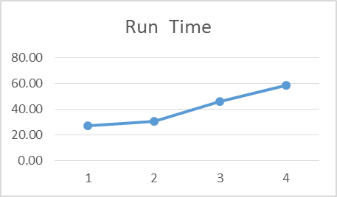
Figure 1 - Convex Hull Run Time
As expected, the run-time of the function increases as the number of nodes in the cluster increases as seen in Figure 1. This is due to the nature of the experimental system which consists of multiple virtual machines running on a single host system. If the experiment were run in a cluster of multiple physical machines, then a decrease of elapsed time would be expected as the cluster size increases until the communications overhead overwhelms the advantage of increasing processing power.
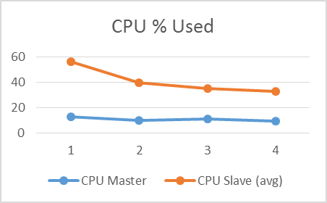
Figure 2 - Convex Hull CPU Used
As shown in Figure 2, the master node uses about the same amount of CPU as the number of nodes increases. There is a very small drop-off. This is likely due to the increased run-time. The master node will perform the same tasks over a longer period, lowering the average CPU load.
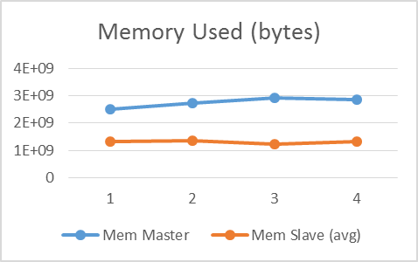
Figure 3 - Convex Hull Memory Used
Figure 3 shows the memory used on the master and the average of the slave nodes. The master shows a small increase as the number of slaves increases. This is likely due to the need to keep track of the work from these slave nodes. The slaves show almost no change in memory usage as the number of nodes increases. One possible explanation is the limited size of the experimental data set.
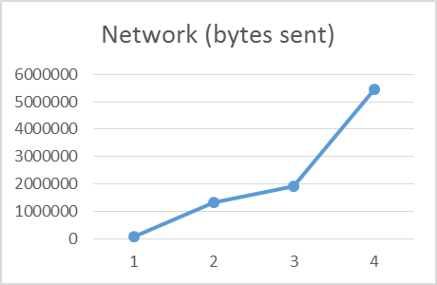
Figure 4 - Convex Hull Network Bytes Sent
The increase in network traffic shown in Figure 4 as more nodes are added to the cluster is expected, as more coordination between the master and slave nodes to perform the algorithm is required as the cluster gets more complicated.
Error: Reference source not found shows the raw results of running the Geometry Convex Hull algorithm on the class provided point data set. One apparent anomaly in the raw data is the last line, showing more than three times the network traffic of any other item, including five times as much output as input. This somewhat skews the remaining results.
This table also illustrates a possible anomaly seen in Figure 4. The network bytes sent shows a consistent increase as the number of nodes increases. The increase with four slave nodes is dramatically more than the rest. Looking at the raw results in Table 1, the last node in each cluster shows the highest network output values of any node. This may just be the

Geometry farthest pair

Geometry closest pair

Spatial range query

Spatial join query

CONCLUSION

REFERENCES
- Bowman, B., Debray, S. K., and Peterson, L. L. Reasoning about naming systems. ACM Trans. Program. Lang. Syst., 15, 5 (Nov. 1993), 795-825.
- Ding, W., and Marchionini, G. A Study on Video Browsing Strategies. Technical Report UMIACS-TR-97-40, University of Maryland, College Park, MD, 1997.
- Fröhlich, B. and Plate, J. The cubic mouse: a new device for three-dimensional iput. In Proceedings of the SIGCHI conference on Human factors in computing systems
(CHI ’00) (The Hague, The Netherlands, April 1-6, 2000). ACM Press, New York, NY, 2000, 526-531.
- Lamport, L. LaTeX User’s Guide and Document Reference Manual. Addison-Wesley, Reading, MA, 1986.
- Sannella, M. J. Constraint Satisfaction and Debugging for Interactive User Interfaces. Ph.D. Thesis, University of Washington, Seattle, WA, 1994.
- https://hadoop.apache.org/docs/r1.2.1/hdfs_design.html

