Strategy Workspace Fix
Short answer: what you’re seeing is expected given your current implementation—but it’s not acceptable UX. Right now your workspace is just a static shell. It’s not bound to data, so creating a Strategic Plan does nothing visually.
Let me show you what it should look like and what’s missing.

What Your Workspace Should Become
1. Current State (yours)
- “No strategic plans yet” → ❌ incorrect (you created one)
- No list, no navigation, no selection
- Programs/Objectives = “Coming soon”
👉 This is a dead dashboard, not a working module.

2. Expected MVP State (after creating 1 plan)
Strategy Workspace (correct behavior)
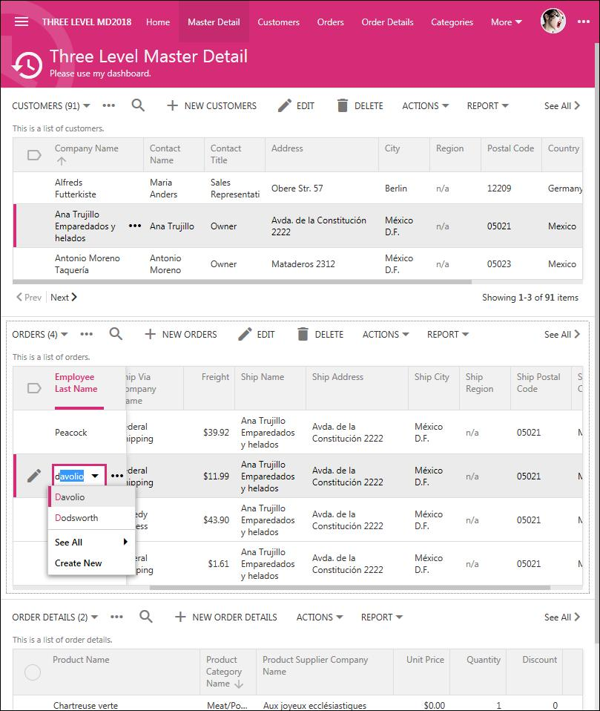
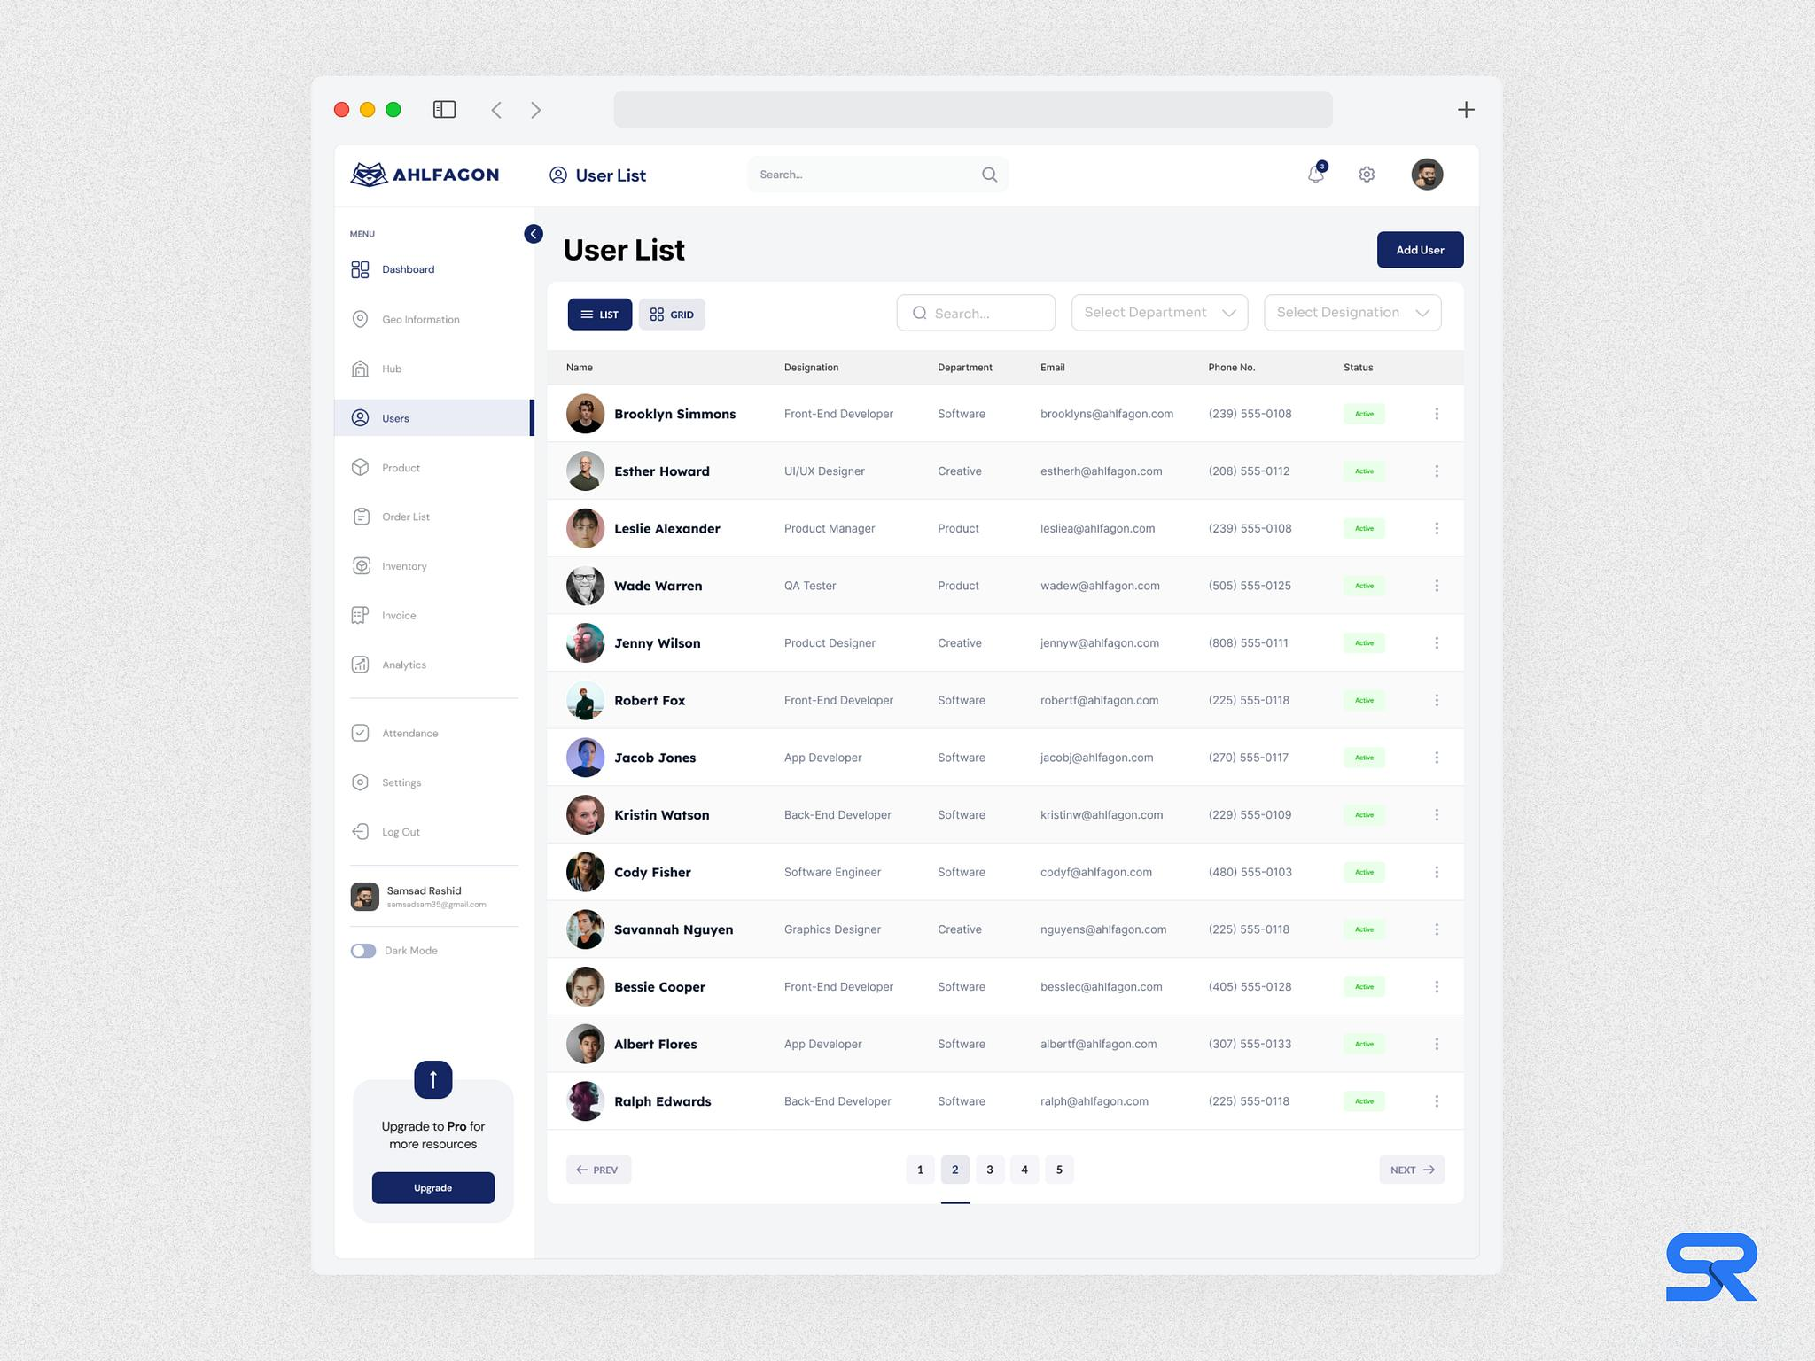
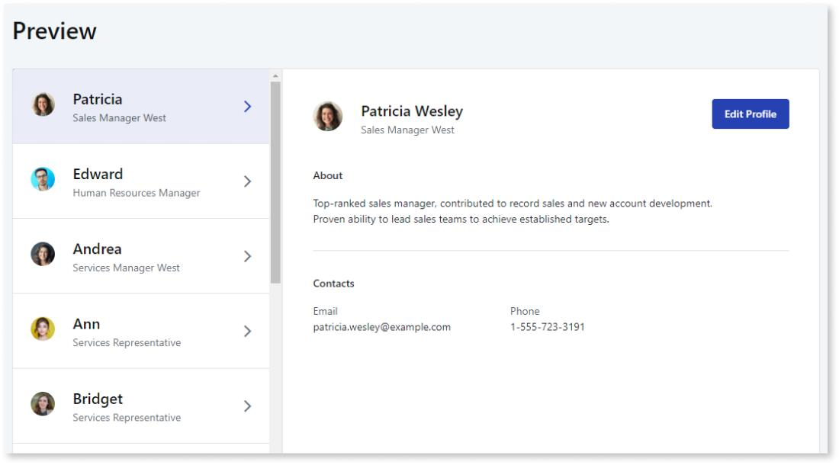

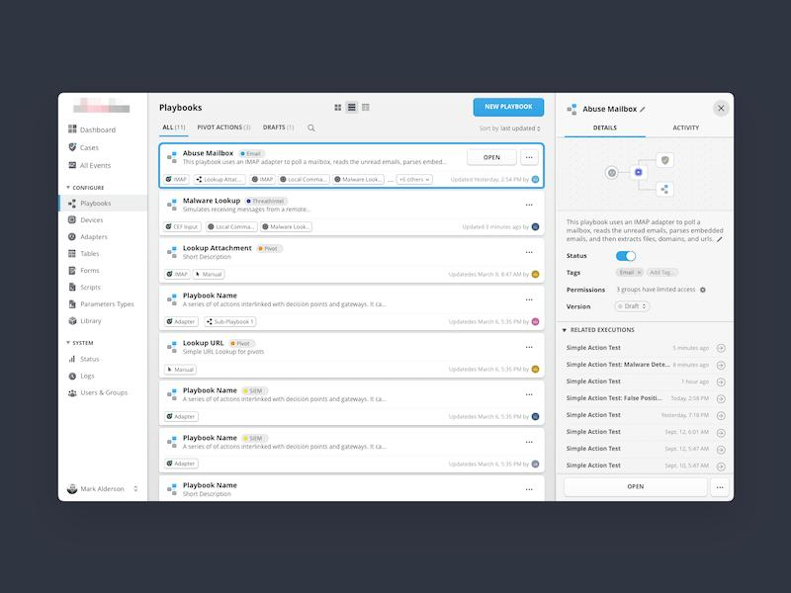
Layout should shift to:
A. Strategic Plans List (LEFT or TOP)
Strategic Plans

[ + New Strategic Plan ]

• MOH Strategic Plan 2026–2030 ← selected
• County Health Plan 2025–2029

B. Selected Plan Detail (MAIN PANEL)
MOH Strategic Plan 2026–2030
Status: Draft | Years: 2026–2030

[ Open Strategy Builder ]
[ Edit ]
[ Archive ]

Programs: 0
Objectives: 0
Targets: 0

C. Replace “No strategic plans yet”
Instead:
1 Strategic Plan found

Why Your Current UI Fails
Let’s be blunt:
👉 You built navigation
👉 You did NOT build state-driven UI
Right now:
- Workspace is static text
- No query to fetch plans
- No rendering logic
- No selection model
So the system has data, but the UI ignores it

What You Need to Implement (exactly)
1. Fetch Plans
In workspace JS:
frappe.call({
method: "frappe.client.get_list",
args: {
doctype: "Strategic Plan",
fields: ["name", "strategic_plan_name", "start_year", "end_year", "status"],
order_by: "creation desc"
},
callback: function(r) {
render_plans(r.message);
}
});

2. Replace Empty State Logic
Current (wrong):
"No strategic plans yet"
Correct:
if (plans.length === 0) {
show_empty_state();
} else {
render_plan_list(plans);
select_first_plan();
}

3. Render Plan List
Each item:
• {strategic_plan_name} ({start_year}–{end_year})
Clickable → loads detail panel

4. Detail Panel Binding
When plan selected:
function select_plan(plan) {
current_plan = plan;

render_plan_header(plan);
render_plan_stats(plan);
}

5. Add “Open Strategy Builder” CTA
Critical:
[ Open Strategy Builder ]
This bridges:
👉 Workspace → Builder (your working feature)

Minimum Acceptance Criteria (you must enforce this)
Before moving forward, your Strategy workspace must:
Data Visibility
- Created plans are visible immediately
- No false “empty state”
Navigation
- Can select a plan
- Selection updates UI
Actions
- Can open builder from workspace
- Can create new plan
Feedback
- Shows counts (even if 0)

Hard Truth
Right now your app is doing this:
“I stored your data successfully… but I won’t show it to you.”
That’s exactly the kind of UX problem that caused your earlier frustration.

What I Recommend Next (very important)
Do NOT move forward yet.
👉 Fix this workspace binding FIRST
Then we do:
- Workspace reflects plans
- Builder reflects hierarchy
- Data model enforces structure
Only then do we move to:
👉 Programs/Objectives UI inside workspace

If you want, next I can give you:
A drop-in Frappe workspace JS template that implements this cleanly (no trial-and-error)

