Broc Nickodemus
hw 4

1) Use your ML / DM tool of choice (e.g., KNIME) to experiment with the K-Nearest Neighbor and Naive Bayes classifiers on the training dataset (i.e., banknote_train.csv). Submit a short description (with screenshots) explaining your experimentation. E.g., • What algorithm parameters did you try? • Did you use K-fold cross-validation? • What were the results (accuracy, precision, and recall)?

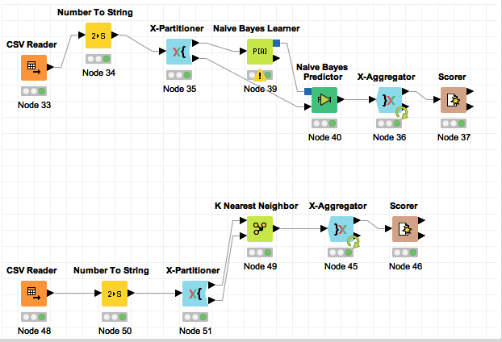

I found that the K-Nearest Neighbor had a greater accuracy predicting the class label for the banknote dataset than the Naïve Bayes model. The K-Nearest Neighbor model had a precision rate of 1 and a recall rate of 0.99 when predicating the class label 0. For the class label 1, K-Nearest Neighbor had a precision rate of 0.988 and a recall rate of 1 and an overall accuracy of 0.995. I experimented with different values of K for the K-Nearest Neighbors model and found that using 15 neighbors worked well.

I found that the Naive Bayes classifier did not work as well as K-Nearest Neighbors; this may have happened because the data might not have been conditionally independent. I ended up using K-fold cross-validation for both models. I also found that the Naive Bayes classified label 0 with a recall of 1 and a precision of 0.555. It also classified label 1 with a recall of 0 and a precision rate of 0 since it had no true positives. The overall accuracy resulted in 0.555 so I determined that K-Nearest Neighbors was a better model for this set of data. In both models, I decided to use all 4 columns (variance, skewness, curtosis, and entropy) to give the model more data to classify the label correctly. When using the Naive Bayes model, I attempted to eliminate some of the columns to see if it would increase the accuracy of the predicted label but it did not.

2) Once you determine the “best” algorithm and parameters (e.g., K), implement the classification workflow in Python to classify the test dataset (i.e., banknote_test.csv). Submit your Python code. • You can hard-code input files “banknote_train.csv” and “banknote_test.csv” • You must write the class predictions to a file named <lastname>.csv
i. Please include each row of test data with class label in your output

see python code

