Broc Nickodemus

Machine Learning hw1

o What trends did you look for?

I looked for trends in the data based on domain knowledge that I have; for example, I expected that the White average salary would be greater than the Black average salary. I would then go about looking for trends by creating a hypothesis and then checking to see if it was true or false. If there was no correlation between a set data, I would then generate a new subset.

o What trends did you find?

I discovered in the first trend that the modeled data showed that Asians and Whites on average earned more than the other races. In the second trend, I found was that on average more people earned more than 50k during their mid-30’s to mid-40’s. In the third trend, I found that on average people whose highest level of education was less than 12th grade typically worked less overtime than those with higher levels of education.

o How did you find them?

I found these trends by creating a hypothesis that tied two or more variables together that were correlated in some way. For example, I decided not to choose sex to compare with gender because they are not correlated (sex does not determine gender).

Trend #1

One interesting trend I found was that Asians and Whites averaged a larger number of people who earned more than 50k than other races. Perhaps this is due to racism in the work force.

Another trend I found that that the average percentage of salary (>50k) of Blacks was less than the average percentage of salary of the Whites.

The bar chart below shows the average percentage earning more than 50k separated by race.

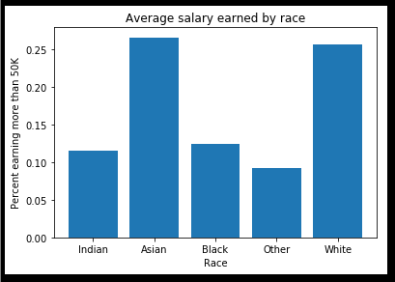

Trend #2

Another interesting trend I found was that on average, people generally earned more than 50k during the mid-30’s to mid-40’s. This would make sense because as people get older they acquire experience and gain expertise. Once a person reaches the threshold of mid-50’s to mid-60’s and beyond they begin looking forward to retirement and begin to become less motivated.

The graph below shows an increased salary ratio when a person is in their mid-30’s to mid-40’s.

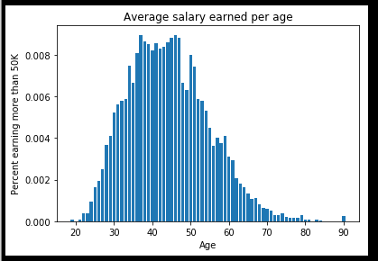

Trend #3

The final trend I found was that those who’s highest level of education was grades 12 and less tended to work less overtime than those who completed higher forms of education.

The diagram below shows the level of education associated with working overtime.

