Broc Nickodemus

P2 on page 288 (by the way, Figure 3.5 is on page 197)

P2. Consider Figure 3.5. What are the source and destination port values in the segments

flowing from the server back to the clients’ processes? What are the IP addresses in the network-layer datagrams carrying the transport-layer segments?

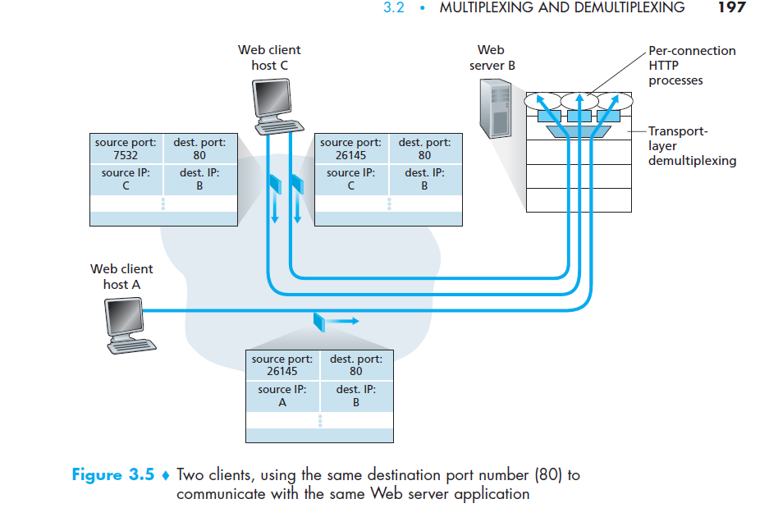

Web client host A is sending segment has a source port of 26145 and a destination port 80. Web server B will send the response back to Host A using source port 80 and destination port 26145. Web server B will send the response back to web client host C with a source port of 80 and destination port of 7532 and 26145. The IP addresses that are heading back to A or C will have the source IP set to their individual IP address and the destination IP of the client address.

P3 on page 288

P3. UDP and TCP use 1s complement for their checksums. Suppose you have the

following three 8-bit bytes: 01010011, 01100110, 01110100. What is the 1s

complement of the sum of these 8-bit bytes? (Note that although UDP and

TCP use 16-bit words in computing the checksum, for this problem you are

being asked to consider 8-bit sums.) Show all work. Why is it that UDP takes

the 1s complement of the sum; that is, why not just use the sum? With the 1s

complement scheme, how does the receiver detect errors? Is it possible that a

1-bit error will go undetected? How about a 2-bit error?

1 11

01010011

01100110 +

10111001

11

10111001

01110100 +

100101101

Wraparound sum = 00101110

Ones compliment = 11010001

If UDP has 1’s compliment it can calculate these four 8-bit values and check if the bits are 1 or not. If any of the bits equal 0, one or more errors have occurred. The problem is that if there are 2-bit errors occur the checksum will not be able to detect it.

P4 on page 288

P4. a. Suppose you have the following 2 bytes: 01011100 and 01100101. What is

the 1s complement of the sum of these 2 bytes?

11111

01011100

01100101 +

11000001

Ones compliment = 00111110

b. Suppose you have the following 2 bytes: 11011010 and 01100101. What is

the 1s complement of the sum of these 2 bytes?

11011010

01100101 +

00111111

Wraparound = 01000000

Ones compliment = 10111111

c. For the bytes in part (a), give an example where one bit is flipped in each of the 2 bytes and yet the 1s complement doesn’t change.

If you swap the 128 digit on each of the bytes it will remain the same.

11111

11011100

11100101 +

11000001

Ones compliment = 00111110

P15 on page 290 (figure 3.17 is on page 217)(not that it really illuminates much :))

P15. Consider the cross-country example shown in Figure 3.17. How big would

the window size have to be for the channel utilization to be greater than 98

percent? Suppose that the size of a packet is 1,500 bytes, including both

header fields and data.

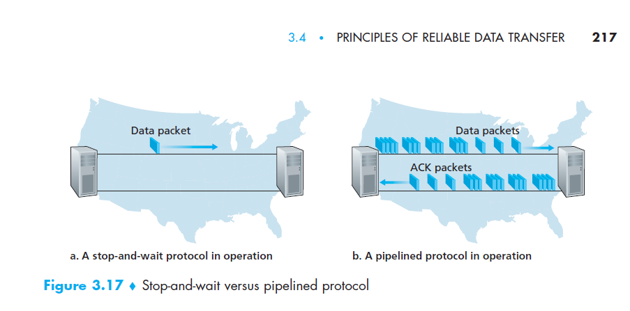

>98% of packet size 1,500 bytes link= 1Gbps

dtrans = L/R = (1500bytes \* 8)/ 109 = 0.000012 seconds = 0.012 ms

Usender = (L/R)/(RTT + L/R)

RTT = 30 from the text

U = (0.012 \* X) / (30 + 0.012) = 0.98

0.98\*30.012/0.012 = 1250.98

X = 2450.98 packets