Broc Nickodemus

1. What is the IP address and TCP port number used by the client computer (source) that is transferring the file to gaia.cs.umass.edu? To answer this question, it’s probably easiest to select an HTTP message and explore the details of the TCP packet used to carry this HTTP message, using the “details of the selected packet header window” (refer to Figure 2 in the “Getting Started with Wireshark” Lab if you’re uncertain about the Wireshark windows.

The IP of the source is 192.168.1.102 and the TCP source port is 1161

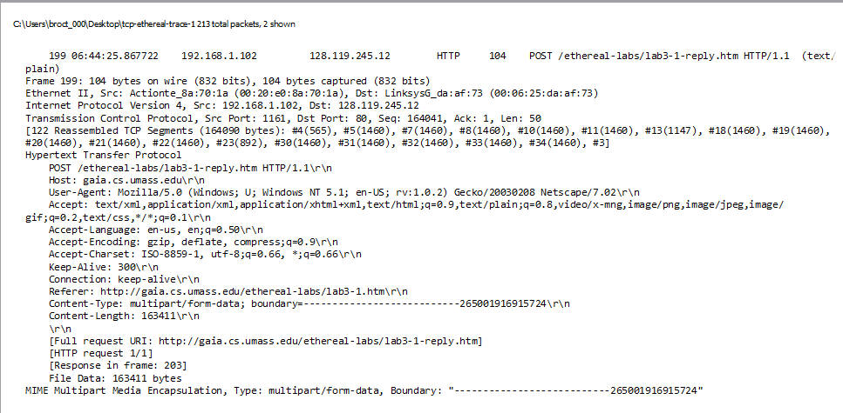

2. What is the IP address of gaia.cs.umass.edu? On what port number is it sending and receiving TCP segments for this connection?

It’s IP address is 128.119.245.12 and the port is 80



3. What is the IP address and TCP port number used by your client computer (source) to transfer the file to gaia.cs.umass.edu?

The IP of the source is 192.168.0.22 and the TCP source port is 58372

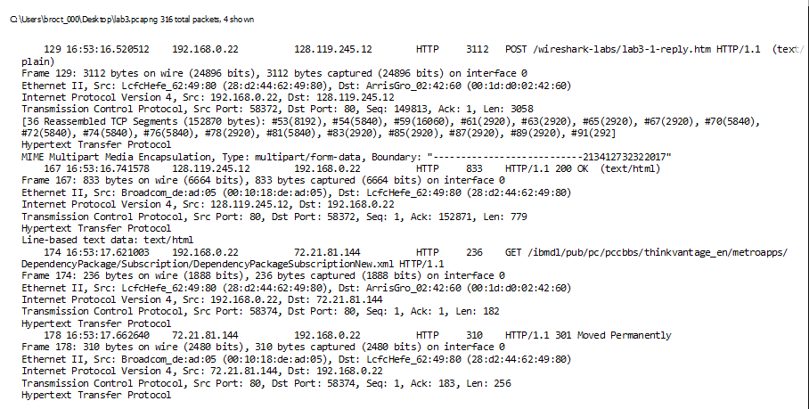

4. What is the sequence number of the TCP SYN segment that is used to initiate the TCP connection between the client computer and gaia.cs.umass.edu? What is it in the segment that identifies the segment as a SYN segment?

The sequence number of the SYN is 0. The SYN flag is set to 1 indicating that this segment is an SYN

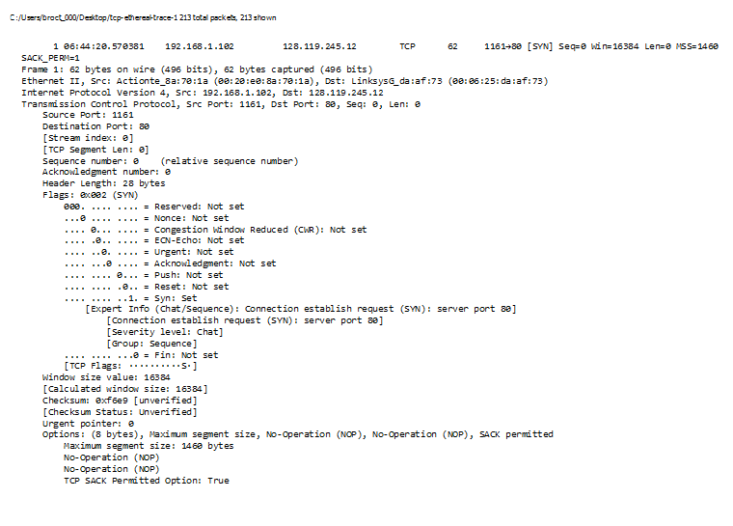

5. What is the sequence number of the SYNACK segment sent by gaia.cs.umass.edu to the client computer in reply to the SYN? What is the value of the Acknowledgement field in the SYNACK segment? How did gaia.cs.umass.edu determine that value? What is it in the segment that identifies the segment as a SYNACK segment?

The sequence number of the SYNACK segment is 0. The acknowledgement number is 1. This value was determined from the previous segment value plus 1. The SYN and ACK flags are both set to 1 meaning this is a SYNACK packet.

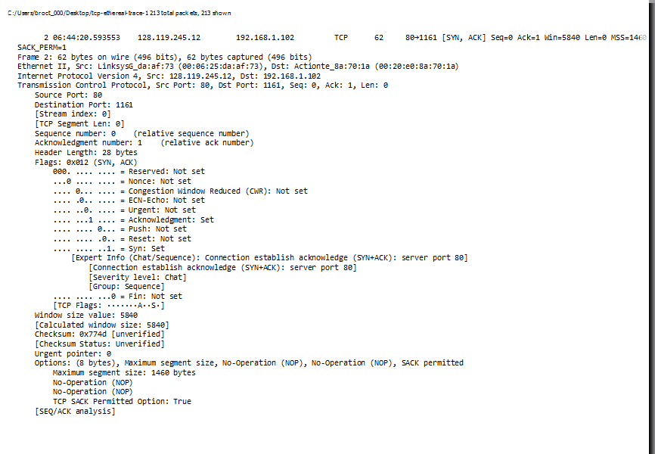

6. What is the sequence number of the TCP segment containing the HTTP POST command? Note that in order to find the POST command, you’ll need to dig into the packet content field at the bottom of the Wireshark window, looking for a segment with a “POST” within its DATA field.

The sequence number is 164041

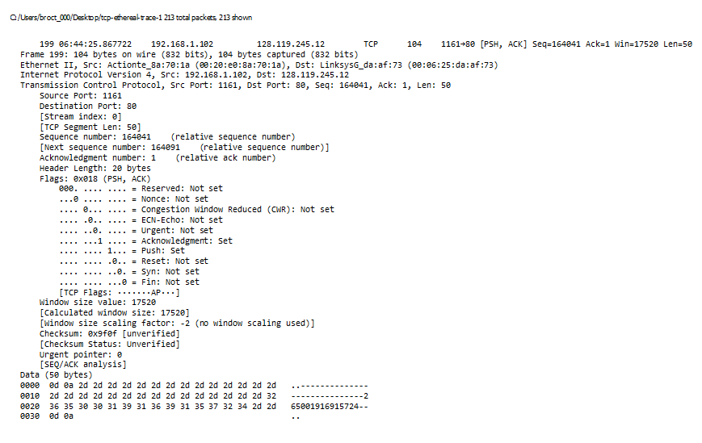

7. Consider the TCP segment containing the HTTP POST as the first segment in the TCP connection. What are the sequence numbers of the first six segments in the TCP connection (including the segment containing the HTTP POST)? At what time was each segment sent? When was the ACK for each segment received? Given the difference between when each TCP segment was sent, and when its acknowledgement was received, what is the RTT value for each of the six segments? What is the EstimatedRTT value (see Section 3.5.3, page 239 in text) after the receipt of each ACK? Assume that the value of the EstimatedRTT is equal to the measured RTT for the first segment, and then is computed using the EstimatedRTT equation on page 239 for all subsequent segments.

EstimatedRTT = 0.875 • EstimatedRTT + 0.125 • SampleRTT

The estimated RTT of packet 1  is: 0.875 \* .028 + 0.125 \* .028= .028  
The estimated RTT of packet 2  is: 0.875 \*  .042+ 0.125 \* .035 = .035  
The estimated RTT of packet 3  is: 0.875 \* .054 + 0.125 \* .070 = .070  
The estimated RTT of packet 4  is: 0.875 \*  .055+ 0.125 \* .114 = .114  
The estimated RTT of packet 5  is: 0.875 \* .077+ 0.125 \* .140 =  .140  
The estimated RTT of packet 6  is: 0.875 \*  .078+ 0.125 \* .190 = .190

8. What is the length of each of the first six TCP segments?

Segment 1 is 565 bytes  
Segment 2 is 1460 bytes  
Segment 3 is 1460 bytes  
Segment 4 is 1460 bytes  
Segment 5 is 1460 bytes  
Segment 6 is 1460 bytes

9. What is the minimum amount of available buffer space advertised at the received for the entire trace? Does the lack of receiver buffer space ever throttle the sender?

The minimum amount of space is 5840. The buffer space is never throttles the sender.

10. Are there any retransmitted segments in the trace file? What did you check for (in the trace) in order to answer this question?

No there aren’t any retransmitted segments. There were no repeat entry’s.

11. How much data does the receiver typically acknowledge in an ACK? Can you identify cases where the receiver is ACKing every other received segment (see Table 3.2 on page 247 in the text).

The receiver typically acknowledges 1460 bytes in an ACK. The receiver is typically sending an ACK twice as often as a TCP segment or is sending an ACK every two TCP segments. This is because TCP uses delayed ACKS.

12. What is the throughput (bytes transferred per unit time) for the TCP connection? Explain how you calculated this value.

The file size of the data is 150KB. The total duration for transmitting is 5.1471 seconds so the average throughput for the TCP connection is 150 x 8 / 5.1471 = 233.1409 Kbit/sec

13. Use the *Time-Sequence-Graph(Stevens*) plotting tool to view the sequence number versus time plot of segments being sent from the client to the gaia.cs.umass.edu server. Can you identify where TCP’s slowstart phase begins and ends, and where congestion avoidance takes over? Comment on ways in which the measured data differs from the idealized behavior of TCP that we’ve studied in the text.



The slow start phase begins from zero and ends around .1 seconds. It appears that the TCP is then in congestion avoidance since the measured data is only a fraction of the window size.

14. Answer each of two questions above for the trace that you have gathered when you transferred a file from your computer to gaia.cs.umass.edu

When I transferred a file something went wrong the graph looked like this:

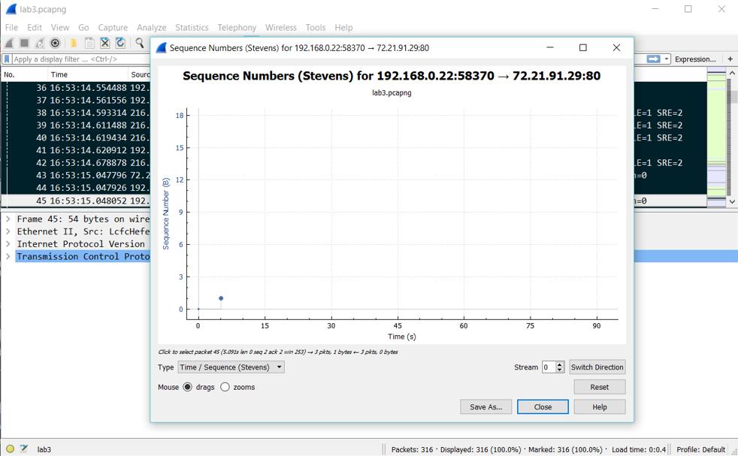

It only showed packet 1 and packet 44 with the stevens graph