Broc Nickodemus

Lab4a

1. What is the IP address of your computer?

192.168.0.22

2. Within the IP packet header, what is the value in the upper layer protocol field?

The value in the upper layer protocol is ICMP 0x01

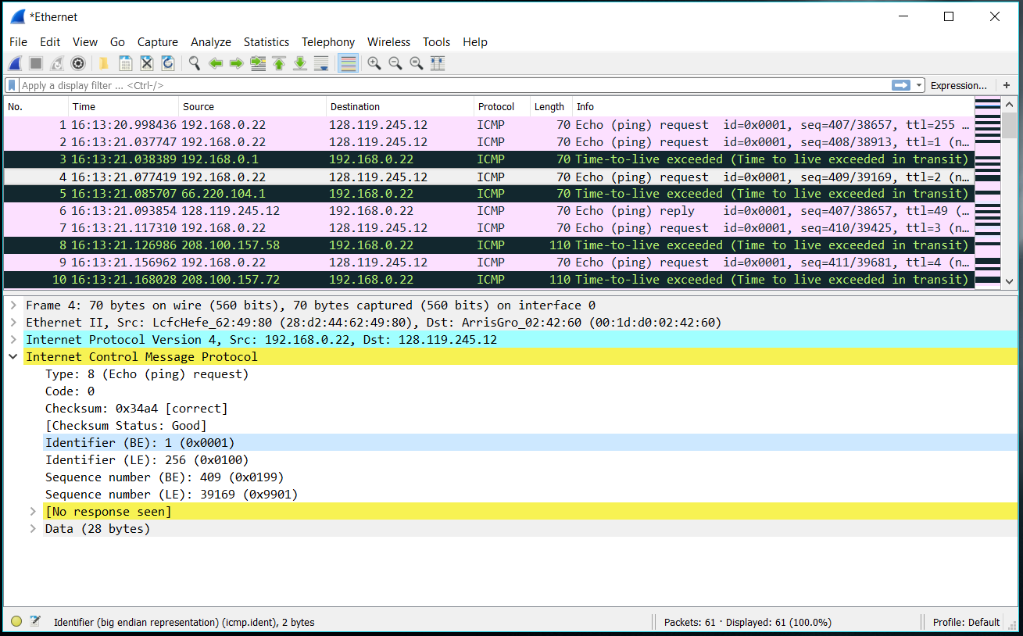

3. How many bytes are in the IP header? How many bytes are in the payload *of the IP datagram*? Explain how you determined the number of payload bytes.

There are 20 bytes in the header which leaves 56 bytes – 20 bytes = 36 bytes for the payload

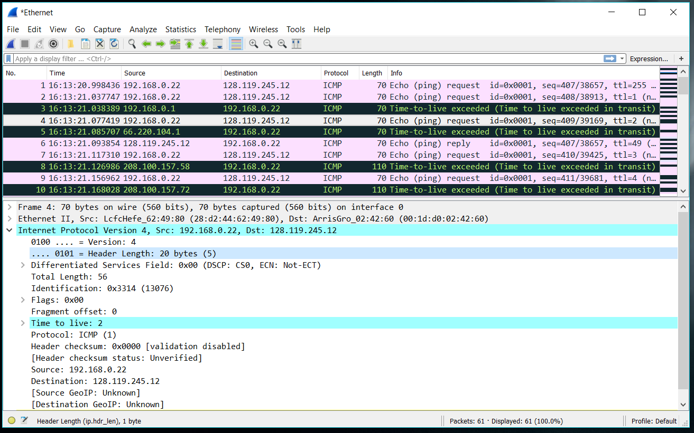

4. Has this IP datagram been fragmented? Explain how you determined whether or not the datagram has been fragmented.

The fragmentation offset is set to 0 so I assume that the packet is not fragmented



5. Which fields in the IP datagram *always* change from one datagram to the next within this series of ICMP messages sent by your computer?

The id and the checksum of the header changes from each diagram.

6. Which fields stay constant? Which of the fields *must* stay constant? Which fields must change? Why?

Fields stay constant:

IPv4 or IPv6 will stay constant because the version won’t change

The protocol ICMP should stay the same

The source IP won’t change because we are sending the data from the same computer

The destination IP won’t change because we are sending

The header length will stay the same

Fields must stay constant:

IPv4 or IPv6 will stay constant because the version won’t change

The protocol ICMP should stay the same

The source IP won’t change because we are sending the data from the same computer

The destination IP won’t change because we are sending

The header length will stay the same

Fields that must change:

The checksum will change because the header will change

The Identification fields will also change

7. Describe the pattern you see in the values in the Identification field of the IP datagram

The ID field is incremented by one every time

8. What is the value in the Identification field and the TTL field?

Identification number: 59396

TTL: 251

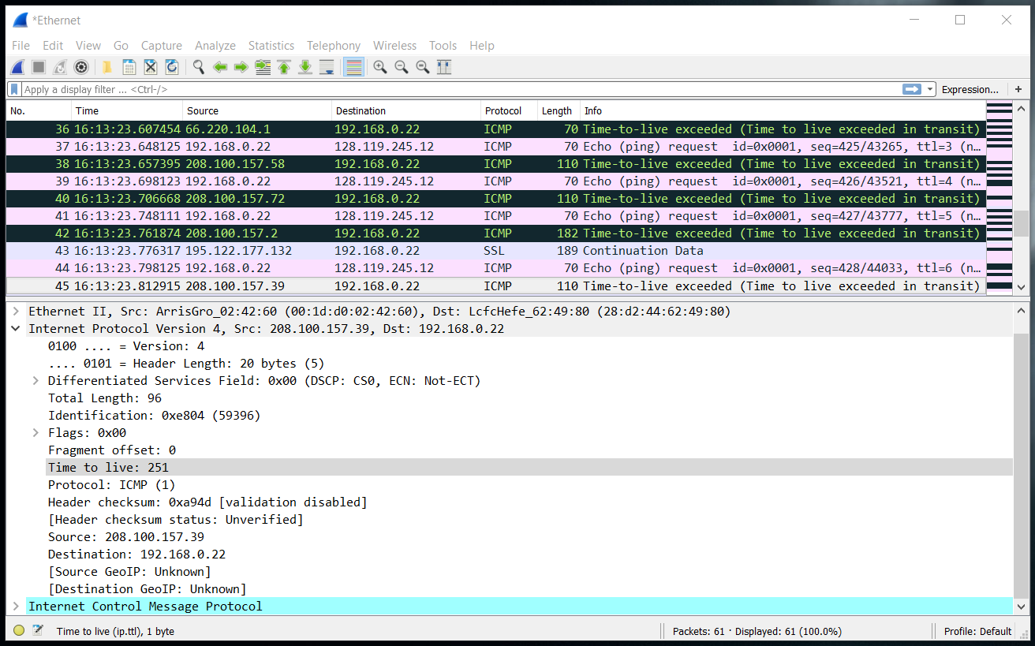

9. Do these value remain unchanged for all of the ICMP TTL-exceeded replies sent to your computer by the nearest (first hop) router? Why?

The Identification field changes every reply because it needs to have a unique id. If two replies have the same id field, then it is fragmented. The TTL field does not change because the time to live is a fixed number.

10. Find the first ICMP Echo Request message that was sent by your computer after you changed the *Packet Size* in *pingplotter* to be 2000. Has that message been fragmented across more than one IP datagram? [Note: if you find your packet has not been fragmented, you should download the zip file http://gaia.cs.umass.edu/wireshark-labs/wireshark-traces.zip and extract the *ipethereal-trace-1*packet trace. If your computer has an Ethernet interface, a packet size of 2000 *should* cause fragmentation.3]

Yes, the message has been fragmented across more than one IP datagram

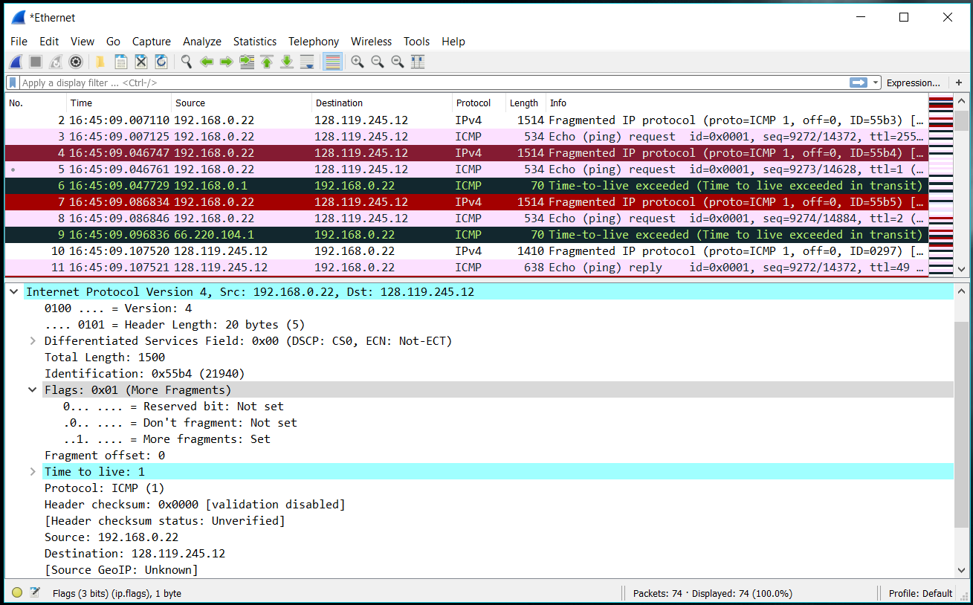

11. Print out the first fragment of the fragmented IP datagram. What information in the IP header indicates that the datagram been fragmented? What information in the IP header indicates whether this is the first fragment versus a latter fragment? How long is this IP datagram?

The set flag shows that more segments have been fragmented. The fragmentation offset is set to 0 and later offsets are set to 1400. The IP diagram has a total length of 1500.

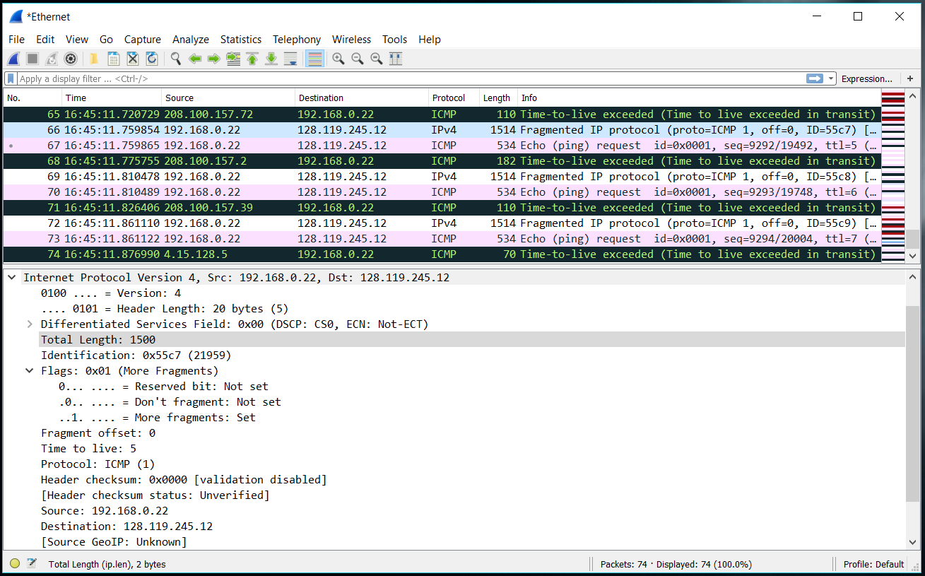

10. Print out the second fragment of the fragmented IP datagram. What information in the IP header indicates that this is not the first datagram fragment? Are the more fragments? How can you tell?

The second fragment is offset of 1480 instead of 0. There are no more fragments since the flag is not set for more fragments.

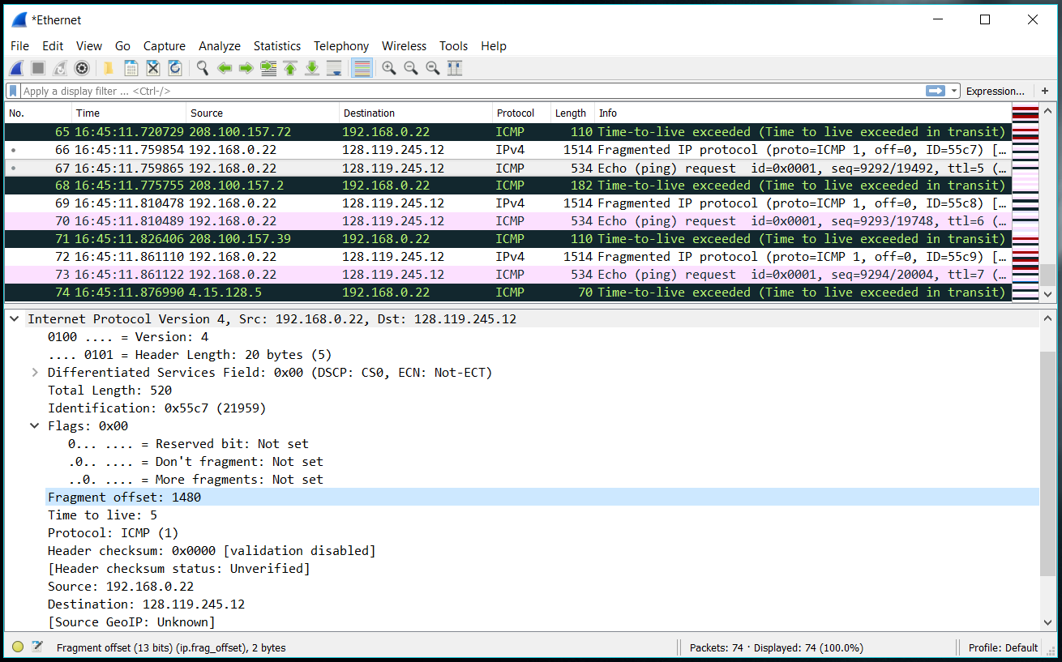

11. What fields change in the IP header between the first and second fragment?

The fragmentation offset, the checksum, the set flags, and the length change between the first and second fragmentation.

12. How many fragments were created from the original datagram?

3 fragments were created for 3500 bytes.

13. What fields change in the IP header among the fragments?

The fragmentation offset changes and the checksum changes.