Broc Nickodemus

HW 7 Chapter 7 Multimedia Networking

R1 on page 656 (Table 7.1 is on page 589).

R1. Reconstruct Table 7.1 for when Victor Video is watching a 4 Mbps video, Facebook Frank is looking at a new 100 Kbyte image every 20 seconds, and Martha Music is listening to 200 kbps audio stream.

* 4,000 (67min) / 8000 (1 kbyte)

|  |  |  |
| --- | --- | --- |
|  | Bit rate | Bytes transferred in 67 min |
| Facebook Frank | 100 kbps | 50 mb |
| Martha Music | 200 kbps | 100 mb |
| Victor Video | 4 mbps | 2 gb |

P6 on page 660 (The VOIP section of 7.3 is from pages 620-623; assume 160 bytes for an IP datagram's size)

P6. In the VoIP example in Section 7.3, let h be the total number of header bytes added to each chunk, including UDP and IP header.

a. Assuming an IP datagram is emitted every 20 msecs, find the transmission

rate in bits per second for the datagrams generated by one side of this application.

transmission rate = diagram + h

((160 bytes + h) * 8) / 20 * 10-3msec = (160+h) * 400

b. What is a typical value of h when RTP is used?

IP + UDP + RTP (common values)

Ip h = 20 bytes

UDP h = 20 bytes

RTP h = 12 bytes

20 + 20 + 12 = 52 bytes

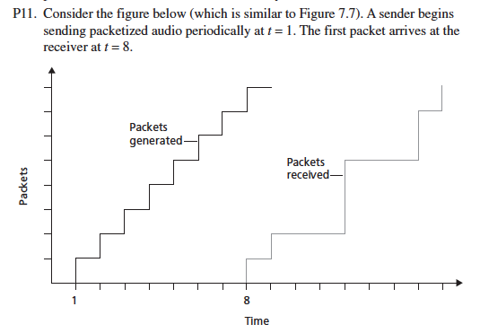

a. What are the delays (from sender to receiver, ignoring any playout delays) of packets 2 through 8? Note that each vertical and horizontal line segment in the figure has a length of 1, 2, or 3 time units.

packet 2 arrives at time 9 - 2 = 7 units

packet 3 arrives at time 12 - 3 = 9 units

packet 4 arrives at time 12 - 4 = 8 units

packet 5 arrives at time 12 - 5 = 7 units

packet 6 arrives at time 15 - 6 = 9 units

packet 7 arrives at time 15 - 7 = 8 units

packet 8 arrives at time 16 - 8 = 8 units

b. If audio playout begins as soon as the first packet arrives at the receiver at t = 8, which of the first eight packets sent will not arrive in time for playout?

Packets 3, 4, and 6 be missed for playout because they take longer than 7 time units.

c. If audio playout begins at t = 9, which of the first eight packets sent will not arrive in time for playout?

Packet 3 and 6 will not arrive since they take 9 time units.

d. What is the minimum playout delay at the receiver that results in all of the first eight packets arriving in time for their playout?

10 time units is the minimum playout delay for all packets to arrive.

P16. True or false: on pages 662-663

a. If stored video is streamed directly from a Web server to a media player, the application is using TCP as the underlying transport protocol.

True

b. When using RTP, it is possible for a sender to change encoding in the middle of a session.

True

c. All applications that use RTP must use port 87.

False

d. If an RTP session has a separate audio and video stream for each sender, then the audio and video streams use the same SSRC.

False

e. In differentiated services, while per-hop behavior defines differences in performance among classes, it does not mandate any particular mechanism for achieving these performances.

True

f. Suppose Alice wants to establish an SIP session with Bob. In her INVITE message she includes the line: m=audio 48753 RTP/AVP 3 (AVP 3 denotes GSM audio). Alice has therefore indicated in this message that she wishes to send GSM audio.

False

g. Referring to the preceding statement, Alice has indicated in her INVITE message that she will send audio to port 48753.

False

h. SIP messages are typically sent between SIP entities using a default SIP port number.

True

i. In order to maintain registration, SIP clients must periodically send REGISTER messages.

True

j. SIP mandates that all SIP clients support G.711 audio encoding.

False