Estimating the cumulative impact and zone of influence of

infrastructure on biodiversity

To be submitted to *Methods in Ecology and Evolution*

Bernardo Brandao Niebuhr˜ 1,2,*, Bram Van Moorter1,*, Audun Stien3, Torkild Tveera4,

Knut Langeland4, Olav Strand1, Per Sandstrom¨ 5, Anna Skarin2, Moudud Alam6, and

Manuela Panzacchi1

1Norwegian Institute for Nature Research (NINA), Trondheim, Norway

2Swedish University of Agricultural Sciences (SLU), Uppsala, Sweden

3University of Tromsø, Tromsø, Norway

4Norwegian Institute for Nature Research (NINA), Tromsø, Norway

5Swedish University of Agricultural Sciences (SLU), Umea, Sweden˚

6Dalarna University, Falun, Sweden

*Joint first authorship

Corresponding author: Bernardo Brandao Niebuhr˜

Norwegian Institute for Nature Research, Postboks 5685 Torgarden,

7485 Trondheim, Norway

Contact: bernardo.brandao@nina.no, bernardo brandaum@yahoo.com.br

Word count: 7969

May 13, 2022

Abstract

1. Infrastructure development often takes place in landscapes already affected by multiple anthropogenic disturbances, leading to cumulative impacts on biodiversity. Typically, the impact of a given type of infrastructure is determined by computing the distance to the nearest feature only, ignoring potential cumulative impacts of multiple features, what can lead to severe underestimations. We propose an approach to assess whether and how multiple anthropogenic features lead to cumulative impacts.
2. We derive a method to estimate the effect size and zone of influence (ZoI) of infrastructure, that allow for flexible functions defining how the impact vary within the ZoI. This formulation allows us to quantify the impact based on the nearest feature only, and the cumulative impact of multiple features of the same type. We use simulations and an empirical case to understand under which circumstances the estimated cumulative impact do not differ from the impact estimated using the nearest feature only. Finally, we illustrate the approach by quantifying and visualizing cumulative impacts of recreational facilities in Norway on habitat selection of wild reindeer, a species highly sensible to anthropogenic disturbance.
3. Simulations show the impact estimated from the nearest feature and the estimated cumulative impact from multiple features cannot be distinguished when the occurrence of the feature is rare and ZoI is small, and when features are clustered and ZoI is large. In our empirical analysis we found strong evidence of cumulative impacts of private cottages and tourist resorts on reindeer, with a radius of the ZoI being 10 and 20 km, respectively. While the impact of a single private cottage was negligible, the cumulative impact of an aggregation of cabins could be larger than that of a tourist resort. Hence, measuring only the ZoI of the nearest private cottage would underestimate the impact of the widespread phenomena of cabin villages.
4. The approach we develop allows to assess cumulative impacts of infrastructure on biodiversity, and can be broadly applied in environmental impact assessment and land use planning. All ZoI metrics are calculated before statistical analysis, making them computationally efficient and flexible, and can be computed in R and GRASS GIS through the oneimpact R package. Although our example focuses on animal space use, the approach can be applied in environmental impact studies from individuals to populations and communities, and counter the widespread trend of underestimating anthropogenic impacts.

Key-words: Anthropocene, cumulative effects, distance-weighting, habitat fragmentation, habitat selection, kernel density, *Rangifer tarandus*, scale of effect

2

# 1 Introduction

Land use change and infrastructure from industrial development are increasing at an accelerated pace across all regions of the world (Venter *et al.*, 2016; Ibisch *et al.*, 2016), including all global biodiversity hotspots (Sloan *et al.*, 2014), and are among the main causes of biodiversity declines (Ben´ıtez-Lopez´ *et al.*, 2010; Newbold *et al.*, 2015). Most infrastructure development takes place in areas already affected by multiple sources of disturbance (Barber *et al.*, 2014) and, thus, infrastructure of the same type are often clustered in the landscape. Understanding a species’ response to spatially co-occurring infrastructure is crucial to adequately assess their total impact. Indeed, the impact of new anthropogenic features might add and spatially interact to that of preexisting ones, leading to a cumulative impact larger than that of single features in isolation (Box 1; Johnson & St-Laurent, 2011). Adequately quantifying cumulative impacts is of crucial importance for ensuring ecological sustainability in land use planning, preventing habitat loss due to anthropogenic development, and informing robust mitigation or off-set measures (Gillingham *et al.*, 2016; Laurance & Arrea, 2017). Most environmental impact assessment studies focus on single infrastructure projects at small spatio-temporal scales (Johnson, 2011), and even broad-scale ecological studies typically consider only the impact of the nearest anthropogenic feature, ignoring cumulative impacts of multiple co-occurring features (e.g. Torres *et al.*, 2016). This relies on the assumption that only the infrastructure feature closest to the species’ location matters, and that other co-occurring features have zero impact on the species. Although there have been increasing efforts to better define, review, and outline approaches for cumulative impact assessment (Johnson & St-Laurent, 2011; Gillingham *et al.*, 2016), we still lack a comprehensive framework to quantify cumulative impacts and thus concretely help sustainable land use planning. We aim at contributing to fill this gap by proposing an approach to assess whether and how multiple anthropogenic features can lead to cumulative impacts, based on the assumptions that each feature has the same effect size, after controlling for spatial decay.

Anthropogenic infrastructure directly affects the area where they are built (e.g. through habitat loss or road kills), but might also affect species and ecological processes far beyond the infrastructure itself (e.g. by causing avoidance responses and reducing the probability of animal occurrence in its proximity; Johnson *et al.*, 2005; Torres *et al.*, 2016; Dorber *et al.*, 2022). Therefore, two intrinsically related dimensions need to be assessed in impact studies: the effect size and the size of the affected area (Box 1; Johnson & St-Laurent, 2011). The *effect size* indicates how strongly a feature influences the focal species, and it is generally estimated through a combination of biological and environmental data via statistical modeling

(Box 1; Polfus *et al.*, 2011). The *zone of influence* (ZoI) corresponds to the area within which there are detectable impacts of the anthropogenic feature, and it is commonly expressed in terms of distances — typically the radius delimiting the affected area (Box 1; Boulanger *et al.*, 2012).

The impact of multiple infrastructures of the same type – our focus here – can accumulate over space (and time), as a linear or non-linear function of the impact of each individual feature. Such cumulative impacts are commonly appraised by reclassifying infrastructure depending on scale. Many buildings together may e.g. be reclassified as an urban area and many wind turbines as a wind park (Torres *et al.*, 2016). When determining the ZoI, the concept of ecological threshold has commonly been used (see Ficetola & Denoel, 2009, and analytical¨ procedures therein). Under this framework, the estimation of the ZoI is often carried out by modelling the response of a species as a function of distance to infrastructure using piece-wise regression or other non-linear regression models (e.g. exponential decay or generalized additive models; Skarin *et al.*, 2018; Ficetola & Denoel, 2009), And typically only the distance to the nearest infrastructure is considered. The approach is generally limited to the assessment of ZoI thresholds for only one or a few types of infrastructure (e.g. Boulanger *et al.*, 2012), since its computation requires repeated fitting and become impractical in a broader context (Lee *et al.*, 2020).

Another approach used to estimate ZoI focuses on spatial and temporal *scales of effect* in the evaluation of species-habitat relationships – called . In this context, the number of features is averaged for multiple spatial extents surrounding the focal study sites (Jackson & Fahrig, 2015) or considering different grains (Laforge *et al.*, 2015), or weighted using neighborhood analysis over several different extents or radii (generally termed *scales*), creating a series of infrastructure density maps (McGarigal *et al.*, 2016). Spatial extents and grains are then typically linked to the spatial and temporal dimensions of the infrastructure considered, as well as to the expected scale of the biological response to such infrastructure. Each of these maps are tested against the response variables to assess the extent at which the relationship is the strongest, most commonly through measures of model performance and explanatory power such as R2, AIC, or BIC, or by evaluating the variation in fitted model coefficients (Jackson & Fahrig, 2015; Huais, 2018). Multi-scale analyses brought important advances to landscape and environmental impact studies (e.g. McGarigal *et al.*, 2016), even though in many cases the scale of effect was not properly evaluated (Jackson & Fahrig, 2015). However, these approaches are rarely put into the framework of cumulative impact assessments (but see Polfus *et al.*, 2011).

We propose an approach to detect the occurrence of cumulative impacts and quantify them assuming additive effects of multiple features, empirical estimates of effect sizes, and a model selection approach to decide on the functional form of the decreasing impact with distance and ZoI. The model approach allows estimation of both the impact using nearest features only, and the cumulative impact of multiple features (Box 1, Fig. 1). Second, we perform simulations to understand under which conditions these two estimates of impact represent similar spatial gradients. Finally, we illustrate our approach by assessing the cumulative impacts of recreational housing facilities (private cottages and tourist resorts) in Norway on habitat selection of the tundra’s flagship species, reindeer (*Rangifer tarandus tarandus*). We provide tools to allow easy implementation of the approach presented in R (R Core Team, 2020) or GRASS GIS (GRASS Development Team, 2017) through the oneimpact R package. This approach allows us to: (i) quantify the cumulative impact of multiple features of an infrastructure type; (ii) evaluate whether there is evidence for cumulative impacts, or whether the impact of the nearest feature sufficiently captures the species’ response to infrastructure; and (iii) estimate the impact of multiple types of infrastructure.

Box 1 – Definitions

Impact We use the term to represent the consequences of industrial landscape changes on a focal biological response variable, such as measures of biodiversity or ecological processes. Thus, impacts represent the functional responses of species and processes to human activity (Johnson & St-Laurent, 2011). We analytically decompose the impact *I* into its effect size *β* and its spatial component, zone of influence (ZoI) *ϕ*, so that *I* = *β* · *ϕ*. A given infrastructure feature (e.g. tourist cabin) might affect a certain process (e.g. an species occurrence) strongly or weakly (*β*), and this impact might decrease fast with distance or extend over several kilometers (ZoI).

Cumulative impacts can result from the interaction between multiple features of an infrastructure – our focus here –, from the impact of different types of infrastructure (e.g. houses, turbines, roads, dams) or from top-down or bottom-up ecological cascades. Cumulative impacts of multiple features depend on the number of features in an area, their spatial distribution, and co-occurrence with other infrastructure types, and might differ for distinct species, values, or processes – possibly leading to stronger negative impacts for some or even to benefits for others, if compared to the impact of single, isolated infrastructure.

Effect size expresses how strongly a given biological response is affected by a type of disturbance at the point in space where the disturbance is located. Here, the effect size is given by the estimated model coefficients *β* (eq. 2).

Zone of Influence The ZoI represents the function *ϕ* defining how the effect size of an infrastructure feature changes with the distance, i.e. it represents how the impact spreads throughout space. The ZoI might be any function *ϕ*(*d,r*) that assumes value 1 at the origin and decreases towards zero as the distance *d* from infrastructure increases. The ZoI is defined by its shape and radius *r*. The ZoI shape determines how *ϕ* decreases with distance, or whether it is constant up to a threshold distance *r* (see Fig. 1A and Appendix A for examples). The ZoI radius *r* is the maximum distance from infrastructure where it affects a given biological response. For some shapes (e.g. threshold, linear decay) *r* is the distance at which *ϕ* reaches zero (Fig. 1A). For non-vanishing functions (e.g. Gaussian decay), a cutoff must be set to define *r* – e.g. the minimal distance where *ϕ* is below 0.05. While in landscape ecology the ZoI radius is often called the *scale of effect* (e.g. Jackson & Fahrig, 2015), we use the term ZoI to avoid confusion from different definitions of *scale*.

ZoI metrics When multiple features of an infrastructure are present, we can compute two ZoI metrics: the ZoI of the nearest feature only (*ϕnearest*, eq. 4) and the cumulative ZoI of multiple features (*ϕcumulative*, eq. 5), which is the sum of each features ZoI (Fig. 1B).

# 2 Defining cumulative impact and ZoI for multiple features

We first derive a measure for the impact of multiple features of an infrastructure type, e.g. roads or houses, on biological response variables. To illustrate this, we use habitat selection analysis, where the aim is to discriminate which environmental conditions are selected or avoided by animals. This is based on ecological data such as species occurrence or movement data and use-availability designs (Fieberg *et al.*, 2021). The main element in habitat selection approaches is the habitat selection function (HSF) *w*(X*,*Z), a function proportional to the probability of selection of a given space resource unit, and estimated from the frequency of used and available resource units (Thurfjell *et al.*, 2014). The HSF *w*(X*,*E) is function of a matrix of spatial predictor variables describing infrastructure, X, for which we want to estimate the impact, and a matrix of other environmental variables, E (e.g. temperature, vegetation type, altitude and/or topography). In its parametric form, the HSF might be represented by

*w*(X*,*E) = exp(X*β* + E*α*) (1)

where *β* and *α* are vector of coefficients for X and E. The first term can be written in vector form

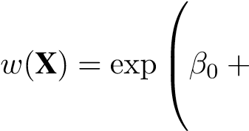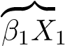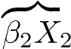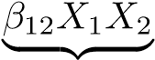 A) Infrastructure type 1 B) Infrastructure type 2 C) Infrastructure type k

{{}|{

+++*...* +

z

*β*

*k*

*X*

*k*



D) Interaction infrastructure types 1 and 2

(2)

where we define each term *Ik* = *βkXk* as the *impact* of a given infrastructure of type *k*, where the impact is decomposed into its effect size *βk* and a spatial component *Xk*. In terms of ecological interpretation, exp(*βk*) might be understood as the relative selection strength (Avgar *et al.*, 2017), and exp(*Ik*) as how this relative selection strength varies in space, for infrastructure type *k* (Fieberg *et al.*, 2021).

In this formulation, *the cumulative impact of different types of infrastructure* is given by the additive impacts of the *k* infrastructure types (e.g. terms A, B, and C in equation 2) and possibly by interaction terms between variables (such as term D in equation 2, with an interaction coefficient *β*12), that allows for non-linear, joint effects caused by the co-occurrence of different types of infrastructure.

In our definition of impact, *β* and *X* are independent, and *the cumulative impact of multiple features of the same infrastructure type* is determined by the spatial component of the impact, *X*. We start by verbally defining the ZoI as a function *ϕ*, a curve that represents how the infrastructure impact changes with distance (Box 1). The ZoI of each infrastructure feature might follow different shapes – it can be either constant (threshold ZoI) or decrease with distance from infrastructure (e.g. linear and Gaussian ZoI, Fig. 1A). More broadly, *ϕ* = *f*(*d,r*) is any decay function that has a maximum value 1 where the infrastructure is located and decreases towards zero as the Euclidean distance *d* increases towards the ZoI radius *r* (Box 1, Appendix A). Determining the ZoI shape and radius is an empirical problem (Miguet *et al.*, 2017). The simplest assumption, widely used in the literature, is that all the area within the ZoI is affected equally (a buffer zone around features; e.g Quinonez-Pi˜ n˜on´ *et al.*, 2007), even though it might be more reasonable to consider that *ϕ* is higher close to infrastructure (Skarin *et al.*, 2018; Zeller *et al.*, 2017).

When there are multiple features of an infrastructure we can define two ZoI metrics: the ZoI based on the nearest feature alone, *ϕnearest*, and the cumulative ZoI of multiple features, *ϕcumulative* (Box 1, Fig. 1B). For *ϕnearest*, the ZoI is assumed to be similar when approaching an isolated house and a small village, while for *ϕcumulative* the ZoI of nearby houses adds up and will be greater than that of a single, isolated house (Fig. 1B).

To translate those representations into a mathematical form, now we decompose each of the impact terms (i.e. A, B, C, ...), in equation 2. Suppose that in the landscape there are *nk* features of the same type of infrastructure *k*, and let the ZoI of feature *i* of an infrastructure *k* follow *ϕik* = *f*(*dik*;*rk*), where *dik* is the distance to feature (*ik*) and *rk* is its ZoI radius. We can sum the effect of each feature on animal habitat selection in spatial point j, with *dijk* being the distance between point j and feature i, and the impact terms in equation 2 become:

*nk*

*Ij,k* = *βkXk* = X*βikϕik* (3)

*i*=1

Typically, only the nearest feature is considered, resulting on the implicit assumption that *βi* = 0 for all but the nearest feature. Thus, eq. 3 turns into:

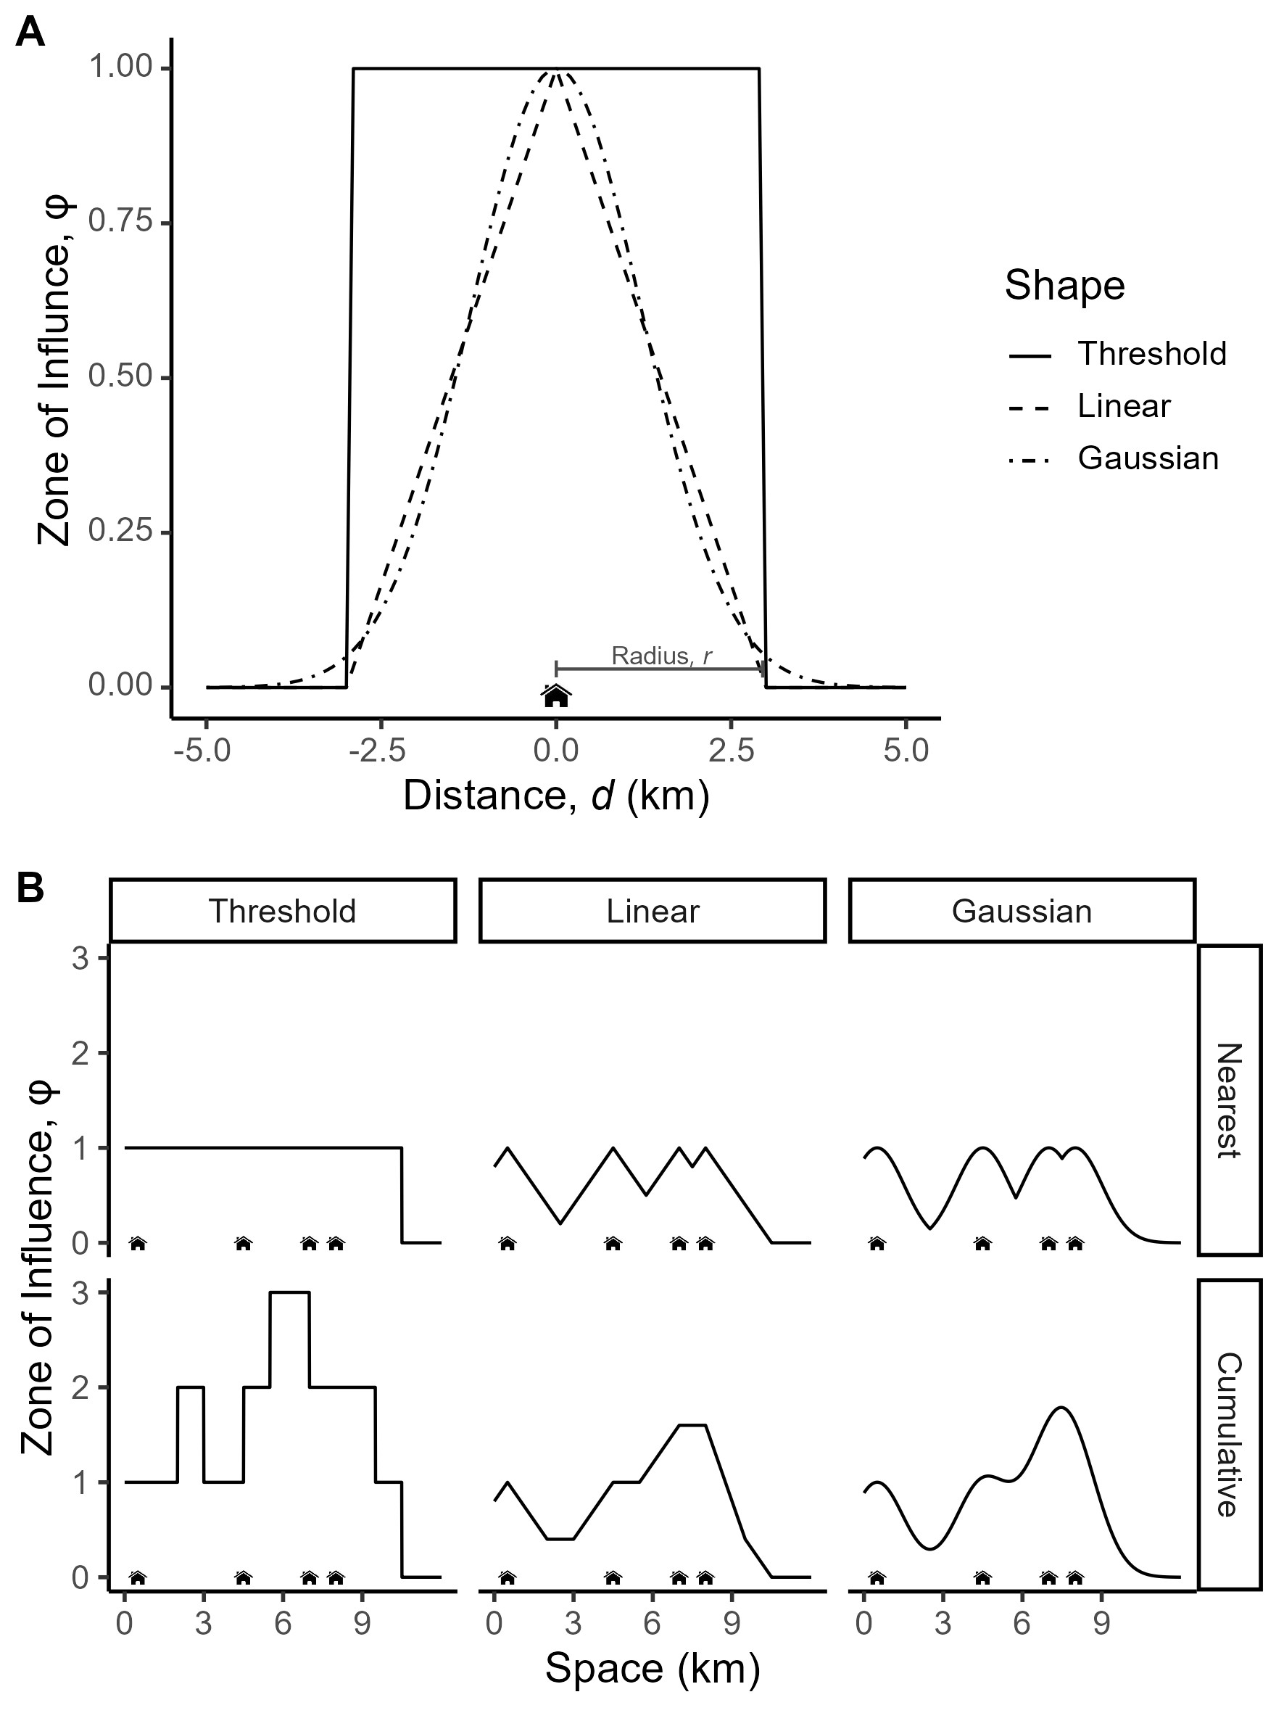

Figure 1: Illustration of the ZoI of infrastructure features in one dimensional space, using houses as example. (A) Examples of ZoI functions *ϕ* with different shapes of decay with distance from feature, *d*. A house has only an influence within its ZoI radius (here *r* = 3 km). For the threshold function, the influence remains constant within the ZoI and drops to zero beyond it, whereas for both the linear and Gaussian functions it declines monotonically for *d* ≤ *r*. (B) Representation of the ZoI of multiple houses by considering only the nearest feature (*ϕnearest*, upper row) or the cumulative ZoI of multiple features (*ϕcumulative*, bottom row), for different shapes. If only the nearest house is considered, *ϕnearest* does not exceed one; when all houses act cumulatively, *ϕcumulative* can be much higher than one.

*Ik* = *β*1*kϕ*1*k*

(4)

= *β*1*kϕnearestk*

where *ϕnearestk* is the ZoI of the nearest feature (*i* = 1) of the infrastructure type *k* (see Fig. 1B). However, possibly a more reasonable assumption would be that *βik* = *β*(*i*+1)*k* = *...* = *βk*, i.e. that all features of a given type present the same ZoI and all *β*’s are identical. Thus, eq. 3 is reduced to:

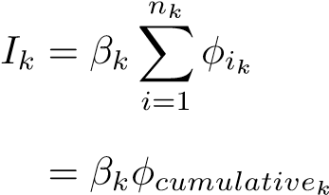 (5)

where *ϕcumulativek* = P*i ϕik* is the cumulative ZoI metric and is proportional to the “density” of features in space (e.g. Panzacchi *et al.*, 2015). The cumulative ZoI metric is easily calculated using geographical information systems, e.g. through neighborhood analysis, and can be rescaled to meaningful scales, such as the number of houses (or length of roads) per km2. For the derivation of similar equations for variables represented as lines and areas, see Appendix A.

# 3 Estimating the cumulative impact of multiple features

In the cumulative impact assessment proposed here, the calculation of the ZoI (*ϕ*)might be done before statistical analysis. In this formulation, *ϕ* defined based on different shapes and radii are considered as different covariates (Fig. 2). Therefore, the evaluation of how the impact of multiple infrastructure features accumulate and the identification of the ZoI are recasted as a model selection rather than a parameterization problem (such as in Lee *et al.*, 2020).

To ease the use of the approach, we developed the oneimpact R package. Based on raster maps with the location of infrastructure or other spatial variables, it allows the calculation of *ϕnearest* and *ϕcumulative* through the calc_zoi functions (Fig. 2, Appendix D). The output influence raster maps are then used with other environmental data to annotate biological data (e.g. GPS locations or sampling points), and the estimation of the effect sizes *β* and evaluation of the cumulative effects for different types of infrastructure

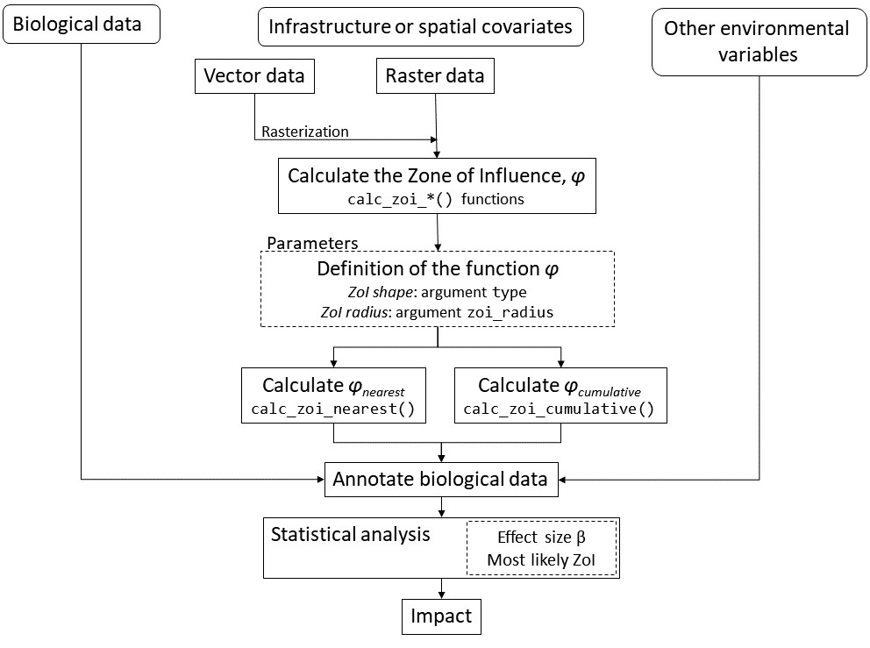

Figure 2: Workflow for calculating infrastructure ZoI *ϕ* and estimating the cumulative impact and ZoI radius of multiple infrastructure. Infrastructure raster data are input to the calczoi functions, which allow the calculation of *ϕnearest* and *ϕcumulative* based on arguments for the ZoI shape and radius. The output influence rasters and other environmental data are then annotated to biological data, which analyzed to estimate *β* and *r* for each infrastructure type and calculate the impact *I*.

is made through statistical fitting of eq. 2 (Fig. 2). Statistical analyses can make use of model selection (Burnham & Anderson, 2002), penalized regression (Lee *et al.*, 2020), or machine learning approaches, for example (James *et al.*, 2021, Appendix D). Such statistical modeling procedures are beyond our scope, and we provide an example using model selection through AIC below (see also Appendix C).

4 Whendo*ϕnearest* and*ϕcumulative* representsimilarspatialvariation?

To interpret the two ZoI metrics – *ϕnearest* and *ϕcumulative* – in ecological contexts, is it important to investigate in which conditions they are correlated and represent similar or different gradients of spatial variation. Similarities between the two variables depend on the spatial distribution of features as well as their ZoI, and might affect our ability to distinguish among their impacts. To illustrate when they converge, we simulated 30 × 30 km2 landscapes with 100m resolution and a constant number of point features (*n* = 100) distributed following different spatial patterns, in a gradient of clustering, from regular and random to clustered (Fig. 3; Appendix B). For each landscape we calculated *ϕnearest* and *ϕcumulative* assuming a range of values for ZoI radius (from 0.06% to 40% of the landscape extent), using a linear decay ZoI (Fig. 1). We then compared the resulting spatial patterns of *ϕnearest* and *ϕcumulative* through Pearson correlation of the values of the two metrics at the same coordinates.

When the minimum distance between features is greater than 2r, *ϕnearest* and *ϕcumulative* are identical (Fig. 3, black dashed vertical line; correlation = 1). This is because the ZoI of each feature is too restrict to overlap. When the ZoI radius increases, the effect of nearby features accumulate and the correlation between *ϕnearest* and *ϕcumulative* decrease (Fig. 3A,B, Figs B5 and B8). In addition, as the features get more clumped in clusters (up to a limit with a single small cluster, Fig. 3C), the correlation between *ϕnearest* and *ϕcumulative* goes through a point of inflection as the ZoI expands, beyond which it increases with *r* (Fig. B5D-F). The point where the correlation stops decreasing is related to the size of the clusters (grey dashed vertical line in Figs. 3B,C). For ZoI radius values larger than the radius of the cluster, *ϕnearest* and *ϕcumulative* converge again and it will be hard to distinguish between the effect of each feature alone, regardless of the ZoI metric, and that a the collection of features grouped in a “super-feature” (e.g. urban areas instead of houses, wind parks instead of wind turbines). While a high correlation between *ϕnearest* and *ϕcumulative*  imply that it will be difficult to distinguish if the impacts of a given infrastructure type accumulate or not, whether a given biological response variable is affected by the nearest feature or cumulatively by multiple features remains a question to be explored empirically.

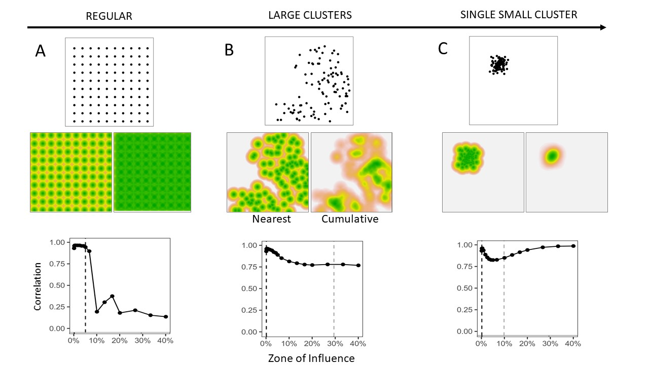

Figure 3: Representation of the ZoI of nearest feature (*ϕnearest*) and the cumulative ZoI (*ϕcumulative*) in landscapes with point infrastructure spatially distributed in a gradient of clustering, from (A) a regular distribution to (B) a set of clusters to (C) only one cluster. The central panel shows a visual comparison between *ϕnearest* (left) and *ϕcumulative* (right) when the ZoI radius *r* = 10% of the landscape extent. The lower panel shows the correlation between *ϕnearest* and *ϕcumulative* in each landscape, as ZoI *r* increases. The dashed vertical lines show half the the minimum distance between features (black), beyond which the ZoI of multiple infrastructure overlap, and the size of the feature clusters (grey), beyond which the correlation stops decreasing.

# 5 Empirical demonstration on reindeer habitat selection

## 5.1 Material and methods

In our empirical demonstration we assessed the impacts of multiple infrastructure on the Hardangervidda reindeer population in Norway using habitat selection during summer (Fig. 5). Reindeer are sensible to human activity, and the populations in Norway are the last remaining wild reindeer populations in Europe. In summer, the area is visited by tourists and mountain hikers. There are 14,154 private cottages, 26 large tourist cabins, and hundreds of kilometers of trails in the area, besides roads and small tourist cabins (Fig. C2). We used GPS-tracking data from 115 female reindeer collected in the month of July from 2001 to 2019 (see Panzacchi *et al.*, 2015, for further details). To assess reindeer habitat selection we used an use-availability setup, where each used GPS location was compared against nine available random locations spread within the area occupied by the population (Fig. 5). All locations were annotated with environmental covariates.

To account for bio-climatic-geographical variation in environmental characteristics we used the four first components from a principal component (PC) analysis conducted for whole Norway (Bakkestuen *et al.*, 2008). They correspond to gradients of (1) PC1 - continentality, (2) PC2 - altitude, (3) PC3 - terrain ruggedness, and (4) PC4 - solar radiation. We included a quadratic term for PC1 and PC2 to account for niche “optima” (*sensu* Panzacchi *et al.*, 2015). We also used a satellite-based land cover map with 25 vegetation classes, which were reclassified into 12 classes (see Table C2). To keep model fitting relatively simple and avoid correlation between covariates, we estimated the cumulative impact for two anthropogenic variables: private cottages and large tourist cabins.

For the two infrastructure types we calculated both *ϕnearest* and *ϕcumulative* (Fig. 1B) for ZoI radii irregularly distributed in the range [100m, 20,000m]. For each ZoI, we used four ZoI shapes: threshold, linear decay, Gaussian decay, and exponential decay (Appendix A). To estimate reindeer habitat selection we fitted HSFs (eq. 2) using binomial generalized linear models (Fieberg *et al.*, 2021) with used and available locations as response and infrastructure, land cover, and bio-climatic variables as fixed effects.

Model fitting consisted in two steps. We first fitted single-infrastructure models using a variable selection procedure (Burnham & Anderson, 2002) to find the most likely ZoI (shape, radius) for each infrastructure type. Single-infrastructure HSF were fitted using the multifit function in R (Huais, 2018) and compared using AIC. Second, using the most likely ZoI from single-infrastructure models, we fitted multi-infrastructure HSF to assess the combined impacts of multiple types of infrastructure, in an approach similar to Laforge *et al.* (2015).

To quantify the impacts of infrastructure, we used eq. 3 using the *β* and *ϕ* included the most likely model. We then estimated habitat suitability predicting the HSF (eq. 2) over the study area and rescaling the predicted values to the interval [0, 1]. For details on data, environmental covariates, modeling, and results, see Appendix C.

## 5.2 Results

Overall, both single- and multi-infrastructure models including *ϕcumulative* performed much better than models including *ϕnearest* (Table C2). This presents a strong evidence that the impacts of private cottages and tourist cabins accumulate over reindeer habitat selection, making them avoid these infrastructures. As a comparison, the most plausible model including *ϕnearest* was ranked 26th in the model selection (∆*AIC* = 921), and the most likely model including the log-distance to the nearest feature was ranked 44th (∆*AIC* = 1197, Table C2).

The most parsimonious model showed private cottages exerted a constant cumulative impact within a threshold ZoI of 10 km and large tourist cabins followed an exponentially decaying cumulative ZoI with 20 km radius (Fig. 4; Table C2). Notice that, as parameterized here, for the tourist cabins an exponential decay with ZoI of 20 km means that the impact of tourist cabins decrease to half of its maximum value at 5 km from the infrastructure (Fig. 4, Appendix A).

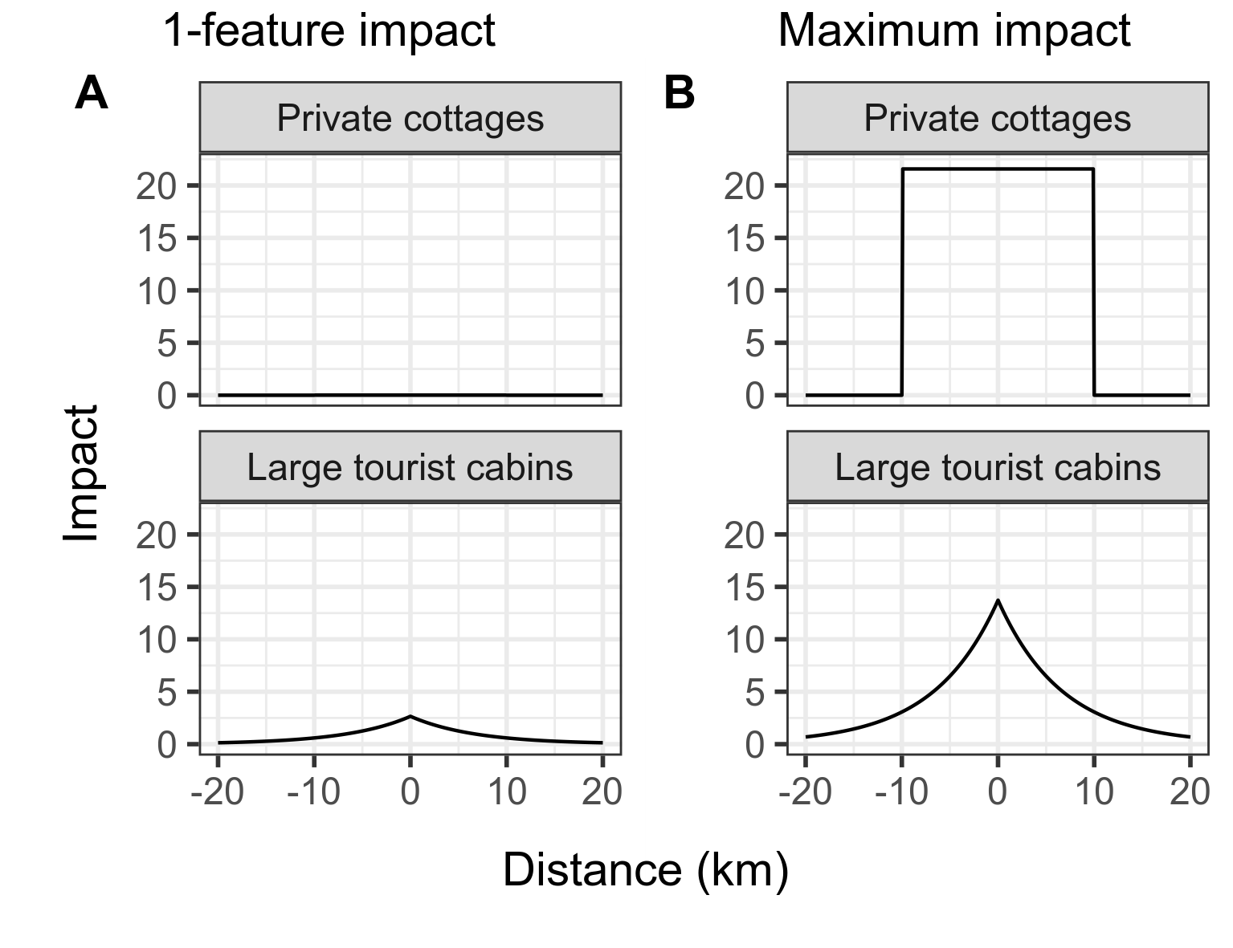

Figure 4: Impact of private cottages and public cabins considering (A) only 1 feature and (B) the maximum number of features of each type of infrastructure in the study area (2664 for cottages, 5 for cabins). The impact is the product of the effect size (*β*) and the cumulative zone of influence (*ϕcumulative*). While the impact of only one private cottage is negligible, at their maximum densities the cumulative impact of private cottages is higher than that of tourist cabins.

The estimated effect size of a single private cottage (*βcottage* = −0*.*0081) was much smaller than that of a single tourist cabin (*β*private cabin = −2*.*654; Fig. 4A, Table C3), as private cottages were used by fewer people than the tourist cabins. However, as private cottages occur at higher densities, in some areas their impact is larger than that of tourist cabins. In the areas where our most parsimonious model show the highest cumulative ZoI of infrastructure in Hardangervidda – where the number of private cottages sum to 2664 and the number of tourist cabins sum to 5 – the impact of private cottages clusters is nearly twice that of tourist cabins (Fig. 4B and 4). Following the HSF coefficient interpretation from Fieberg *et al.* (2021), considering that all other conditions are kept constant, a reindeer avoids an area 14.43 times more than another area with 330 fewer private cottages within a radius of 10 km. That is nearly the same difference in avoidance a reindeer presents among two areas that differ in 1 tourist cabin in a radius of 20 km (Appendix C).

When cumulative impacts of infrastructure are predicted in space by multiplying the effect size and *ϕcumulative* (eq. 5), we see how the relative impact of private cottages and tourist cabins changes across space (Fig. 5). While the impact for private cottage rises to 20 in the areas with the highest cumulative ZoI of cottages, it hardly goes above 10 for tourist cabins (values in the scale of predictors). Because of the combined impact of infrastructure, and given reindeer avoided high densities of both infrastructure types at relatively large extents, areas of high habitat suitability for reindeer correspond to those in which the cumulative impact of both infrastructure is low – what matches the locations used by reindeer, indicated through the GPS data (Fig. 5).

# 6 Discussion

There is an urge to evaluate, debate, and inform scientists, decision-makers, and citizens about the past, current, and future impacts of global infrastructure on biodiversity (Laurance, 2018). Most of the decisions and regulations made for infrastructure projects are carried out with little knowledge about the potential, multiple impacts on the ecosystems where they are built and on the species living therein. Even when environmental impact assessments are well conducted, they hardly estimate the cumulative impacts of new infrastructure with existing infrastructure or new infrastructure planned in parallel (Laurance & Arrea, 2017; Johnson, 2011). Current approaches and tools still lack in incorporating cumulative impacts (but see Gillingham *et al.*, 2016, for recent advances). Thus, building upon previous frameworks (Johnson & St-Laurent, 2011) and adapting concepts from landscape ecology literature to measure the ZoI of the nearest and of multiple features (*ϕnearest* and *ϕcumulative*), here we present a way forward to clearly assess cumulative impacts on biodiversity.

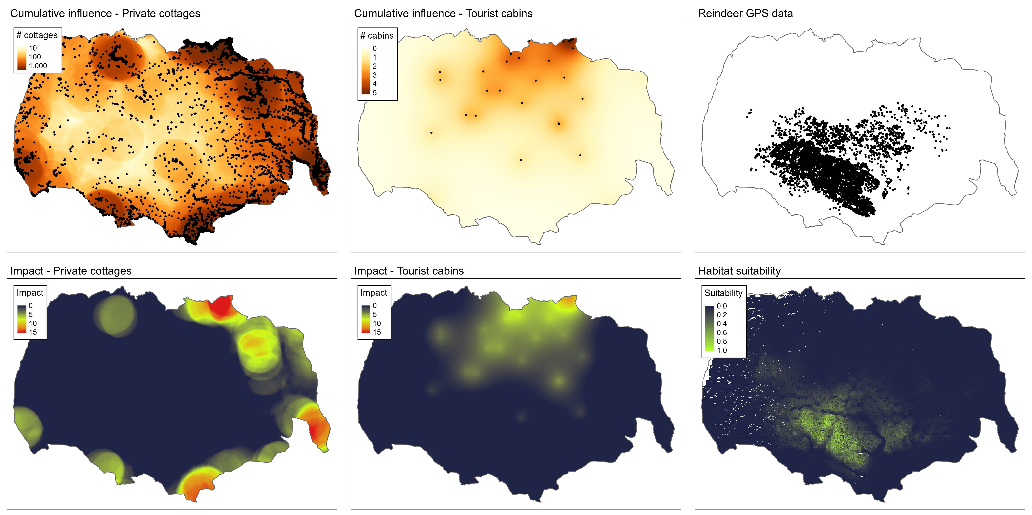

Figure 5: Maps of the most parsimonious cumulative ZoI (private cottages: threshold with 10km radius; tourist cabins: exponential decay with 20km radius) and their estimated impacts on reindeer habitat selection. These maps are showed alongside the reindeer GPS locations in the Hardengervidda wild reindeer area and the predicted reindeer habitat suitability.

## 6.1 Applying the approach to impact assessment

In our empirical demonstration using wild reindeer in Norway, we found strong support for the hypothesis of cumulative impacts of private cottages and tourist resorts on reindeer habitat selection, leading to large ZoI of 10 and 20 km, respectively. Quantifying impacts based on effect sizes and ZoI functions *ϕ* allows us to compare as well as to combine the effects of different types of infrastructure. Our results show that the impact of a single cottage is smaller than that of a single tourist cabin, but that the impact of several aggregated private cottages may be larger than that of tourist cabins (Fig. 4 and 5, Fig. C5). We also found less support for all models based only on the ZoI of the nearest feature (*ϕnearest*) compared to the models incorporating the cumulative ZoI of multiple features (*ϕcumulative*). This includes the models based on the log-distance to the nearest feature, which is a common proxy for the effect of spatial variables in the ecological literature (e.g. Torres *et al.*, 2016; Polfus *et al.*, 2011). This means that, by limiting measures of infrastructure influence to the nearest feature only, researchers and practitioners have been ignoring the possibility of cumulative impacts in ecological studies and impact assessments, what limits our overall understanding of the impacts of landscape change on biodiversity.

Three points must be highlighted regarding the interpretation of the ZoI. First, if ZoI functions with different shapes are found to affect a biological response variable, the ZoI represents distinct areas affected by infrastructure. For instance, while we found a constant ZoI (threshold function) of private cabins in a radius of 10km, for tourist cabins ZoI decays exponentially with distance, which means the radius of 20 km around the resorts are not affected homogeneously. Therefore, understanding the impact of infrastructure across space requires us to interpret the combination of effect size and ZoI (eq. 3, Fig. 4 and 5). Second, since the ZoI might vary according to different shapes, the area affected by infrastructure of a given type might drastically change. Indeed, in a study with bird and insect abundance, Miguet *et al.* (2017) showed that the area affected by landscape variables can increase by a factor of up to 5.7 when using a distance-weighted influence measure (as the exponential and Gaussian decay functions used here), in comparison to a threshold-based landscape measure. Third, given that the estimation of *β* and *ϕ* is independent, the most likely *β* and ZoI radius can differ significantly between *ϕnearest* and *ϕcumulative*, depending on the abundance and spatial distribution of features. For private cottages, which are abundant in our study area, the estimated ZoI for *ϕcumulative* was 10 km and the effect size was small (Fig. C3). In contrast, if only the nearest feature was considered (*ϕnearest*), the estimated ZoI would be ten times lower (1 km) and the effect size would be several orders of magnitude higher. This was not the case for tourist cabins, however, which are scarce and sparsely distributed in the study area (Fig. C4).

## 6.2 Assumptions, advantages, and limitations of the approach

As formulated here, the ZoI metrics are calculated before model fitting through the oneimpact R package (Fig. 2). Here lies one of the main strengths of this approach: the cumulative impact of multiple features of an infrastructure are estimated without the necessity of repeated model fitting and complex parameterization of non-linear functions (Lee *et al.*, 2020). This allows one to estimate ZoI for several types of infrastructure. It also allows fitting models for large datasets (millions of points, e.g. Tucker *et al.*, 2018) encompassing large study areas and fine resolution landscape covariates, making the approach applicable over a wide range of fields in ecology. The pre-computation of *ϕ* makes their visualization easy and their calculation computationally efficient and flexible.

Our formulation of *ϕ* follows two main assumptions. First, the ZoI is assumed to be constant regardless of the density of points in an area. A possibly more reasonable assumption would be to consider that the ZoI of a single or few features is smaller than that of a clusters of features (e.g. for tourist cabins, clusters are expected to be used by more people and cumulatively affect a wider area). Analogous calculations with variable radius have been implemented for decades in adaptive kernel density estimation (Worton, 1989), so this premise can in principle be relaxed. Second, our formulation represents two extremes where only the nearest feature influences a focal ecological process (*βi* = 0 for *i >* 1 in *ϕnearest*) or all features affect the process equally (*β* is constant over all features in *ϕcumulative*). This is the simplest form of accounting for cumulative impacts of multiple features of the same type. The advantage of this formulation lies on the independence between the magnitude of the impacts (*β*’s) and the ZoI (*ϕ*), what makes it possible to pre-compute *ϕ* before model fitting. However, more complex formulations could be extended from eq. 3, for instance by considering that the ZoI of multiple features accumulate yet the closest feature exerts a larger influence than features far away (higher *β* for the nearest feature).

Through simulations, we showed that *ϕnearest* and *ϕcumulative* represent similar gradients of spatial variation when the spatial distribution of infrastructure features is sparse and the ZoI is small (the features are too spaced for their impacts to accumulate) and when the features are clustered and ZoI is large (clusters of features act as “super-features”, e.g. urban areas instead of houses; Appendix B). In these two situations, it will be difficult to document that the impact of multiple infrastructure features accumulate. This might be assessed prior to statistical analysis through the computation of *ϕnearest* and *ϕcumulative* with multiple ZoI and a careful evaluation of their correlations. However, as the “true” ZoI of an infrastructure type is hardly known in advance, we recommend a general approach of computing and using both of the two ZoI metrics, to evaluate if there is evidence of cumulative impacts in the different ecological systems and processes.

The extent of the study area and the ZoIs to be evaluated must be carefully selected, as the impact of infrastructure on ecological processes might differ depending of the extent of the study area (Vistnes & Nellemann, 2008). Skarin & Ahman (2014) showed that, depending˚ of the temporal and spatial range of the study, the same type of infrastructure might vary in their effect on biological response variables, from no effect to positive or negative effects.. Furthermore, depending on the response variable, the range of ZoI evaluated should encompass radi that extend the range size or perhaps the average dispersal distance of the species under study (Jackson & Fahrig, 2012). This is needed to ensure that the “true” ZoI at which the ecological process being measured is affected is included among the possible ZoI, and hinder conclusions based on an estimated ZoI that is wrong and mislead management and conservation policies based on that scientific inference (e.g. Jackson & Fahrig, 2015).

# 7 Conclusions

There is an increasing need to include cumulative impacts on environmental impact assessments and ecological studies. However, even when they are present, bringing concepts and theoretical frameworks into concrete and objective analyses to estimate cumulative impacts is often challenging and left to the responsibility of either the analysts or the regulators that review impact assessments (Johnson, 2011). Our approach offers resources for ecologists, environmental agencies, and stakeholders dealing with impact assessment to build concrete estimates of cumulative impacts of multiple features of an infrastructure and their zone influence. Even though the examples given here focused on animal space use, the cumulative effect approach we presented is applicable over a wide range of fields within ecology. Our formulation can be easily adapted to model other types of biological responses, such as population abundance (e.g. Ben´ıtez-Lopez´ *et al.*, 2010), species richness (e.g. Ficetola & Denoel, 2009) or other measures of biological¨ diversity and ecological processes, with direct application in environmental and strategic impact assessment and integrated land use planning.

# Acknowledgements

We thank C. Johnson for discussions on cumulative impact concepts, P. Dodonov, M.H. Vancine, and J. Nowosad for discussion around the implementation ZoI metrics in R, R. Muylaert for a critical review of the text, and E. Gurarie for the incentive and teachings on how to build an R package. We also thank everyone at NINA responsible for the GPS data collection and management. The work presented here is the result of large projects supported by the Research Council of Norway (OneImpact, RenewableReindeer, ProdChange). BBN, AS, PS, and MA were also supported by a grant from the Swedish Energy Agency within the research programme Vindval (grant n. 46780-1) and by project MineDeer (Vinnova project n.

2019-05191).

Conflicts of Interest

The authors declare no conflicts of interest.

# Authors’ contributions

BBN, BVM, and MP conceived the idea and designed the methods, with contributions from TT, ASt, MA, and ASk; BBN, BVM, MP, TT, KL, and OS collected and provided the data; BBN, BVM, and MP analyzed the data and interpreted the results; BBN and BVM led the writing of the manuscript. All authors contributed critically in discussions and to the drafts, and gave final approval for publication.

# Data availability statement

GPS data is archived in Movebank (www.movebank.org) and might be accessed upon request. All environmental data was retrieved from public repositories. The oneimpact package is open and available at github. com/NINAnor/oneimpact, and all scripts used in the analyses are available in the Github repository github.com/bniebuhr/cumulative_influence_paper (to be made public upon the acceptance

of the manuscript).

# Supplementary Material

Appendix A. Additional definitions and derivations for influence functions.

Appendix B. Comparing the the influence of the nearest feature with the cumulative influence of multiple features

Appendix C. Cumulative effects of infrastructure on reindeer space use: fitting habitat selection models Appendix D. Getting started with oneimpact.

Appendix E. Calculating cumulative influence in GRASS GIS using the oneimpact package in R.

# References

Avgar, T., Lele, S.R., Keim, J.L. & Boyce, M.S. (2017) Relative Selection Strength: Quantifying effect size in habitat- and step-selection inference. *Ecology and Evolution* 7, 5322–5330.

Bakkestuen, V., Erikstad, L. & Halvorsen, R. (2008) Step-less models for regional environmental variation in Norway. *Journal of Biogeography* 35, 1906–1922.

Barber, C.P., Cochrane, M.A., Souza, C.M. & Laurance, W.F. (2014) Roads, deforestation, and the mitigating effect of protected areas in the Amazon. *Biological Conservation* 177, 203–209.

Ben´ıtez-Lopez, A., Alkemade, R. & Verweij, P.A. (2010) The impacts of roads and other infrastructure on´ mammal and bird populations: A meta-analysis. *Biological Conservation* 143, 1307–1316.

Boulanger, J., Poole, K.G., Gunn, A. & Wierzchowski, J. (2012) Estimating the zone of influence of industrial developments on wildlife: a migratory caribou *Rangifer tarandus groenlandicus* and diamond mine case study. *Wildlife Biology* 18, 164–179.

Burnham, K.P. & Anderson, D.R. (2002) *Model selection and multimodel inference: a practical information-theoretic approach*. Springer, New York, 2nd ed edn., oCLC: ocm48557578.

Dorber, M., Panzacchi, M., Strand, O. & Van Moorter, B. (2022) Indicators of habitat functionality reveal significant underestimations in SDG trade-off risk - The case of wild reindeer and hydropower development. Submitted.

Ficetola, G.F. & Denoel, M. (2009) Ecological thresholds: an assessment of methods to identify abrupt¨ changes in species–habitat relationships. *Ecography* 32, 1075–1084.

Fieberg, J., Signer, J., Smith, B. & Avgar, T. (2021) A ‘How to’ guide for interpreting parameters in habitat-selection analyses. *Journal of Animal Ecology* 90, 1027–1043.

Gillingham, M.P., Halseth, G.R., Johnson, C.J. & Parkes, M.W. (eds.) (2016) *The Integration Imperative: cumulative environmental, community and health effects of multiple natural resource developments*. Springer International Publishing, Cham.

GRASS Development Team (2017) *Geographic Resources Analysis Support System (GRASS GIS) Software, Version 7.8*. Open Source Geospatial Foundation.

Huais, P.Y. (2018) multifit: an R function for multi-scale analysis in landscape ecology. *Landscape Ecology* 33, 1023–1028.

Ibisch, P.L., Hoffmann, M.T., Kreft, S., Pe’er, G., Kati, V., Biber-Freudenberger, L., DellaSala, D.A., Vale, M.M., Hobson, P.R. & Selva, N. (2016) A global map of roadless areas and their conservation status. *Science* 354, 1423–1427.

Jackson, H.B. & Fahrig, L. (2012) What size is a biologically relevant landscape? *Landscape Ecology* 27, 929–941.

Jackson, H.B. & Fahrig, L. (2015) Are ecologists conducting research at the optimal scale? *Global Ecology and Biogeography* 24, 52–63.

James, G., Witten, D., Hastie, T. & Tibshirani, R. (2021) *An introduction to statistical learning: with applications in R*. Springer texts in statistics, Springer, New York, second edition edn.

Johnson, C.J. (2011) Regulating and planning for cumulative effects: the Canadian experience. *Cumulative effects in wildlife management: impact mitigation* (eds. P.R. Krausman & L.K. Harris), pp. 29–46, CRC Press, Boca Raton, 1 edn.

Johnson, C.J., Boyce, M.S., Case, R.L., Cluff, H.D., Gau, R.J., Gunn, A. & Mulders, R. (2005) Cumulative Effects of Human Developments on Arctic Wildlife. *Wildlife Monographs* 160, 1–36.

Johnson, C.J. & St-Laurent, M.H. (2011) Unifying Framework for Understanding Impacts of Human Developments on Wildlife. *Energy Development and Wildlife Conservation in Western North America* (ed. D.E. Naugle), pp. 27–54, Island Press/Center for Resource Economics, Washington, DC.

Laforge, M.P., Vander Wal, E., Brook, R.K., Bayne, E.M. & McLoughlin, P.D. (2015) Process-focussed, multi-grain resource selection functions. *Ecological Modelling* 305, 10–21.

Laurance, W.F. (2018) Conservation and the Global Infrastructure Tsunami: Disclose, Debate, Delay!

*Trends in Ecology & Evolution* 33, 568–571.

Laurance, W.F. & Arrea, I.B. (2017) Roads to riches or ruin? *Science* 358, 442–444.

Lee, Y., Alam, M., Sandstrom, P. & Skarin, A. (2020) Estimating zones of influence using threshold¨ regression. *Working papers in transport, tourism, information technology and microdata analysis* 2020:01, 1–16.

McGarigal, K., Wan, H.Y., Zeller, K.A., Timm, B.C. & Cushman, S.A. (2016) Multi-scale habitat selection modeling: a review and outlook. *Landscape Ecology* 31, 1161–1175.

Miguet, P., Fahrig, L. & Lavigne, C. (2017) How to quantify a distance-dependent landscape effect on a biological response. *Methods in Ecology and Evolution* 8, 1717–1724.

Newbold, T., Hudson, L.N., Hill, S.L.L., Contu, S., Lysenko, I., Senior, R.A., Borger, L., Bennett,¨

D.J., Choimes, A., Collen, B., Day, J., De Palma, A., D´ıaz, S., Echeverria-Londono, S., Edgar, M.J.,˜ Feldman, A., Garon, M., Harrison, M.L.K., Alhusseini, T., Ingram, D.J., Itescu, Y., Kattge, J., Kemp, V.,

Kirkpatrick, L., Kleyer, M., Correia, D.L.P., Martin, C.D., Meiri, S., Novosolov, M., Pan, Y., Phillips,

H.R.P., Purves, D.W., Robinson, A., Simpson, J., Tuck, S.L., Weiher, E., White, H.J., Ewers, R.M.,

Mace, G.M., Scharlemann, J.P.W. & Purvis, A. (2015) Global effects of land use on local terrestrial biodiversity. *Nature* 520, 45–50.

Panzacchi, M., Van Moorter, B., Strand, O., Loe, L.E. & Reimers, E. (2015) Searching for the fundamental niche using individual-based habitat selection modelling across populations. *Ecography* 38, 659–669.

Polfus, J., Hebblewhite, M. & Heinemeyer, K. (2011) Identifying indirect habitat loss and avoidance of human infrastructure by northern mountain woodland caribou. *Biological Conservation* 144, 2637–2646.

Quinonez-Pi˜ n˜on, R., Mendoza-Dur´ an, A. & Valeo, C. (2007) Design of an environmental monitoring´ program using NDVI and cumulative effects assessment. *International Journal of Remote Sensing* 28, 1643–1664.

R Core Team (2020) *R: A Language and Environment for Statistical Computing*. R Foundation for

Statistical Computing, Vienna, Austria.

Skarin, A., Sandstrom, P. & Alam, M. (2018) Out of sight of wind turbines: Reindeer response to wind¨ farms in operation. *Ecology and Evolution* 8, 9906–9919.

Skarin, A. & Ahman, B. (2014) Do human activity and infrastructure disturb domesticated reindeer? The˚ need for the reindeer’s perspective. *Polar Biology* 37, 1041–1054.

Sloan, S., Jenkins, C.N., Joppa, L.N., Gaveau, D.L. & Laurance, W.F. (2014) Remaining natural vegetation in the global biodiversity hotspots. *Biological Conservation* 177, 12–24.

Thurfjell, H., Ciuti, S. & Boyce, M.S. (2014) Applications of step-selection functions in ecology and conservation. *Movement Ecology* 2, 4.

Torres, A., Jaeger, J.A.G. & Alonso, J.C. (2016) Assessing large-scale wildlife responses to human infrastructure development. *Proceedings of the National Academy of Sciences* 113, 8472–8477.

Tucker, M.A., Bohning-Gaese, K., Fagan, W.F., Fryxell, J.M., Van Moorter, B., Alberts, S.C., Ali, A.H.,¨

Allen, A.M., Attias, N., Avgar, T., Bartlam-Brooks, H., Bayarbaatar, B., Belant, J.L., Bertassoni, A.,

Beyer, D., Bidner, L., van Beest, F.M., Blake, S., Blaum, N., Bracis, C., Brown, D., de Bruyn, P.J.N., Cagnacci, F., Calabrese, J.M., Camilo-Alves, C., Chamaille-Jammes, S., Chiaradia, A., Davidson, S.C.,´ Dennis, T., DeStefano, S., Diefenbach, D., Douglas-Hamilton, I., Fennessy, J., Fichtel, C., Fiedler, W.,

Fischer, C., Fischhoff, I., Fleming, C.H., Ford, A.T., Fritz, S.A., Gehr, B., Goheen, J.R., Gurarie, E., Hebblewhite, M., Heurich, M., Hewison, A.J.M., Hof, C., Hurme, E., Isbell, L.A., Janssen, R., Jeltsch,

F., Kaczensky, P., Kane, A., Kappeler, P.M., Kauffman, M., Kays, R., Kimuyu, D., Koch, F., Kranstauber,

B., LaPoint, S., Leimgruber, P., Linnell, J.D.C., Lopez-L´ opez, P., Markham, A.C., Mattisson, J., Medici,´

E.P., Mellone, U., Merrill, E., de Miranda Mourao, G., Morato, R.G., Morellet, N., Morrison, T.A.,˜ D´ıaz-Munoz, S.L., Mysterud, A., Nandintsetseg, D., Nathan, R., Niamir, A., Odden, J., O’Hara, R.B.,˜ Oliveira-Santos, L.G.R., Olson, K.A., Patterson, B.D., Cunha de Paula, R., Pedrotti, L., Reineking, B.,

Rimmler, M., Rogers, T.L., Rolandsen, C.M., Rosenberry, C.S., Rubenstein, D.I., Safi, K., Sa¨ıd, S.,

Sapir, N., Sawyer, H., Schmidt, N.M., Selva, N., Sergiel, A., Shiilegdamba, E., Silva, J.P., Singh, N.,

Solberg, E.J., Spiegel, O., Strand, O., Sundaresan, S., Ullmann, W., Voigt, U., Wall, J., Wattles, D., Wikelski, M., Wilmers, C.C., Wilson, J.W., Wittemyer, G., Zieba, F., Zwijacz-Kozica, T. & Mueller, T.

(2018) Moving in the Anthropocene: Global reductions in terrestrial mammalian movements. *Science* 359, 466–469.

Venter, O., Sanderson, E.W., Magrach, A., Allan, J.R., Beher, J., Jones, K.R., Possingham, H.P., Laurance, W.F., Wood, P., Fekete, B.M., Levy, M.A. & Watson, J.E.M. (2016) Sixteen years of change in the global terrestrial human footprint and implications for biodiversity conservation. *Nature Communications* 7, 12558.

Vistnes, I. & Nellemann, C. (2008) The matter of spatial and temporal scales: a review of reindeer and caribou response to human activity. *Polar Biology* 31, 399–407.

Worton, B.J. (1989) Kernel Methods for Estimating the Utilization Distribution in Home-Range Studies. *Ecology* 70, 164–168.

Zeller, K.A., Vickers, T.W., Ernest, H.B. & Boyce, W.M. (2017) Multi-level, multi-scale resource selection functions and resistance surfaces for conservation planning: Pumas as a case study. *PLOS ONE* 12, e0179570.