GSS->Self Service->Time Reporting

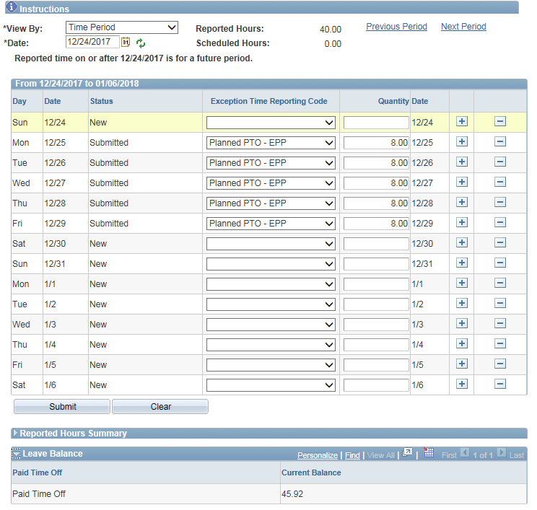

Removed PTO and hours from holiday 12/25 and submitted

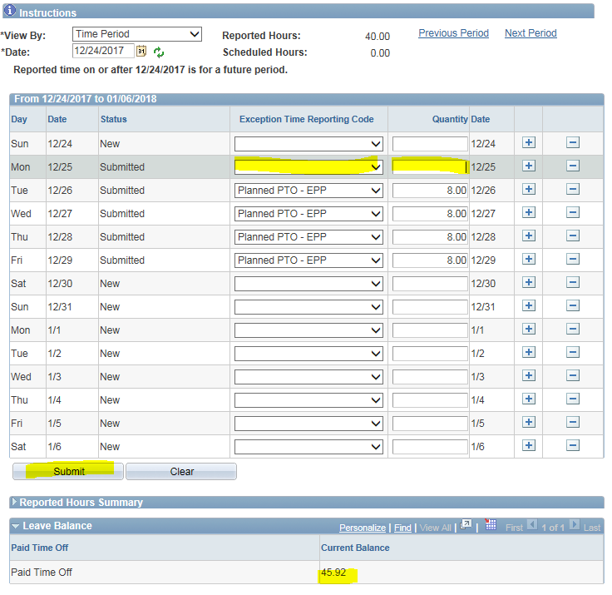

Attestation

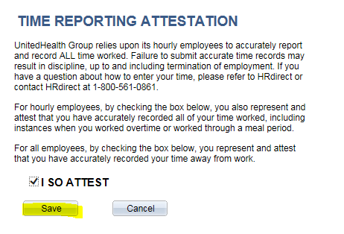

Timesheet is shown again without 12/25 removed and adding 8 more hours to PTO balance. I have tried this 4 times and each time 8 hours was added back to my balance.

