1. Dictionary attack using John the ripper

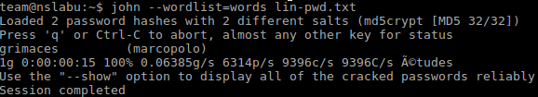User marcopolo’s password in win-pwd.txt was cracked by dictionary attack.

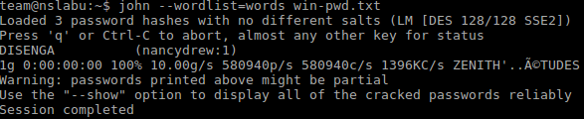pwd = grimaces

User nancydrew’s part of password in lin-pwd.txt was cracked by dictionary attack.

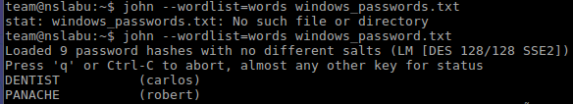part 1 of pwd = DISENGA

User carlos password: DENTIST

User Robert password: PANACHE

In windows_passwords_txt

None of linux-passwords are cracked by dictionary attack.

2. Brute-force attack

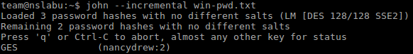

part 2 of nancy in win-pwd.txt: GES

Nancydrew pwd: DISENGAGES

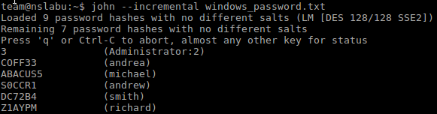

BF attack for windows_message:

administrater second part:3

andrea pwd: COFF33

Michael pwd: ABACUS5

Andrew pwd: SOCCRl

smith pwd: DC72B4

Richard pwd: Z1AYPM

As far as for brute force attack and dictionary attack:

win-pwd.txt: (1/2 left)

nancydrew: DISENGAGED (part dictionary part BF)

Sherlock: 5LYYPm (rainbow)

lin-pwd.txt: (1/2 left)

marcopolo: grimaces (dictionary)

Magellan: uncracked

windows_password.txt: (2/9 left)

administrater: XXXXXXXXX3 (cracked the last character)

Robert: PANACHE (dictionary)

Andrew: SOCCR1 (BF) (rainbow)

carlos: DENTIST (dictionary)

andrea: COFF33 (BF) (rainbow)

Michael: ABACUS5 (BF)

Richard: Z1AYPM (BF) (rainbow)

Smith: DC72B4 (BF) (rainbow)

linux_passwords: all uncracked (3/3 left)

4. Pre-computation attack

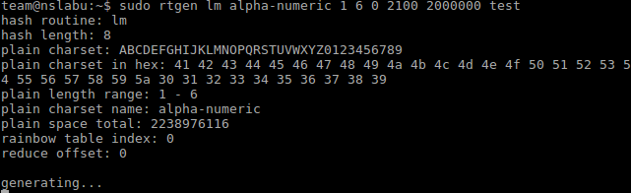

command for generating rainbow table.

Following is the outcome of running command:

“sudo rcrack *.rt –f windows_password.txt”

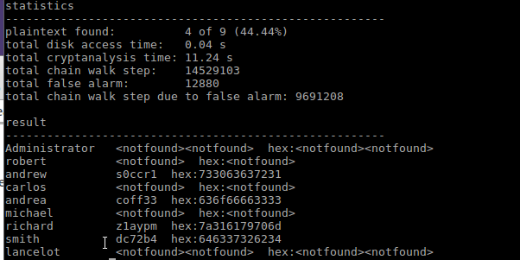the password for administrater and the individual password is strong enough

Following is the outcome of running command:

“sudo rcrack *.rt –f win-pwd.txt”

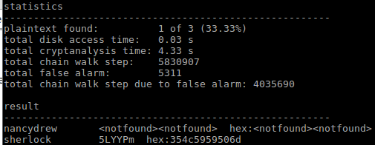

The password of Sherlock is found, which is 5LYYPm.