PROJECT 3 – DOCKER CONTAINERIZATION
Name : Nithin Chakravarthi Bandi Naga
UC ID : M17136422
1. Objective
The objective of this project is to create a fully automated Docker container that:
- Reads IF.txt and AlwaysRememberUsThisWay.txt from /home/data
- Counts total words in each file
- Calculates the grand total
- Identifies the top 3 most frequent words in IF.txt
- Handles contractions (e.g., I'm, can't, don't)
- Determines the container IP address
- Writes results to /home/data/output/result.txt
- Prints the results to the console before exiting
- Runs without manual intervention

2. Docker Installation & Image Verification
Docker Desktop was installed and verified to be running successfully on a Windows machine.
The Docker image project3:latest was built using a lightweight base image (python:3.9-slim) to ensure optimized size.
The final image size is 183.09 MB, which satisfies the requirement of being under 200MB.
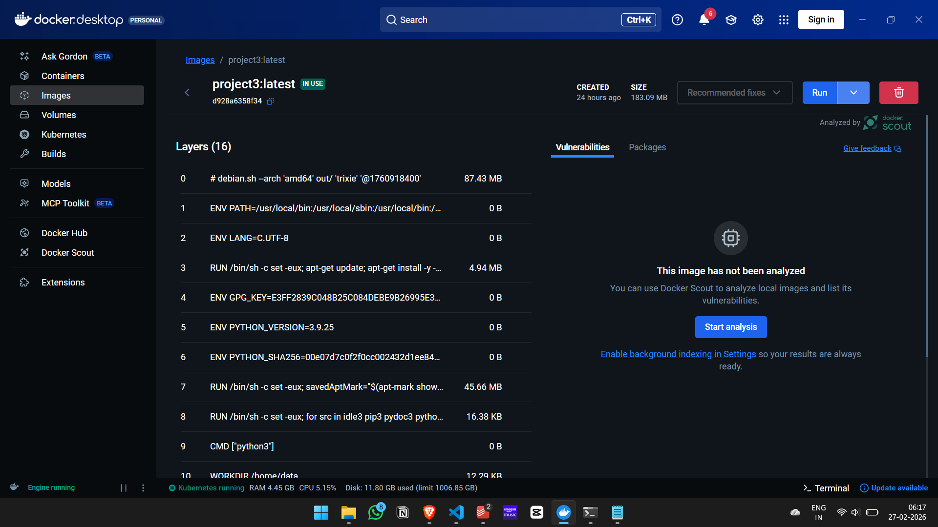
3. Dockerfile
A lightweight base image was used to minimize image size and improve efficiency.
FROM python:3.9-slim
WORKDIR /home/data
COPY IF.txt /home/data/
COPY AlwaysRememberUsThisWay.txt /home/data/
COPY script.py /home/data/
RUN mkdir -p /home/data/output
CMD ["python", "script.py"]

4. Python Script Implementation
The Python script (script.py) performs the following:
- Reads both text files from /home/data
- Counts total words in each file
- Computes the grand total word count
- Identifies the top 3 most frequent words in IF.txt
- Splits contractions using regular expressions
- Identifies the top 3 frequent words in AlwaysRememberUsThisWay.txt after splitting
- Retrieves the container’s IP address
- Writes all results to /home/data/output/result.txt
- Prints the contents of result.txt before exiting
The complete script is submitted separately as script.py.

5. Mandatory Commands Used
- docker build -t project3 . – Builds the Docker image using the Dockerfile in the current directory.
- docker run --name project3_container project3 – Runs the container and executes the Python script automatically.
- docker images – Verifies that the image was created and confirms its size is under 200MB.
- docker save -o 2100030041cseh.tar project3 – Exports the final Docker image as a tar file for submission.

6. Container Execution Verification
The container was executed successfully.
During execution:
- Word counts were calculated for both files
- Grand total was computed
- Top 3 frequent words were identified
- Contractions were handled correctly
- Container IP address was retrieved
- Output was written to /home/data/output/result.txt
- Results were printed to the console
The container exited with status Exited (0), indicating successful execution without errors.
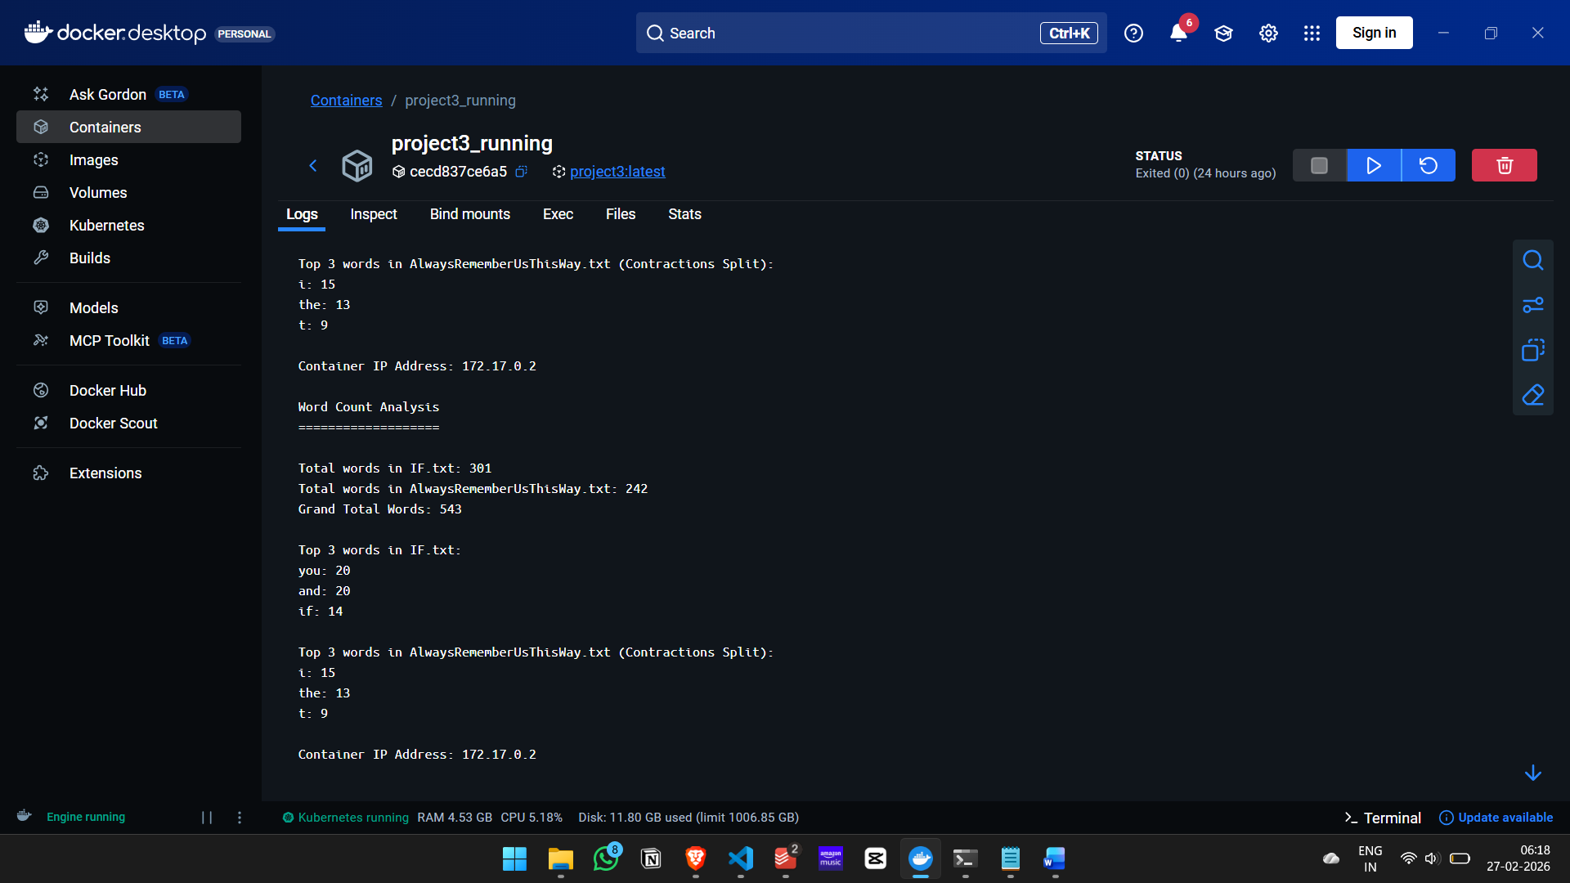
7. Exporting Docker Image
The final Docker image was exported as required for grading:
- docker save -o 2100030041cseh.tar project3 – Creates the tar file for submission.
The tar file was uploaded to Canvas as required.

8. Extra Credit – Kubernetes Orchestration
Kubernetes was enabled in Docker Desktop.
A deployment with 2 replicas was created using deployment.yaml to demonstrate orchestration and scalability.
Mandatory Kubernetes commands used:
- kubectl apply -f deployment.yaml – Deploys the container with 2 replicas.
- kubectl get pods – Verifies that the replicas are running.
- kubectl get pods > kube_output.txt – Saves pod status output to a file for submission.
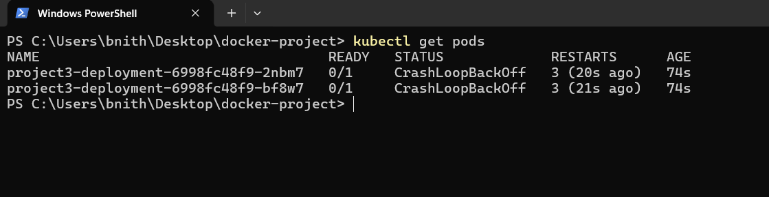
The files deployment.yaml and kube_output.txt were submitted for extra credit evaluation.

9. Conclusion
This project successfully demonstrates:
- Docker container creation using a lightweight base image
- Automated execution of a Python script inside a container
- Text processing and contraction handling
- Image optimization under 200MB
- Exporting a Docker image as a tar file
- Kubernetes orchestration with multiple replicas
All mandatory requirements and extra credit tasks were completed successfully.

