The effectiveness of anti-naturalistic fallacy messages on acceptance of clean meat

Pre-analysis plan

Bobbie Macdonald and Eva Vivalt

February 26, 2017

# Introduction

Clean or clean meat has the potential to significantly reduce animal suffering and environmental damage while improving human health. Yet, similar to welfare-improving technologies such as vaccination and genetically modified organisms (GMOs), clean meat is likely to face substantial public resistance because it goes against prevailing cultural intuitions that “what is natural is good”. How do individuals respond when exposed to this “naturalistic” reasoning? And how can we overcome this *naturalistic fallacy* for technologies that offer significant welfare improvements?

Building on recent work examining the effectiveness of messaging strategies for improving public acceptance of vaccines (e.g. Nyhan et al. 2014), in this study we examine how messages and social information affect individual acceptance of clean meat products and susceptibility to the naturalistic fallacy. Specifically, we implement a 4x2 full factorial survey experiment with three different anti-naturalistic messages (and a placebo message) crossed with whether or not subjects are exposed to social information beforehand (i.e. how previous survey respondents have reacted to clean meat).

The purpose of this study is to shed light on the ways in which individuals respond to the naturalisic fallacy and whether information treatments can help to counter it. More broadly, this research will deepen our understanding of the ways in which individuals form opinions towards new technologies that may conflict with cultural intuitions.

# Research design

## Research questions

In this study, we address four main questions:

1. What kinds of messages are effective at combating the naturalistic fallacy and increasing individual acceptance of clean meat?
2. How does negative social information affect acceptance of clean meat and susceptibility to the naturalistic fallacy?
3. What kinds of messages are most effective at combating the naturalistic fallacy and increasing individual acceptance of clean meat in the face of negative social information about clean meat?
4. Absent of any messaging or social information, what kinds of individuals are most susceptible to bringing up the naturalistic fallacy after learning about clean meat?

## Data collection

Data will be collected in three online survey waves:

1. **Baseline survey:** Participants will be asked about demographics, current levels of meat consumption, attitudes, and potential moderators.
2. **Treatment exposure:** One week after completing the baseline survey, the same participants will be recontacted and asked to complete a second survey. Participants will be randomly assigned to one of eight experimental cells (see Table 1 below). Participants in all arms will be given information about clean meat. Then participants assigned to the four “social information” cells will be shown a page containing 5 short quotes from previous survey respondents that contain negative sentiment about clean meat (e.g. "This seems very unnatural. I don't feel comfortable about this."). All participants will then be shown a placebo or anti-naturalistic fallacy news article corresponding to their experimental cell. Immediately afterwards, all participants will then complete a short survey containing a discrete choice block (see below) and several open-ended questions regarding their reactions to the news article. We will also survey participants on their attitudes towards clean meat, willingness-to-pay, and interest in further information about clean meat products and vegetarian products.
3. **Endline survey:** Two weeks after completing the treatment exposure survey, the same participants will be recontacted and asked to complete a third and final survey. Participants will again be asked to complete a short survey containing a discrete choice block, attitudes towards clean meat, willingness-to-pay, and interest in further information about clean meat products and vegetarian products.

## Experimental conditions

This study is organized as a randomized 4x2 full factorial design, where the two randomized factors are: (1) anti-naturalistic fallacy news article; and (2) exposure to social information.

In the first factor, participants will be randomly assigned to read either: (a) a “placebo” article on an issue unrelated to the naturalistic fallacy; (b) an “explicit debunking” anti-naturalistic fallacy news article; (c) a “similar to foods you already eat” anti-naturalistic fallacy news article; or (d) a “social norms” anti-naturalistic fallacy news article. All articles will be approximately 150-200 words in length, with 3 images that help to convey the main message.

In the second factor, before reading a news article participants will be randomly assigned to either: (a) receive no social information; or (b) receive social information. We define exposure to “social information” as a single web page containing short quotes from previous survey respondents with negative sentiment about clean meat.

See the Appendices A and B for text of the treatment arms.

**Table 1: Number of participants by experimental condition**

|  |  |  |
| --- | --- | --- |
|  | *No social information* | *Social information* |
| *Placebo article* | 400 | 400 |
| *Anti-naturalistic article #1* | 400 | 400 |
| *Anti-naturalistic article #2* | 400 | 400 |
| *Anti-naturalistic article #3* | 400 | 400 |

## Subject recruitment and sample size

We will recruit participants through Amazon Mechanical Turk (MTurk). Each participant will be paid approximately US$0.50 for completing the baseline survey, US$0.50 for completing the treatment survey, and US$1.00 for completing the endline survey (for a total of US$2.00 for participation in the entire study). Following the baseline survey, we will recontact participants via email.

We will recruit 400 subjects per experimental cell, for a total of 3200 subjects. Previous research on MTurk with similar multi-wave designs have yielded retention rates around 80% between baseline and endline, which would leave us with approximately 320 subjects per cell. We will use block randomization based on baseline survey responses in order to increase statistical power.

## Outcome measures

All variables described in this section will be measured in both the baseline and endline surveys, unless otherwise stated. Full details on all questions are provided in the supplementary materials.

### Primary outcomes

**Interest in clean meat.** We will collect several attitudinal measures on attitudes towards clean meat, such as “how interested are you in purchasing the clean meat product you just read about?” (1-7 scale) and “Would you like to be notified when clean meat products are available in your area?” (yes/maybe/no and provision of e-mail address in a follow-up question asked to those answering "yes" or "maybe").

**Concerns about clean meat.** We will ask participants to select the two most important concerns they have about clean meat products. We will also provide participants with an open-ended text box to state what their most important concerns are.

**Perceived benefits of clean meat.** We will ask participants to select the benefits they think clean meat products will have. We will also provide participants with an open-ended text box to state what they think the most important benefits will be.

**Willingness to pay for clean meat.** We will infer participants’ willingness to pay for clean meat from a discrete choice experiment at the end of the treatment survey. The respondents will be presented with sets of descriptions of two or three different products, each consisting of a set of 2 attributes:

* Product: clean meatballs, vegetarian meatballs, conventional meatballs
* Price per lb: $5, $10, $15, or $20

A full factorial design accounting for all interactions among those exposed to information about clean meat would consist of 3x4 = 12 different combinations. We will ask respondents to answer one of two alternative blocks of 6 questions (randomly assigned).

### Secondary outcomes

**Attitudes towards factory farming.** We will collect four attitudinal measures on meat consumption and factory farming. Participants will be asked to rate whether and how much factory farming contributes to animal suffering and whether this is an issue they care about; whether and how much factory farming contributes to environmental degradation, and whether this is an issue they care about; and whether they think it is morally preferable to avoid eating factory farmed meat. Participants will also be asked whether they would be interested in receiving tips on how to reduce their meat consumption.

**Perceptions of social norms.** On a seven point scale, participants will be asked whether they agree or disagree with the statement that more and more people in the US are reducing their meat consumption (1=*strongly disagree*, 7=*strongly agree*).

**Perceptions of vegetarians.** Participants will be asked to give their feelings towards vegetarians. (1=*extremely positive*, 7=*extremely negative*).

**Perceptions of intelligence and sentience.** Participants will be asked to rate seven species of animals on a 1-7 scale in terms of perceived intelligence (1=*very unintelligent*, 7=*very intelligent*). Similarly, participants will be asked to rate how capable these seven species of animals were of experiencing pain and suffering on a 1-7 scale (1=*completely incapable*, 7=*highly capable*). One species of animal, humans, will be omitted or used as a comparison group in the analyses.

**Difficulty of reducing meat consumption.** On a seven point scale ranging from *very difficult* (1) to *very easy* (7), participants will be asked to rate how difficult it would be to completely eliminate conventional meat products from their diet over the next year and how difficult it would be to reduce their consumption of conventional meat products by 25% over the next year.

## Specifications

### Main specifications

The main comparisons of interest are listed below. For each comparison, the average treatment effect (ATE) will be estimated by regressing each of the main outcome measures (described above) on a vector of binary indicators represent the treatment groups of interest. To reduce the influence of outliers, we will report all analyses after removing the top 2.5% and bottom 2.5% of responses. Further, all individuals who say at baseline they are vegetarian or vegan will be dropped from the sample. To improve power, we will control for baseline meat consumption and the Utilitarian score (described elsewhere) where this is significant. To address concerns about multiple hypothesis testing, we will restrict the false discovery rate (FDR) using the weighted FDR control method proposed in Benjamini and Hochberg (1997).

Below, we list the main hypothesis tests of interest, organized by research question.

*RQ1: What kinds of messages are effective at combating the naturalistic fallacy and increasing individual acceptance of clean meat?*

* **H1.1**: naturalistic fallacy article #1 has no effect on the main outcomes, relative to placebo.
* **H1.2**: naturalistic fallacy article #2 has no effect on the main outcomes, relative to placebo.
* **H1.3**: naturalistic fallacy article #3 has no effect on the main outcomes, relative to placebo.
* **H1.4:** the three naturalistic fallacy articles differ in their effect on the main outcomes.

*RQ2: How does negative social information affect acceptance of clean meat and susceptibility to the naturalistic fallacy?*

* **H2.1:** exposure to social information increases the likelihood of stating “unnatural” as a concern about clean meat.
* **H2.2:** exposure to social information weakens perceived benefits of cultured meat.
* **H2.3:** exposure to social information weakens willingness to pay for clean meat.

*RQ3: What kinds of messages are most effective at combating the naturalistic fallacy and increasing individual acceptance of clean meat in the face of negative social information about clean meat?*

* **H3.1:** all anti-naturalistic fallacy articles are less effective (relative to placebo) at increasing individual acceptance of clean meat when preceded by exposure to negative social information.
* **H3.2:** the *relative effectiveness* of the anti-naturalistic fallacy articles is conditional on exposure to social information.

*RQ4: Absent of any messaging or social information, what kinds of individuals are most susceptible to bringing up the naturalistic fallacy after learning about clean meat?*

* **H4.1:** individuals with lower levels of education are more likely to state “unnatural” as a concern about clean meat and to be less accepting of clean meat overall.
* **H4.2:** individuals with lower levels of household income are more likely to state “unnatural” as a concern about clean meat and to be less accepting of clean meat overall.
* **H4.3:** older individuals are more likely to state “unnatural” as a concern about clean meat and to be less accepting of clean meat overall.
* **H4.4:** individuals with a more conservative political leaning are more likely to state “unnatural” as a concern about clean meat and to be less accepting of clean meat overall.
* **H4.5:** individuals who score higher on a scale of Utilitarianism are less likely to state "unnatural" as a concern about clean meat and to be more accepting of clean meat overall.
* **H4.6:** individuals who state at baseline that they care most about nutritional information and health effects when choosing between food products will be more likely to raise “unnatural” as a concern about clean meat.

### Subgroup analyses

#### Initial feelings towards clean meat

Individuals who themselves bring up the naturalistic fallacy at baseline or who state that they agree with the negative social information treatment are of particular interest to us. We will test whether these individuals are more or less responsive to the anti-naturalistic fallacy treatments.

#### Diet choice priorities

We expect that individuals who state at baseline that they care most about nutritional information and health effects when choosing between food products will be less receptive to the anti-naturalistic fallacy treatments. We also expect that individuals who express higher levels of baseline concern for the environment or animal well-being will be more receptive to the anti-naturalistic fallacy treatments.

#### Utilitarian index

As pre-specified in a companion paper, we will construct a measure of subjects' Utilitarianism. We expect that individuals who score higher on this measure will be more receptive to the anti-naturalistic fallacy treatments in general but less receptive to the social norms anti-naturalistic fallacy treatment.

## Appendix A: News article text

***NOTE: the text below just contains snippets of what we might want to include in each treatment article. All of these articles are clearly incomplete.***

### Placebo article

We will select a placebo article that is similar in length to the anti-naturalistic fallacy articles, but which does not elicit any thoughts about whether clean meat is a good/bad thing.

Text:

**The simple yet potent exercise that benefits everyone**  
  
Walking. We all know it's good for us. But why?  
  
Regular physical activity is essential for good health. It reduces the risk of chronic diseases (like heart disease, stroke, certain cancers and type 2 diabetes), promotes healthy weight, reduces the risk for depression, lowers blood pressure, and decreases stress.  
  
All it takes is 30 minutes a day. Moderate walking is a terrific form of exercise, as it doesn't over-stress the body like some more intense activities can. Walking is good for your body, plain and simple.  
  
  
Walking can decrease stress.  
  
  
Walking can be done anywhere.  
  
​  
Walking can improve your health.  
  
  
What you may not have considered is the effect communities might have on walking. Walkable communities are associated with healthy citizens. If kids are able to walk or bike to school safely, they are already accomplishing most of their required minimum physical activity by simply getting to and from school. There are benefits to adults as well.  
  
With more and more Americans starting to get moving and walking each year, it's important for our communities to keep up.

### Anti-naturalistic fallacy arm #1: Direct debunking

*(this article is designed to explicitly debunk the naturalistic fallacy through reasons that the feeling that clean meat is”unnatural” is an irrational thought)*

This arm will:

- Give examples of products that seem “unnatural” but clearly good, such as vaccines, antibiotics, electricity, fermented and other clean foods.

- Give examples of things that seem natural but are clearly bad (e.g. naturally occurring arsenic/cyanide, smallpox, …).

Text:

**"Natural" doesn't mean "good"**

Sometimes we hear that a new product that has been developed is "unnatural".

However, just being "natural" doesn't mean a product is good. Arsenic occurs naturally and can contaminate local water sources, but we probably wouldn't think arsenic is good! Appendicitis and health conditions like heart disease might have natural causes, but we still strive to avoid them.

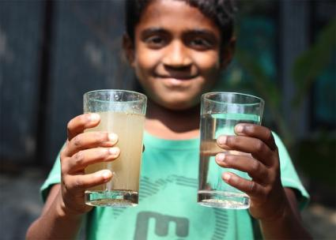  
Arsenic naturally contaminates many water sources.  
   
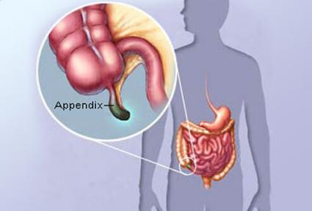  
Appendicitis has natural causes.  
  
   
Antibiotics are grown in a lab.  
  
  
While not all "natural" products are good for us, many "unnatural" products are actually beneficial. Most antibiotics were developed in a lab. Most of us also appreciate the benefits of electricity or fermented foods.

At the end of the day, whether or not a product is natural does not determine whether it is good for us.

### Anti-naturalistic fallacy arm #2: “Clean meat is similar to foods you already eat” argument

*(this article is designed to convey the idea that clean meat is very similar to many foods that you already eat regularly and that you also don’t know much about how many of these foods are made.)*

This arm will:

- Give examples of products that most people already eat which may be thought of as "unnatural".

Text:

**There’s no such thing as a “natural” food**  
  
Unless you’re living exclusively on foraged berries and wild-caught fish, you’re eating food that’s the result of thousands – or even tens of thousands – of years of purposeful human intervention. Why is the banana such a perfect food? Because we bred it to be that way. Why is corn so big and sweet? Because that’s how we like it. From cows that produce gallons of milk a day to chickens that reach maturity by four weeks, our food is as much a cultural artifact as it is a natural one.  
  
  
Natural vs. modern banana.  
  
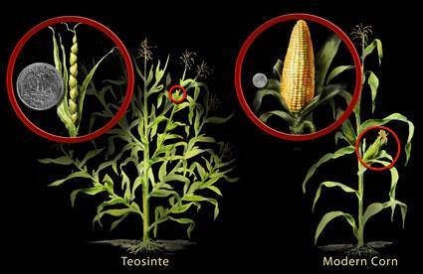  
Natural vs. modern corn.  
  
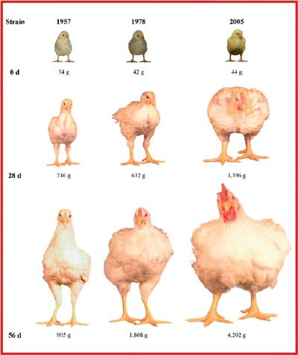  
Natural vs. modern chickens.

Cultured cells and microbes are also used in some of the oldest foods on the planet. If you wanted to cut food produced with the help of microbes out of your life, you’d have to stop consuming bread, beer, wine, yoghurt, vinegar, sour cream, sauerkraut, soy sauce, kombucha, and kimchi. Not to mention that fact that, if you look at them under a microscope, lab-grown muscle tissue and animal-grown muscle tissue are identical.

### Anti-naturalistic fallacy arm #3: Social norms

*(this article is designed to not making any value judgments about clean meat, but to merely convey that it is becoming more popular and many people are interested in trying it)*

This arm will:

- provide text suggesting many people may be interested in clean meat.

Text:

**Consumers demand clean meat**  
  
Demand for "clean" meat products keeps growing, despite higher price points compared with conventional meat, according to data from Nielsen Perishables Group.  
  
The call for food transparency continues to build, and with it, the use of terms like “natural,” “hyper-local” and “antibiotic-free” in conversations around our food. When it comes to meat, discussions include the added dimensions of livestock care and processing, complicating the labeling of meat products well beyond what’s needed for an organic banana or a package of fiber cereal. So what exactly do these meat labels mean, and what are the nuances? But perhaps more importantly, do consumers really want “cleaner” meat?  
  
  
Consumer demand for clean meat has been increasing over time.  
  
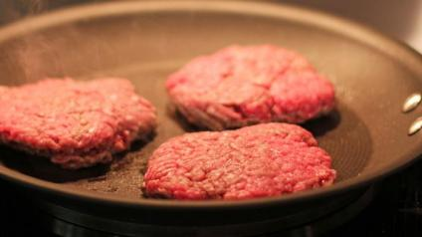  
Consumers now care about clean meat.  
  
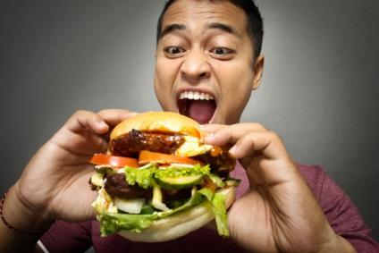  
72% of people say they would be interested in eating clean meat.  
  
  
A recent survey, published this month in PLOS One, investigated the views of people in the United States, a country with one of the largest appetites for meat and an equally large appetite for adopting new technologies.

72 percent of people who normally eat beef and pig products said they would still do so if they were produced as cultured meat. The perceived advantages of clean meat were that it was environmentally and animal-welfare friendly, ethical, and less likely to carry diseases.

## Appendix B: Social information text

The following snippets of text will be presented to each subject receiving this treatment arm.

"Artificial meat sounds disgusting."

"This seems very unnatural. I don't feel comfortable about this."

"No one will like clean meat."

"Clean meat isn't real meat."

"Our guts are not meant to digest unnatural things."